
Chapter 5
Groups and Teams in Organization
अध्याय ५ — संगठनमा समूह तथा टोली
English + नेपाली — Based Strictly on the Provided Source Notes

NDGURU — Your Gateway of Success
LEARN TODAY. LEAD TOMORROW.
A Note on This Document

This document is a bilingual (English + नेपाली) reorganization of the handwritten source notes titled “Unit 5: Groups and Teams in Organization.” Every heading, definition, list, and table below comes directly from that source. Nothing has been added from outside the source material. Where a word or phrase in the original handwriting could not be read with confidence, it is marked [unclear in source] rather than guessed.
यो कागजात “Unit 5: Groups and Teams in Organization” शीर्षकको हस्तलिखित स्रोत नोटलाई अंग्रेजी + नेपाली दुवै भाषामा व्यवस्थित गरेर तयार पारिएको हो। तलका सबै शीर्षक, परिभाषा, सूची र तालिका सोही स्रोतबाट लिइएका हुन्। स्रोत बाहिरबाट कुनै थप जानकारी थपिएको छैन। हस्तलिखित स्रोतमा स्पष्ट नबुझिएको शब्द वा अंश भए त्यसलाई अड्कल नगरी [स्रोतमा अस्पष्ट] भनी चिन्ह लगाइएको छ।
Original Chapter Outline (as listed in the source)
- Concept of Group and Group Dynamics
- Stages of Group Formation
- Types of Groups
- Nature and Significance of Informal Group
- Teams: Concept, Nature and Types
- Difference between Group and Team
- Team Performance Factors
- Issues in Managing Work Team
1. Concept of Group
ENGLISH
A group is a collection of two or more people who work with one another regularly to achieve common goals. If an individual will be unable to perform all the required activities, the group formation is essential to achieve organizational goals. In a group, members are mutually dependent on one another to achieve a common goal. They interact with one another regularly to pursue those goals over a period of time, which is good for both the organization and their members — helping to accomplish important tasks and maintain a high-quality workforce.
नेपाली
समूह भनेको दुई वा दुईभन्दा बढी व्यक्तिहरूको समूह हो, जसले साझा लक्ष्य हासिल गर्न आपसमा नियमित रूपमा काम गर्छन्। यदि कुनै व्यक्तिले आवश्यक सबै गतिविधि एक्लै सम्पादन गर्न सक्दैन भने, संगठनात्मक लक्ष्य हासिल गर्नका लागि समूह गठन आवश्यक हुन्छ। समूहमा, सदस्यहरू साझा लक्ष्य हासिल गर्न एकअर्कामाथि पारस्परिक रूपमा निर्भर हुन्छन्। उनीहरू ती लक्ष्यहरू पछ्याउनका लागि निश्चित समयावधिसम्म आपसमा नियमित रूपमा अन्तरक्रिया गर्छन्, जुन संगठन र त्यसका सदस्य दुवैका लागि लाभदायक हुन्छ — महत्त्वपूर्ण कार्य पूरा गर्न र उच्च गुणस्तरको कार्यबल कायम राख्न मद्दत गर्दै।
Features of Group
समूहका विशेषताहरू
# | English | नेपाली
a | Two or more person | दुई वा दुईभन्दा बढी व्यक्ति
b | Common objectives | साझा उद्देश्यहरू
c | Collective identity | सामूहिक पहिचान
d | Mutual interaction | पारस्परिक अन्तरक्रिया
e | Mutual support | पारस्परिक सहयोग
f | Mutual accountable | पारस्परिक जवाफदेहिता
g | Structured basis | संरचित आधार
h | Group leader | समूह नेता

2. Reasons of Group Formation
ENGLISH
The reasons for group formation can be studied under two points of view:
- Employee point of view
- Organizational point of view
नेपाली
समूह गठनका कारणहरूलाई दुई दृष्टिकोणबाट अध्ययन गर्न सकिन्छ:
- कर्मचारीको दृष्टिकोण (Employee point of view)
- संगठनात्मक दृष्टिकोण (Organizational point of view)
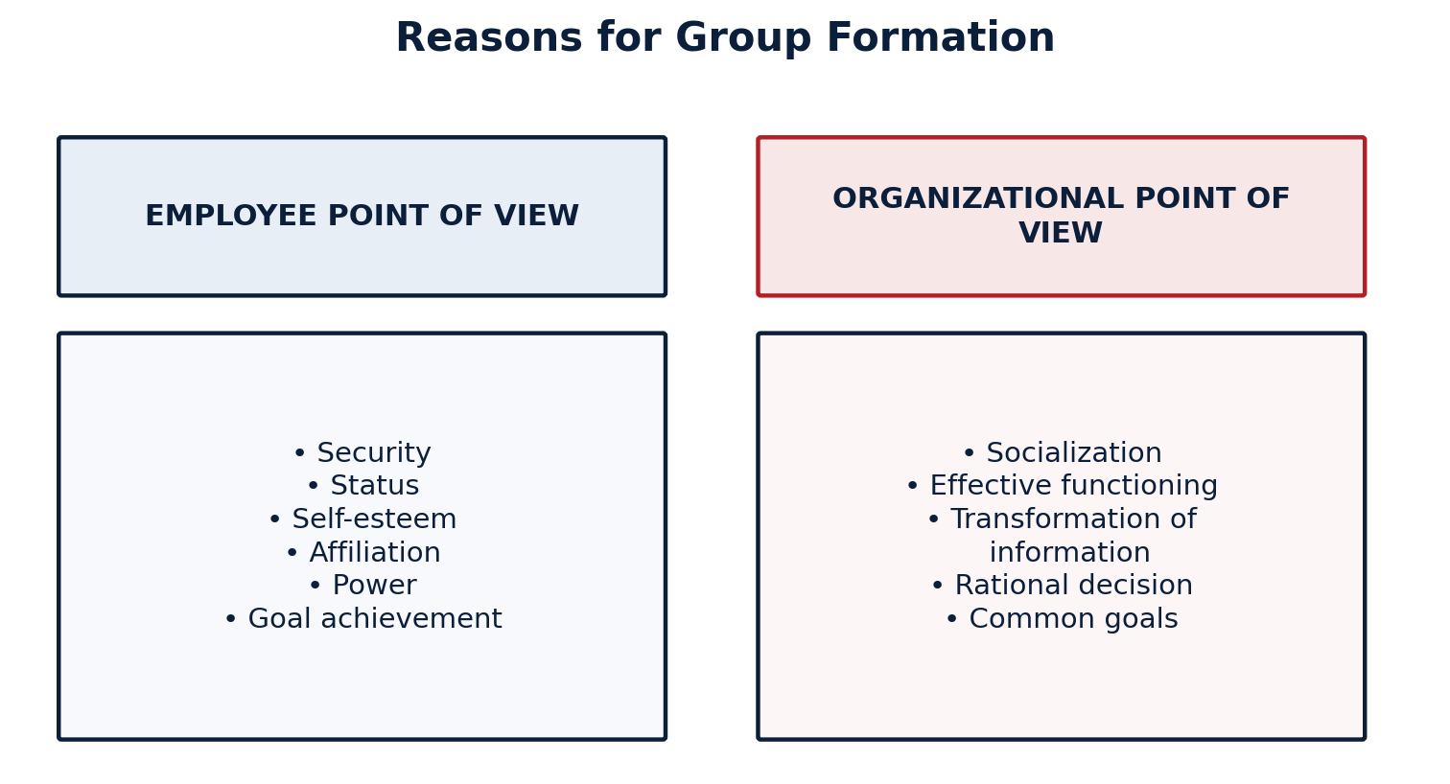
a. Employee Point of View
क. कर्मचारीको दृष्टिकोण
# | English | नेपाली
i | Security | सुरक्षा
ii | Status | हैसियत / स्तर
iii | Self esteem | आत्मसम्मान
iv | Affiliation | सम्बद्धता
v | Power | शक्ति
vi | Goal achievement | लक्ष्य प्राप्ति

b. Organizational Point of View
ख. संगठनात्मक दृष्टिकोण
# | English | नेपाली
i | Socialization | समाजीकरण
ii | Effective functioning | प्रभावकारी सञ्चालन
iii | Transformation of information | सूचनाको आदानप्रदान
iv | Rational decision | तर्कसंगत निर्णय
v | Common goals | साझा लक्ष्यहरू

3. Stages of Group Formation
ENGLISH
There are mainly five stages of group formation:
- Forming
- Storming
- Norming
- Performing
- Adjourning
नेपाली
समूह गठनका मुख्यतः पाँच चरणहरू छन्:
- Forming (गठन चरण)
- Storming (द्वन्द्व चरण)
- Norming (मापदण्ड निर्माण चरण)
- Performing (कार्यसम्पादन चरण)
- Adjourning (विसर्जन चरण)
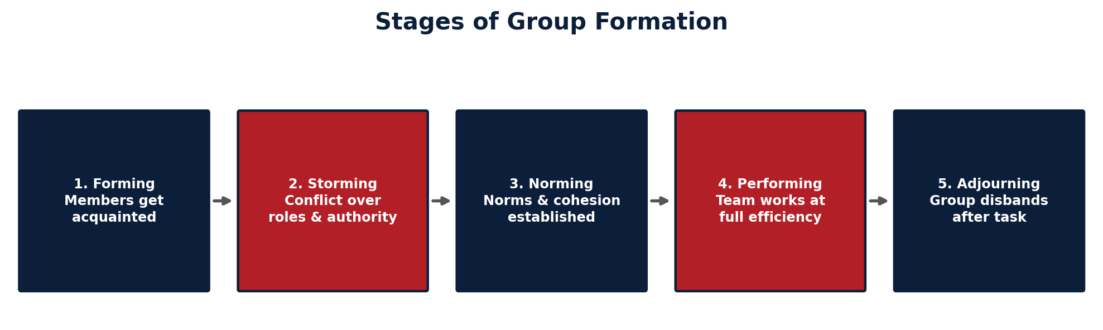
a. Forming
It is the first stage of group development. Individuals ask a number of questions as they begin to identify with each other. In this stage, employees know what is expected from them and how they will fit into the group.
क. Forming (गठन चरण)
यो समूह विकासको पहिलो चरण हो। व्यक्तिहरूले एकअर्कासँग पहिचान बनाउन थाल्दा धेरै प्रश्नहरू सोध्छन्। यस चरणमा कर्मचारीहरूलाई थाहा हुन्छ कि उनीहरूबाट के अपेक्षा गरिएको छ र उनीहरू समूहमा कसरी मिल्नेछन्।
b. Storming
It is characterized by high degree of conflict and confrontation. Members involving in group accept rules and regulations of group but different issues occur regarding leadership styles, authority, individual goals, and organizational goals. Managing the expectation and status is a great challenge in this stage.
ख. Storming (द्वन्द्व चरण)
यो चरण उच्च मात्राको द्वन्द्व र टकरावद्वारा चिन्हित हुन्छ। समूहमा सामेल सदस्यहरूले समूहका नियम र विनियमहरू स्वीकार गर्छन्, तर नेतृत्व शैली, अख्तियार, व्यक्तिगत लक्ष्य र संगठनात्मक लक्ष्यसम्बन्धी विभिन्न मुद्दाहरू देखा पर्छन्। यस चरणमा अपेक्षा र हैसियत व्यवस्थापन गर्नु ठूलो चुनौती हो।
c. Norming Stage
This stage is also known as the initial integration stage because in this stage, employees serve as a coordinated unit, make close relationships, and protect from the possibility of disintegration. This stage is complete when all group members have common expectation and are doing work in unity.
ग. Norming Stage (मापदण्ड निर्माण चरण)
यस चरणलाई प्रारम्भिक एकीकरण चरण (initial integration stage) पनि भनिन्छ, किनभने यस चरणमा कर्मचारीहरू एउटा समन्वित इकाइको रूपमा काम गर्छन्, नजिकको सम्बन्ध बनाउँछन्, र विघटनको सम्भावनाबाट आफूलाई जोगाउँछन्। जब सबै समूह सदस्यहरूको साझा अपेक्षा हुन्छ र उनीहरू एकतामा काम गर्छन्, तब यो चरण पूर्ण हुन्छ।
d. Performing Stage
It is the fourth stage of group formation. The structure at this point is fully functional and accepted; members can redirect their effort from the development of the group's structure to complete the task at hand. Here, the group is able to deal with complex tasks and handle internal disagreements.
घ. Performing Stage (कार्यसम्पादन चरण)
यो समूह गठनको चौथो चरण हो। यस बिन्दुमा समूहको संरचना पूर्ण रूपमा कार्यात्मक र स्वीकृत हुन्छ; सदस्यहरूले समूहको संरचना विकास गर्नेबाट ध्यान हटाई हातमा रहेको कार्य पूरा गर्नतर्फ आफ्नो प्रयास लगाउन सक्छन्। यहाँ समूह जटिल कार्यहरू सम्हाल्न र आन्तरिक असहमतिहरू व्यवस्थापन गर्न सक्षम हुन्छ।
e. Adjourning
The last stage for permanent work groups is performing. But for temporary groups like committees, teams, and similar groups, there is an adjourning stage. Groups prepare for their disbandment. In the adjourning stage, attention is directed toward wrapping up activities.
ङ. Adjourning (विसर्जन चरण)
स्थायी कार्य समूहहरूको लागि अन्तिम चरण Performing हो। तर समिति, टोली र त्यस्तै अस्थायी समूहहरूको लागि Adjourning चरण हुन्छ। समूहहरू आफ्नो विघटनको लागि तयारी गर्छन्। Adjourning चरणमा ध्यान गतिविधिहरू टुंग्याउनेतर्फ केन्द्रित हुन्छ।
4. Types of Groups
ENGLISH
Groups are broadly divided into:
- Formal Group — i. Command group ii. Task group
- Informal Group — i. Interest group ii. Friendship group
नेपाली
समूहहरूलाई मुख्यतः दुई भागमा विभाजन गरिन्छ:
- औपचारिक समूह (Formal Group) — i. Command group ii. Task group
- अनौपचारिक समूह (Informal Group) — i. Interest group ii. Friendship group
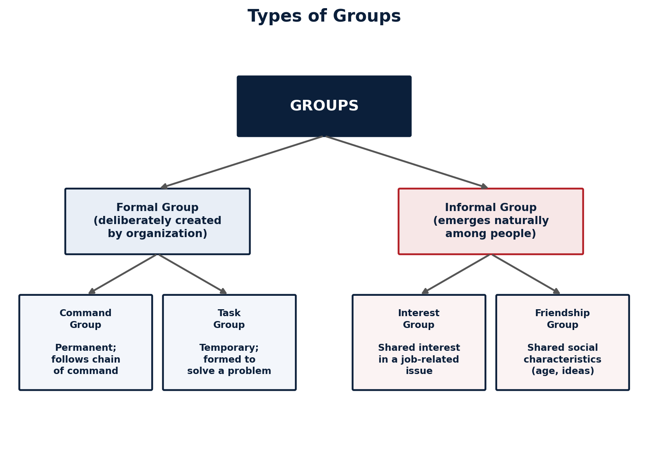
Formal Group
A formal group is deliberately created by the organization to carry out its operation and achieve its goal. The organizational chart depicts a formal group in the organization. The placement of organizational members in such areas as the production department and marketing department are examples of establishing a formal group. Formal groups are commonly divided into command group and task group.
औपचारिक समूह
औपचारिक समूह भनेको संगठनले आफ्नो सञ्चालन गर्न र आफ्नो लक्ष्य हासिल गर्नका लागि जानाजानी गठन गरेको समूह हो। संगठनात्मक चार्ट (organizational chart) ले संगठनभित्रको औपचारिक समूह देखाउँछ। उत्पादन विभाग (production department), बजार विभाग (marketing department) जस्ता क्षेत्रहरूमा संगठनका सदस्यहरूको स्थान निर्धारण गर्नु औपचारिक समूह स्थापना गर्ने उदाहरण हो। औपचारिक समूहलाई सामान्यतया command group र task group मा विभाजन गरिन्छ।
i. Command Group
Command groups are permanent work groups in the organization. They are outlined in the vertical line in the organizational chart as department or division. They usually handle routine organizational activities. In all cases, they are officially created to perform on an ongoing basis.
i. Command Group
Command group संगठनका स्थायी कार्य समूह हुन्। यिनीहरू संगठनात्मक चार्टमा ठाडो रेखामा विभाग वा महाशाखाका रूपमा उल्लेख गरिएका हुन्छन्। यिनीहरूले सामान्यतया नियमित संगठनात्मक गतिविधिहरू सम्हाल्छन्। सबै अवस्थामा, यिनीहरू निरन्तर आधारमा काम गर्नका लागि आधिकारिक रूपमा सिर्जना गरिएका हुन्छन्।
ii. Task Group
Task groups are temporary work groups. Most committees and task forces are task groups. They are created to solve a problem or to perform a defined work. The organization specifies group members. They often disband once the assigned purpose or task has been accomplished.
ii. Task Group
Task group अस्थायी कार्य समूह हुन्। धेरैजसो समिति (committees) र कार्यदल (task forces) task group नै हुन्। यिनीहरू कुनै समस्या समाधान गर्न वा निर्धारित कार्य सम्पादन गर्नका लागि गठन गरिन्छन्। संगठनले नै समूह सदस्यहरू तोक्छ। तोकिएको उद्देश्य वा कार्य पूरा भएपछि यिनीहरू प्रायः विघटन हुन्छन्।
Informal Group
Informal groups emerge whenever people come together and interact regularly. Such groups are not pre-planned; they develop naturally in the workplace in response to the need for social contact. Informal groups are not highly structured; their procedures are not formally recognized as formal groups by the organization. Informal groups can be divided into interest group and friendship group.
अनौपचारिक समूह
अनौपचारिक समूहहरू मानिसहरू सँगै आउँदा र नियमित रूपमा अन्तरक्रिया गर्दा स्वतः उत्पन्न हुन्छन्। यस्ता समूहहरू पूर्वयोजित हुँदैनन्; यिनीहरू सामाजिक सम्पर्कको आवश्यकताका कारण कार्यस्थलमा स्वाभाविक रूपमा विकसित हुन्छन्। अनौपचारिक समूहहरू उच्च स्तरमा संरचित हुँदैनन्; तिनका प्रक्रियाहरूलाई संगठनले औपचारिक समूहका रूपमा आधिकारिक रूपमा मान्यता दिँदैन। अनौपचारिक समूहलाई interest group र friendship group मा विभाजन गर्न सकिन्छ।
i. Interest Group
Interest groups are formed to share common interest in some job-related event or possible outcomes. Employees having the same interest form interest groups, which are unstructured. This type of group is formed in the area of sports, holidays, cafeteria, overtime facilities, etc.
i. Interest Group
Interest group कुनै कामसँग सम्बन्धित घटना वा सम्भावित परिणामप्रति साझा रुचि साझा गर्नका लागि गठन गरिन्छ। समान रुचि भएका कर्मचारीहरूले interest group बनाउँछन्, जुन असंरचित (unstructured) हुन्छ। यस प्रकारका समूह खेलकुद, बिदा, क्यान्टिन, ओभरटाइम सुविधा जस्ता क्षेत्रहरूमा गठन गरिन्छन्।
ii. Friendship Group
Friendship groups are formed in an organization because of the social needs of employees for belonging, affiliation, acceptance, etc. Employees having common characteristics such as age, ethnic background, political sentiment, etc. form a friendship group. Friendship helps members to motivate work.
ii. Friendship Group
Friendship group संगठनमा कर्मचारीहरूको सामाजिक आवश्यकता — जस्तै belonging (आत्मीयता), affiliation (सम्बद्धता), acceptance (स्वीकृति) आदिका कारण गठन हुन्छ। उमेर, जातीय पृष्ठभूमि, राजनीतिक झुकाव जस्ता साझा विशेषता भएका कर्मचारीहरूले friendship group बनाउँछन्। Friendship ले सदस्यहरूलाई काम गर्न प्रेरित गर्न मद्दत गर्छ।
5. Significance of Informal Groups
ENGLISH
A. For Group Members
- Sense of belonging
- Identity and self esteem
- Stress reduction
- All for one
- Social control
- Solution of work problems
B. For the Management
- Better performance
- Utilization of creativity
- Development of leaders
- Minimize supervision cost
- Strategic information
नेपाली
क. समूह सदस्यहरूका लागि
- Sense of belonging (आत्मीयताको भावना)
- Identity and self esteem (पहिचान र आत्मसम्मान)
- Stress reduction (तनाव कमी)
- All for one (सबै एकका लागि)
- Social control (सामाजिक नियन्त्रण)
- Solution of work problems (कार्य समस्याको समाधान)
ख. व्यवस्थापनका लागि
- Better performance (राम्रो प्रदर्शन)
- Utilization of creativity (सिर्जनशीलताको उपयोग)
- Development of leaders (नेताहरूको विकास)
- Minimize supervision cost (निरीक्षण लागत न्यूनीकरण)
- Strategic information (रणनीतिक सूचना)
Features of Informal Groups
अनौपचारिक समूहका विशेषताहरू
# | English | नेपाली
a | Based on formal groups | औपचारिक समूहमा आधारित
b | Unofficial groups | अनाधिकारिक समूह
c | Focus in person | व्यक्तिमा केन्द्रित
d | Common interest | साझा रुचि
e | Basis of interaction | अन्तरक्रियाको आधार
f | Informal communication | अनौपचारिक सञ्चार
g | Groups norms | समूह मापदण्ड
h | Source of power | शक्तिको स्रोत
i | Less stable | कम स्थायी

6. Concept of Team
ENGLISH
- A team can be defined as any number of persons who interact and influence each other toward a common purpose.
- A team is a group of workers that functions as a unit, often with little or no supervision, to carry out organizational functions.
- Team involves two aspects: interaction among two or more people, and next is team members are influenced by each other.
- Group and team are not the same thing. All teams are groups because they consist of people with a unifying relationship. But all groups assembled together — groups do not need to engage in collective work that requires joint effort.
नेपाली
- टोली (Team) भनेको साझा उद्देश्यतर्फ आपसमा अन्तरक्रिया गर्ने र एकअर्कालाई प्रभाव पार्ने जुनसुकै संख्याका व्यक्तिहरू हुन्।
- टोली भनेको कामदारहरूको एउटा समूह हो जसले प्रायः थोरै वा कुनै निरीक्षण नभई संगठनात्मक कार्यहरू सम्पादन गर्न एउटा इकाइको रूपमा काम गर्छ।
- टोलीमा दुई पक्ष समावेश हुन्छन्: दुई वा दुईभन्दा बढी व्यक्तिबीचको अन्तरक्रिया, र टोलीका सदस्यहरू एकअर्काबाट प्रभावित हुनु।
- समूह (Group) र टोली (Team) उस्तै कुरा होइनन्। सबै टोली समूह हुन् किनभने तिनमा एकताबद्ध सम्बन्ध भएका व्यक्तिहरू हुन्छन्। तर सबै जम्मा भएका समूहले संयुक्त प्रयास आवश्यक पर्ने सामूहिक कार्यमा संलग्न हुनुपर्छ भन्ने छैन।
Nature of Team
टोलीको प्रकृति
# | English | नेपाली
1 | Clear team goal and commitment | स्पष्ट टोली लक्ष्य र प्रतिबद्धता
2 | Complementary skill / relevant skill | परिपूरक सीप / सान्दर्भिक सीप
3 | Share leadership | साझा नेतृत्व
4 | Individual and mutual accountability | व्यक्तिगत र पारस्परिक जवाफदेहिता
5 | Positive synergy | सकारात्मक सहक्रिया (synergy)
6 | Team based reward system | टोलीमा आधारित पुरस्कार प्रणाली
7 | Open communication | खुला सञ्चार
8 | Mutual trust | पारस्परिक विश्वास

7. Difference between Group and Team
ENGLISH
Group | Team
1. Has a leader chosen by the members. | 1. Share the role of leadership.
2. Individual accountability. | 2. Accountability is mutual and individual.
3. The similarity between the goal and organization. | 3. Vision and mission only for special team.
4. Individual work. | 4. Collective work.
5. The effectiveness is measured by the business effect indirectly. | 5. Every meeting open a discussion. The effectiveness is measured by directly and collectively.
6. Discussion, decision, delegation of a work for each individual. | 6. Discussion, decision and sharing of work.

नेपाली
समूह (Group) | टोली (Team)
१. सदस्यहरूद्वारा छानिएको नेता हुन्छ। | १. नेतृत्वको भूमिका साझा गरिन्छ।
२. व्यक्तिगत जवाफदेहिता। | २. जवाफदेहिता पारस्परिक र व्यक्तिगत दुवै हुन्छ।
३. लक्ष्य र संगठनबीचको समानता। | ३. दूरदृष्टि (vision) र लक्ष्य (mission) विशेष टोलीका लागि मात्र हुन्छ।
४. व्यक्तिगत काम। | ४. सामूहिक काम।
५. प्रभावकारिता अप्रत्यक्ष रूपमा व्यावसायिक प्रभावद्वारा मापन गरिन्छ। | ५. हरेक भेला छलफलका लागि खुला हुन्छ। प्रभावकारिता प्रत्यक्ष र सामूहिक रूपमा मापन गरिन्छ।
६. छलफल, निर्णय, र प्रत्येक व्यक्तिका लागि कामको जिम्मेवारी बाँडफाँड। | ६. छलफल, निर्णय, र कामको साझेदारी।

8. Types of Work Teams
ENGLISH
There are mainly four types of work teams:
- Problem solving team
- Self-managed team
- Cross-functional team
- Virtual team
नेपाली
कार्य टोलीका मुख्यतः चार प्रकार छन्:
- Problem solving team (समस्या समाधान टोली)
- Self-managed team (स्व-व्यवस्थित टोली)
- Cross-functional team (अन्तर-कार्यात्मक टोली)
- Virtual team (भर्चुअल टोली)
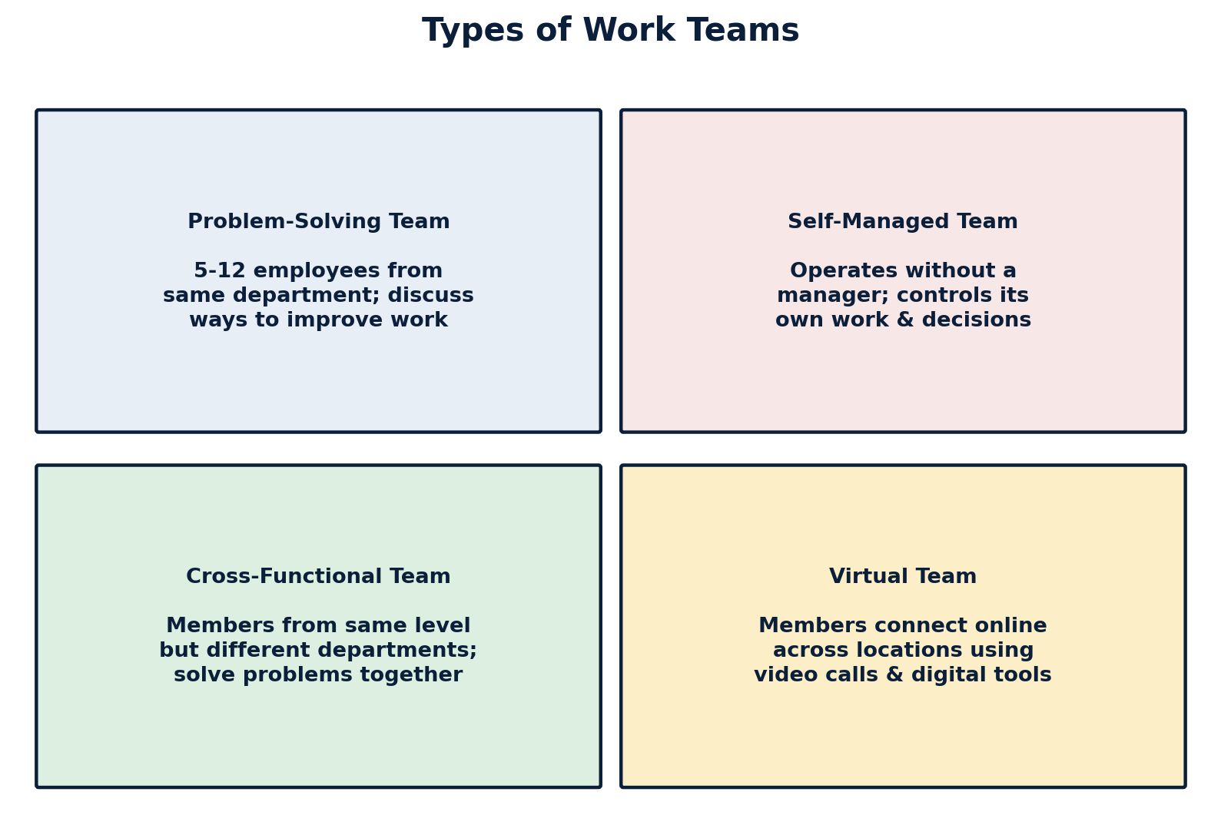
Problem Solving Team
Problem-solving teams are composed of 5 to 12 employees from the same department. They meet for a few hours each week to discuss the problem situation. It can also be established temporarily to attack specific problems in the workplace. They improve their work quality, efficiency, and work environment. They share ideas or offer suggestions on how to improve the work standard and solve the problem.
Problem Solving Team
Problem-solving team उही विभागका ५ देखि १२ जना कर्मचारीहरूबाट बनेको हुन्छ। उनीहरू समस्याको अवस्थाबारे छलफल गर्न प्रत्येक हप्ता केही घण्टा भेला हुन्छन्। यसलाई कार्यस्थलका निश्चित समस्यालाई सम्बोधन गर्न अस्थायी रूपमा पनि गठन गर्न सकिन्छ। यिनीहरूले आफ्नो कामको गुणस्तर, दक्षता र कार्य वातावरण सुधार गर्छन्। उनीहरूले कार्य मापदण्ड सुधार गर्ने र समस्या समाधान गर्ने उपायबारे विचार वा सुझाव साझा गर्छन्।
Self-Managed Team
Self-managed team is a formal group of employees who operate without a manager. They are responsible for a complete work process and for getting the work done. Self-managed teams collectively control their work, assignment, choice of procedures, and so on. Such teams select their own members, who evaluate the performance of each member. They implement their decisions and take full responsibility for outcomes.
Self-Managed Team
Self-managed team भनेको म्यानेजर बिना नै सञ्चालन हुने कर्मचारीहरूको औपचारिक समूह हो। उनीहरू सम्पूर्ण कार्य प्रक्रिया र काम सम्पन्न गर्ने जिम्मेवारी बहन गर्छन्। Self-managed team ले सामूहिक रूपमा आफ्नो काम, कार्यभार, प्रक्रियाको छनोट आदि नियन्त्रण गर्छ। यस्ता टोलीले आफ्नै सदस्य छनोट गर्छन्, जसले प्रत्येक सदस्यको कार्यसम्पादनको मूल्याङ्कन गर्छ। उनीहरूले आफ्नो निर्णय कार्यान्वयन गर्छन् र परिणामको पूर्ण जिम्मेवारी लिन्छन्।
Cross-Functional Team
Cross-functional team consists of members from about the same hierarchical level but from different work areas. People from diverse areas join together to find out solutions. They are experts in various specialities and work together on various tasks. They can solve the problem with a positive combination of functional expertise. A task force is one example of cross-functional teams.
Cross-Functional Team
Cross-functional team लगभग उही तहका तर फरक-फरक कार्यक्षेत्रका सदस्यहरूबाट बनेको हुन्छ। विविध क्षेत्रका मानिसहरू समाधान पत्ता लगाउन एकसाथ जोडिन्छन्। उनीहरू विभिन्न विशेषज्ञता क्षेत्रका विज्ञ हुन्छन् र विभिन्न कार्यहरूमा सँगै काम गर्छन्। उनीहरूले कार्यात्मक विशेषज्ञताको सकारात्मक संयोजनबाट समस्या समाधान गर्न सक्छन्। Task force cross-functional team को एउटा उदाहरण हो।
Virtual Team
Virtual team is a modern method of formation of team, and its use is rapidly increasing nowadays. It is done through online. This team is commonly formed when team members are from international areas and a physical meeting is not possible. Meeting/discussion is done on the internet through video conference, audio call, messenger, and social networks.
Virtual Team
Virtual team टोली गठनको आधुनिक तरिका हो, र आजकल यसको प्रयोग तीव्र गतिमा बढिरहेको छ। यो अनलाइन मार्फत सञ्चालन गरिन्छ। यो टोली सामान्यतया तब गठन गरिन्छ जब टोलीका सदस्यहरू अन्तर्राष्ट्रिय क्षेत्रका हुन्छन् र भौतिक रूपमा भेट्न सम्भव हुँदैन। भेला/छलफल इन्टरनेटमार्फत भिडियो कन्फरेन्स, अडियो कल, मेसेन्जर र सामाजिक सञ्जालहरू प्रयोग गरेर गरिन्छ।
9. Team Performance Factors
ENGLISH
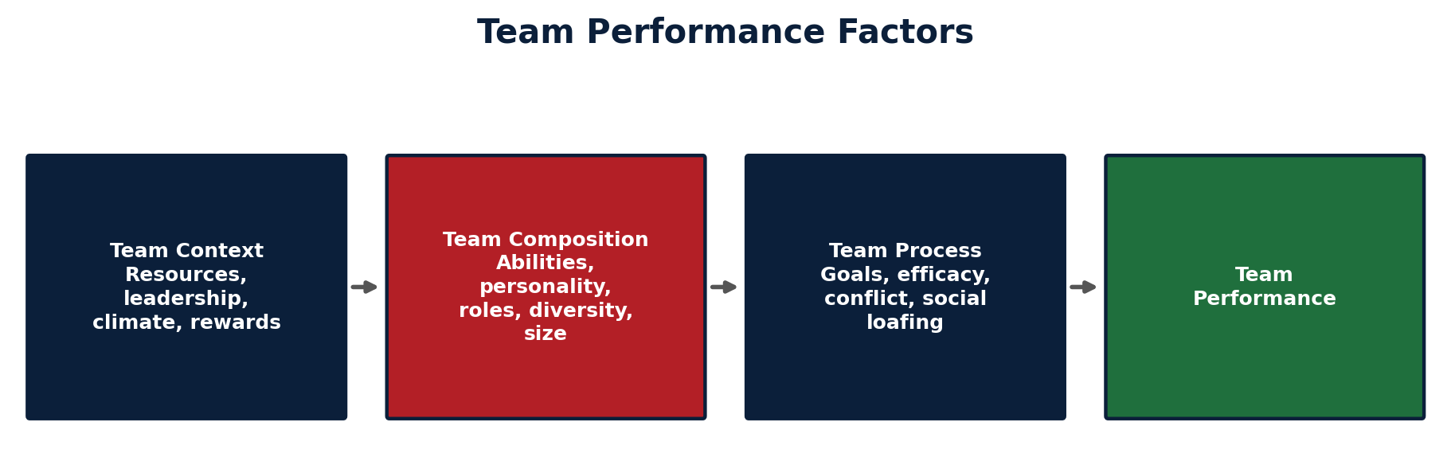
1. Team Context Factor
Context is the situation in which a team performs activities. It includes:
- Adequate resources [unclear in source — a Nepali gloss was written beside this point but could not be read with confidence]
- Leadership and structure
- Climate trust
- Performance evaluation and reward system
Such factors from team context influence the team performance.
2. Team Composition
- Abilities of members
- Personality
- Allocating roles
- Diversity
- Size of teams
- Members' preferences
3. Team Process
- Common purpose
- Specific goals
- Team efficiency
- Conflict levels
- Social loafing
नेपाली
१. Team Context Factor
Context भनेको त्यो परिस्थिति हो जसमा टोलीले गतिविधिहरू सम्पादन गर्छ। यसमा समावेश छन्:
- Adequate resources — पर्याप्त स्रोतहरू [स्रोतमा यस बुँदाछेउ लेखिएको नेपाली शब्द अस्पष्ट भएकाले टिप्पणी थपिएको छैन]
- Leadership and structure — नेतृत्व र संरचना
- Climate trust — वातावरणीय विश्वास
- Performance evaluation and reward system — कार्यसम्पादन मूल्याङ्कन र पुरस्कार प्रणाली
टोली सन्दर्भ (team context) का यस्ता तत्वहरूले टोलीको कार्यसम्पादनलाई प्रभाव पार्छन्।
२. Team Composition
- Abilities of members — सदस्यहरूको क्षमता
- Personality — व्यक्तित्व
- Allocating roles — भूमिका बाँडफाँड
- Diversity — विविधता
- Size of teams — टोलीको आकार
- Members' preferences — सदस्यहरूको प्राथमिकता
३. Team Process
- Common purpose — साझा उद्देश्य
- Specific goals — विशिष्ट लक्ष्यहरू
- Team efficiency — टोली दक्षता
- Conflict levels — द्वन्द्वको स्तर
- Social loafing — सामाजिक अल्छीपन (Social Loafing)
10. Issues in Managing Work Team
ENGLISH
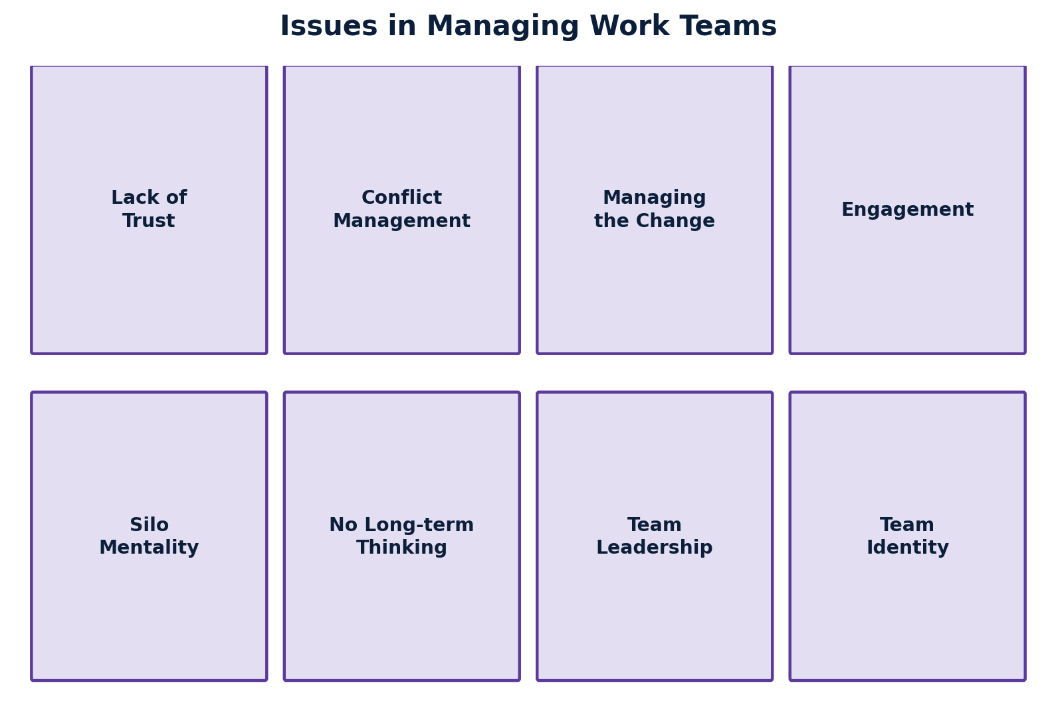
- Lack of trust
- Conflict management
- Managing the change
- Engagement
- Working in silo mentality (tendency of being reluctant to share the real information)
- No long-term thinking
- Team leadership
- Team identity
- Lack of open communication
नेपाली
- Lack of trust — विश्वासको कमी
- Conflict management — द्वन्द्व व्यवस्थापन
- Managing the change — परिवर्तन व्यवस्थापन
- Engagement — संलग्नता
- Working in silo mentality — पृथक (silo) मानसिकतामा काम गर्ने प्रवृत्ति (वास्तविक जानकारी साझा गर्न अनिच्छुक हुने प्रवृत्ति)
- No long-term thinking — दीर्घकालीन सोचको अभाव
- Team leadership — टोली नेतृत्व
- Team identity — टोली पहिचान
- Lack of open communication — खुला सञ्चारको कमी
11. Previous Years' University Exam Questions (from Chapter 5)
ENGLISH
The following questions on Groups and Teams in Organization were verified from the actual Tribhuvan University, BBS 2nd Year, Organizational Behavior and HRM (MGT-223) question papers available online for 2080, 2081, and 2082 (Regular). Each is listed with its year, group/section, and marks.
Year (BS) | Question | Marks / Group
2082 (Regular) | Define group dynamics. | 2 marks — Group A (Brief Answer Questions)
2082 (Regular) | Describe the major issues in managing work teams. | 10 marks — Group B (Descriptive Answer Questions)
2081 (Regular) | Mention two significances of informal group. | 2 marks — Group A (Brief Answer Questions)
2080 (Regular) | Point out any two types of groups. | 2 marks — Group A (Brief Answer Questions)

Note on coverage: Verified past-paper questions on this chapter were found for 2080, 2081, and 2082 (Regular) only. Question papers for MGT-223 “Organizational Behavior and HRM” for 2077, 2078, and 2079 could not be located/verified in a form that could be reliably confirmed, so no questions are listed for those years rather than guessing at them.
Most Important Topics for the Exam (based on the pattern above)
Based on the questions that have actually appeared, these topics from Chapter 5 are the ones most consistently tested and deserve priority revision:
- Group dynamics — meaning/definition (asked 2082)
- Types of groups — Formal (Command/Task) and Informal (Interest/Friendship) (asked 2080)
- Significance of informal groups — for members and for management (asked 2081)
- Issues in managing work teams (asked 2082, as a full 10-mark descriptive question)
- Stages of group formation (Forming, Storming, Norming, Performing, Adjourning) and Difference between Group and Team are core chapter topics not yet seen directly in the located papers, but remain fundamental and commonly asked in this subject area.
नेपाली
Groups and Teams in Organization सम्बन्धी तलका प्रश्नहरू Tribhuvan University, BBS २ वर्ष, Organizational Behavior and HRM (MGT-223) का वास्तविक प्रश्नपत्र (२०८०, २०८१, २०८२ Regular) बाट रुजु गरी लिइएका हुन्। प्रत्येक प्रश्नसँग वर्ष, समूह/खण्ड, र अंक उल्लेख गरिएको छ।
वर्ष (वि.सं.) | प्रश्न | अंक / समूह
२०८२ (Regular) | Define group dynamics. (Group dynamics को परिभाषा दिनुहोस्।) | २ अंक — समूह क
२०८२ (Regular) | Describe the major issues in managing work teams. (कार्य टोली व्यवस्थापनका प्रमुख समस्या वर्णन गर्नुहोस्।) | १० अंक — समूह ख
२०८१ (Regular) | Mention two significances of informal group. (अनौपचारिक समूहका दुई महत्त्व उल्लेख गर्नुहोस्।) | २ अंक — समूह क
२०८० (Regular) | Point out any two types of groups. (समूहका कुनै दुई प्रकार औंल्याउनुहोस्।) | २ अंक — समूह क

दायरासम्बन्धी टिप्पणी: यस अध्यायसँग सम्बन्धित रुजु गरिएका विगतका प्रश्नहरू २०८०, २०८१ र २०८२ (Regular) का लागि मात्र फेला परे। २०७७, २०७८ र २०७९ का MGT-223 “Organizational Behavior and HRM” प्रश्नपत्रहरू भरपर्दो रूपमा फेला पार्न/रुजु गर्न सकिएन, त्यसैले ती वर्षका लागि अड्कल गरी प्रश्न राखिएको छैन।
परीक्षाका लागि सबैभन्दा महत्त्वपूर्ण विषयवस्तु (माथिको ढाँचामा आधारित)
माथि वास्तवमै सोधिएका प्रश्नहरूका आधारमा, अध्याय ५ का यी विषयवस्तुहरू सबैभन्दा बढी दोहोरिने र प्राथमिकतामा राखेर दोहोर्याउनुपर्ने देखिन्छन्:
- Group dynamics को अर्थ/परिभाषा (२०८२ मा सोधिएको)
- समूहका प्रकार — औपचारिक (Command/Task) र अनौपचारिक (Interest/Friendship) (२०८० मा सोधिएको)
- अनौपचारिक समूहको महत्त्व — सदस्य र व्यवस्थापन दुवैका लागि (२०८१ मा सोधिएको)
- कार्य टोली व्यवस्थापनका समस्याहरू (२०८२ मा पूरा १० अंकको वर्णनात्मक प्रश्नका रूपमा सोधिएको)
- समूह गठनका चरणहरू (Forming, Storming, Norming, Performing, Adjourning) र Group र Team बीचको भिन्नता — फेला परेका प्रश्नपत्रमा प्रत्यक्ष सोधिएको भेटिएन, तर यी अध्यायका आधारभूत विषय भएकाले यस क्षेत्रमा सामान्यतया सोधिने गरिन्छन्।
Source Coverage Verification
This document has been checked page-by-page against the uploaded handwritten source (“Unit 5: Groups and Teams in Organization”). All sections listed in the source outline are covered: Concept of Group, Features of Group, Reasons of Group Formation (Employee and Organizational points of view), Stages of Group Formation (Forming, Storming, Norming, Performing, Adjourning), Types of Groups (Formal — Command/Task; Informal — Interest/Friendship), Significance of Informal Groups (for members and for management), Features of Informal Groups, Concept of Team, Nature of Team, Difference between Group and Team, Types of Work Teams (Problem-Solving, Self-Managed, Cross-Functional, Virtual), Team Performance Factors (Context, Composition, Process), and Issues in Managing Work Team. A separate section adds verified past-year TU exam questions (2080–2082) relevant to this chapter, clearly labeled and sourced, with no fabricated years or questions.
Item flagged for review: One handwritten annotation next to “Adequate resources” under Team Context Factor was not legible enough to transcribe with confidence. It has been marked [unclear in source] rather than guessed, as instructed.
यो कागजातलाई अपलोड गरिएको हस्तलिखित स्रोत (“Unit 5: Groups and Teams in Organization”) सँग पृष्ठ-पृष्ठ दाँजेर जाँच गरिएको छ। स्रोतको रूपरेखामा सूचीबद्ध सबै खण्डहरू समेटिएका छन्।
NDGURU — Your Gateway of Success
LEARN TODAY. LEAD TOMORROW.
Chapter 5 : Groups and Teams in Organization — Bilingual Notes (Source-Faithful)

