BBA 8th Semester
Insurance and Risk Management
Chapter Description


1️⃣ Introduction
2️⃣ Risk Management
3️⃣ Insurance Device
4️⃣ Legal Principles in Insurance
5️⃣ Life Insurance
6️⃣ Non-life Insurance
7️⃣ Government Regulations of Insurance

Chapter one: Introduction
Risk refers to the uncertainty concerning the occurrence of a loss. It arises when there is a possibility that an unfavorable event may happen in the future.

Key Elements of Risk:
- Uncertainty
- Possibility of loss
- Future event
- Measurable impact
In simple terms:
Risk = Chance of loss + Uncertainty
Meaning of Peril
A Peril is the actual cause of loss or damage. It is the event that directly produces financial loss or property damage. In insurance, peril is the specific risk that an insurance policy covers.
🔹 Key Features of Peril:
- It is the direct cause of damage
- It results in measurable loss
- It is accidental in nature (in most cases)
- It is clearly identifiable
Examples of Peril:
- Fire, Flood and Earthquake
1️⃣ Natural Perils Caused by natural forces: Examples Earthquake, Flood, Cyclone, Landslide
2️⃣ Human Perils: Caused by human actions. Examples: Theft, Riot, Negligence, and War
3️⃣ Economic Perils: Inflation Examples Recession, Market crash
Meaning of Hazard
A Hazard is a condition that increases the probability or severity of loss caused by a peril. Hazard does not directly cause loss but makes the peril more dangerous.
🔹 Key Features of Hazard:
- Increases chance of loss
- Increases severity of loss
- Indirect cause of damage
- Can often be controlled or reduced
3️⃣ Types of Hazards (Very Important for Exam)
1. Physical Hazard : A tangible or visible condition that increases risk. Examples Faulty electrical wiring , Slippery floor, Poor road condition, Weak building structure and Storing petrol near fire
2. Moral Hazard
Dishonesty or bad intention of a person that increases risk. Examples: Setting fire intentionally to claim insurance, Fake accident claim, Exaggerating insurance loss, Insurance fraud
3. Morale Hazard
Carelessness or negligence due to the existence of insurance. Examples: Leaving car unlocked because it is insured, Careless driving, and not maintaining the property
4. Legal Hazard: Risk created by the legal system or court decisions. Examples: Strict liability laws, High compensation ordered by the court, and Consumer protection laws
Classification of Risk
Risk can be classified into different categories based on its nature, impact, and source. Understanding classification helps in risk identification, insurance decision, and management planning.
Risk is classified into:
- Pure vs Speculative
- Diversifiable vs Non-diversifiable
- Enterprise vs Systemic

  - Pure vs Speculative Risk
Pure Risk
It refers to a situation where there is only the possibility of loss or no loss, but no chance of profit or gain. In simple words: Pure Risk = Loss or No Loss (No Gain) It is generally accidental, unplanned, and beyond the control of the individua

Key Features of Pure Risk
1️⃣ Only two possible outcomes – loss or no loss
2️⃣ No possibility of financial gain
3️⃣ Usually accidental and unexpected
4️⃣ Measurable in financial terms
5️⃣ Insurable in nature
6️⃣ Common in personal and business life
Speculative Risk
Speculative Risk refers to a situation where there is a possibility of profit, loss, or no change. In simple words: Speculative Risk = Chance of Gain or Loss Unlike pure risk, speculative risk includes the opportunity to earn profit.
Key Features of Speculative Risk
1️⃣ Possibility of profit and loss
2️⃣ Taken voluntarily and intentionally
3️⃣ Usually related to business and investment
4️⃣ Difficult or impossible to insure
5️⃣ Influenced by market conditions
6️⃣ Can sometimes be controlled through strategy

  - Diversifiable vs Non-diversifiable
Diversifiable Risk
It (also called Specific Risk or Unsystematic Risk) is the type of risk that affects a particular individual, company, or small group, and can be reduced or eliminated through diversification. Examples: Factory fire, Car accident, Theft Business strike
Characteristics:
- Local impact
- Can be minimized
- Independent in nature

B. Non-Diversifiable Risk (Systematic Risk)
Non-Diversifiable Risk, also known as Systematic Risk, is the type of risk that affects the entire economy, market, or a large number of firms and individuals at the same time. In simple words: Systematic Risk = Market-wide risk that cannot be reduced through diversification. Even if an investor spreads investment across many companies, this risk still remains. Examples: Inflation, Recession, War, Political instability, and Pandemic
Characteristics:
- Widespread effect
- Cannot be eliminated by diversification
- Caused by macroeconomic factors
  - Enterprise Risk and Systemic Risk
A. Enterprise Risk
Enterprise risk refers to risks that arise within an organization and affect its operations. It refers to all types of risks that arise within an organization and affect its operations, profitability, and overall objectives. Examples: Machine breakdown, Poor management decision, Credit default, Cyber attack
Types of Enterprise Risk:
- Operational risk
- Financial risk
- Strategic risk
- Compliance risk
B. Systemic Risk
Systemic risk is the risk that can collapse or disrupt the entire financial system. It is the risk that affects the entire market, economy, or financial system, not just a single company or industry. Examples: Banking crisis, Global financial crisis, Market crash
Characteristics:
- Interconnected impact
- Spreads quickly
- Difficult to control

Major Personal Risks
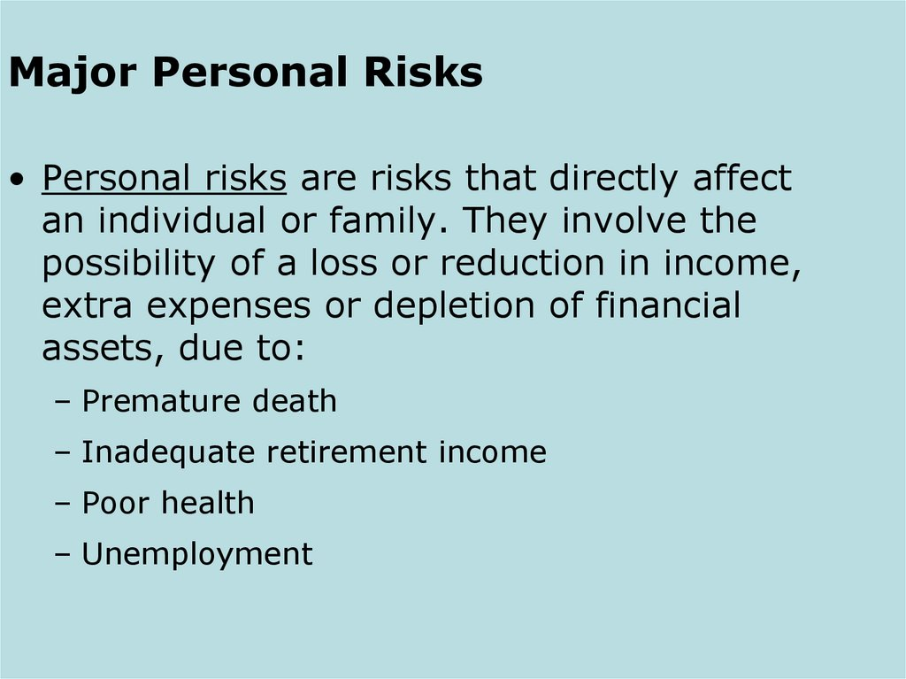
Personal risks are risks that directly affect an individual’s income, assets, or financial security.
Major Personal Risks
- Premature death
- Inadequate retirement income
- Poor health
- Unemployment
- Property loss
- Liability risk
- Premature Death
Premature death refers to death that occurs before the expected working age ends, resulting in loss of family income.
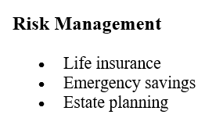
Financial Impact
- Loss of regular income
- Funeral expenses
- Outstanding loan burden
- Children’s education cost
- Daily living expenses
- Inadequate Retirement Income
Risk of not having sufficient funds after retirement.

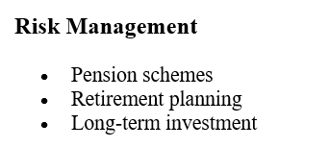
Causes
- Low savings
- Inflation
- Longer life expectancy
- Poor financial planning
- Poor Health
Risk of illness, injury, or disability that leads to high medical expenses.

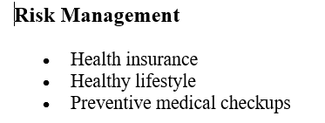
Financial Impact
- Hospital bills
- Surgery cost
- Loss of earning ability
- Long-term treatment expenses

- Unemployment
Loss of job leading to income interruption.

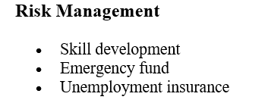
Causes
- Economic recession
- Company closure
- Automation/technology
- Skill mismatch
- Property Risk
Property Risk refers to the possibility of loss or damage to physical property, resulting in financial loss.
- Liability Risk
Risk of being legally responsible for injury or damage to others. Liability Risk refers to the possibility of being legally responsible for injury or damage to others, which may result in financial loss due to legal claims.

Examples
- Car accident injury claim
- Damage to neighbor’s property
- Legal lawsuits
Major Commercial Risks
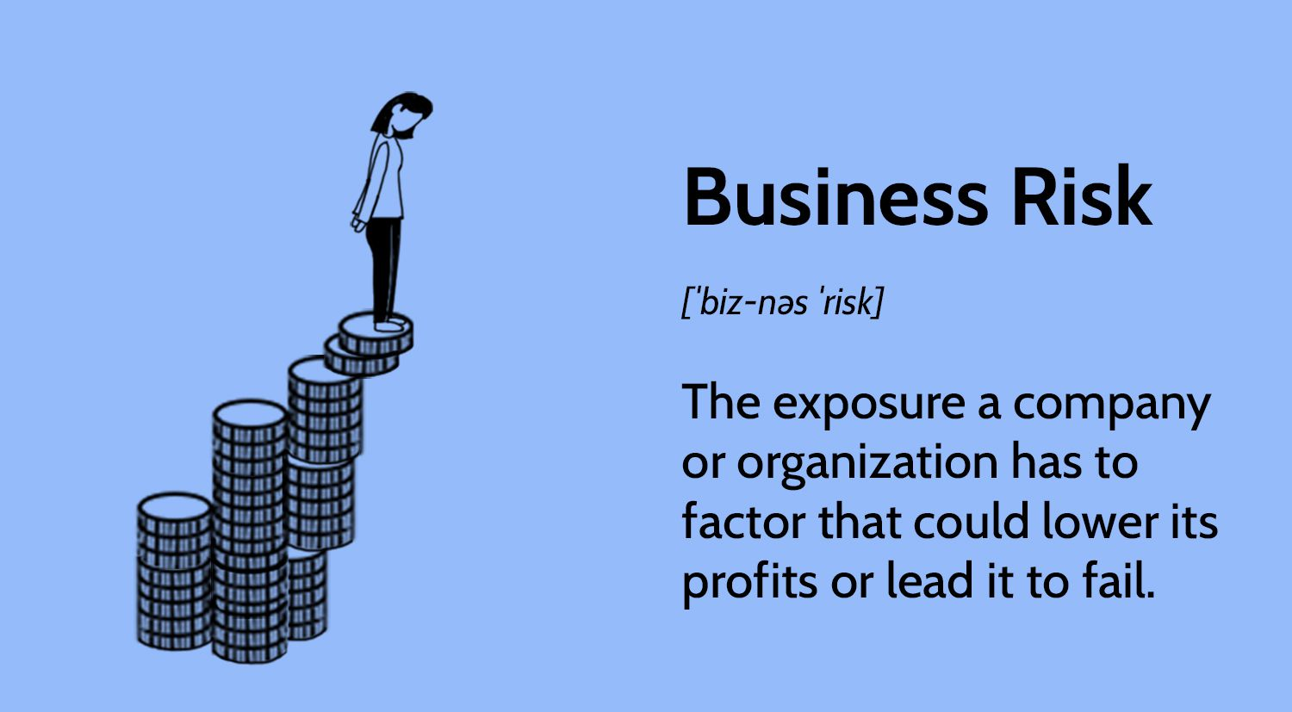
Commercial Risks refer to the risks faced by businesses or organizations that may cause financial loss, operational disruption, or damage to assets and reputation.
- Property risk
- Liability risk
- Loss of business income
- Cyber security risk
- Identity theft
Burden of Risk on Society
Risk is not only an individual or business problem; it affects society as a whole in economic, social, and psychological ways.
1. Economic Burden
When risks materialize, society bears a financial cost:
- Businesses may fail → leading to job losses
- Reduced production → affecting national GDP
- Increased cost of goods and services due to uncertainty
- Government spending increases for disaster relief and welfare programs
2. Social Burden
Risks can cause social problems:
- Families may fall into poverty due to loss of income
- Increased crime rate and social instability
- Reduced access to education and healthcare for affected families
3. Psychological Burden
- Risk and uncertainty create stress, anxiety, and fear
- People may become risk-averse, reducing entrepreneurship and innovation
- Mental health problems may increase in disaster-affected areas
4. Government Burden
- Public authorities bear the cost of natural disasters, unemployment, and social welfare
- Development funds may be diverted to handle losses
- Insurance and safety regulations may be needed to reduce societal risk

Key Note
Without proper risk management, society faces financial losses, reduced economic growth, social instability, and psychological stress. Insurance and risk management help spread the financial burden across many individuals, reducing the societal impact.

Techniques of Managing Risk
Risk management involves identifying, analyzing, and taking steps to reduce or finance risk. The techniques are broadly divided into Risk Control and Risk Financing.

