Passage No : 1
Reading Comprehension Text ( 15)
================================
In this age of texts and tweets, it is easy to send messages. You just press a few buttons, and boom! Your message is sent. The person to whom you sent it will get it in just a few seconds. Distance is no longer an issue. But things weren’t always so easy.
In 1848 gold was found in California. Thousands of people rushed there to get some. Many people liked living there and decided to stay. But there wasn’t a whole lot between California and Missouri, where the nearest trains ran. The train line to California wasn’t finished until 1869. It took a long time to ride a horse to Missouri.
Imagine that it is the year 1860. You have moved to California to open a shop. Most of your family stayed back East. Your shop is doing well and now you want your family to join you. How do you find news to them? There’s no phone, no train, and you can’t leave your shop for too long. What do you do? Well, you could use the Pony Express.
In 1860 and 1861, the Pony Express was the fastest way to get news to and from the West. The trail that they rode was around 2000 miles long. It took most people weeks or months to ride that far. The Pony Express could make the trip in just ten days. Those speeds were unheard of at the time. So how did they do it? Well, they had a good system.
The Pony Express had 184 stations along the trail. The stations were around ten miles apart. This is about how far a horse could run at a gallop before tiring. The rider would switch to a new horse at each station. He would only take his mail pouch with him. Every 75-100 miles, the rider would get to a home station. At each home station, riders would rest. Before resting, he would give his mail pouch to a new rider. The mail never stopped moving, even while the horses and riders rested.

It was tough to ride for the Pony Express. Each rider had to weigh less than 125 pounds. Speed was the key. Most of the riders were teenage boys. They rode at a fast pace for up to 100 miles a day. If there were an emergency, one might have to ride 200 miles in a day. The ride could be rough and dangerous. Attacks by Native Americans were common. But in its time running, the Pony Express only lost one mail pouch.
The Pony Express filled an important role for a time, but it did not last. The Civil War started in April of 1861. This was bad news for the owners. The worst for them was yet to come. On October 24th, 1861, the first telegraph line to California was finished. This linked them to the rest of the country. People could send messages in an instant. Two days later the Pony Express closed. But the lore of the brave riders lives on even today.
Questions and Answers (5*1)= 5
================================
A. Complete the following sentences using the appropriate words highlighted in the text. Two of them are not necessary.

a. While you are in Pokhara, take a ……………….to Dhampus.
b. Running away was less…………………………. than participating in the revolution, but it was still a risk.
c. Don’t worry. You will ………….the hotel easily. It is well off the trail.
d. At the end of the class, the teacher ……………. out of the class.
e. You can see inside the box. There is a small ……………… containing five.

B. True False
================================
a. There was a train line between California and Missouri in 1848.
b. The Pony express was the only fastest means of transportation in the USA in 1860.
c. The Pony express stations were exactly at a distance of ten miles.
d. Pony express carrying young boys could travel 200 miles in a day in an emergency.
(If there were an emergency, one might have to ride 200 miles in a day.)
e. The Civil War began in April 1861.

C. Answer the following questions:
================================
a. When was gold found in California?
b. How would people living between California and Missouri get newspapers to their family in 1860?
c. Who does the word 'they' in the second line of the sixth paragraph refer to?
d. Why does the author refer to Native Americans in the text?
e. What can you conclude from the last paragraph?

Passage No: 2
1. Read the following text and complete the tasks that follow. [15]
Can you imagine a college without walls, professors or classrooms ? Educator Bunker Roy can. More than 40 years ago, Roy, now 69, founded the Barefoot college in Tilonia, Rajasthan. His school admits rural women, often grandmothers and teaches them the basics of solar engineering and freshwater technology. His efforts have yielded enormous benefits. When the women return to their homes, they are trained enough to provide their communities, some of the world's most lonely places, with electricity and clean water. They also gain something important: a new found self confidence. The Barefoot model has already been used to empower women throughout Asia, Africa, and Latin America. Last year, former president, Bill Clinton presented Roy with a Clinton Global Citizen Award, which honours leaders who are solving the world's problems in effective ways.
If you go all over the world, to very remote villages, you will often find only very old people and very young people. The men have already left. So, two ideas were put into practice in order to make the Barefoot model work. First, it was declared that men are untrainable, restless, always ready to move, ambitious, and they all want a certificate to show for their efforts. And the moment you give one of them a certificate, he leaves the village looking for a job in the city. That is how, the simple, practical solution of training grandmothers came up. They are sympathetic, tolerant, willing to learn, and patient. All the qualities you need are there. And the second idea was not to give out certificates. Because the moment a certificate is given, a woman, like a man, will see it as a passport for leaving rural areas and going to urban areas to find a job.
Barefoot college follows the lifestyle of Mahatma Gandhi; students eat, sleep and work on the floor. They can work for 20 years or they can go home the next day. As of today, 604 women solar engineers from 1083 villages in 63 countries have been trained. The engineers have given solar power to 45,000 houses. These were done by women who had never left their homes before. They hate the idea of leaving their families and getting on a plane. When they reach India, sometimes after 19 hours of travel, they are faced with strange food, strange people and strange language. All the training is done in sign language. Yet in six months, they will know more about solar engineering than most university graduates. Some women face problems at home for attending college. Most of the husbands do not like their wives going to these colleges and tell them not to come back if they do so. But, on her return when she is able to help, provide her village with solar electricity, her husband wants her to get back home. The respect she now has is enormous and she considers, herself no less than solar engineers. Bunker Roy dreams of providing the world's 47 least developed countries with Barefoot college trained grandmothers, and solar-electrify more than 1,00,000 houses.
A. Complete the following sentences using the words highlighted in the text. Two of those words are not necessary. [5x1=5 ]
a. I could not understand what he is saying, Can you tell me which..... he is speaking?
b. The children in my class always become ....... near the end of the lecture.
c. A group of volunteers ...... a club and started to raise funds to help the poor people.
d. On completion of the training, everyone will be awarded a .....
e. I have no idea why she is behaving in a ... way today.

B. Read the text again and write TRUE if the statement agrees with the information given in the text. FALSE if the statement contradicts the information given in the text. NOT GIVEN if there is no information in the text. [5x1=5]
a. Barefoot college was established forty years ago.
b. According to the passage, Bunker Roy is sixty nine years old.
c. Roy's father encouraged him to set up Barefoot college.
d. Barefoot college enrolled only grandmothers who are willing to leave their homes.
e. Majority of the men from the remote villages moved to city in search of work.

C. Read the text again and answer the following questions in ONE SENTENCE each. [5x1=5]
a. In what way do you think Barefoot college is different from other colleges?
b. How was Roy's work recognised?
c. Why does the author mention the word 'passport' in the second paragraph?
d. Do you agree or disagree with the ideology of Bunker Roy? Why, why not? Give a reason.
e. What is the main idea of the text?

Passage No: 3
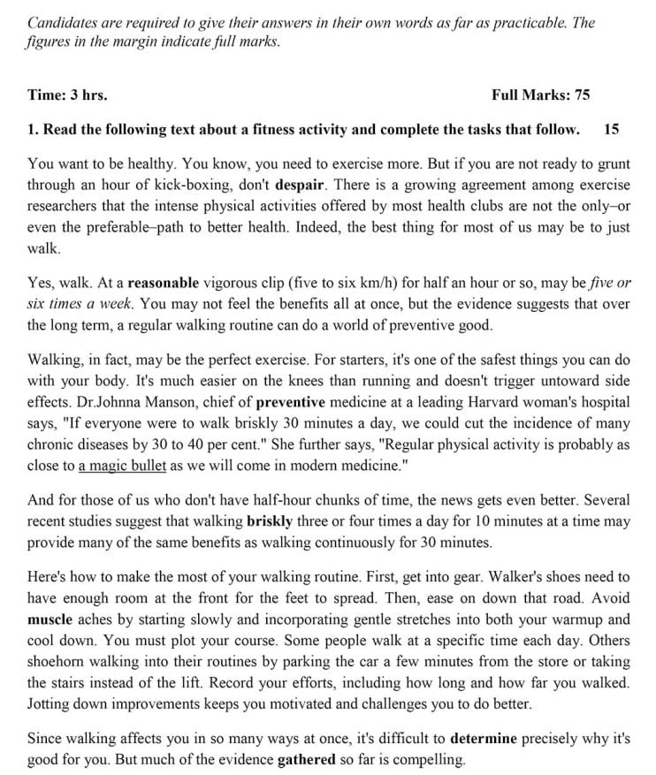
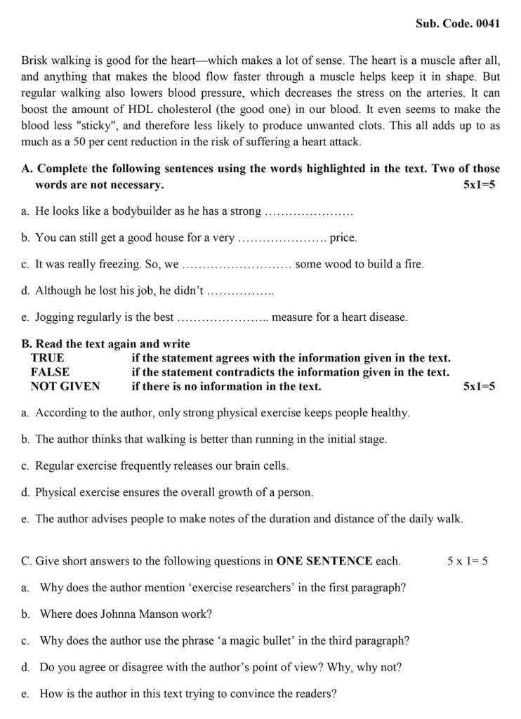
Passage no: 4
