BBA 8th Semester
Insurance and Risk Management
Chapter Description

1️⃣ Introduction
2️⃣ Risk Management
3️⃣ Insurance Device
4️⃣ Legal Principles in Insurance
5️⃣ Life Insurance
6️⃣ Non-life Insurance
7️⃣ Government Regulations of Insurance

Chapter 02 : Insurance Device

Topic Cover
- Meaning of Insurance - Adverse Selection of Insurance
- Characteristics of Insurance (Basic and Insurable) - Insurance and Gambling
- Insurance and Hedging -Types of Insurance (public and Private Insurance)
- Benefit to Society and Cost of Insurance

Meaning of Insurance:
Insurance is a cooperative arrangement in which individuals facing similar risks contribute to a common fund so that the loss suffered by any member is compensated from that fund. From the functional point of view, insurance is a co-operative mechanism through which the financial loss caused by a particular risk is shared among a large number of people who are exposed to that risk and agree to contribute to a common fund.
When any member of the group suffers a loss, compensation is paid from the accumulated fund created by the contributions of all members.
According to D. S. Hansell:
"Insurance may be defined as a social device providing compensation for the effects of misfortune, the payment being made from accumulated contributions of all parties participating in the scheme."
The simple meaning of insurance it is a financial contract between the two parties to protect against the financial loss of individuals or business organization of the another parties.
Contractual Concept:
Insurance is a contract between two party in which one party agrees to pay premium in against for the compensation of any loss or damage to another party. Insurance can be defined as a contract whereby one party (the insurer), in exchange for a premium, agrees to compensate the other party (the insured) for a specified loss or damage caused by uncertain events.

Characteristic of Insurance
Insurance is financial protection against the uncertainty or loss that can occur in human life or any other entity. For a risk to be insurable, it must have certain basic characteristics. Insurance companies accept only those risks that meet these conditions.
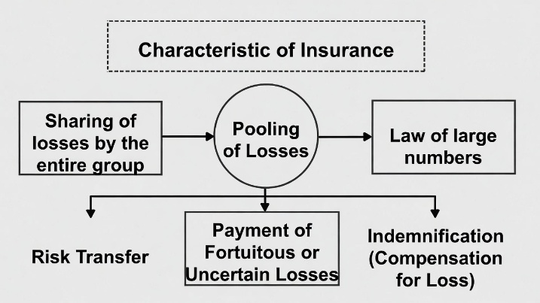
Basic Characteristics of Insurance
- Pooling of Losses
- Sharing of losses by the entire group
- Law of large numbers
- Payment of Fortuitous/Uncertain Losses
- Risk Transfer
- Indemnification (Compensation for Loss)
- Contractual Agreement
Characteristics of Insurable Risk
- Large number of exposure units (e.g., houses, cars, lives)
- Loss must be accidental and unintentional
- Loss must be determinable and measurable
- Loss should not be catastrophic (e.g., war, nuclear disaster)
- Chance of loss must be calculable
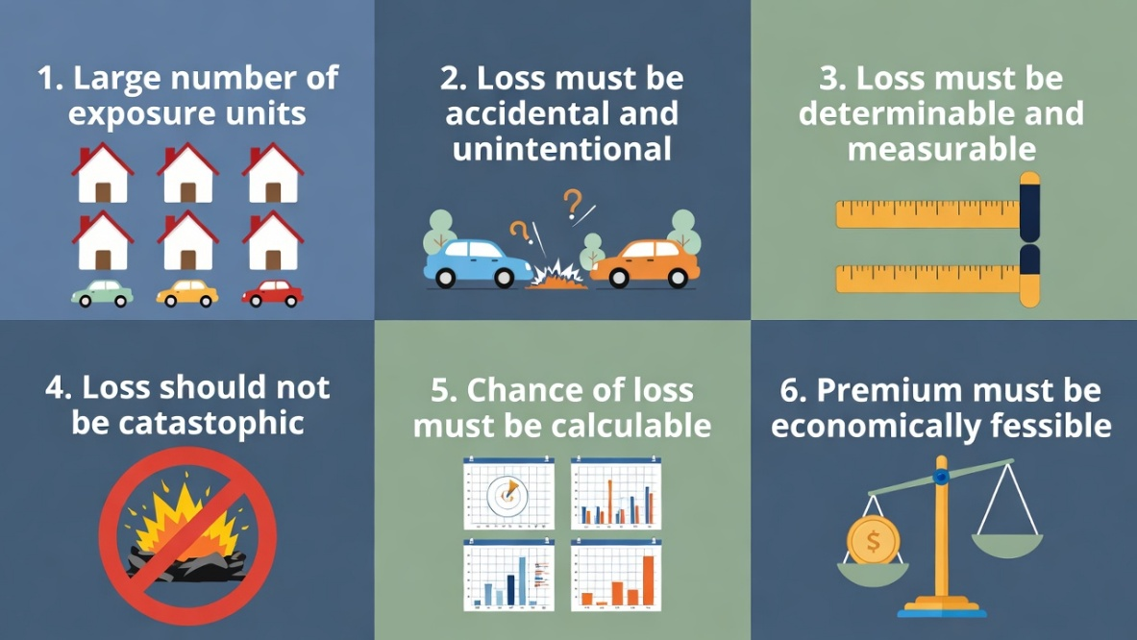
- Premium must be economically feasible

Adverse selection and insurance
Adverse selection is when people with higher risks are more likely to buy insurance than low-risk people, because they know their own risk better than the insurer. This can lead to higher losses for the insurance company.

Example: A sick person buys health insurance, while a healthy person may avoid it.

Insurance and Gambling
Insurance is mostly regarded as gambling, but there are important differences between them:
Feature | Insurance | Gambling
Purpose | Protects against existing risks | Seeks profit from chance events
Risk Type | Pure risk (risk of loss) | Speculative risk (chance of gain or loss)
Social Impact | Socially productive | Socially unproductive
Financial Outcome | Restores the insured financially | The winner gains at the loser’s expense
Legal Status | Fully regulated by law | Often illegal in many countries
Risk Handling | Transfers risk from insured to insurer | Creates new risk

Insurance and Hedging
Insurance is a financial arrangement where you pay a premium to an insurer, and in return, they promise to compensate you if a specific loss happens (like accidents, illness, fire, theft, etc.) Hedging is a risk-management strategy used to reduce or offset the chance of financial loss, usually by taking an opposite position in the market
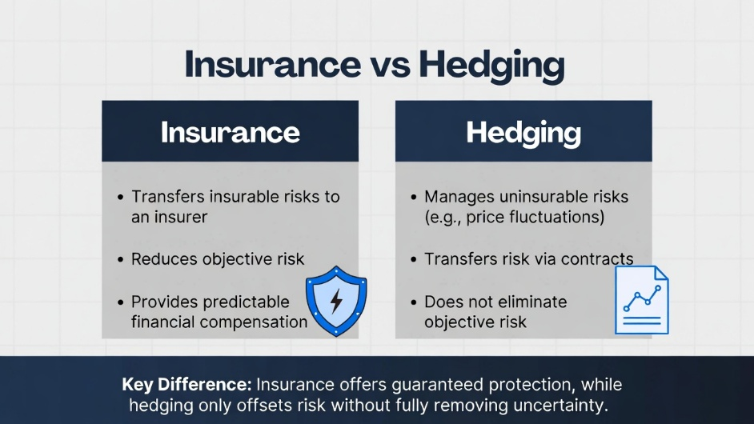

Insurance
- You pay a premium to an insurance company.
- In return, the insurer pays you if a loss happens (like fire, illness, accident).
- Insurance reduces uncertainty because you know you will get compensated.
- It covers insurable risks—risks that can be measured and predicted.
Example: If your house burns down, your insurance pays you the full loss.
Hedging
- Hedging is used to protect against financial losses, usually in markets like stocks, crops, or commodities.
- You take an opposite position to offset risk (like futures contracts).
- Hedging does not completely remove risk because prices can still fluctuate.
- It handles uninsurable risks—risks that cannot be fully predicted.
Example: A farmer fears crop prices falling, so he locks in a price using a futures contract. The price may still vary slightly, so risk remains.

Types of Insurance
Insurance means the financial contract between the parties who pay the sum of premium to protect against the uncertainty to the insurer ( another party who pays compensation for any kids of insurable loss). Insurance is classified into two major types: Private Insurance and Government Insurance.
1. Private Insurance
Meaning: Provided by private companies aiming for profit. Premiums depend on risk, and claims are paid from the company’s fund.
Types:
A. Life and Health Insurance
- Life Insurance: Pays a sum to nominee after insured’s death.
- Health Insurance: Covers medical expenses due to illness or injury.
B. Property and Liability Insurance
- Fire Insurance: Protects against losses from fire, lightning, explosion, including indirect losses.
- Marine Insurance: Covers goods and ships during transport (sea, air, land).
  - Ocean Marine: Ocean-going vessels & cargo.
  - Inland Marine: Goods transported by land.
- Casualty Insurance: Covers liability for accidents or damage to others.
  - Auto Insurance: Covers vehicle accidents.
  - General Liability Insurance: Protects businesses from legal claims.
  - Burglary/Theft Insurance: Covers losses from theft.
  - Workers’ Compensation: Covers accidents or sickness at work.
  - Glass Insurance: Covers repair/replacement of broken glass.
  - Nuclear Insurance: Covers nuclear accident losses.
  - Crop Hail Insurance: Protects crops from hail and perils.
  - Title Insurance: Covers financial loss from legal defects.
  - Credit Insurance: Covers non-payment of debts.
C. Multiple-line Insurance
- Combines two or more types of coverage (property + liability + auto) in one policy.
D. Fidelity & Surety Bonds
- Fidelity Bond: Protects against employee fraud or dishonesty.
- Surety Bond: Guarantees a party will fulfill obligations; insurer pays if they fail.

2. Government Insurance
Provided by the government to protect citizens from major social or economic risks. Focuses on welfare, often subsidized.
Examples & Types:
- Social Insurance: Protects against economic risks (unemployment, sickness, disability, old age).
  - Old-age, Survivors, Disability Insurance (Social Security): Provides retirement, survivor, and disability benefits.
  - Medicare Insurance: Covers medical expenses for elderly & some disabled people.
  - Unemployment Insurance: Cash benefits for short-term job loss.
  - Workers’ Compensation Insurance: Provides care and benefits for work-related sickness/accidents.
  - Compulsory Temporary Disability Insurance: Protects against temporary disability losses.
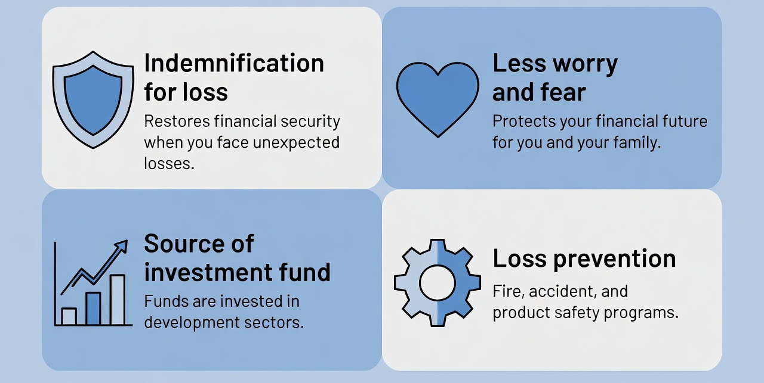
Benefits of Insurance to Society

- Indemnification for Loss: Compensates for losses, helping individuals, families, and businesses restore financial security.
- Less Worry and Fear: Reduces anxiety about financial losses; for example, life insurance reassures dependents’ future.
- Source of Investment Fund: Insurance company funds are invested in sectors like education, health, energy, and real estate, aiding national development.
- Loss Prevention: Insurers actively prevent losses through specialists in fire safety, accident prevention, and product safety.
- Enhancement of Credit: Insurance increases trust for banks, making it easier for individuals and businesses to get loans.

Costs of Insurance to Society
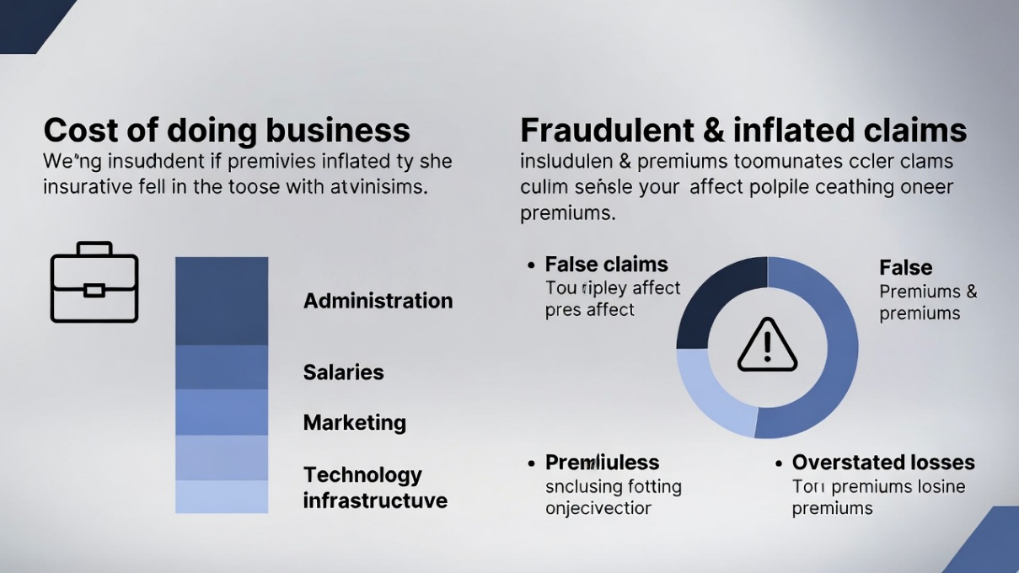

- Cost of Doing Business: Administrative expenses, salaries, marketing, and technology costs increase premiums.
- Fraudulent Claims: False claims raise premiums for all policyholders.
- Inflated Claims: Overstated losses increase overall claim costs, leading to higher premiums.

Important That should Remember
