Chapter 04: Legal Principles in Insurance

Chapter Included
- Principles - Requirements of Insurance Contract
- Distinct Legal Characteristics of an Insurance Contract
- Law and Insurance of Agent - Basic Part of Insurance
- Insurance Provision
Introductions
Insurance in Nepal is governed by a combination of common legal principles, the Insurance Act, 2079 BS, and the Insurance Regulation, 2081 BS. Understanding these principles is essential for anyone working in the insurance sector, whether as an agent, underwriter, or policyholder.
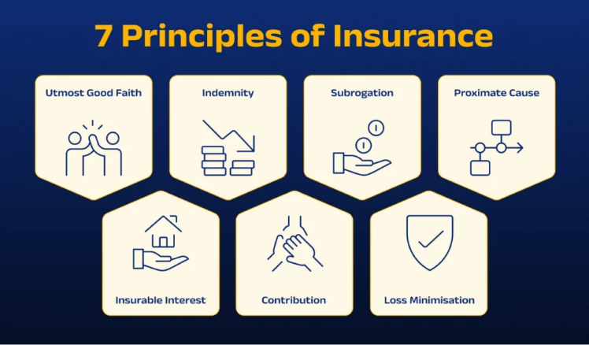
Insurance is governed by specific legal principles to ensure fairness, protect parties’ interests, and make contracts enforceable.
The main principles are:
- Principle of Indemnity
- Principle of Insurable Interest
- Principle of Subrogation
- Principle of Utmost Good Faith
Principle of Indemnity
The insurer promises to compensate the insured for the actual financial loss suffered due to an insured event. The goal is to restore the insured to the same financial position they were in before the loss, not to make a profit.
Key Features:
  - Compensation equals the actual loss only.
  - Over-insurance or under-insurance affects claim amount.
  - Applies to property and casualty insurance, but not life insurance.
Example:
If your house is damaged by fire and the loss is worth Rs. 200,000, the insurer will pay Rs. 200,000, not more.

2️⃣ Principle of Insurable Interest
The insured must have a legal or financial interest in the subject matter of insurance. You can’t insure something you do not stand to lose.
Key Features:
  - Ensures insurance is for protection, not gambling.
  - Must exist at the time of insurance and, in some cases, at the time of loss.
Example:
You can insure your own car or house, but you cannot insure your neighbor’s car because you have no financial interest in it.

3️⃣ Principle of Subrogation
After compensating the insured for a loss, the insurer acquires the legal right to recover the loss amount from any third party responsible for the damage.
Key Features:
  - Prevents double compensation.
  - Insurer can take legal action against the party at fault.
Example:
If someone crashes into your car and you are compensated by your insurer, the insurer can claim the same amount from the negligent driver.

4️⃣ Principle of Utmost Good Faith (Uberrimae Fidei)
Both parties (insurer and insured) must fully disclose all material facts honestly and accurately. Any concealment or misrepresentation can make the contract void.
Key Features:
  - Applies to pre-contractual disclosures.
  - Protects insurer from fraud or hidden risks.
  - Insured must declare facts that affect risk assessment.

Requirements of an Insurance Contract
- Offer and Acceptance
- Consideration
- Insurable Interest
- Legal Capacity
- Legal Purpose
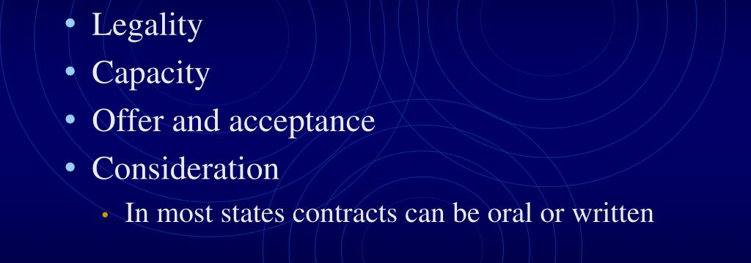
- Utmost Good Faith

1️⃣ Offer and Acceptance
The insured initiates the contract by submitting an insurance application, which is considered an offer. The insurer reviews the application and, if satisfied, accepts it. Once accepted, a legally binding insurance contract is formed between both parties.

2️⃣ Consideration
Consideration is the value exchanged in the contract. The insured provides the premium payment, while the insurer promises to pay compensation in case of loss. Without this mutual exchange, the contract cannot exist or be enforceable in law.

3️⃣ Insurable Interest
The insured must have a financial, legal, or emotional stake in the insured property or life. This ensures the insured suffers a genuine loss if the insured event occurs. Without insurable interest, an insurance contract is not valid.

4️⃣ Legal Capacity
Both parties must be legally competent to enter a contract. The insured and insurer should be of legal age, of sound mind, and not disqualified by law. Contracts entered by minors or mentally unsound persons are generally voidable.

5️⃣ Legal Purpose
The contract must have a lawful objective. It cannot be used to commit illegal acts or fraud. Insurance contracts covering unlawful activities, like smuggling or illegal trade, are invalid and unenforceable under the law.

6️⃣ Utmost Good Faith
Both parties must fully disclose all material facts. The insured should provide accurate information about the subject matter, and the insurer should clearly explain policy terms. Any misrepresentation or concealment can void the contract.

Distinct Legal Characteristics of Insurance Contracts
- Contract of Adhesion
- Aleatory Contract
- Personal Contract
- Conditional Contract

- Contract of Utmost Good Faith

1️⃣ Contract of Adhesion
The insurer drafts the insurance contract entirely. The insured cannot negotiate terms but must either accept or reject it. Courts interpret ambiguities in favor of the insured since they have no role in preparing the contract.

2️⃣ Aleatory Contract
This contract’s value depends on an uncertain future event, like a loss. The insured may pay a small premium but could receive large compensation, or nothing at all, depending on whether the event occurs or not.

3️⃣ Personal Contract
Insurance is a personal agreement between the insured and the insurer. It cannot be transferred to another person without the insurer’s written consent. The contract is based on the insured’s personal risk and circumstances.

4️⃣ Conditional Contract
The insurance contract’s effectiveness depends on certain conditions being fulfilled. The insurer’s liability arises only after conditions, like timely premium payment or accurate disclosure, are met by the insured. Rights and obligations are conditional.

5️⃣ Contract of Utmost Good Faith
Both parties must honestly and fully disclose all material facts. The insured cannot hide information, and the insurer must clearly explain terms. Misrepresentation or concealment by either party can void the contract.

Law and the Insurance Agent
An insurance agent is a person authorized by the insurer to sell, service, and manage insurance policies on behalf of the company. They act as a bridge between the insurer and the insured.
- Acts as a mediator between insurer and insured
- Authorized to solicit, advise, and bind policies
Duties of the Agent
- Provide accurate and complete information to the insured.
- Ensure policies comply with Insurance Act 2079 & Regulations 2081.
- Collect premiums and issue proper receipts.
- Assist insureds in filing claims correctly and promptly.
Responsibilities to the Insured
- Disclose all material facts about the insurance policy.
- Act honestly and fairly; avoid misrepresentation.
- Explain terms, conditions, and limitations clearly.
- The agent must represent the insurer faithfully.
- Misleading the insured can make the insurer liable for damages.
- Agents are often legally empowered to sign proposals on behalf of the insurer.

Basic Parts of an Insurance Contract
- Policy Declaration
- Insuring Agreement
- Exclusions
- Conditions
- Endorsements / Riders
- Policy Declaration
- Contains essential information about the insured, such as name, address, type of insurance, insured property, and sum insured.
- Forms the first section of the contract and identifies the parties and subject matter clearly.
- Insuring Agreement
- Explains the coverage provided by the insurer and specifies the risks or events for which compensation will be paid.
- It is the core promise of the insurer to indemnify or pay in case of loss.
- Exclusions
- Lists situations, events, or losses that are not covered by the policy.
- Helps avoid misunderstandings and ensures the insured knows the limits of protection.
- Conditions
- Defines rules and responsibilities of both the insurer and the insured to keep the contract valid.
- Includes payment of premiums, claim procedures, notifications, and other obligations.
- Endorsements / Riders
- Optional modifications or additions to the main policy.
- Can expand, restrict, or clarify coverage, such as adding extra protection or changing terms to suit the insured’s needs.

Insurance Provisions
Insurance provisions are specific clauses or terms written in an insurance policy that define the rights, duties, and obligations of both the insurer and the insured. They explain how the policy works, what it covers, and the conditions for claims.
- Endorsements and Riders
- Deductibles
- Coinsurance
- Other-Insurance Provisions

1. Endorsements and Riders
Endorsements or riders are additional clauses added to a basic insurance policy to modify, enhance, or expand coverage. They allow the insured to include extra protection.
Example: Adding accidental death coverage to a standard health policy.

2. Deductibles
A deductible is the fixed amount the insured must pay out of pocket before the insurer pays the remaining loss. It reduces small claims and keeps premiums lower.
Example: A Rs. 5,000 deductible on a car damage claim means the insured pays Rs. 5,000 first.

3. Coinsurance
Coinsurance is the cost-sharing arrangement between the insured and insurer. The insured bears a certain percentage of the loss, and the insurer pays the rest. It is common in property insurance.
Example: If coinsurance is 20%, and loss occurs, the insured pays 20% and insurer pays 80%.

4. Other-Insurance Provisions
These provisions apply when the insured has multiple insurance policies covering the same risk. They ensure the insured does not receive more than the actual loss, usually sharing the compensation proportionally among insurers.
Example: Two fire policies on the same building share the claim amount.

