BBA 8th Semester
Insurance and Risk Management
Chapter Description

1️⃣ Introduction
2️⃣ Risk Management
3️⃣ Insurance Device
4️⃣ Legal Principles in Insurance
5️⃣ Life Insurance
6️⃣ Non-life Insurance
7️⃣ Government Regulations of Insurance



Chapter 02 : Risk Management

Topic Cover
- Meaning - Benefits of Risk Management
- Objective of Risk Management - Process of Risk Management
- Personal Risk Management ( Process and Benefits)
- Business Risk Management ( Process and Benefits)
- Changing scope in Risk Management and Loss Forecasting
- Financial analysis in RMDM
Meaning
Simply, risk is defined as the possibility of occurrence of a loss . Risk Management basically involves two concept: Identification of Risk and identification of the appropriate technique to control risk.
Hence, Risk management is a process of identifying the risk (loss exposure) faced by an organization and selects the most appropriate techniques for treating such risk. Where, loss exposure is any situation or circumstance in which a loss is possible, regardless of whether a loss actually occurs.
Therefore, Risk management is the process of identifying, assessing, and reducing risks that could negatively impact an organization, project, or individual.

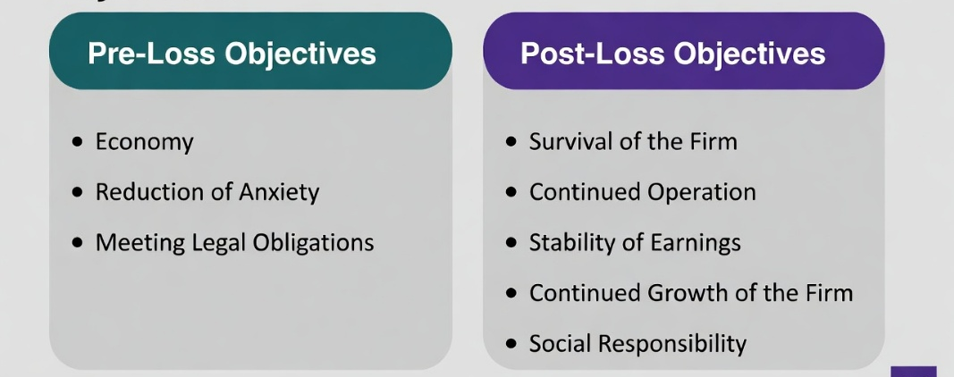
Objectives of Risk Management
- Identify potential risks
- Minimize financial losses
- Protect assets and resources
- Ensure business continuity
- Improve decision making

Risk Management Process
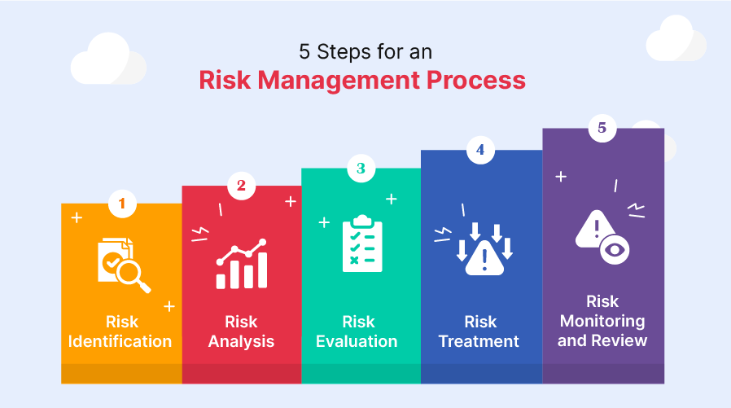
Risk management process refers to the systematic steps used to identify, analyze, and control risks to minimize losses and achieve organizational objectives.
- Risk Identification
- Risk Analysis / Risk Measurement
- Selection of Risk Management Techniques
- Implementation of Risk Management Decisions
- Evaluation and Review of the Program

1. Risk Identification
The first step is to identify all possible risks that may affect the organization such as fire, theft, accident, market changes, or natural disasters.
2. Risk Analysis / Measurement
After identifying risks, the firm analyzes the probability and severity of loss to understand how serious each risk is. Loss frequency refers to the probable number of losses that may occur during some given time period . And, Loss intensity refers to the probable size of the losses that may occur.
3. Selection of Risk Management Techniques
The organization chooses appropriate methods to handle risks, such as risk avoidance, risk reduction, risk transfer (insurance), or risk retention. Risk Control: (Avoidance, Loss Prevention and Loss Reduction) , Risk Financing: (Retention, Active Retention and Passive Retention),, Non-insurance Transfer and Insurance.
4. Implementation of Risk Management Decisions
In this step, the firm applies the selected techniques, for example purchasing insurance, installing safety equipment, or creating safety policies.

5. Evaluation and Review
Finally, the risk management program is regularly reviewed and evaluated to ensure it is effective and updated when necessary.

Benefits of Risk Management
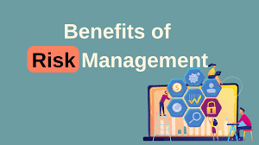
Risk management helps an organization identify, control, and reduce risks, which improves safety, stability, and decision-making.
- Reduction of potential losses
- Better decision making
- Protection of assets and resources
- Improvement in financial stability
- Business continuity and survival
- Efficient use of resources
- Improved safety for employees and property
- Enhancement of company reputation and confidence
Personal and Business Risk Management
Personal Risk Management
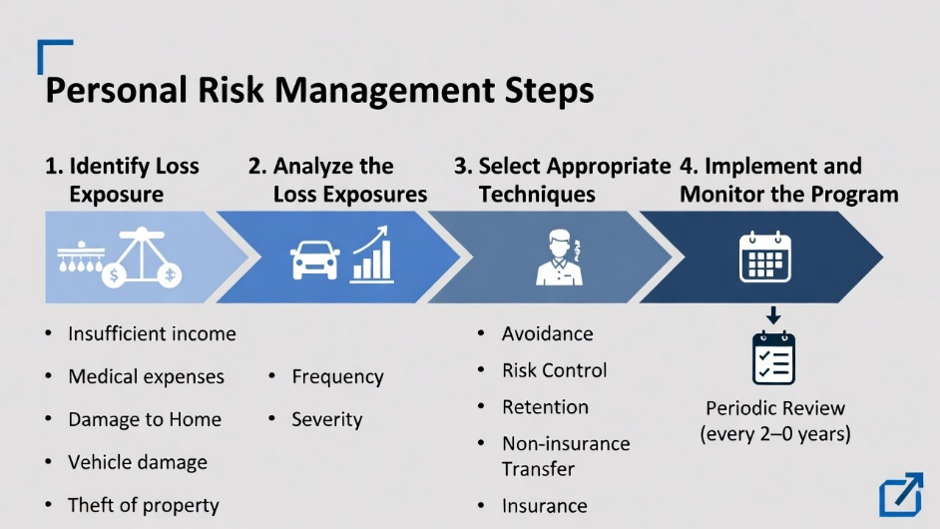
Personal risk management refers to the identification and analysis of risks faced by an individual or family, and to the selection and implementation of the most appropriate technique(s) for treating such risks.
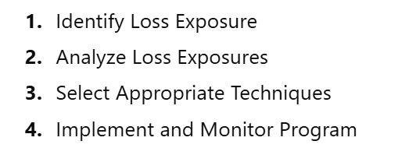

1. Identify Loss Exposure: Insufficient income, Medical expenses, Unemployment, Damage to home, Vehicle damage, Theft of property
2. Analyze the Loss Exposures: Estimate frequency of loss, Estimate severity (impact) of loss
3. Select Appropriate Techniques: Avoidance, Risk Control, Retention, Non-insurance Transfer, Insurance
4. Implement and Monitor the Program: Implement the risk management plan and Review and update the program periodically (every 2–3 years)
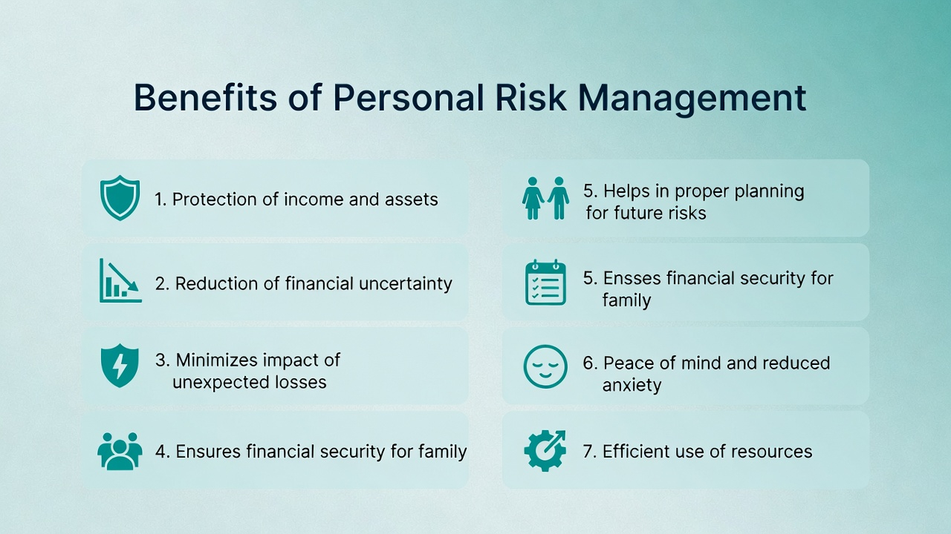

Business Risk Management
Business risk management is the systematic process through which the organization identify, evaluate, and address the risk that could affects their ability to achieve the objectives. These risks go beyond insurable financial or property losses, encompassing strategic, operational, financial, and reputational uncertainties.
Steps in Risk Management
- Risk Identification – recognize internal risks, recognize external risks, example: machinery breakdown, fluctuations in consumer demand
- Analysis and Evaluation of Risk – determine likelihood, assess potential impact, example: legal claims, supply delays
- Risk Treatment – risk avoidance, risk reduction, risk transfer, risk retention, example: safety measures, insurance, setting aside funds
- Implementation and Monitoring of Risk – implement strategies, monitor effectiveness, update program, respond to emerging threats
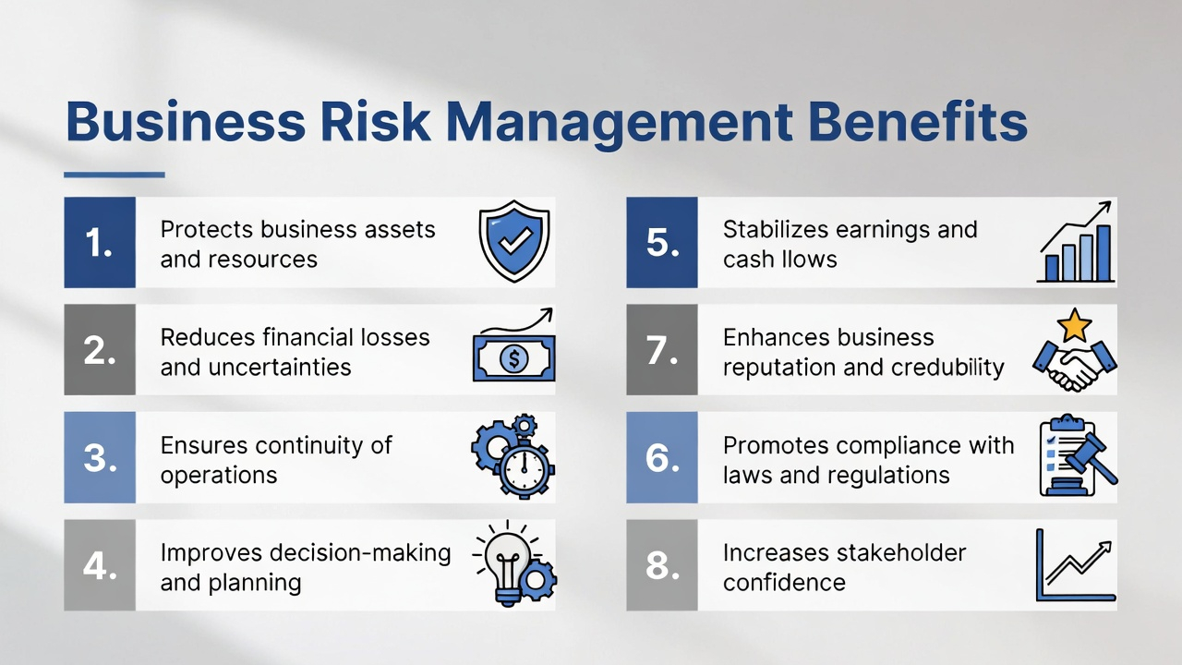

The Changing Scope of Risk Management
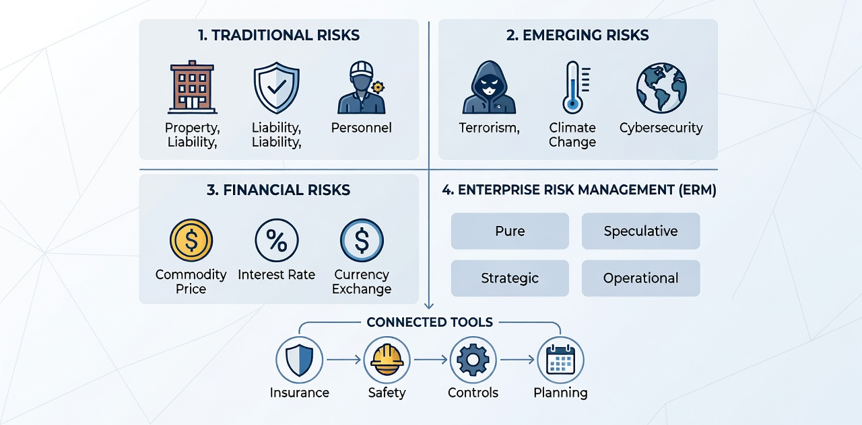

Traditionally, risk management focused on pure risks (loss or no loss), such as:
- Property risks
- Liability risks
- Personnel risks
From the 1990s, businesses expanded risk management to include speculative and emerging risks (profit or loss possible) and financial risks.

1. Emerging Risks : Emerging risk refers to new or evolving risks that are uncertain in nature, scale, or impact.
- Terrorism Risk – Losses from violence, sabotage, or politically motivated attacks.
- Climate Change Risk – Impacts from extreme weather, rising temperatures, supply chain disruption.
- Cybersecurity Risk – Losses due to hacking, malware, or data breaches.
2. Financial Risks: Financial risk is the possibility of losing money due to changes in financial markets, interest rates, currency exchange rates, or commodity prices.
- Commodity Price Risk – Loss from changes in commodity prices (e.g., wheat for bakeries).
- Interest Rate Risk – Loss due to changes in market interest rates (e.g., banks with fixed loans).
- Currency Exchange Rate Risk – Loss due to changes in foreign exchange rates (e.g., importing goods from USD).
3. Enterprise Risk Management (ERM): A comprehensive approach to managing all types of risks: pure, speculative, strategic, and operational.
- Strategic Risk – Uncertainty in goals, opportunities, or threats.
- Operational Risk – Risks in business operations, manufacturing, or service delivery.
- Uses insurance, safety measures, internal controls, financial analysis, and strategic planning.
- Helps organizations make better decisions, reduce losses, and stay stable.

