BBA 8th /BBS 3rd Year
Strategics Management
Topics
- Introduction
- Environmental Analysis
- Strategy Formulation
- Strategy Implementation
- Strategy Emulation and Control

Chapter 02: Environmental Analysis
Topic Covered
Meaning
Environmental analysis is the process of examining internal and external factors to identify opportunities, threats, strengths, and weaknesses for strategic decision-making. Environment refers to all internal and external factors that affect an organization’s performance and decision-making. It includes internal elements like employees and resources, and external elements such as customers, competitors, economic, political, and technological factors. Environment is dynamic, complex, and uncertain, and plays a vital role in strategic management.
“It is a process in which business managers closely analyze the threats, opportunities, weaknesses, and strengths of a company to make strategic decisions.”

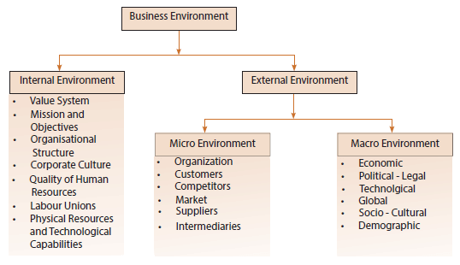

Techniques of External Environment Analysis
Techniques of External Environment Analysis refer to the systematic methods or tools used by business managers to study and evaluate external factors that affect an organization. t refers to all external forces which have the bearing on the functioning of BUSINESS. In other words The factors and conditions (such as economic, legal, political, and social circumstances) that generally affect everyone in an industry or market in more or less similar manner.
The process of environmental analysis consists of the following stages
- Scanning
- Monitoring
- Forecasting
- Assessing
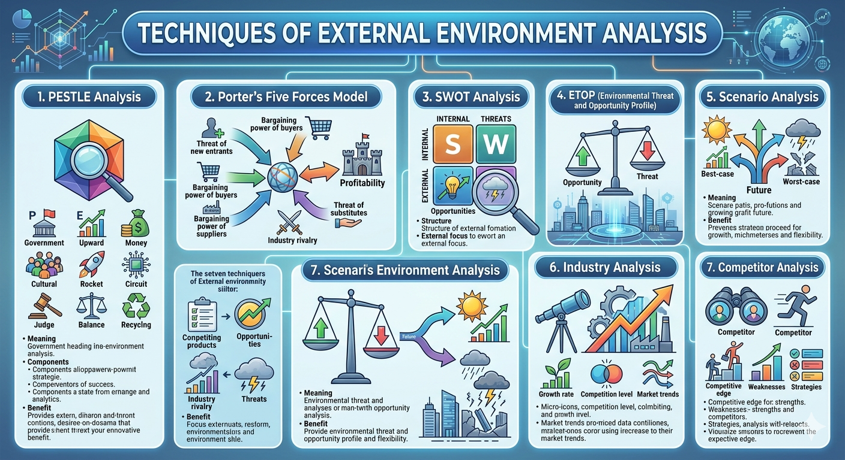
Techniques of External Environment Analysis

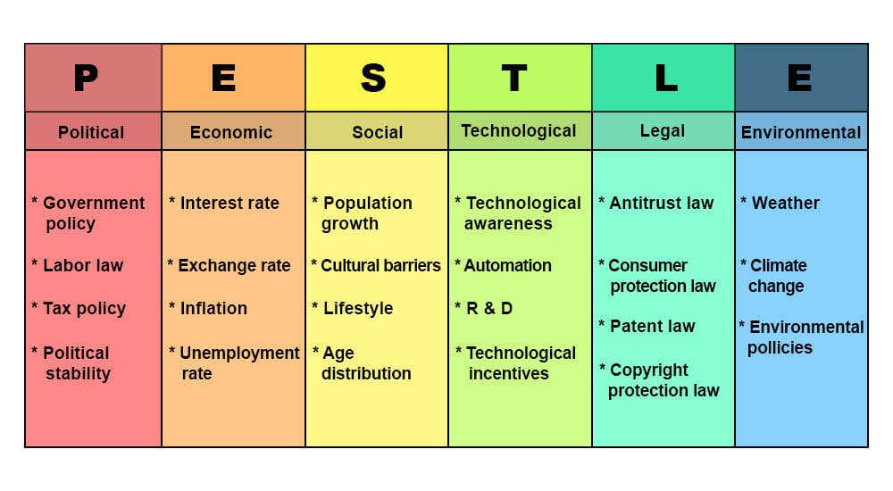
- ESTLE Analysis
PESTLE Analysis is a strategic tool used by businesses to analyze and understand the macro-environmental factors that can impact their operations. It helps managers identify external conditions—political, economic, social, technological, legal, and environmental—that may create opportunities or pose threats to the organization.
Key Points:
- Focuses on external factors beyond the company’s control.
- Assists in strategic planning and decision-making.
- Provides a broad overview of the environment in which a business operates.

- Porter’s Five Forces Model
Porter’s Five Forces Model, developed by Michael E. Porter, is a framework used to analyze the competitive forces within an industry. It helps businesses understand the intensity of competition, profitability, and potential for strategic advantage. By examining these forces, firms can develop strategies to strengthen their market position.

Porter’s Five Forces
- Threat of New Entrants
  - Ease of new competitors entering the market.
  - High threat → more competition → lower profits.
  - Factors: Capital needs, brand loyalty, economies of scale, distribution access.
- Bargaining Power of Suppliers
  - Suppliers’ ability to raise prices or reduce quality.
  - High power → higher costs → lower profits.
  - Factors: Number of suppliers, uniqueness of product, switching costs.
- Bargaining Power of Buyers
  - Customers’ influence on prices and terms.
  - High power → pressure for lower prices or better quality.
  - Factors: Number of buyers, product differentiation, switching costs.
- Threat of Substitutes
  - Availability of alternative products or services.
  - High threat → limits pricing → reduces profitability.
  - Examples: Tea vs. Coffee, Uber vs. Public Transport.
- Industry Rivalry
  - Competition among existing players.
  - High rivalry → price wars, heavy marketing → lower profits.
  - Factors: Number of competitors, industry growth, product differentiation.

- Competitor Analysis
Competitor analysis is the process of identifying, evaluating, and understanding your competitors to improve your business strategy.
Purpose:
- Identify competitors’ strengths and weaknesses.
- Spot market opportunities and threats.
- Improve your products, pricing, and marketing
- Scenario Planning
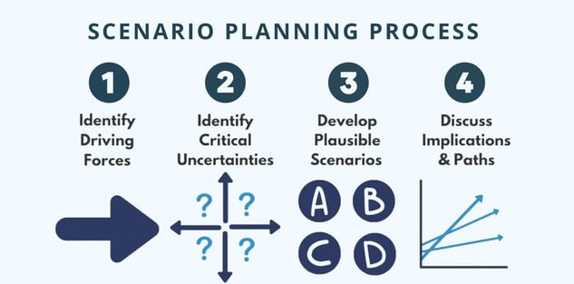
Scenario planning a particular kind of planning which helps businesses to deal with future difficulties. Proper planning is done considering the upcoming scenarios, and businesses lay plans accordingly. All future investment by the company depends on scenario planning. Extreme scenarios are hard to predict; some assumptions can help mitigate their impact.
- Environmental threat opportunity profile ( ETOP)
ETOP is a tool used by businesses to identify external environmental factors that can affect the company positively (opportunities) or negatively (threats).
- Helps in strategic planning.
- Focuses on factors outside the company that impact growth and profitability.
- Prioritizes threats and opportunities for decision-making.
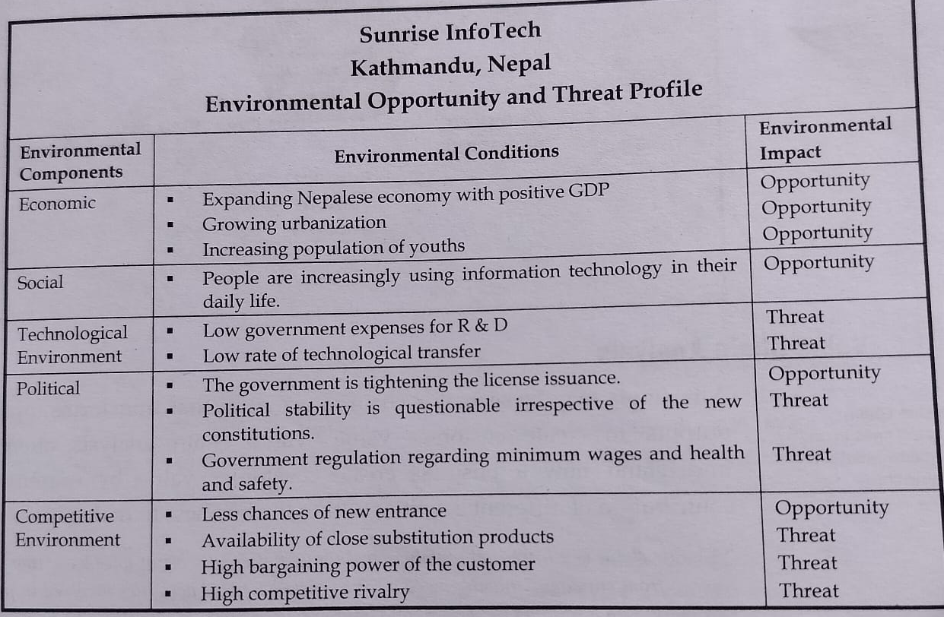
Steps of preparing ETOP
  - List the Key External Components
  - Sub divided the components
  - Determined the effects
Techniques of Internal Environmental Analysis

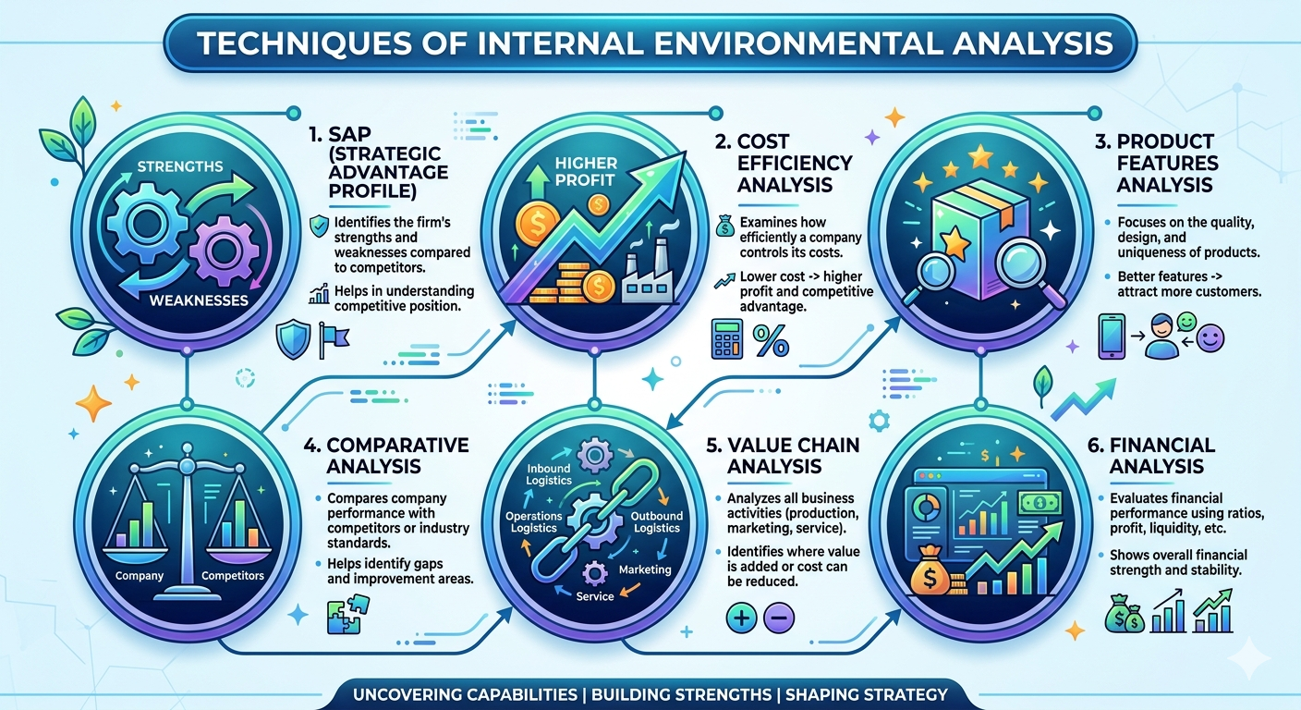
Internal Environmental Analysis refers to the process of examining the internal strengths and weaknesses of an organization to improve its performance and gain competitive advantage. It focuses on analyzing resources, capabilities, and activities within the organization to support effective decision-making and strategy formulation.

1. SAP (Strategic Advantage Profile)
SAP is a technique used to analyze a firm’s internal strengths and weaknesses in comparison to its competitors.
- It focuses on key areas like marketing, finance, production, and management.
- Each factor is rated (strong/average/weak) to determine the firm’s position.
- Helps managers understand where the company has competitive advantage.
Importance:
- Identifies core strengths
- Helps in strategy formulation
- Improves competitive position
Example or Creation of SAP Profile
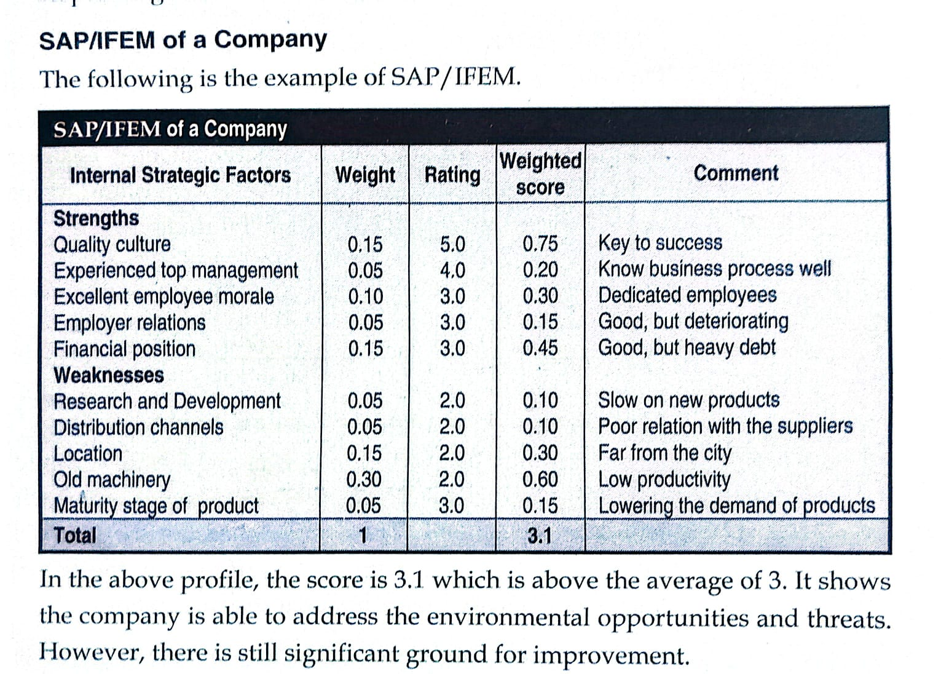

2. Cost Efficiency Analysis
It examines how effectively a firm manages and controls its cost of operations.
- Focuses on reducing production, labor, and operational costs.
- Compares cost with competitors to see efficiency level.
- A cost-efficient firm can offer lower prices or earn higher profits.
Importance
- Increases profitability
- Helps in price competition
- Improves operational efficiency

3. Product Features Analysis
It evaluates the quality, design, and unique characteristics of a product.
- Focuses on innovation, durability, style, and usability.
- Helps in differentiating products from competitors.
- Better features attract more customers and increase loyalty.
Components
- Customer Requirements
- Value added by organizations
Importance:
- Creates product differentiation
- Enhances customer satisfaction
- Builds brand value

4. Comparative Analysis
It is the process of comparing a company’s performance with competitors or industry standards. It is also involved in the company's standard performance at present.
Components
- Company standard performance
- Historical analysis
- Benchmarking
- Uses benchmarks like sales, profit, cost, and quality.
- Identifies gaps between company and competitors.
- Helps in improving weak areas.
Importance:
- Identifies performance gaps
- Encourages improvement
- Supports strategic decisions

5. Value Chain Analysis
It analyzes all activities of a firm to identify where value is created and costs can be minimized.
  - Primary activities: Production, marketing, logistics, service
  - Support activities: HR, technology, procurement
- Helps in improving efficiency and value creation.

Importance:
- Identifies cost advantage
- Enhances value creation
- Improves competitive advantage

6. Financial Analysis
It evaluates the firm’s financial performance and position using financial data.
Uses tools like:
  - Ratio analysis (profitability, liquidity, solvency)
  - Income statement and balance sheet analysis
- Shows whether the company is financially strong or weak.

Importance:
- Helps in decision-making
- Measures financial health
- Attracts investors and lenders

SWOT Analysis
SWOT Analysis is a strategic tool used to identify and evaluate an organization’s Strengths, Weaknesses, Opportunities, and Threats for effective decision-making and planning.
