BBA 8th Semester
Corporate Financing Decision
Chapter Description

Units | Name of chapter.
1 | Introduction | Theory
2 | Long-Term Financing | Numerical
3 | Term Loan and Lease Financing | Numerical
4 | Short-Term Financing | Numerical
5 | Private equity and Venture capital financing | Theory
6 | Warrants and Convertible | Numerical
7 | Financial Distress | Theory


Chapter -02 | Long-Term Financing | 10 marks

Important Topics
- Meaning
- Long-term instruments
- Method of selling securities
- Analysis of Right offering
- Effect of Financing alternatives on balance sheet and Income statement
Meaning of LTF
Long-term financing is the capital obtained by a company that is repayable after more than one year and is used to finance long-term assets such as buildings, machinery, or expansion projects. Examples Common sources of long-term financing include: Bank loans with long repayment period, Issuing shares (equity), Issuing bonds or debentures, Mortgage loans, and Government loans or funding

Long-term instruments
Long-term instruments are financial assets or debt obligations with maturities exceeding one year, typically 5+ years, used for capital growth or financing major investments.
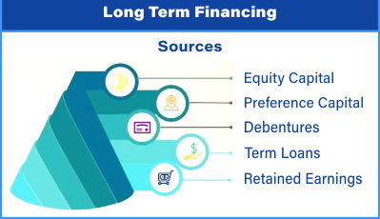
Types
- Term Loan
- Bonds
- Preferred Stock
- Common stock

- Term Loan
A term loan is a loan provided by a bank or financial institution to a company for a fixed period, usually more than one year, and it is repaid in regular installments with interest. Such kinds of loan has fixed time of payment with a fixed interest rate. After maturity need to be provided principle with interest
Key Features
- Fixed repayment period
- Regular installments of principal and interest
- Usually secured by company assets
- Used for long-term investments

- Bonds
A bond is a long-term debt instrument issued by a company (or government) to raise capital. When a company issues a bond, it borrows money from investors and agrees to pay interest periodically and repay the principal at maturity.
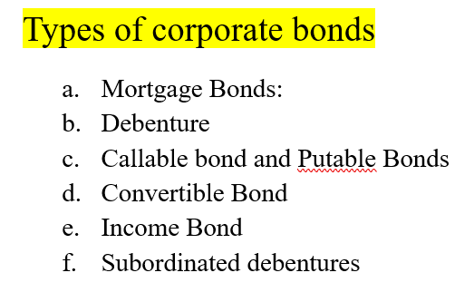
Key Features of Bonds
- Fixed maturity period
- Par value
- Interest payments (coupon)
- Principal repayment:
- Indenture
- No ownership dilution

Advantages and disadvantages of bonds

- Preferred Stock
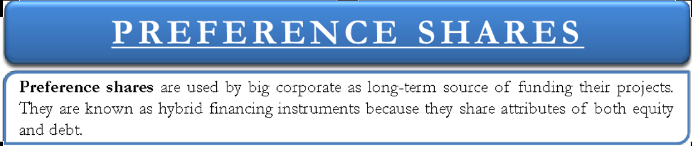
Preferred stock (or preference shares) is a type of equity that gives shareholders a fixed dividend and priority over common shareholders in dividend payment and liquidation, but usually does not provide voting rights.

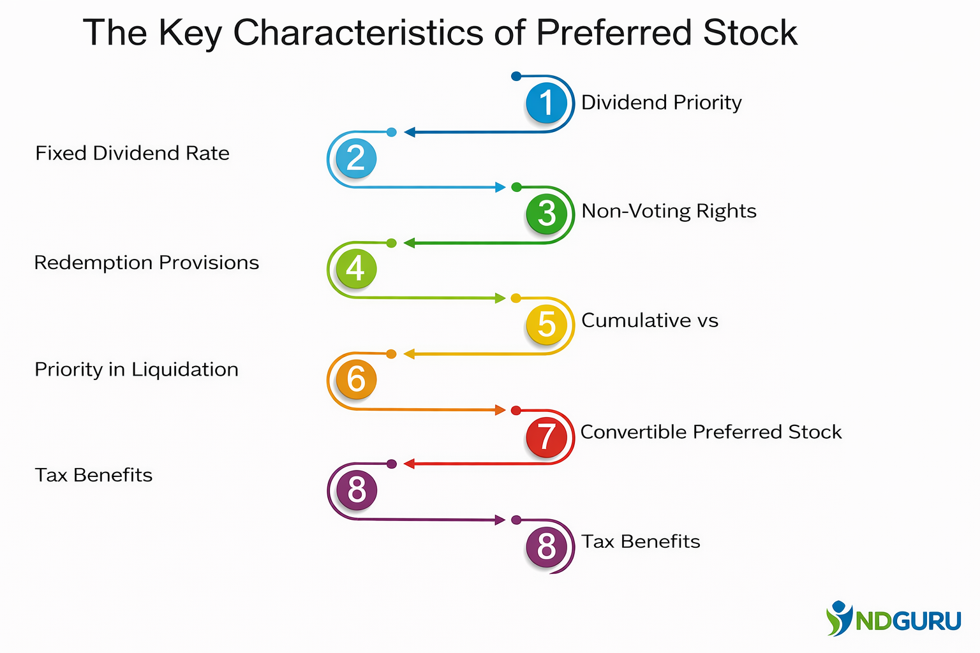

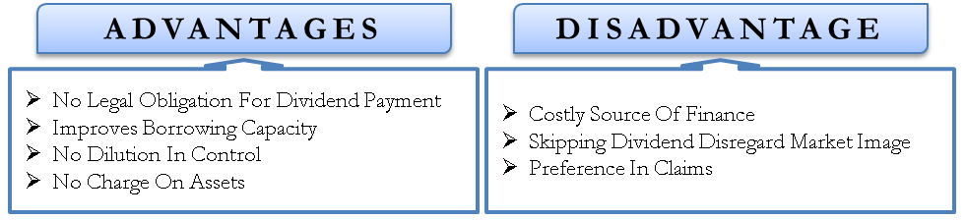

- Common Stock
Common stock represents the ownership interest in a company. Holders of common stock are shareholders who have a claim on the company's profits and assets after creditors and preferred shareholders are paid. Common stockholders are also called equity shareholders.
Features
• Ownership rights in the company
• Variable dividends based on profit
• Residual claim on assets after creditors and preferred shareholders
• Voting rights in company decisions
• Capital appreciation potential
• Limited liability for shareholders
• Transferability of shares
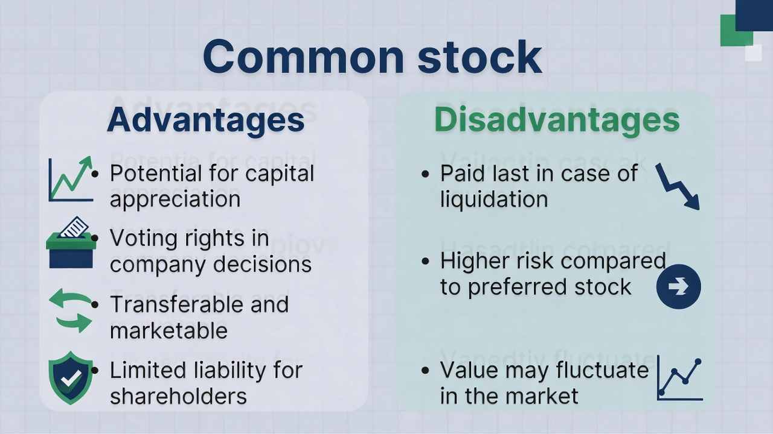

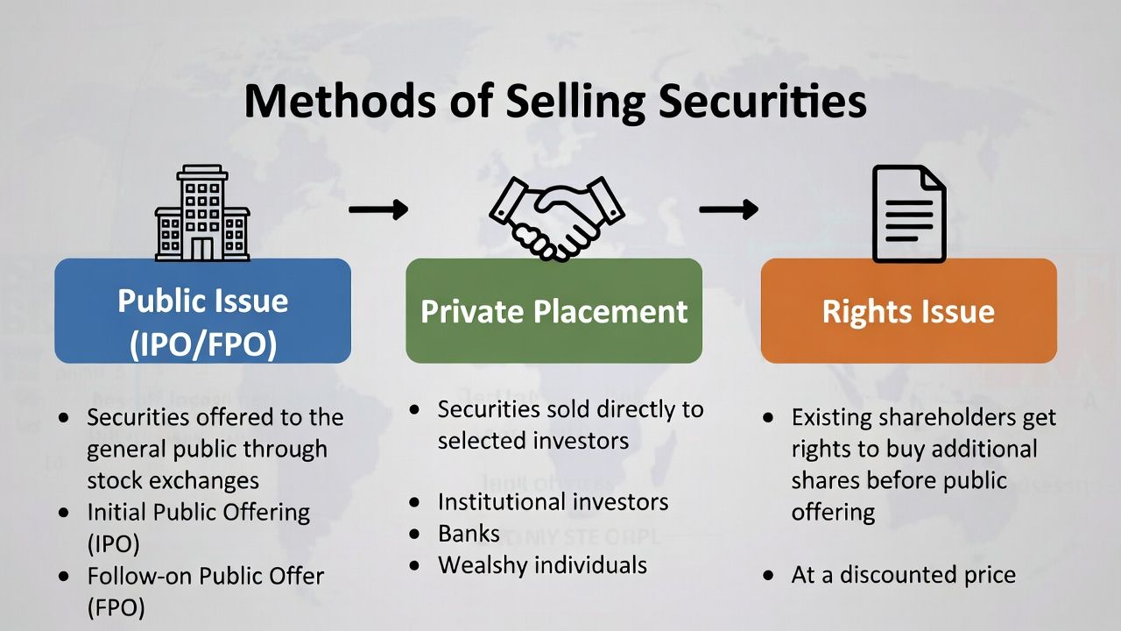
Method of selling securities

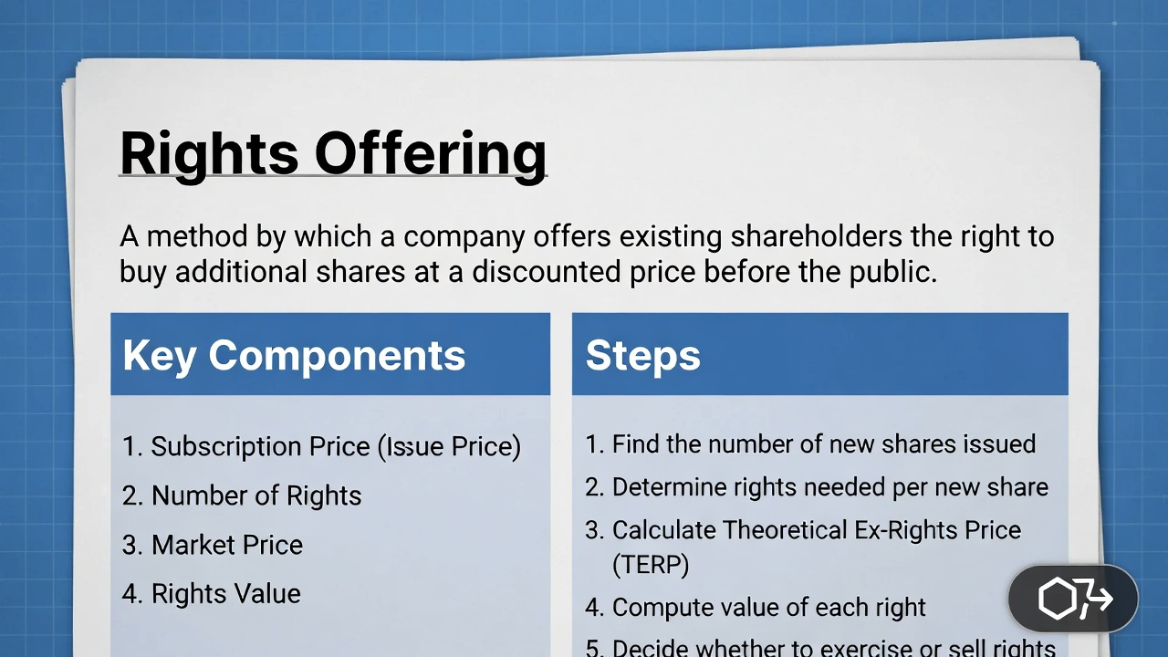

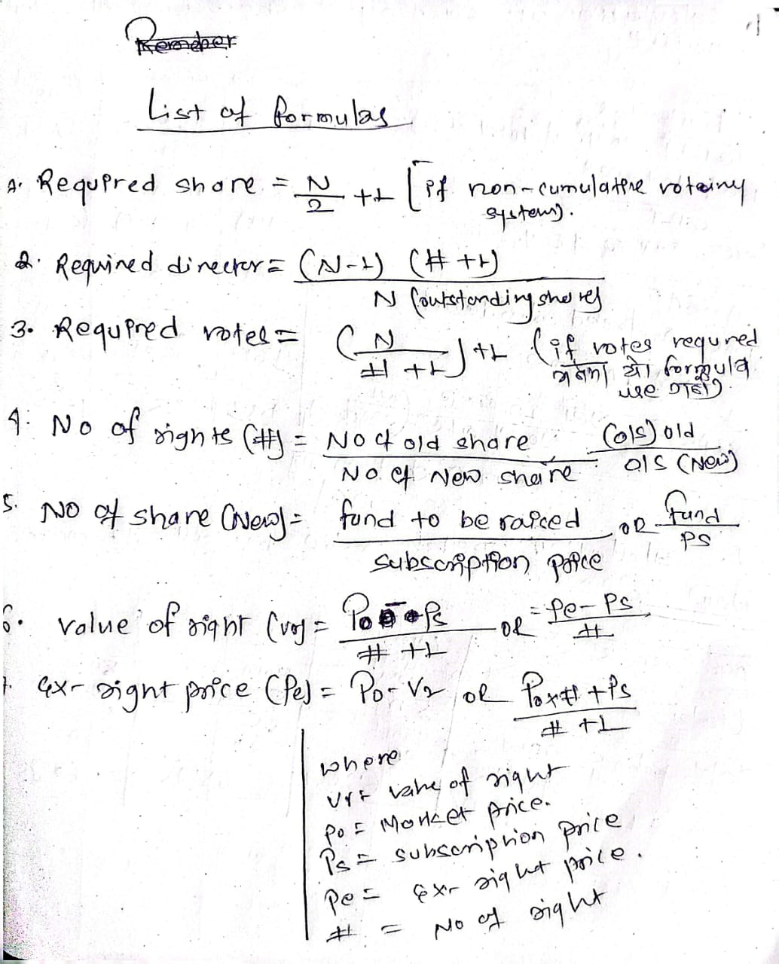

Problem Solution

Problem 2.1 Rapti Finance Company has 1,000,000 shares of authorized common stock. It has issued 600,000 common shares. The company presently has treasury stock and additional paid-in capital but presently the company is having Rs 5,000,000.
a. How many shares are now outstanding?
b. How much is the maximum amount the company could raise if it were able to sell stock at Rs 125 per share?
c. What would be the financing including treasury stock and retained earnings after the accounts?

Problem 2.2 Supra Nepal Limited has a nine-person board and is chartered with a cumulative voting rule. It is outstanding common stock 240,000 shares and additional 500,000 shares. Mr Bijay Karki directly or indirectly controls 240,000 shares. Because he disagrees with present management, he wants to elect his own director.
a. If all directors are elected at once a year, how many directors can he elect?
b. If the directors' terms are staggered so that only three are elected each year, how many directors can he elect?

Problem 2.3 Mrs. Gauri Aryal, a disgruntled stockholder of the Triveni Gas Company, which has 800,000 shares outstanding, desires representation on the board. The Company has a cumulative voting system.
a. How many directorship under a cumulative voting system would Mrs. Aryal have to control to be assured of 1 directorship?
b. How many directorship would Mrs. Aryal have to control to be assured of a majority on the board?

Problem 2.4 As one of the minority shareholders under a cumulative voting system of the Bishan Trading Corporation, you are dissatisfied with current operations of the company. You feel that you could pursue the company to make improvements in the operations of the company. The current management controls 70 percent of the voting shares. Ten percent of the other minority stockholders are a total of 500,000 voting shares and the balance is held by the next annual stockholder meeting.
a. If voting is non-cumulative, can you elect yourself a director?
b. Suppose you can persuade all the minority shareholders that you should be elected. If voting is non-cumulative, can they select you?
c. . If voting is cumulative, can you elect yourself a director?
d. What percent of minority shares other than you own will you need to have voted for you to be certain of election?
e. What is the number of directors the minority shareholders can elect with certainty?

Problem 2.6 The stock of the Jhapa Electronic Company is selling for Rs 180 per share. The company issues rights to subscribe for one additional share of stock at Rs 140 a share, for each three held. Compute the theoretical value of:
a. A right when the stock is selling rights-on.
b. One share of stock when it goes ex-rights.
c. A right when it goes ex-rights and the actual market price goes to Rs 172 per share.

Problem 2.7 The Bikash Furniture Company has grown rapidly during the past five years. Recently, company has discovered some good investment opportunity. It plans to raise an additional Rs 1,000,000 through rights offerings. Current market price of the stock is Rs 150. But subscription price is set at Rs 100 which is equal to its par value. Company has 40,000 shares outstanding.
Required: a. Number of new shares to be issued.
b. Number of rights required to purchase one new share.
c. Theoretical value of each right.
d. Theoretical value of a share when stock goes ex-right.
e. Theoretical value of a right when the stock sells ex-rights and the actual market price goes to Rs 145 per share.

