BBA 8th Semester
Corporate Financing Decision
Chapter Description

Units | Name of chapter.
1 | Introduction | Theory
2 | Long-Term Financing | Numerical
3 | Term Loan and Lease Financing | Numerical
4 | Short-Term Financing | Numerical
5 | Private equity and Venture capital financing | Theory
6 | Warrants and Convertible | Numerical
7 | Financial Distress | Theory

Theory One Shot
Chapter One: Introduction to Corporate Finance
Important
- Meaning
- Financial Instruments
- Function of financial instruments
- Financial Market and Function
- Financial intermediaries
- Ethics in financial decision-making
- Financial innovation and corporate finance
- Capital Structure and Financial Structure

Meaning of Corporate Finance
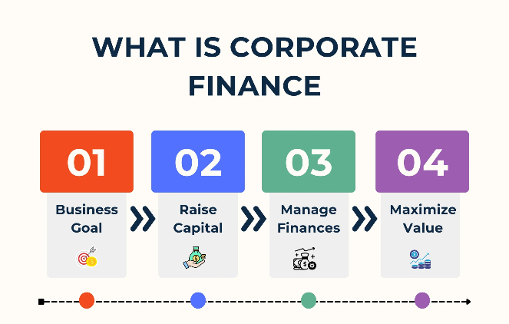
Corporate Finance refers to the branch of finance that deals with how corporations manage their financial resources, funding sources, capital structure, and investment decisions to maximize shareholders’ wealth.
It mainly focuses on:
- Raising funds
- Investing funds
- Managing profits

Corporate Financing Decision
Corporate Financing Decision refers to the decision taken by a company regarding how to raise funds for its business activities. It decides where the money will come from.
A company needs funds for:
- Starting a business
- Expanding operations
- Buying machinery
- Launching new products
- Paying daily expenses
Objective of Financing Decision
- Minimize cost of capital
- Maintain financial stability
- Maximize shareholders’ wealth
- Maintain an optimal capital structure
Financial Instruments and Their Classification
A financial instrument is a legal contract that represents a financial asset for one party and a financial liability or equity for another party. It is a document or contract that has monetary value and can be traded. Examples: Shares, Bonds, Treasury Bills, Debentures, etc.
Classification of Financial Instruments
  - Equity Securities
  - Debt Securities
Short-Term Debt Securities (Money Market)
Long-Term Debt Securities (Capital Market)
  - Hybrid Securities
  - Derivative Securities

- Equity Securities
Equity securities are financial instruments that represent ownership in a company. When a person buys equity securities, they become a part-owner (shareholder) of that company.
A) Common Stock (Equity Shares)
Common Stock (Equity Shares) are securities that represent ownership in a company.
A person who buys common stock becomes a real owner (shareholder) of the company. Common stock gives ownership + voting rights + profit share.
Features of Common Stock:
- Ownership right
- Voting rights
- Dividend is not fixed
- Dividend depends on profit
- High risk, high return
- Residual claim (paid after creditors and preference shareholders)
- Capital appreciation possible
B) Preferred Stock (Preference Shares)
Preferred Stock (Preference Shares) are a type of equity security that gives shareholders priority over common shareholders in receiving dividends and repayment of capital at the time of liquidation. Preference shares give fixed dividend + priority benefit, but usually no voting rights.
Features of Preferred Stock:
- Fixed dividend rate
- Priority in dividend payment
- Priority in liquidation
- Generally no voting rights
- Lower risk than common stock
- May be cumulative or non-cumulative
2. Debt Securities
Debt securities are financial instruments that represent borrowed money.
When an investor buys a debt security, they are lending money to a company or They are classified into:
A) Short-Term Debt Securities (Money Market Instruments)
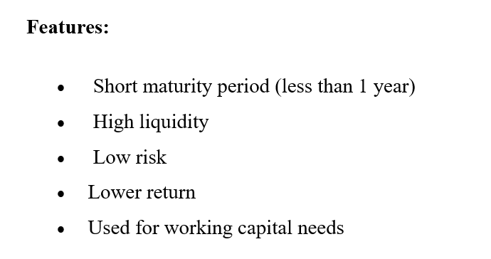
Short-term debt securities are financial instruments used to raise funds for a short period, usually less than one year. These instruments are traded in the Money Market.They are short-term loans taken by companies or governments to meet temporary financial needs. These are traded in the Money Market.
Types
- Treasury Bills (T-Bills)
- Commercial Papers
- Certificates of Deposit (CD)
- Bankers’ Acceptance

B) Long-Term Debt Securities (Capital Market Instruments)
Long-term debt securities are financial instruments issued to raise funds for a period of more than one year. These instruments are traded in the Capital Market. They are long-term loans taken by companies or governments to finance major projects and expansion.

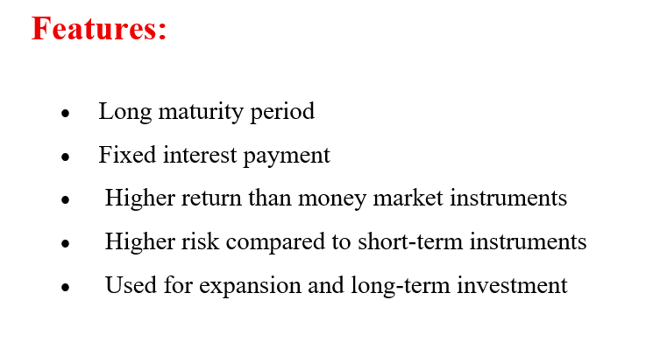
Types
- Bonds
- Debentures
- Long-term Bank Loans
- Mortgage Loans
3.Hybrid securities
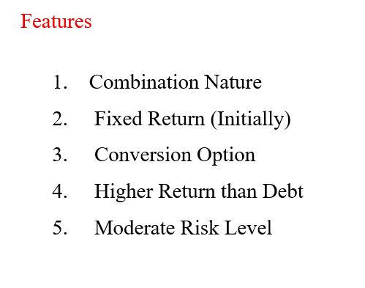
Hybrid securities are financial instruments that have features of both equity securities and debt securities. Hybrid securities = Combination of debt + equity features. Fixed income like debt, Ownership or conversion option like equity
Types
    - Convertible Bond
    - Convertible Preferred stock
    - Warrants

4. Derivatives Securities
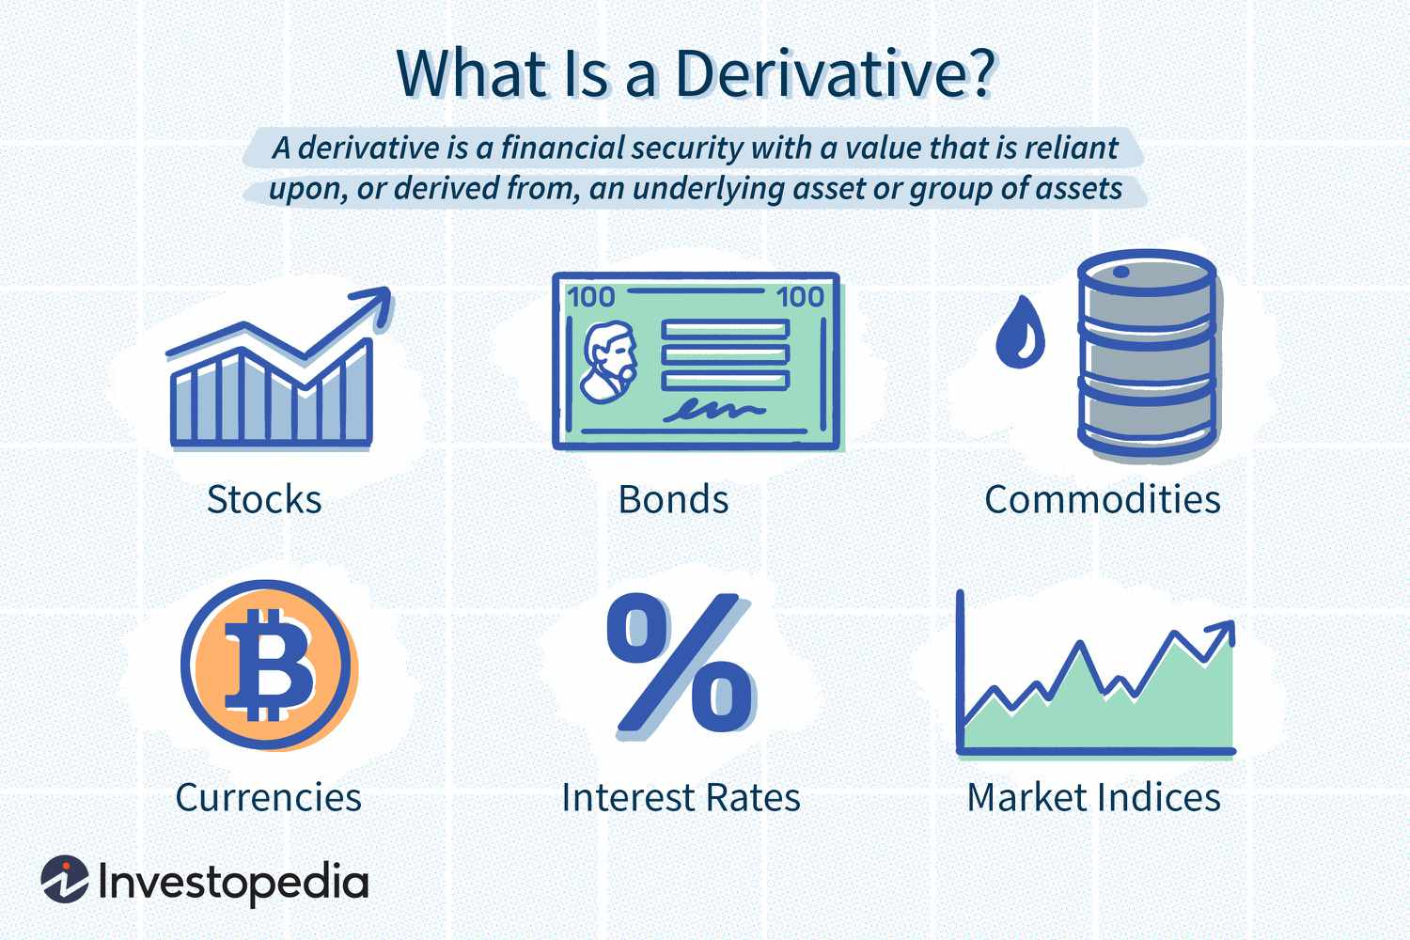
Derivative securities are financial instruments whose value is derived from the value of an underlying asset. Derivatives are contracts based on assets like stocks, bonds, commodities, or currencies.
Features
Derived Value
Used for Hedging or Speculation
Leverage and Traded in Specialized Markets
Function of financial instruments
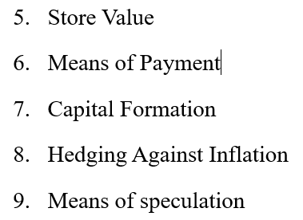
- Mobilization of Savings
- Facilitate Investment
- Risk Management
- Price Discovery

Financial Market
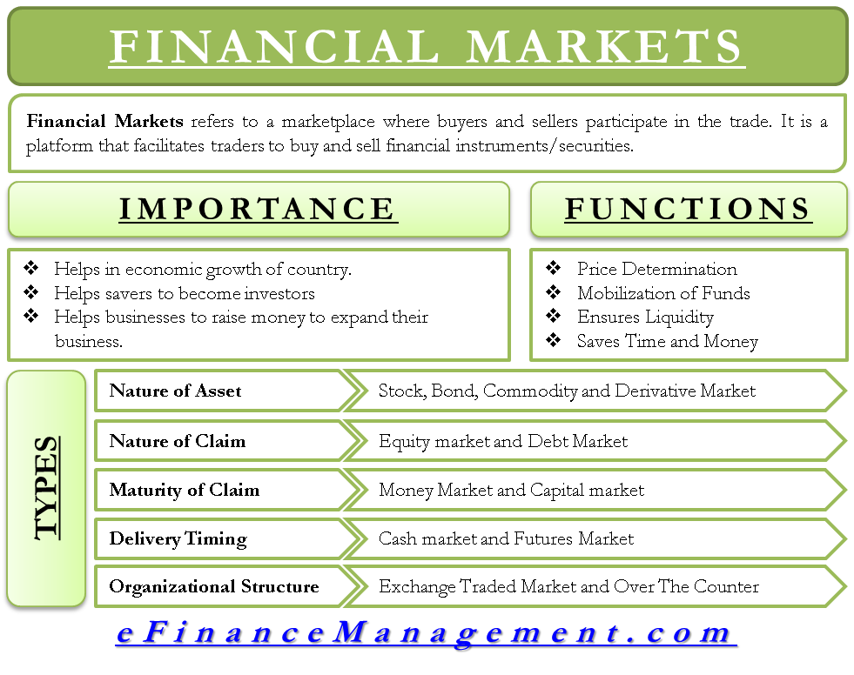
A financial market is a marketplace where buyers and sellers trade financial instruments like stocks, bonds, derivatives, and currencies. It is a place for raising funds, investing, and transferring financial assets.

Financial Intermediaries
Financial intermediaries are institutions that act as a bridge between savers and borrowers. They collect funds from savers and lend/invest them to borrowers.
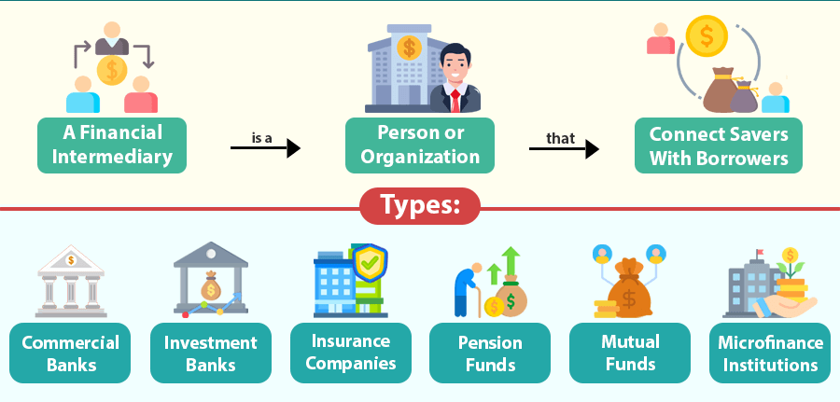

Ethics in Financial Decision-Making
Ethics in financial decision-making refers to the application of moral principles and standards of behavior in financial decisions made by individuals, managers, and corporations.
Importance
Builds trust and credibility with investors and stakeholders
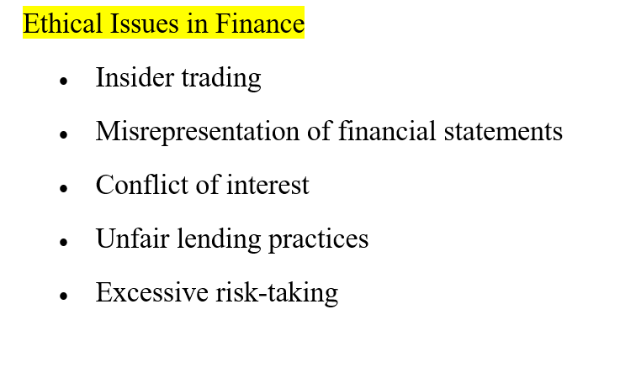
Ensures compliance with laws and regulations
Prevents fraud and financial misconduct
Promotes long-term sustainability of the firm

Financial Innovation and Corporate Finance
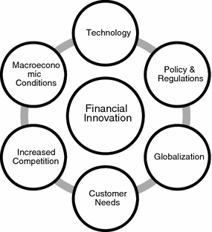
Financial innovation refers to the creation of new financial instruments, technologies, or practices to improve the efficiency of financial markets and corporate finance activities. Financial innovation plays a vital role in corporate finance by offering flexible, cost-effective, and efficient ways to raise capital, manage risk, and improve financial performance.
Importance
- Reduces transaction costs
- Enhances liquidity in financial markets
- Provides new sources of finance
- Improves risk management
- Supports corporate growth and diversification

Capital Structure and Financial Structure
Basis | Capital Structure | Financial Structure
Meaning | Mix of long-term debt & equity | Mix of all liabilities & equity
Scope | Long-term only | Short-term + Long-term
Objective | Minimize cost & maximize wealth | Ensure liquidity & solvency
Components | Equity, Long-term debt | Equity, Long-term debt, Short-term borrowings, Payables
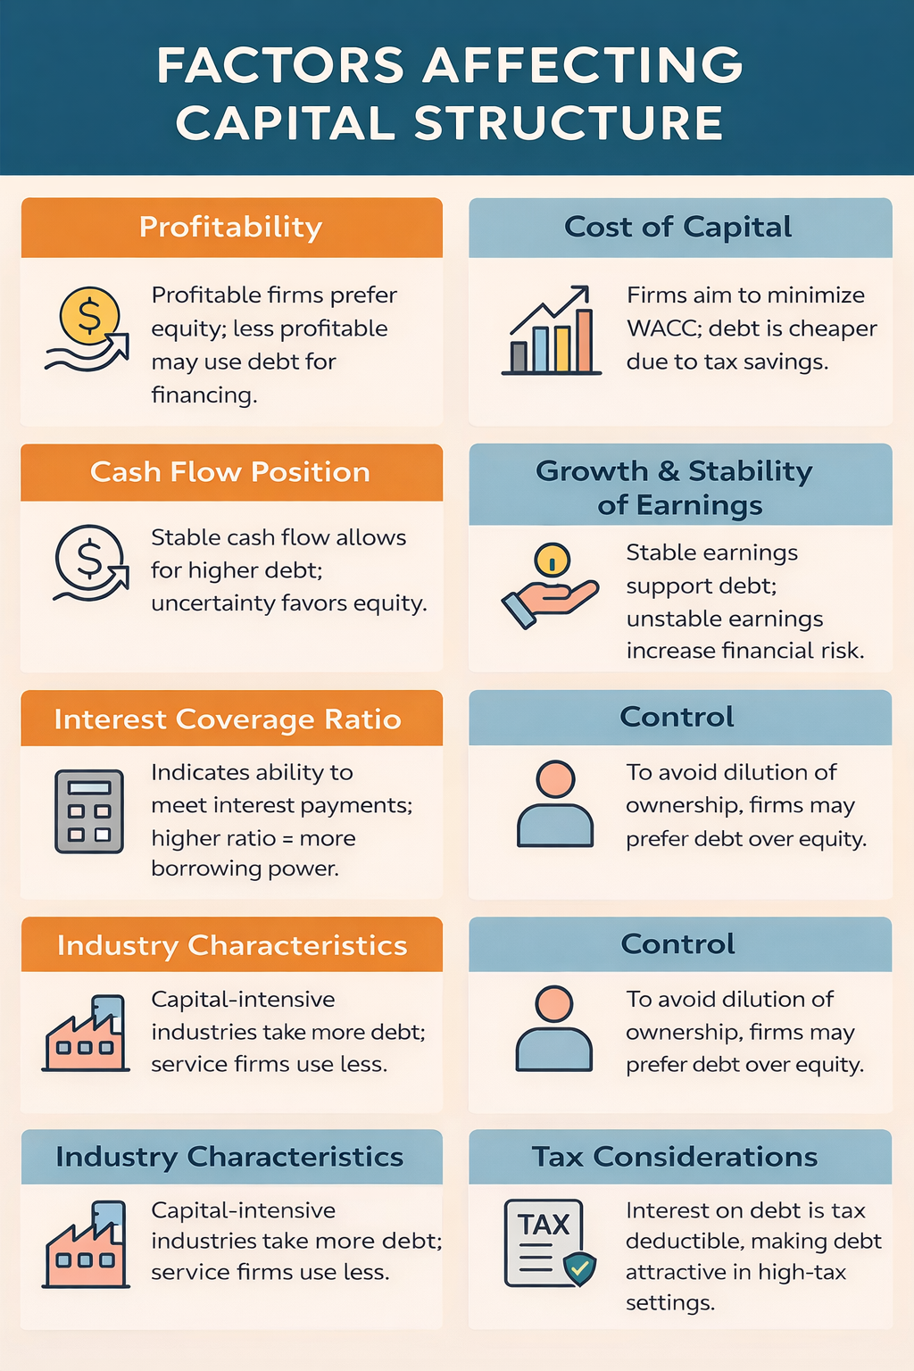

MOTIVATIONS FOR GOING PRIVATE
Meaning of Going Private
Going private refers to the process by which a publicly listed company purchases its outstanding shares from public shareholders and removes (delists) its shares from the stock exchange, thereby becoming a privately held company.
After going private:
- Shares are no longer traded publicly
- Company is not required to follow stock exchange regulations
- Ownership is limited to a small group (promoters, private equity, or management)

Motivations for Going Private
1️⃣ Avoid Pressure from Public Market
Public companies must:
- Report profits every quarter
- Satisfy shareholders continuously
- Maintain stock price performance
2️⃣ Reduce Regulatory and Reporting Costs.
- Audit cost
- Compliance burden
- Reporting expenses

3️⃣ Greater Managerial Control
- Decision-making becomes centralized
- Managers gain operational freedom
- Less interference from minority shareholders

4️⃣ Improve Operational Efficiency
- Restructure business operations
- Close unprofitable divisions
- Reduce workforce if necessary
- Invest in risky but valuable long-term projects

5️⃣ Tax & Financial Benefits
- Interest payments are tax-deductible
- Reduces taxable income
- Improves after-tax profitability

6️⃣ Easy Restructuring & Leveraged Management
- Restructure capital
- Change management
- Modify strategic direction
- Operate without public scrutiny

LEVERAGED BUYOUT (LBO)
A Leveraged Buyout (LBO) is the acquisition of a company using a significant proportion of debt financing (usually 70–80%) and a small portion of the buyer’s own capital (equity). The target company’s assets and future cash flows are used as security to repay the borrowed funds.

Characteristics of LBO
- High use of debt
- Low equity investment
- Company assets used as collateral
- Requires strong and stable cash flow
- High financial risk
- Tax advantage (interest is deductible)
- Active management involvement
- Planned long-term exit strategy

🔹 LBO Structure Explanation
- Sponsor (Private Equity Firm) identifies Target company.
- Sponsor arranges 70–80% debt from lenders.
- Sponsor invests small equity.
- Debt + Equity used to purchase target.
- Target’s cash inflow used to repay debt.
- After improvement, sponsor exits and earns profit.

LEVERAGED RECAPITALIZATION
Leveraged recapitalization is a strategy where a publicly listed company borrows a large amount of money and uses it to:
- Pay large dividends
- Repurchase shares
Instead of buying another company, the firm increases its own debt to reward shareholders.
🔹 Implications of Leveraged Recapitalization
- Increase in financial risk
- Higher interest burden
- Tax advantage due to interest deduction
- Immediate benefit to shareholders
- Reduction in equity base
- Increased performance pressure on management

BANKRUPTCY, LIQUIDATION & REORGANIZATION IN NEPAL
In Nepal, bankruptcy and insolvency matters are governed by:
- Company Act 2063 (2006)
- Insolvency Act 2063 (2007)

BANKRUPTCY IN NEPAL
According to Section 2(b) of the Insolvency Act 2007, a company is considered bankrupt if:
- It has outstanding dues to creditors, and
- There is no possibility of paying future dues partially or fully
Also under Section 7(2), a company is bankrupt if:
- Value of liabilities exceeds value of assets

Process of Involuntary Bankruptcy Liquidation
- Filing petition in court by creditor
- Court review and hearing
- Issuing show cause notice
- Court order
- Inquiry into financial position
- Meeting of creditors
- Court order to liquidate
- Statement of claims submitted

LIQUIDATION OF COMPANY (Nepal)
Liquidation is the legal process of closing a company by selling its assets to pay creditors and permanently ending business operations. Under Company Act 2063 (2006), Chapter 10 provides provisions for voluntary liquidation.

🔹 Process of Liquidation
a. General meeting resolution
(Section 126(2))
b. Filing application
c. Appointment of liquidator
d. Liquidator takes over management
e. Realisation of claims
f. Settlement of accounts
g. Submission of final report
h. Cancellation of company registration

REORGANIZATION OF COMPANY
Reorganization means restructuring the financial, managerial, and operational system of a bankrupt company in order to improve performance and continue operations.
It is provided under the Insolvency Act 2007.
Instead of closing the company, it is restructured to recover.
Process of Reorganization
- Filing petition in court
- Court order for reorganization
- Appointment of reorganization manager
- Formulation of reorganization program
- Meeting of creditors
- Submission of resolution
- Voting and approval
- Implementation and modification
- Completion of reorganization

