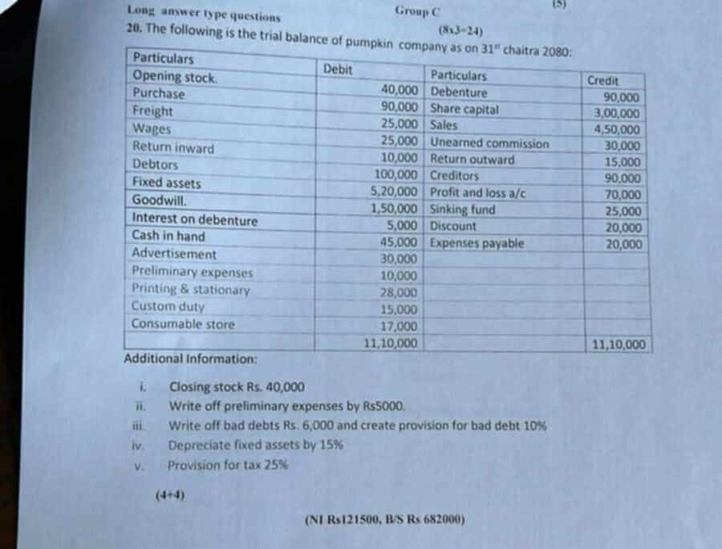

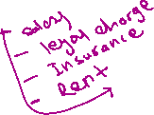

|  |  |  |
| --- | --- | --- |
| Particulars | Amount | Amount |
| Saales/ sales revenues   Less:- Sales return  Less: Cost of Goods Sold  Opening Stock  Purcahse 90000  Less: purchase return (15000)  Fright  Wages  Custom duty  Less: Closing stock ( if given additional information) | 450000  (10000)  40000  75000  25000  25000  15000  (40000) | 440000  (140000) |
| Gross Profit ( sales- cogs)  Les:- Operating expense   * Office and administrative   Printing and stationery  Written of primilary expense  Depreciation on fixed assets ( 15% of 520000)  Total office expnse   * Selling and distribution expense   Advertisment  New total Bad debts  Bad debts 6000  Add:- New create of provision for bad debts 9400  Total selling expense  Total Operating expense ( A+B) | 28000  5000  780000  111000  30000  15400  45400 | 3,00,000  (156400) |
| Income from operation ( GP- OE)  Add: Other Income ( Revenue / gain)  Discount  Less:- Financial expesne / non- opearting losses  Inetrest on debentures |  | 143600  20000  (5000) |
| Net profit before tax  Less;- Tax ( provision for tax @25%) ( 158600*25/100) |  | 158600  39650 |
| Net income after tax |  | 118950 |

Retained earning =

