Grammar all chapter

Story Important chapter

* Neighbor
* A Respectable Women
* The treasure in the forest
* A Devoted Son
* A very old Man with
* My old Home

- Subject verb agreement

Passivevoice

Reported speech

Perpsoition

Relative clause

Girls = she   
boys = He

Old is gol quesionpractic

1. Sita is cooking now,…isn't she …?
2. We are certain, aren't we…..?
3. They had a big project execute …didn’t they…?
4. He had to go market,……wouldn’t he…?
5. She has not booked ticket for theatre…has she .?

Hav/had+v3

Had- v2/v3  
have= v1

Has= v5

Being = v4

Rules for question tag

If question has been given

Let me go, will you?   
help me, will you?  
pelease sit, down, wiil you?  
let me go, will you?  
have a cup of tea , will you?   
sita, help me, will you?  
let's us go now, shall we?

I am a students ,…aren’t I… ?

I am not a student…am I?

If question positive = answer negative   
if negative ( barely, noboday, no, not) = positive

Nobody , somebody, no one, someone, everyone = subject they

The bus, the cat, book, fan = it

Girls = she   
Boys = He

Using term

is/am/ are / was/were/do/did/does/will/shall/should/would/has/have/had/may/might/must + subject

Had + better = had + subject   
had+ v1= would + subject   
have + rather= would+ subject   
is+v4=is subject  
am + verb = am + subject   
have+ verb = have + subject   
had + v3 = had + subject   
had+have+ v3= would + subject  
is + object= is + subject  
is + v3 = has + subject   
will/shall + verb = shall/will + subject

If sentences

V2 = did/didn’t ( question) ( she worked very hard, didn’t she…….. ?

V1= do /don’t+subjet ) ( I play football, ..dont I …..?

V5 = does/ doesn’t + subj ) ( Does she go to market…doesn’t she ..…?

Everbody play football well,…don’t they ..?

We are certain aren’t we …..( choose question tag)

She has booked ticket for theatre …hasn’t she …?

I am not regular student …am I ….?

I am a teacher …aren’t I …?

Sulochana isn’t here…is she …..?

For example

Old is Gold

1. I am a regulars students,…aren’t I…?
2. They had a big project to execute, didn’t they ……?
3. She had better booked the bus ticket…hadn’t she …..?

Had = V2 /v3   
have = v1  
has = v5

He is a teacher, is not he?

* 1. You got my letter, …?
  2. The bus will stop here…..will+not= won’t it …?
  3. You don’t smoke,…do you …?
  4. I am not so fat as you…am I . .?
  5. He did not come to school… ..?
  6. You haven’t taken your meal…have you …?
  7. She is gone ,…isn’t She….?
  8. Have another cigarette…will you ?  
      have you ever go to pokharara……?
  9. Let me go now…will you …?
  10. Rita had + main verb to cook…didn’t She…?

Is =v5 = am = are = V1 = was = v2 = being , have= V1 = had = v3 = has =v5

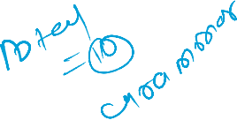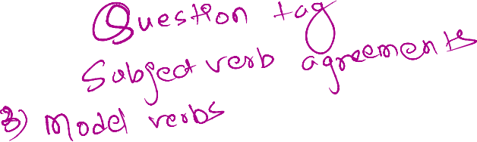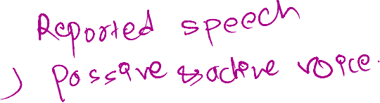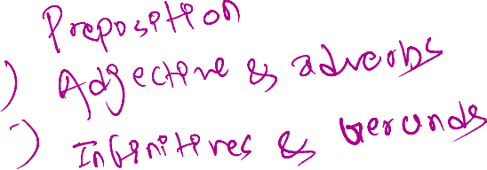

Passive voice-

Object + auxiliary verb + V3 + by + subject

* Tens change into passive

|  |  |
| --- | --- |
| Active | Passive |
| Present…………………………..  V1/do/does  Is/am/are+ ing(v4)  Has/have+v3    Past tens  V2/did  Was/were+ v4  Had+v3  Future tens  Shall/will  Shall/will+ have+v3  **To + v1** | ……………..V3  Is/am/are +v3 ( if singular object use is and is plural object use are and i= am)  Is/am/are+being+v3  Has/have +been +v3 ( if singular object use has and plural object use have, I = have)  … v3  Was/were+ v3  Was/were+ being + V3  Had + been + v3  ………..v3  Shall/will + be+v3  Shall/will+ have+ been + v3  **To be + v3** |

Special Case = यदि sentences ( I don’t love , I don’t care, no one loves, I intend, I resent ) छ भने Main Verb मात्र change garne

I resent people interrupting me when I am speaking( Change into passive) - I resent being interrupted when I am speaking.

1 I want my students to respect me . Change into passive

- I want to be respected by my studnts

1. They wrote an essay .

- An essay was written by them.

* I resent being interrupted when I am speaking.
  1. Parents gave children a bar of chocolates
* A bar of chocolates was given to children by parents.
  1. Did they confess the crime?
* Was/were the crime confessed by them .
* They wrote an essay

An essay was written by them.

I want students to respect me . Change into passive

* I want to be respected by my students
* No one loves people teasing them in the public. ( change into passive)

No one loves being teased in the public.

Help me- let me be hlped.

Open the door- let the door be opend

Practice question

Present tens

1. I eat rice ( active ) = Rice is eaten by me.
2. Do I take this meal? = is this meal taken by me.
3. I am buying a pen (Active ) = A pen is being bought by me.   
   -
4. Sita has helped him = He has been helped by sita, her.



Past tens

1. She helped him = He was helped by her.
2. Ramesh was going to market = Market was being gone by him/ramesh
3. He had bought a pen = A pen had been bought by him.

Qeustion

People speak English all over the world = English is spoken all over the world by people.

Ramesh eats a mango

Rita was cooking food

He helped her

Rita is writing a letter

Children likes sweets

* Sweets are liked by children.

He did not speak a word

A word was not spoken by him.

They do not visit us.

* We are not visited by them.

I had written a letter

A letter had been written by me.

He knows me ( I am known by him.

I want my student to respect me. ( change into passive)

* I want to be respected by my student.

Someone talk in English ( English is talked by them.

1. Nobody called me last week. ( change into passive)

* I was not called last week./ I was called by no one last week.
* Help me ( change into passive) let me be helped
* Open the door. – let the door be oppned
* Where are you going now? ( change into )
* Where are being gone by you now ?
* Where are being gone by you now?

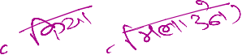

Subject Verb Agreement



|  |  |
| --- | --- |
| Person | Pronoun/ noun |
| 1st | I, We |
| 2nd | You |
| 3rd | He, She, It, Name, They |

Magical words

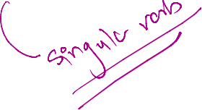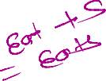

1. One of the boys still…is…..working on the project assignedby thetachr ( choose the beverb)
2. Be verb = is/am/are/were/was
3. The principal along with the other expert …has….( has/hav/was/were) presented at meeting ( choose the bs one) - v3
4. Nithr the gas nor the electric haters …are….(is/am/are) suitablfor room hatings

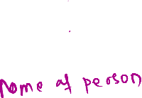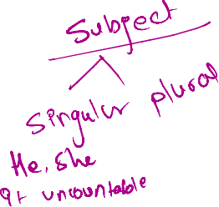

|  |  |
| --- | --- |
| Singulars ( he, she, it, or uncountable) | Plural verbs( they, you, we, and countable |
| V5 ( goes, eats, comes etc)  Is  Was  Has  Does  Will/ shall | V1 ( go, eat, come etc)  Are/ am ( I = am) You=are  Were  Have  Do  Shall / will |

Rules:

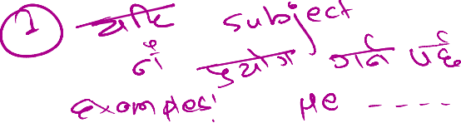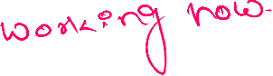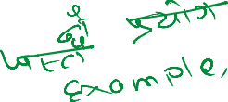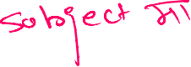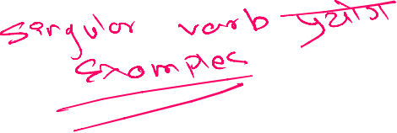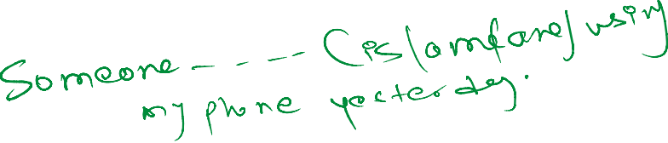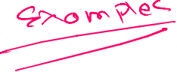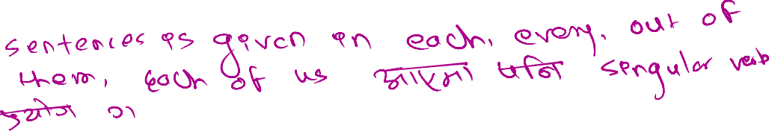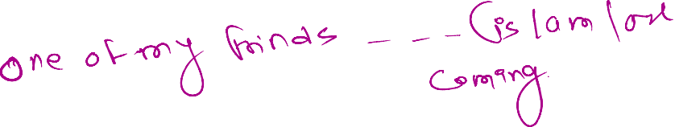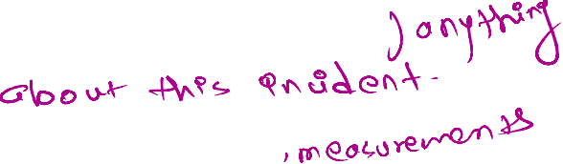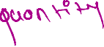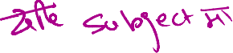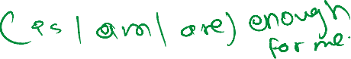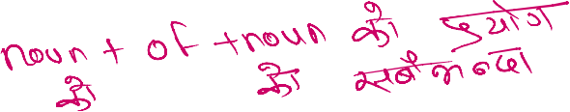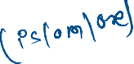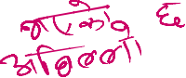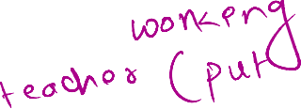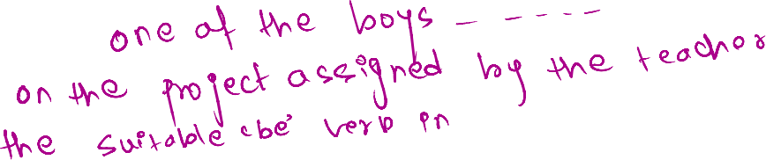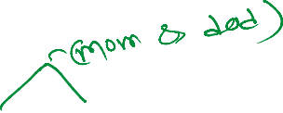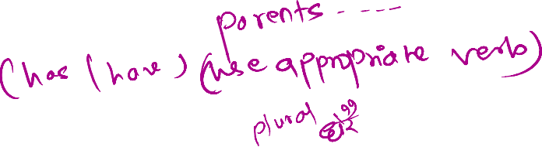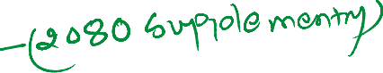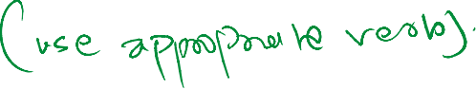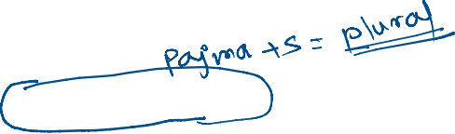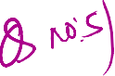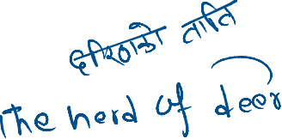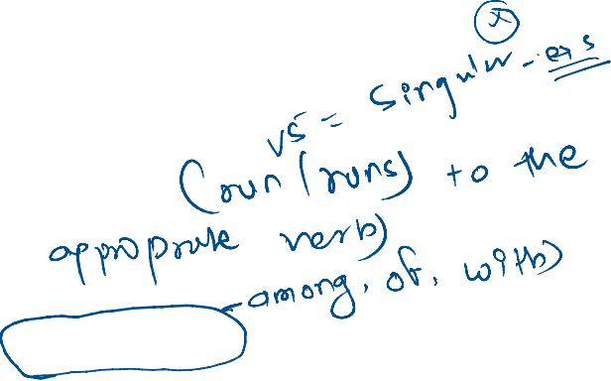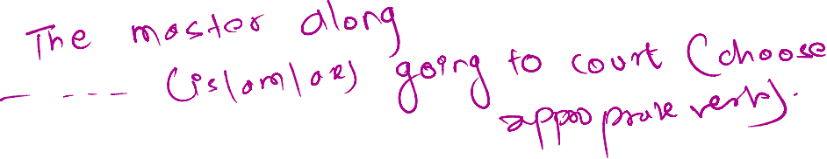

1. Either the teacher or the students _are__ responsible for the decorations.  
a) is  
b) are  
c) was  
d) were

• The bouquet of flowers __is on the table.  
a) is  
b) are  
c) were  
d) have

• Neither the cat nor the dogs seem ___ hungry after the meal.  
a) seem  
b) seems  
c) has  
d) have

• Everyone in the office __is_ excited about the new project.  
a) is  
b) are  
c) were  
d) have

• The committee __has _ decided to postpone the meeting.  
a) has  
b) have  
c) are  
d) were

• A pair of shoes ___ on the floor.  
a) is  
b) are  
c) were  
d) have

• Mathematics ___ my favorite subject in school.  
a) is  
b) are  
c) were  
d) have

• One of the players ___ ready to leave the field yet.  
a) was  
b) is  
c) are  
d) were

• The news about the elections ___ surprising to many people.  
a) is  
b) are  
c) were  
d) have

• Each of the students ___ given a study guide for the test.  
a) was  
b) is  
c) are  
d) were

Reported Speech (

Change of pronoun

|  |  |
| --- | --- |
| Direct | Indirect |
| I we You My our  Your  Me  Us  Mine  Ours  Your  Now | He, she  They  He, she, they  His, her  Their  His, her, their  Him, her  Them  His, her  Their  His, her ther  Then |

Change of tens

|  |  |
| --- | --- |
| Direct | Indirect |
| Simple present  Is/am/are  Have/has  Was /were  Can  Will  Doesn’t +v1/don’t  Have to +v1/ has to + v1  Did not  Sub +v2 | Past simple  Was/were  Had  Had been  Could  Would  Didn’t +v1  Had to +v1  Had not  Subj + had +v3 |

Sita Said to me, “ I am not attdeting my class”.

- Sita told me that she was not attending her class.

Did you receive my email? ( she asked me ….?

She asked me if I had received her eamil?

Help the poor ( he requested .,…

He requested us to help the poor

Students said to the principal “ can you manae extra classes through virtual process” ?

- Students asked to the principal that if could he/she manage extra classes through virtual prcocess.

Say to = said + that   
says= says   
tell to = told

Tell= tell

Example

1. Ram said to her," I am selling my house". ( change into indirect)

Ram told her that he was selling his house.

1. Hari said, "she is calling her friend".

Hari said that she was calling her friend.

1. They said, " we may pass in our exam".

They said that they might pass in their exam.

1. He said , " the sun is hot".

He said that the sun is hot

1. They will say,"we shall win the race".   
   they will say that they should/will win the race.:
2. Did you hear me? ( she asked me….

-she asked me I had heard her

1. Please help the poor ( he requested ….)

He requested me/them to help the poor.

1. The headmaster say, "how many of you are there?

The headmaster say/ asked us how many of we were there?

1. What is your name? ( he asked me….

He asked me what my name was? Or what was my name?

1. I have been to france( he says

He says that he had been to france.

1. Students said to the principle, " can you mange the extra classes trough virtual process?

Students asked /told the principle that could she/he manage extra classes trough virtual process?

If he/she could manage ……

Relative clause

|  |  |
| --- | --- |
|  |  |
| Who  Which  What  That  Whom  Whose  When  Why  Where | को (person) ( subject….. verb)  जुन ( things, animals)  के (thoughts)  त्यो ( person, things, animals but only use)  जसलाई(Person but use in object place)   जसको( person …. And pronoun/noun )  कहिले ( time period)  Reason ( direct verb…..) where |

1. There is a lady ……whose ……….. wallet has been stolen.
2. Do you know the man … who…sold these glasses?
3. The knife… which….you cut the bread with is very sharp .
4. Why do you blame him for everything …that… goes wrong?
5. A cemetery is a place…where… dead bodies are buried.
6. This school is for those children …whose. Mother tongue is not nepali.
7. I don’t know the name of the person whom… …I speak over the telephone .

Tiktok: Nagendra Dimal , Facebook

Connective/ Conjunction

Although + subject+ verb + object ( even though, though)   
Despite + + ing noun/phrases/ genres  
In spite+ ing+ noun/ phrases …..   
despite the fact that+ …….  
Because ‍= किनभने  
Unless = until ( जबसम्म)  
so that ‍= त्यसकारण

If sentences presrent- having  
if sentencs past = being

Example

1. We got wet in the rain, We had an umbrella.( use appropriate connective)

- Although we had an umbrella, we got wet in the rain.

Depsite being an umbrella, we got wet in the rain.

1. Ram is a very handsome, he still unmarried. ( use approparte connective)

Althougth ram is very handsome, he still unmarried.

Inspite having very handsome, he still unmarried.

Inspite being handosme , his still unmarried.

1. It is impossible for one to successes unless/ until. One works hard. ( put correct connective in the space)
2. I couldn’t submitted the assignment on time… ..beacuse …I was out in the country ( put connective)

Preposition

Link between two words

Pre= पहिले   
position = ठाउ

Direction   
Time   
place

|  |  |
| --- | --- |
| Preposition | Use in sentences |
| On | Day, date, सतह, expression |
| In | Longer time, ठुला शहर, stage of age |
| At | Clock time, parts of day, small city, festivals |
| Of | Age, nature, possession |
| With | Situation, instruments and सगै |
| By | Future perfect point of time and transportation, near, passive |
| Toward | Matter |
| Along | सिधा गहिरहेको अवस्थामा |
| Out of | बाहिर जादा |

Example

1. I do not in fact, know who she is staring …at.. ( on/in/at/with) ( Put the suitable preposition)
2. He was just come at….6ö clock. (at,in,with)
3. Rita was going to market …with..(in/ with/at/of) their kinship.
4. He was coming…towards…..me( towards/ with/off)
5. She is 6 years old …of .lovely in nature (of/in/at/with)

Adjective And Adverbs

|  |  |
| --- | --- |
| Adjective ( Descriptive) कस्तो छ | Adverbs कसरि भयो |
| Good  Nice | Well  Nicely |
| Many /few | Little /Much ( uncountable ) |
| Plural form ( countable) | Liquid or milk, water |
| Some | Any |
| Plural , uncountable , affirmative | Singular, negative |

1. The little girl dance really…well/ beautifully..in the annual program of the school. ( choose the approparte adverb)
2. This year the whole winter season was dry. There was very…..( little /many/ more) rain. ( choose the appropriate word)
3. Health care in Nepal is not as….as it is abroad. ( use 'expensive' appropriately)
4. Can I borrow…some ..books from you?( choose the any/some)
5. The cool breeze blew slowly/ fastly….. on her face ( complete the sentences use appropriate adverb)

