Final account अन्तिम खाता- ५ मार्क

Final account shows the profit, loss and financial position of company at the end of year. It helps to classify assets, liabilities and capital of company. ब्यवसायको अन्तिम खाता भन्नाले नाफा, नोक्सान र बित्तिय अवस्थाको बारेमा जानकारी प्रदान गर्ने खातालाई अन्तिम खाता भनिन्छ। उक्त खाता बर्षको अन्तिममा बनाउने गरिन्छ।

1. Tarding account (ब्यापार खाता)
2. Profit / loss account (नाफा नोक्सान खाता)
3. p/l appropriations account (नाफाको अबितरित खाता)
4. balance sheet (वासलत)

Trading account(ब्यापार खाता)

TSrading account is the process of recording sundry expenses which are incurred in manufacturing .

process

opening stock   
purchase

less : purchase return

wages, fule,custom duty , import duty, carriage inward

To gross profit c/d

Cr

Sales   
less ; sales return

Closing

By gross loss C/D

10 …….

Format trading account of ……abc……for the ending year

2075 chitra 31 st

Dr Cr

|  |  |  |  |
| --- | --- | --- | --- |
| Particular | Amount | Particular | Amount |
| To opening stock  To purchase  Less : purcahase return/ purchase outward  To wages  To carriage inward /carriage/ fright cost  To custom duty  To packing expenses  To Royalties  To motive power/Fuel  To factory electricity  To gross profit c/d  To gross loss b/d | xx  xx  Xx  Xx | By sales xx  Less: sales return /sales inward xx  By closing stock ( if given in additional information)  By gross loss c/d  By gross profit b/d | xx  xx  Xx |

Profit / loss account

p/l appropriations

balance sheet 300000 =2500

profit or loss account

Dr for the year of 2075 chitra 31st Cr

|  |  |  |  |
| --- | --- | --- | --- |
| Particular | Amount | Particular | Amount |
| **Administrative overheads**  To salaries  To rent and taxes  To telephone charge  To audit fees  To electricity of office  **Maintenance expenses** ;  To repair and renewals  To depreciation on  Furniture  Plant & machinery  **Selling and distributions**  To salary of salesman  To godwn rent  To bad bed  To carriage outward  To sales commission  **Financial expense :**  To bank charge  To interest on loan  To discount on bills  To Tax paid  **Expense as written on**  To good will written off  To patent written off  To copyright  To trademark written  **Intangible assets written off**  To loss on sales of machinery  To loss on sale of investment  To loss by fire  To net profit c/d……… | Xx | **Others income**  By discount received  By commission received  By bad debt recovered  By sundry and misscalanious incom  **Non trading income**  By interest on investment  By rent received  By dividend received  **Abnormal gain**  By Profit on sale of machinery  By profit on sale of investment  By transfer fee ( Cr of T/B)  By net loss c/d …………… | Xx |

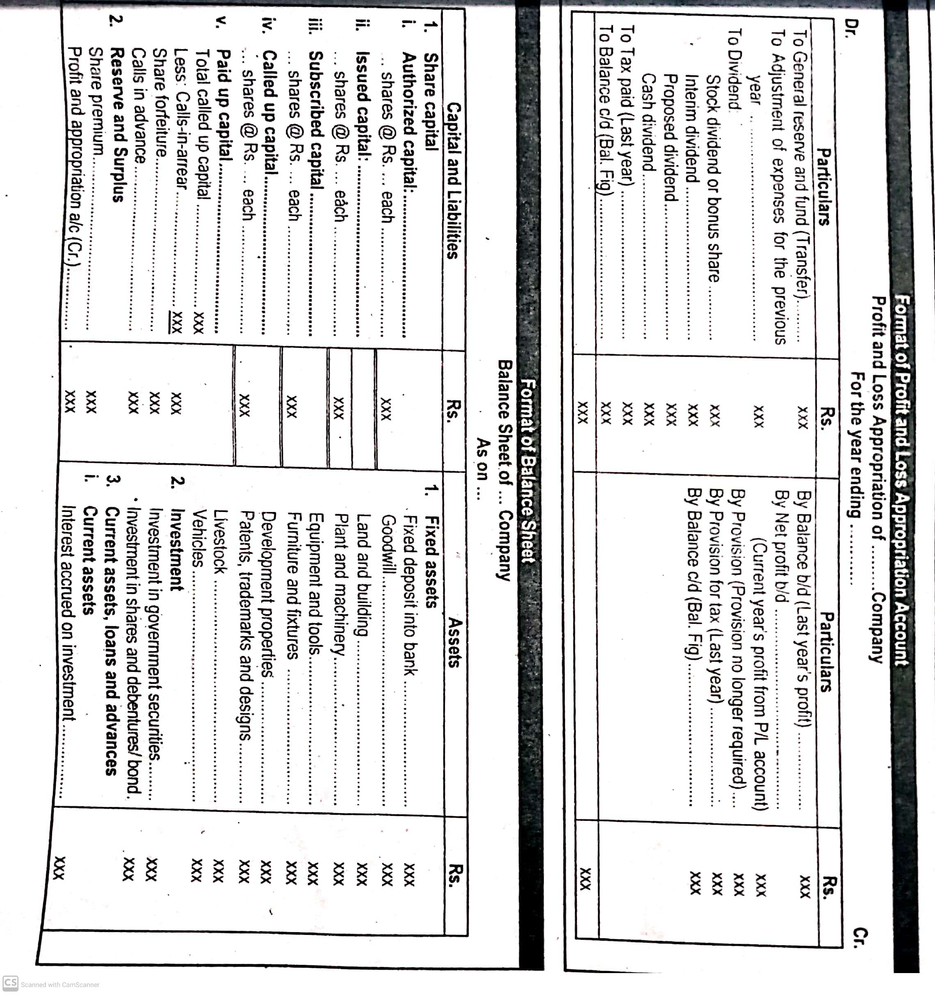



Trail Balance- एक ठाउँमा मात्र जान्छ।

Dr Cr

* Loss/ Expense/ Assets - Income/ profit/ Share capital /liabilities

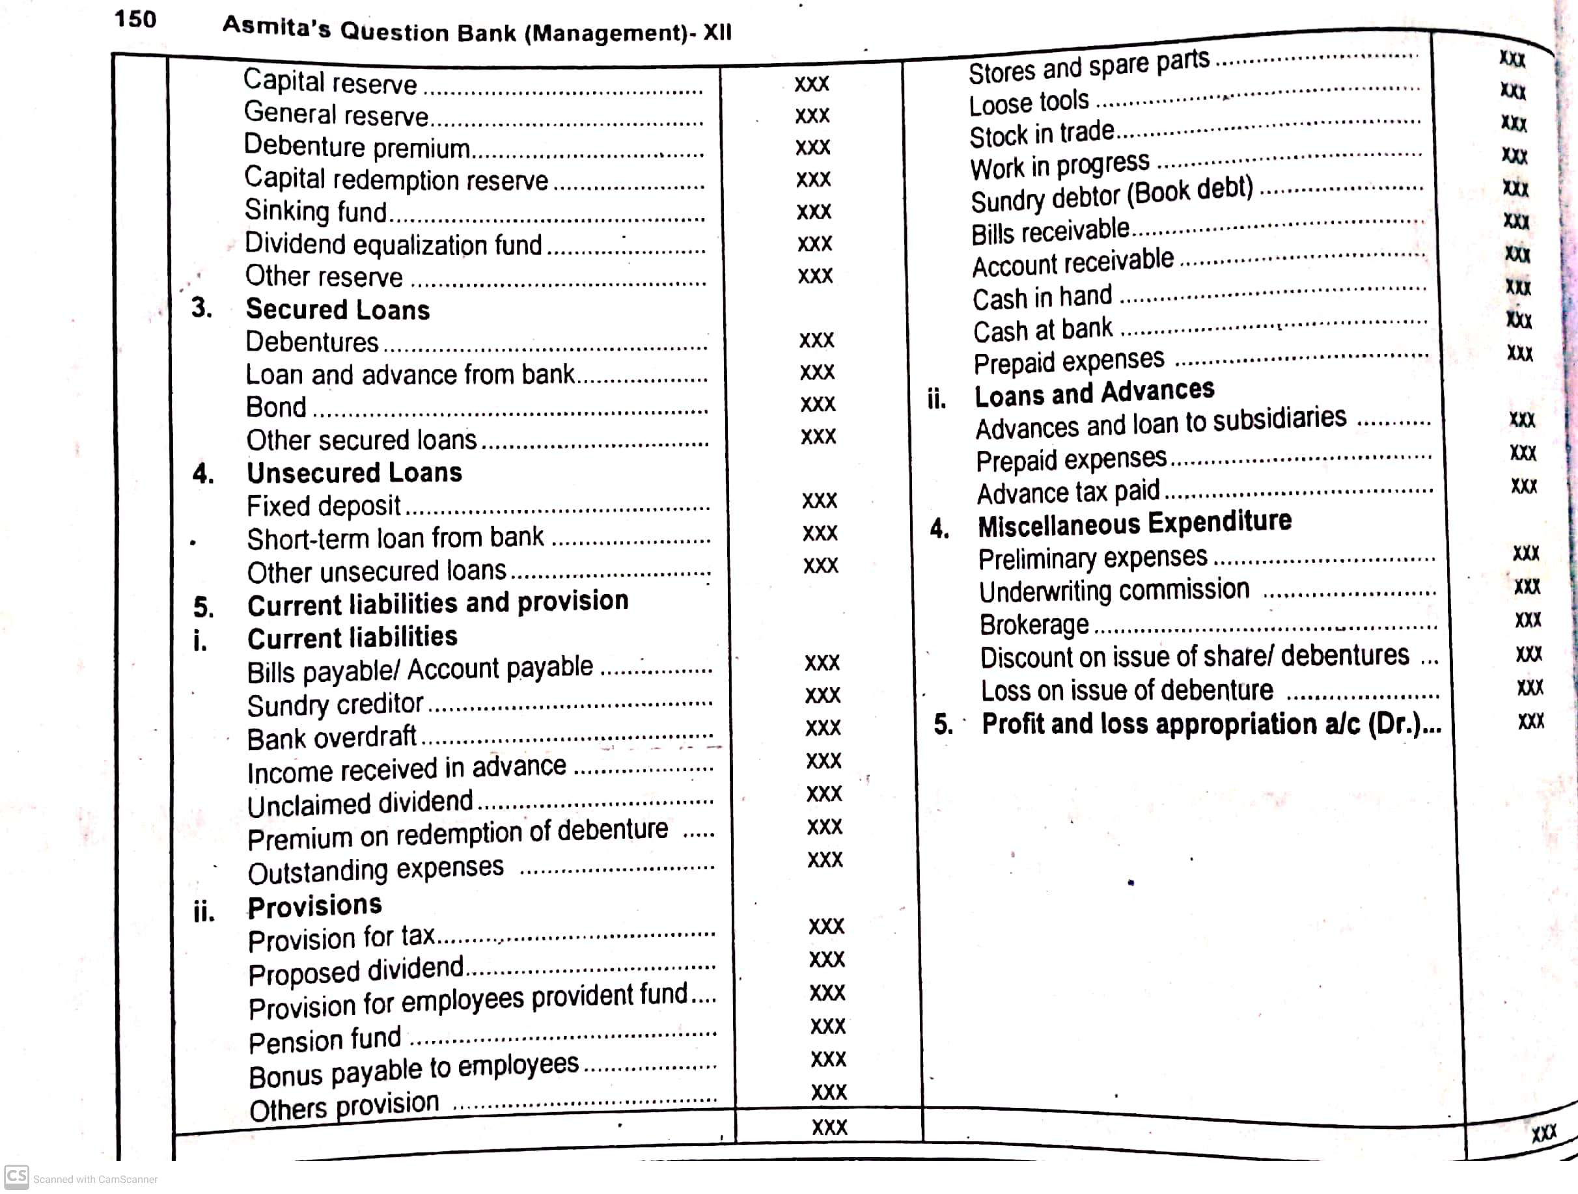



Adjustment / additional information

1. outstanding /payable/due/still to be paid (expense)

p/l related/ trading related heading add

balance sheet labilities side (current liabilities).

1. prepaid /advance (expense) prepaid insurance

p/l / trading a/c Dr related heading less

balance sheet (assets ) =current assets

1. advance expenses   
   p/l trading a/c Dr side less related heading

advance expenses =asstes /current assets

advance income/unearned = liabilities

related heading less p /l Cr side

balance sheet liabilities (current liabilities)

hidden adjustment   
Bank , debenture and investment   
Bank and debenture given % are written in expense (p/l Dr and current liabilities )

investment given % are written in (p/l cr side and balance sheet assets) .  
bad debts   
bad debts given in t/B p/l Dr side  
bad debts and provision for bad debts % given in addititional information   
provision for doubtful debts = debtors – bad debts= xx provision calculation   
total bad debts = bad debts+ provision for doubtful debts P/L Dr   
balance ssheet debtors- less

**tax paid conditions in final account**

**if the tax paid is given in trial balance**

tax paid (last year)=p/l appropriation a/c Dr side

**if provision for tax paid given in trial balance**

provision for tax paid =p/l appropriations a/c Cr side

**If provision for tax paid given in additional information**

Provision for tax paid a/c = p/l a/c Dr side and balance sheet (liabilities)

Provision for tax given in additional information as well as trial balance

Provision for tax (current year)= profit/loss =Dr side

Provision for tax for last year = p/l appropriation a/c Cr side

Treatment of additional information

|  |  |  |  |  |  |  |  |
| --- | --- | --- | --- | --- | --- | --- | --- |
| Items | Trading/ p/L account | | P/l appropriation account | | Balance sheet | |  |
| Dr | Cr | Dr | Cr | Liabilities | Assets |
|  |  |  |  |  |  |  |  |



