Unit -1

अभाव (Scarcity):
यहाँ अभाव भन्नाले उपलब्ध स्रोतहरूबाट चाहना पूरा गर्न नसक्नु वा स्रोतहरूको कमी हुनु हो। मानव चाहना असीमित छ, तर उत्पादनशील स्रोतहरू सीमित छन्। मुख्य अभाव स्रोतहरूमा श्रम स्रोत, प्राकृतिक स्रोत, र पूँजी स्रोत पर्छन्। स्रोतहरूको अभावका कारण चाहनाहरू पूरा हुन नसक्दा आर्थिक समस्याहरू उत्पन्न हुन्छन्।
मानव चाहना असीमित हुन्छ, तर तिनलाई पूरा गर्नका साधनहरू सीमित हुन्छन्।
Scarcity
Scarcity here means failure to meet wants through available resources or there is a shortage of resources. Human wants are unlimited but productive resources are limited. The major scarce resources are labor resources, natural resources, and capital resources. Because of the scarcity of resources, wants will not be fulfilled, leading to economic problems.
Human wants are unlimited, but the means to satisfy them are limited.

चयन (Choice):
चयन भन्नाले वस्तुहरूको बन्डलबाट केही वस्तु वा मात्राहरू छनोट गर्ने कार्यलाई जनाउँछ। यो धेरै चाहनाहरूबाट केही चाहनाहरू छनोट गर्ने प्रक्रिया हो। त्यसैले, चयन भन्नाले आफ्नो आम्दानीलाई विभिन्न वस्तुहरू र सेवाहरूको खरिदमा यसरी बाँडफाँड गर्नु हो, जसले गर्दा व्यक्तिले आफ्नो सन्तुष्टिलाई अधिकतम गर्न सक्छ।
Choice
The choice is the act of selecting a few goods or quantities among the bundles of goods. In other words, it is the process of selecting few wants from the bundles of wants. So, choice means the allocation of income to the purchase of different goods and services in a manner such that he maximizes his satisfaction.

अवसर लागत (Opportunity Cost):
अवसर लागत भन्नाले कुनै व्यक्तिले अर्को कार्य गर्न रोजाई गर्दा त्यागेको लाभलाई जनाउँछ।
यसलाई वैकल्पिक लागत पनि भनिन्छ, र यसले निर्णय गर्दा रोजिएको उत्कृष्ट विकल्पको मूल्यलाई जनाउँछ। सूक्ष्म आर्थिक सिद्धान्तमा, अवसर लागत भनेको अर्को रोजाइ त्यागेर गरिएको निर्णयको मूल्य हो।
Opportunity cost
Opportunity cost refers to a benefit that a person could have received, but gave up, to take another course of action. Stated differently, an opportunity cost represents an alternative given up when a decision is made.
In microeconomic theory, the opportunity cost, also known as alternative cost, is the value (not a benefit) of the choice of a best alternative cost while making a decision.

श्रम विभाजन (Division of Labour):
श्रम विभाजन भन्नाले उत्पादनको मुख्य प्रक्रियालाई धेरै साधारण भागहरूमा विभाजन गर्नु हो। प्रत्येक भागलाई फरक श्रमिकहरूले गर्नुपर्ने हुन्छ, जो तिनै भागमा विशेषज्ञ हुन्छन्।
ह्यान्सनका अनुसार, "श्रम विभाजन भनेको प्रक्रिया विशेषीकरण (specialization of process) हो।"
Division of labour
Division of Labour means that the main process of production is split up into many simple parts and each part is taken by different workers who are specialized in the production of that specific part.
According to Hanson "Division of Labour means specialization of process."

श्रम विभाजनका फाइदाहरू (Advantages of Division of Labour):

Advantages of Division of Labour
- Increase in Production: With the adoption of the Division of Labour, the total production increases.
2 . Maximum Utilization of Machinery: The Division of Labour is the result of large-scale production which implies more use of machines.
3.Increases Producer's profit: Due to the fuller use of plants and machinery under the Division of Labour, production starts increasing rapidly thereby reducing the cost of production. Less cost of production increases the profit of the producer.
4. Availability of Commodities at a Cheaper Price: Division of Labour leads to mass production. Thus, production becomes less expensive and more economical. Hence, cheaper goods are produced by manufacturers. Availability of cheaper goods for consumers improves their living standards.
5. Increase in Efficiency of Labour: With the Division of Labour, a worker has to do the same work frequently, and he gets specialization in it. So, the Division of Labour leads to an increment in the efficiency of the workers.
6. Increase in Skill: Division of Labour contributes to the development of labor skills to a great extent. With the repetition of the same type of work, labor becomes well versed and specialized in it. This specialization enables him to do the work in the best possible way.
7. Full Utilization of Natural Resources: Division of Labour in the country also helps in the full utilization of natural resources. There will be production on a large scale to increase the utilization of resources.

- उत्पादनमा वृद्धि:
श्रम विभाजनको अपनाइबाट कुल उत्पादनमा वृद्धि हुन्छ।
- यन्त्रहरूको अधिकतम उपयोग:
श्रम विभाजनले ठूलो मात्रामा उत्पादनलाई बढावा दिन्छ, जसले गर्दा यन्त्रहरूको अधिक प्रयोग हुन्छ।
- उत्पादकको नाफामा वृद्धि:
श्रम विभाजनले उत्पादन लागत घटाउँछ। लागत घट्दा उत्पादकको नाफा बढ्छ।
- सस्तो मूल्यमा वस्तुको उपलब्धता:
श्रम विभाजनले ठूलो मात्रामा उत्पादनलाई प्रोत्साहन दिन्छ। यसले उत्पादनलाई कम खर्चिलो बनाउँछ, जसले उपभोक्ताहरूलाई सस्तो मूल्यमा सामान उपलब्ध गराउँछ।
- श्रमिकको दक्षतामा वृद्धि:
एउटै काम बारम्बार गर्दा श्रमिक त्यो काममा विशेषज्ञ बन्छ।
- सीपमा वृद्धि:
एउटै प्रकारको काम दोहोर्याइ गर्दा श्रमिक सीपमा कुशल बन्छन्।
- प्राकृतिक स्रोतहरूको पूर्ण उपयोग:
श्रम विभाजनले ठूलो मात्रामा उत्पादन गरेर प्राकृतिक स्रोतहरूको अधिकतम उपयोग गर्न मद्दत गर्छ।
श्रम विभाजनका बेफाइदाहरू (Disadvantages of Division of Labour):
Dis-Advantages of Division of Labour
- Danger of Over-production: Over-production means that the supply of production is comparatively more than its demand in the market. Because of the Division of Labour when production is done on a large scale, the demand for production lags much behind its increased supply.
2 .Increased Dependence: When the production is divided into several processes and each department/ segment is handled by different workers, it may lead to over-dependence.
3. Division of Labour Kills Creative Instinct: Since many workers contribute to the making of a commodity, no one can claim credit for making it. Labor's creative instinct is not satisfied.
4. Monotony of Work: Under the Division of Labour, a worker has to do the same job repeatedly for years long. Therefore, the worker feels bored.
5. Reduction in Mobility of Labour: It has been observed that the mobility of labor is reduced due to the Division of Labour. The worker performs in case they want to change the job. In this situation the mobility of labor gets retarded.
7. Lack of Responsibility: Since multiple processes are involved in a production process, no department of labor will be accountable for the poor production. They want to shift the burden to another division for the defective output.

- अत्यधिक उत्पादनको खतरा (Over-production):
श्रम विभाजनले ठूलो मात्रामा उत्पादन गर्दा बजारको मागभन्दा आपूर्ति धेरै हुन्छ।
- अधिक निर्भरता (Increased Dependence):
उत्पादनका विभिन्न प्रक्रिया फरक श्रमिकहरूले गर्ने हुँदा एकअर्कामा धेरै निर्भरता हुन्छ।
- सिर्जनात्मक क्षमतामा ह्रास:
धेरै श्रमिकले उत्पादनमा योगदान गर्दा कसैले पनि पूर्ण श्रेय लिन सक्दैन, जसले श्रमिकको सिर्जनात्मक भावना समाप्त पार्छ।
- कामको एकरूपताबाट दिक्दारी (Monotony of Work):
श्रम विभाजनमा श्रमिकले एउटै काम बारम्बार गर्नुपर्ने हुँदा ऊ दिक्दार हुन्छ।
- श्रमिकको चलायमानतामा कमी (Reduction in Mobility of Labour):
श्रमिकले विशेष काममा मात्र दक्ष हुने हुँदा नयाँ कामको खोजी गर्दा समस्या हुन्छ।
- जिम्मेवारीको अभाव (Lack of Responsibility):
उत्पादन प्रक्रिया धेरै चरणमा विभाजित हुँदा कुनै श्रमिकले खराब उत्पादनको जिम्मेवारी लिन चाहँदैन। दोष अर्को विभागमा सारिन्छ।
विशेषज्ञता(Specialization):
विशेषज्ञता भन्नाले एउटै काम बारम्बार गर्दा त्यो काममा विशेषज्ञ बन्ने प्रक्रिया हो। यो श्रम विभाजनको परिणाम हो। विशेषज्ञताको प्रक्रियामा, कुनै व्यक्ति वा संस्था आफ्नो बलियो पक्षमा ध्यान केन्द्रित गर्छ। जब व्यक्तिले विशेषज्ञता हासिल गर्छ, उनी आफ्नो फोकसलाई एक विशेष गतिविधिमा सीमित गर्छन्। जब कम्पनीले विशेषज्ञता अपनाउँछ, यसले सीमित वस्तु वा सेवामा ध्यान केन्द्रित गर्छ। यसले scarce (अभावयुक्त) स्रोतहरूको प्रभावकारी उपयोग गर्न मद्दत गर्छ।
Specialization
Specialization means doing the same thing over and over until one becomes an expert in doing that particular task. It is the outcome of the division of labor. In the process of specialization, an individual or firm concentrates on what they are good at. When an individual specializes, they limit their focus to one specific activity. When a company specializes, it focuses on a narrow range of goods or services. This helps to use scarce resources efficiently.

विशेषज्ञताका फाइदाहरू (Advantages):
Advantages

1. Increases efficiency: In specialization, jobs and duties are divided among the employees according to their skills and abilities.
2. Reduces the risk of errors and mistakes: The person who is a specialist is less likely to commit a mistake in doing a particular task than a non-specialist person doing the same task. Hence, specialization helps to reduce errors and mistakes.
3. Time-saving: In specialization, workers have to do the same job again and again. This leads to finding the shortcut way to do the thing which in turn results in a lot of saving of time. Also, the workers have to perform specific types of jobs, there is no need to change tools and machines. This helps to save time.
4. Reduces costs: Increased efficiency, fewer errors, and mistakes increase the production and productivity of the firm. Specialization also reduces waste and unnecessary costs, which helps to minimize the cost of production and increases the revenue of the firm.
5. Less supervision and control: Specialization is based on the principle of "right man in the right place". Thus, a firm hires highly competent and self-motivated employees. So it requires less supervision, guidance, and control to carry out activities.

- दक्षतामा वृद्धि (Increases Efficiency):
विशेषज्ञतामा, काम र जिम्मेवारी कर्मचारीहरूको सीप र क्षमताका आधारमा बाँडिन्छ।
- त्रुटि र गल्ती घट्छ (Reduces the Risk of Errors and Mistakes):
विशेषज्ञ व्यक्तिले कुनै विशेष काम गर्दा गैर-विशेषज्ञको तुलनामा कम गल्ती गर्छ। यसले त्रुटि र गल्ती घटाउन मद्दत गर्छ।
- समयको बचत (Time-saving):
विशेषज्ञतामा, श्रमिकले एउटै काम बारम्बार गर्नुपर्ने हुँदा छोटो मार्ग पत्ता लगाउँछन्, जसले धेरै समय बचत गर्छ। साथै, श्रमिकले विशेष प्रकारको काम मात्र गर्ने भएकाले उपकरण र मेसिन परिवर्तन गर्न आवश्यक हुँदैन, जसले समय बचत गर्छ।
- लागत घट्छ (Reduces Costs):
दक्षता वृद्धि, कम गल्ती, र अपव्यय घटाउँदा उत्पादन लागत कम हुन्छ। यसले उत्पादन लागत घटाई कम्पनीको आम्दानी बढाउँछ।
- कम निगरानी र नियन्त्रण (Less Supervision and Control):
"सही मान्छे सही स्थानमा" भन्ने सिद्धान्तमा आधारित भएर विशेषज्ञताले योग्य र आत्म-प्रेरित कर्मचारी भर्ना गरिन्छ। यसले गतिविधि संचालन गर्न कम निगरानी र निर्देशन आवश्यक पार्छ।
विशेषज्ञताका बेफाइदाहरू (Disadvantages):

Disadvantages of Specialization
- Monotony: Specialization means focusing on a specific job. Repetitive work or doing the same job, again and again, can create monotony. The work becomes boring, which leads to dissatisfaction and loss of interest.
- . Increase in cost: Skilled employees may demand a high salary and other financial benefits as compared to unskilled workers. So, it may increase administrative expenses in the organization.
3. Increases dependency: Specialization increases dependency. One worker depends on the other, one company depends on the other and one country depends on the other. This is because specialization leads to concentration in one product or one sector only.

- एकरूपताको समस्या (Monotony):
विशेषज्ञता भन्नाले एउटै काममा ध्यान केन्द्रित गर्नुपर्छ। बारम्बार एकै काम गर्दा दिक्दारी महसुस हुन सक्छ, जसले असन्तुष्टि र रुचिको ह्रास ल्याउँछ।
- लागतमा वृद्धि (Increase in Cost):
सीपयुक्त कर्मचारीहरूले अकुशल श्रमिकको तुलनामा बढी तलब र अन्य लाभ माग्न सक्छन्। यसले संगठनको प्रशासनिक खर्च बढाउन सक्छ।
- निर्भरता वृद्धि (Increases Dependency):
विशेषज्ञताले निर्भरता बढाउँछ। एक श्रमिक अर्को श्रमिकमा, एक कम्पनी अर्को कम्पनीमा, र एक देश अर्को देशमा निर्भर हुन्छ। यो विशेषज्ञताले एकल उत्पादन वा क्षेत्रमा ध्यान केन्द्रित गर्ने प्रवृत्तिका कारण हुन्छ।
आर्थिक प्रणाली (Economic System):
आर्थिक प्रणाली भन्नाले वस्तु तथा सेवाहरूको उत्पादन, उपभोग, र विनिमयका गतिविधिहरूको आपसमा सम्बन्धित प्रणाली हो।
यसलाई उत्पादन, वितरण, र उपभोगका लागि एकीकृत गतिविधि वा संगठनका रूपमा बुझ्न सकिन्छ। यी गतिविधि सम्पन्न गर्न, मानिसहरू लेनदेनमा संलग्न हुन्छन्, जसमा वस्तु तथा सेवाहरूको किनबेच गरिन्छ। यसले मानिसहरूलाई काम गर्न र जीविकोपार्जन गर्न सहयोग पुर्‍याउँछ।

Economic system
An economy is a system of interrelated production, consumption, and exchange of goods and services. In other words, it is an integrated activity or organization for production, distribution, and consumption. In carrying out these activities, people are involved in making transactions, i.e. buying and selling of goods and services. It provides people with the means to work and earn a living.

आर्थिक प्रणालीका प्रकार (Types of Economic System):

Types of economic System
There are three types of economic system or economy, which are as follows:
- Capitalistic/Market Economic System
- Socialist Economic System
- Mixed Economic system
आर्थिक प्रणालीका तीन प्रमुख प्रकार छन्:
- पूँजीवादी/बजार आर्थिक प्रणाली (Capitalistic/Market Economic System)
- समाजवादी आर्थिक प्रणाली (Socialist Economic System)
- मिश्रित आर्थिक प्रणाली (Mixed Economic System)
- बजार अर्थतन्त्र/पूँजीवादी अर्थतन्त्र (Market Economy/Capitalistic Economy):
- यो प्रणाली उत्पादनका साधनहरूको निजी स्वामित्वमा आधारित हुन्छ र नाफाका लागि सञ्चालन गरिन्छ।
यो उपभोक्ताहरूको मागअनुसार स्वनियन्त्रित रूपमा उत्पादन र वितरण गरिन्छ।
- बजार आर्थिक प्रणालीका विशेषताहरू (Features of Market Economic System):
a. निजी सम्पत्ति र स्वामित्व (Private Property and Ownership):
बजार आर्थिक प्रणालीमा निजी सम्पत्तिको संस्था रहन्छ। व्यक्तिले सम्पत्ति जम्मा गर्न र आफ्नो इच्छाअनुसार प्रयोग गर्न सक्छ।
- b. नाफाको उद्देश्य (Profit Motive):
यस अर्थतन्त्रमा नाफा कमाउने चाहना नै सबैभन्दा महत्त्वपूर्ण प्रेरणा हो। उद्यमीहरूले बढी नाफा हुने उद्योग वा पेशा सुरु गर्न खोज्छन्।
- c. प्रतिस्पर्धा (Competition):
बजार अर्थतन्त्रमा उद्यमीहरूले बढी नाफा कमाउन प्रतिस्पर्धा गर्छन्।
- d. उपभोक्ताको सर्वोपरिता (Consumers' Sovereignty):
उपभोक्ता एक सार्वभौम राजा मानिन्छ। उत्पादनको सम्पूर्ण संरचना उपभोक्ताको इच्छाअनुसार हुन्छ।
- e. सरकारको सीमित भूमिका (Limited Role of the Government):
यो प्रणालीमा सरकारको भूमिका न्यून हुन्छ।

Market economy/ Capitalistic economy
It is based on private ownership of means of production and their operation for profit.
Self-regulated produced and distributed in response to demand from consumers.

Features of Market Economic System
The main features of market economic system are as follows:
a. Private property and ownership: A market economic system always has the institution of private property. An individual can accumulate property and use it according to her/his will.
b. Profit motive: In this economy, the desire to earn a profit is the most important inducement for any economic activity. All entrepreneurs try to start those industries or occupations in which they hope to earn the highest profit.
c. Competition: A market economic system is characterized by free competition because entrepreneurs compete for getting the highest profit.
d. Consumers' sovereignty: In a market economic system a consumer is compared to a sovereign king. The whole production framework is according to their directions. Consumers' taste governs the whole production line because entrepreneurs have to sell their products.
e. Limited role of the government: there is obviously little role for the government to play.

२. समाजवादी अर्थतन्त्र (Socialist Economic System):
- समाजवादी आर्थिक प्रणाली भन्नाले उत्पादन र वितरणका गतिविधिहरू सरकारद्वारा स्वामित्व र नियन्त्रण गरिन्छ।
यसले जनताको कल्याण, अवसरको समानता, र सामाजिक न्याय सुनिश्चित गर्छ। यसलाई नियोजित वा कमाण्ड अर्थतन्त्र पनि भनिन्छ।

- समाजवादी आर्थिक प्रणालीका विशेषताहरू (Features of Socialist Economic System):
a. राज्यद्वारा स्वामित्व (State-Owned Resources):
यस प्रणालीमा उत्पादनका सबै साधन समाजको हितका लागि राज्यद्वारा स्वामित्व र सञ्चालन गरिन्छ।
- b. नियोजित अर्थतन्त्र (A Planned Economy):
समाजवादी अर्थतन्त्र पूर्ण रूपमा योजनाबद्ध हुन्छ।
- c. सरकारी नियन्त्रण (Government Control):
उत्पादन र मूल्य निर्धारणमा सरकारले नियन्त्रण गर्छ।
- d. सामाजिक कल्याण (Social Welfare):
यस प्रणालीको मुख्य उद्देश्य सामाजिक कल्याण हो।
- e. निजी उद्यमहरूको अभाव (Absence of Private Enterprises):
उत्पादन कार्य राज्यद्वारा आरम्भ र सञ्चालन गरिन्छ। नाफा कमाउने उद्देश्य हुँदैन।
- f. आर्थिक समानता (Economic Equality):
निजी सम्पत्ति र व्यवसायको अभावले आर्थिक समानता कायम रहन्छ।

2. Socialist economy
A Socialist economic system is defined as the economic system in which production and distribution activities are owned and controlled by the government. It ensures welfare, equality of opportunity, and social justice to people. It is also known as the command or planned economy.

Features of Socialist Economic System
- State-owned resources: In such an economic system, all the means of production are owned and operated by the state in the interest of society as a whole. This is to ensure equality of opportunity for all citizens. This is also aimed at full and efficient utilization of the country's resources.
b. A planned economy: A socialist economy is a fully planned economy. The main task of the central planning authority is to formulate short-term and long-term plans for the economy.
c. Government control: In a fully socialist economic system, the government controls the main aspects of all economic activities. There are controls on the production and price determination of goods and services. In a fully socialist economic system, market forces are given very little importance.
d. Social welfare: One of the most important features of a socialist economic system is social welfare.
e. Absence of private enterprises: In the socialist economic system, private enterprises are not allowed to establish. Production is initiated and conducted by the state. The state makes investment itself and makes all arrangements for the production itself. There is no profit motive in the production.
f. Economic equality: There is economic equality in the socialist economic system. Since there is no private property, private enterprises, or businesses, there is no possibility of an individual to collect the wealth alone. There is also equality of opportunity. The government also makes sincere efforts to maintain economic equality.

- ३. मिश्रित अर्थतन्त्र (Mixed Economic System):
- मिश्रित आर्थिक प्रणाली भन्नाले निजी क्षेत्र र सार्वजनिक वा सरकारी क्षेत्रको सहअस्तित्व रहेको प्रणालीलाई बुझाउँछ।
यसमा उत्पादन र वितरणका गतिविधिहरू दुवै क्षेत्रद्वारा तय गरिन्छ।
- मिश्रित आर्थिक प्रणालीका विशेषताहरू (Features of Mixed Economic System):
a. सार्वजनिक र निजी क्षेत्रको सहअस्तित्व (Co-Existence of Public and Private Sectors):
यी दुई क्षेत्रहरूबीच सहकार्य महत्त्वपूर्ण मानिन्छ।
- b. मूल्य निर्धारण र नियन्त्रण (Price Mechanism and Controlled Price):
उपभोक्ता वस्तुहरूको मूल्य निर्धारण बजारले नै गर्छ।
- c. नाफा र सामाजिक कल्याण (Profit Motive and Social Welfare):
यस प्रणालीमा नाफा कमाउन र सामाजिक कल्याण गर्न दुवै उद्देश्यका लागि आर्थिक गतिविधि गरिन्छ।
- d. एकाधिकार नियन्त्रण (Control on Monopoly Power):
निजी व्यवसायका एकाधिकार अभ्यासलाई सरकारले विभिन्न नियम र कानूनहरू लागू गरेर नियन्त्रण गर्छ।
- e. आर्थिक योजना (Economic Planning):
मिश्रित आर्थिक प्रणालीमा आर्थिक योजना विकास र वृद्धिका लागि महत्त्वपूर्ण माध्यम मानिन्छ।
उदाहरणका लागि, नेपालमा राष्ट्रिय योजना आयोगले देशको स्रोतहरूलाई प्रभावकारी रूपमा परिचालन गर्न योजना बनाउँछ।

3. Mixed economy
The mixed economic system is defined as the economic system where there is the coexistence of both the private sector and the public or government sector. In other words, in the mixed economic system, both public and private sectors decide about production and distribution activities.

Features of Mixed Economic System
- Co-existence of the public and the private sectors: In mixed economic systems, the role of the public sector and the private sector is clearly defined. These two sectors cannot operate in the absence of another. The co-operation between these two sectors is considered important.
b. Price mechanism and controlled price: In a mixed economic system, both price mechanism and price control are in operation. Generally, the price of consumer goods that are produced by private industries is left to be determined by the market itself.
c. Profit motive and social welfare: Economic activities in mixed economic systems are conducted for both the purpose of profit and social welfare as in capitalist and socialist economic systems respectively.
d. Control on monopoly power: In a mixed economic system, the government controls the monopoly practice of the private businesses by enforcing different rules and regulations.
e. Economic planning: Most of the mixed economic systems of the world have taken economic planning as an instrument for rapid economic development and growth. For example, in Nepal, the National Planning Commission has been set up by the government. Its main function is to formulate plans in order to allocate and effectively mobilize the resources of the nation.
उत्पादन सम्भाव्यता वक्र (PPC)
उत्पादन सम्भाव्यता वक्र (PPC) दुई वस्तुको विभिन्न संयोजनहरूलाई दर्शाउँछ, जुन कुनै अर्थतन्त्रले उपलब्ध स्रोत र प्रविधिको पूर्ण उपयोग गरी एक निश्चित अवधिमा उत्पादन गर्न सक्छ।
PPC दुई वस्तुहरूको वैकल्पिक उत्पादन सम्भावनाको ग्राफिकल प्रतिनिधित्व हो, जुन सीमित स्रोतहरूद्वारा उत्पादन गरिन्छ। PPC वक्रको प्रत्येक बिन्दुले वस्तुहरूको अधिकतम उत्पादन देखाउँछ।

पूर्वधारणाहरू
- केवल दुई वस्तुहरू उत्पादन गरिन्छ।
- स्रोतहरूको पूर्ण उपयोग गरिन्छ।
- उत्पादनका कारकहरू स्थिर रहन्छन्।
- उत्पादनका कारकहरूलाई विभिन्न प्रयोगहरूमा प्रतिस्थापन गर्न सकिन्छ।
- प्रविधि दिइएको र स्थिर रहन्छ।
PPC एक ग्राफ हो, जसले कुनै अर्थतन्त्रले निश्चित समय अवधिमा उत्पादन गर्न सक्ने दुई वस्तुहरूको विभिन्न संयोजनहरू देखाउँछ, जस्तै जुत्ता र माखन (Butter) को उत्पादन। यसको बारेमा थप स्पष्ट गर्नका लागि निम्न तालिका र चित्र दिइएको छ।

Production possibility Curve v.v.i

PPC is the different combination of two goods that an economy can be produce using full resources and technology during a specific period.
PPC is the graphical representation of alternative production possibility of two goods. Which are produce by limited resources. Each point of PPC curve shows maximum production of goods.
Assumptions
- Only two commodity are produced
- There is full utilization of resources
- Factors of production is constant
- Factors of production can be substitute in different uses.
- Production Technology is given and constant.

PPC is a graph that shows various combinations of the amount of two commodities that an economy can produce per unit of time such as the number of shoes versus kilograms of butter. The table and diagram are given below clarify about PPC.

Possibilities | Butter (Kilograms) | Shoes ( Pairs)
A | 0 | 10
B | 1 | 9
C | 2 | 7
D | 3 | 4
E | 4 | 0
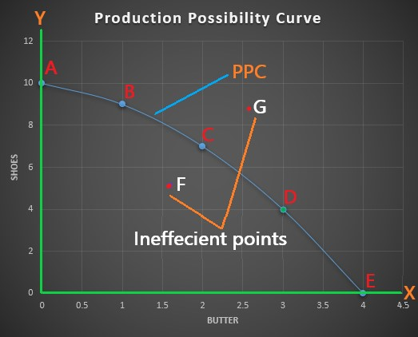

In the above table and diagram, there are different possibilities with factor combinations A, B, C, D and E. When all the resources are employed to produce shoes, then no butter can be produced in possibility A. when 1 kg of butter is produced, then only 9 pairs of shoes can be produced and so on.

Allocation of resources
Use of scarce resources in order to produce goods and services that maximize satisfaction of human wants.
Points to consider while allocation of resources
What to produce?
How to produce?
Labour intensive – use of production labour than capital and technology
Capital intensive- capital and technology used more than labour
Deciding factor – maximum output and cost minimization
For whom to produce
How to achieve efficient use of resources?
What provision should be made for economic growth
- Allocation of resources on consumer goods
- - Allocation of resources on capital goods
Unit -2

Concept of market

Market is a place or process where buyers and sellers involve for buying and selling of goods and services. Market can be physical or virtual. For market there should be buyers, sellers, place, goods, price, communication etc.

According to P.A Samuelson,” a market is a mechanism by which buyer and seller interact to determine the price and quantity of a good or service. “

Features/characteristics of the market:
- Availability of commodity
There should be a commodity in the market which is being demanded and supplied.
- Availability of buyers and sellers
There must be buyers and sellers of the commodity in the market. Without buyers and sellers, there is no trading and no market.
- Communication
There must be communication between buyer and seller in the market. Without interaction between buyer and seller, there is no transaction.
- Place
There must be a place or an area where buyers and sellers interact with each other. It may be local, national or global.
- Medium of exchange
There must be a medium of exchange in order to trade in a market. Such a medium may be money, cheques, swipe cards, and other near money items.
बजारको अवधारणा
बजार भनेको यस्तो स्थान वा प्रक्रिया हो जहाँ किन्ने र बेच्ने व्यक्तिहरू वस्तु तथा सेवाहरूको खरिद-बिक्रीका लागि संलग्न हुन्छन्। बजार भौतिक वा भर्चुअल हुन सक्छ। बजारको लागि खरिदकर्ताहरू, विक्रेता, स्थान, वस्तु, मूल्य, सञ्चार आदिको आवश्यकता पर्दछ।
पिए. ए. सामुएलसनका अनुसार, "बजार एक यस्तो संयन्त्र हो जसद्वारा खरिदकर्ता र विक्रेताले वस्तु वा सेवाको मूल्य तथा मात्रा निर्धारण गर्न आपसमा अन्तर्क्रिया गर्छन्।"

बजारका विशेषताहरू:
- वस्तुको उपलब्धता
बजारमा आपूर्ति तथा माग भइरहेको कुनै वस्तु वा सेवा हुनुपर्छ।
- क्रेता र विक्रेताको उपलब्धता
बजारमा क्रेता र विक्रेता हुनुपर्छ। यदि क्रेता र विक्रेता नभएमा कारोबार हुँदैन र बजारको अस्तित्व रहँदैन।
- सञ्चार
बजारमा खरिदकर्ता र विक्रेताबीच सञ्चार हुनुपर्छ। सञ्चार नभएमा कारोबार सम्भव हुँदैन।
- स्थान
बजारमा खरिदकर्ता र विक्रेता एकआपसमा अन्तर्क्रिया गर्नका लागि स्थान वा क्षेत्र हुनुपर्छ। यो स्थानीय, राष्ट्रिय वा विश्वव्यापी हुन सक्छ।
- विनिमयको माध्यम
बजारमा कारोबार गर्नका लागि कुनै माध्यम आवश्यक पर्छ। यो माध्यम नगद, चेक, कार्ड वा अन्य वित्तीय उपकरणहरू हुन सक्छन्।

Types of market
1. Perfect competition
2. Imperfect competition
(a) Monopoly market
(b) Monopolistic market
(c) Oligopoly market

बजारका प्रकार
- प्रतिस्पर्धा (Perfect Competition)
- अप्रतिस्पर्धा (Imperfect Competition)
(a) एकाधिकार बजार (Monopoly Market)
(b) एकाधिकारात्मक प्रतिस्पर्धा (Monopolistic Market)
(c) अल्पाधिकार बजार (Oligopoly Market)

1. Perfect competition market

- Perfect competition is the market structure in which, there are large number of buyers and sellers engaged in transaction of homogeneous product.
- There are many small firms, they can easily entry and exit in market and no single firm has control over the price of product.
- Each firm is price taker meaning that it has to accept the market price of product and has no power to influence the price.

Feature of perfect competition market
- Large number of buyers and sellers
- Homogeneous product
- Free entry and exit of firm
- Perfect knowledge of market
- Uniform (constant) price
- No government regulation

प्रतिस्पर्धा बजार (Perfect Competition Market)
- प्रतिस्पर्धा भनेको यस्तो बजार संरचना हो, जहाँ धेरै संख्यामा खरिदकर्ता र विक्रेताहरू हुन्छन् र तिनीहरू समरूप (homogeneous) उत्पादनको कारोबार गर्छन्।
- बजारमा धेरै साना व्यवसायहरू हुन्छन् जसले स्वतन्त्र रूपमा प्रवेश वा निर्गमन गर्न सक्छन्। कुनै पनि व्यवसायलाई उत्पादनको मूल्य नियन्त्रण गर्ने अधिकार हुँदैन।
- प्रत्येक व्यवसाय मूल्य स्वीकार गर्ने (Price Taker) हुन्छ, जसले गर्दा त्यसले बजारमा तोकिएको मूल्य स्वीकार गर्नुपर्छ।

प्रतिस्पर्धा बजारका विशेषताहरू:
- ठूला संख्यामा क्रेता र विक्रेता
- समरूप (homogeneous) उत्पादन
- स्वतन्त्ररूपमा व्यवसाय प्रवेश र निर्गमन
- बजारको सम्पूर्ण जानकारी (Perfect Knowledge)
- समान (Uniform) मूल्य
- सरकारी हस्तक्षेपको अभाव

2 . Imperfect competition
It is a market structure where market do not fulfill all the necessary condition of perfect competition. it is market situation with missing of homogenous product, large number of sellers , price taker etc. it include,
(a) Monopoly market
(b) Monopolistic market
(c ) Oligopoly market

अप्रतिस्पर्धा बजार (Imperfect Competition Market)
सिद्ध प्रतिस्पर्धाका सबै शर्तहरू पूरा नभएका बजारहरूलाई असिद्ध प्रतिस्पर्धा भनिन्छ। यसमा समरूप उत्पादनको अभाव, सीमित विक्रेता, र मूल्य नियन्त्रण गर्ने व्यवसायहरूको उपस्थिति हुन्छ।
यसका प्रकारहरू:
(a) एकाधिकार बजार (Monopoly Market)
(b) एकाधिकारात्मक प्रतिस्पर्धा (Monopolistic Market)
(c) अल्पाधिकार बजार (Oligopoly Market)

Monopoly market
It has a market structure where exist single seller of product having no close substitute of it. Single sellers or firms dominates the market and has the power to control the price of product and services. the monopolist has the power to set price , they can charge higher price than competitive market.
According to Anna Koutsoyiannis, “Monopoly is a market situation in which there is a single seller. There are no close substitutes of the commodity it produces, there are barriers to entry.”

Features of monopoly:
- Single seller and a large number of buyers
A monopoly firm is the only firm and industry of a monopolist. But there are a large number of buyers.
- No close substitutes
There are no substitutes which are close to the product and services sold by a monopolist.
- Entry barriers
There is a difficulty for new firms to enter into the monopoly industry. There are either natural or artificial restrictions on the entry of firms into the industry.
4.Price maker
A monopolist has absolute control over the supply of the commodity. As monopolist is a single supplier of a product, the buyer has to pay the price fixed by the monopolist. So, he/she is the price maker.
5.profit motive objective

एकाधिकार बजार (Monopoly Market)
यो यस्तो बजार संरचना हो, जहाँ एउटै विक्रेता हुन्छ र उसले उत्पादन गर्ने वस्तुको कुनै नजिकको विकल्प हुँदैन। यस्तो व्यवसाय बजारमा पूर्णरूपमा हावी हुन्छ र मूल्य नियन्त्रण गर्न सक्षम हुन्छ।
एना कौत्सोयियानिसका अनुसार,
"एकाधिकार भनेको यस्तो बजार हो, जहाँ एउटै विक्रेता हुन्छ, उसले उत्पादन गर्ने वस्तुको कुनै नजिकको विकल्प हुँदैन, र नयाँ व्यवसायहरू प्रवेश गर्न सक्दैनन्।"

एकाधिकार बजारका विशेषताहरू:
- एउटा मात्र विक्रेता र धेरै संख्यामा खरिदकर्ताहरू
- नजिकको प्रतिस्थापन नभएको उत्पादन
- नयाँ व्यवसायहरू प्रवेश गर्न कठिनाइ (Entry Barriers)
- मूल्य निर्धारण गर्ने शक्ति (Price Maker)
- नाफा कमाउने प्रमुख उद्देश्य
Monopolistic market
It is a market structure where many producer involve to produce differential (heterogeneous) product which are close substitute of each other.
It is mixed firm of perfect competition and monopoly, as the product are differentiated, they include the power of monopoly but present of close substitute create of competition.

Feature of monopolistic market
  - Large number of buyers and sellers
  - Heterogeneous product
  - Price difference
  - Close substitute

एकाधिकारात्मक प्रतिस्पर्धा बजार (Monopolistic Market)
यसमा धेरै उत्पादनकर्ताहरू हुन्छन्, जसले फरक-फरक प्रकारका (heterogeneous) उत्पादनहरू बनाउँछन्, तर ती एकअर्काका नजिकका प्रतिस्थापन हुन सक्छन्।
यसलाई प्रतिस्पर्धा र एकाधिकारको मिश्रण मान्न सकिन्छ। उत्पादनहरू भिन्न भएका कारण यसमा एकाधिकारको शक्ति रहन्छ, तर प्रतिस्पर्धी वस्तुहरू उपलब्ध भएकाले प्रतिस्पर्धा पनि रहन्छ।

एकाधिकारात्मक प्रतिस्पर्धाका विशेषताहरू:
- धेरै संख्यामा क्रेता र विक्रेता
- विभिन्न प्रकारका (heterogeneous) उत्पादनहरू
- मूल्य भिन्नता (Price Difference)
- नजिकको प्रतिस्थापन उपलब्ध

Oligopoly market
Oligopoly is a market situation in which there are few firms selling a homogeneous or differentiated product.
The entry and exit of a firm are difficult in an Oligopoly market.

अल्पाधिकार बजार (Oligopoly Market)
अल्पाधिकार बजार यस्तो बजार संरचना हो, जहाँ सीमित संख्याका व्यवसायहरू छन्, जसले समरूप (homogeneous) वा भिन्न (differentiated) उत्पादनहरू बेच्न सक्छन्।
यसमा व्यवसायहरू प्रवेश गर्न र बाहिर निस्कन गाह्रो हुन्छ।

Market and revenue curve
The total amount of money received by a firm from the sale of the product is called revenue. The profit of a firm depends upon the cost and revenue. The profit earned by the firm is the difference between the revenue and the cost of production.

Total revenue(TR)
Total revenue is the total amount of money received by a firm from the sales of a given quantity of product. Technically, total revenue is the sum of marginal revenues. Mathematically, total revenue is the product of price and quantity sold.
Symbolically;
TR=P×Q
Where,
TR= Total Revenue
P=price per unit
Q= Quantity sold

Average revenue (AR)
Average revenue is the price per unit. Average revenue is obtained by dividing the total revenue by the total number of quantity sold.
Symbolically;
AR=TR/Q
Where,
AR= Average Revenue
TR= Total revenue
Q= Quantity sold

Marginal Revenue (MR)

Marginal revenue is the addition to the total revenue from the sales of an additional unit of a commodity. Marginal revenue is obtained by dividing change in total revenue by the change in quantity sold.
Symbolically,
MR= ∆TR / ∆Q
Where,
∆TR =Change in TR

∆Q= Change in quantity sold
बजार र आय वक्र (Market and Revenue Curve)
कुनै व्यवसायले उत्पादन बेच्दा प्राप्त गर्ने कुल रकमलाई आय (Revenue) भनिन्छ। व्यवसायको नाफा लागत र आयमा निर्भर हुन्छ।

1. कुल आय (Total Revenue - TR)
कुनै उत्पादन बेचेर व्यवसायले प्राप्त गर्ने कुल रकमलाई कुल आय भनिन्छ।
TR= P×Q
जहाँ,
TR = कुल आय
P = प्रति इकाई मूल्य
Q = बिक्री गरिएको मात्रा

2. औसत आय (Average Revenue - AR)
औसत आय भनेको प्रति इकाई उत्पादनको मूल्य हो।
AR= ​ TR/Q
जहाँ,
AR = औसत आय
TR = कुल आय
Q = बिक्री गरिएको मात्रा

3. सीमान्त आय (Marginal Revenue - MR)
सीमान्त आय भनेको अतिरिक्त उत्पादनको बिक्रीबाट प्राप्त थप आय हो।
MR= ​∆TR / ∆Q
जहाँ,
ΔTR = कुल आय भएको परिवर्तन
ΔQ = बिक्री भएको मात्रामा परिवर्तन

Derivation of TR, AR, and MR under perfect competition v.v.i
Perfect competition is a market structure having a large number of buyer and sellers selling homogeneous products at a uniform price. The TR, AR, and MR under Perfect competition can be derived as follows:

प्रतिस्पर्धामा TR, AR, र MR को व्युत्पत्ति
प्रतिस्पर्धामा धेरै संख्यामा खरिदकर्ता र विक्रेताहरू हुन्छन् र समान उत्पादनहरू बेचिन्छन्। यस अवस्थामा, कुल आय (TR), औसत आय (AR), र सीमान्त आय (MR) निम्न रूपमा निर्धारण गरिन्छ:
- प्रतिस्पर्धामा औसत आय (AR) र सीमान्त आय (MR) बराबर हुन्छ।
- MR वक्र सीधा र क्षैतिज (horizontal) हुन्छ, किनकि व्यवसायले बजार मूल्य स्वीकार गर्नुपर्छ।
- TR वक्र सीधा माथि जान्छ, किनकि मूल्य स्थिर रहन्छ।

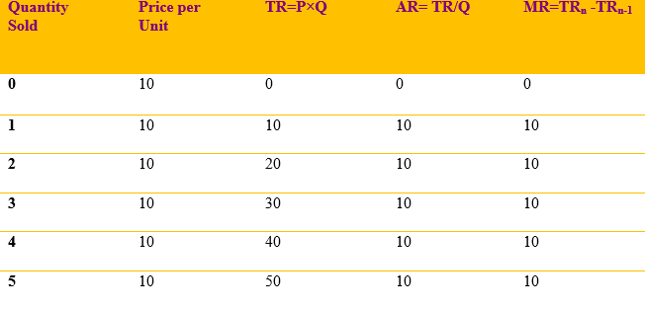
In the above schedule, we can see that the value of TR is increasing at the same rate because every additional of the commodity is sold at Rs.10. Average revenue remains constant at all levels of output. AR, MR, and price are equal to each other. It can be graphically explained as follows:
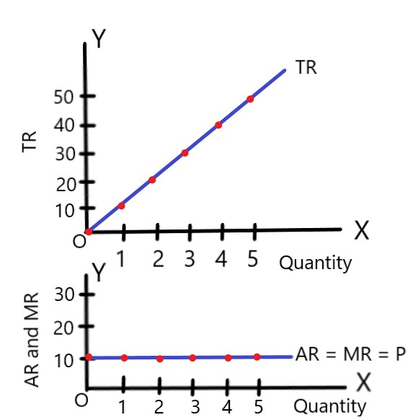
In the above diagram, we can see that the TR curve is increasing at a constant rate. AR and MR curve are the same and they coincide with each other. They are the same at all levels of output. TR curve is positively sloped whereas AR and MR are a horizontal straight line parallel to the x-axis.

Derivation of TR, AR, and MR under Monopoly or imperfect competition
Monopoly is the market structure having a single seller selling the type of product which has no close substitute. They are the price makers. Under Monopoly, a monopolist can increase its revenue by selling few products at a high price and more products at a low price. The TR, AR, and MR can be derived with the help of the following schedule:

एकाधिकार कुल आय (TR), औसत आय (AR), र सीमान्त आय (MR) को व्युत्पत्ति
एकाधिकार बजार भनेको यस्तो बजार संरचना हो, जहाँ एउटै विक्रेता हुन्छ र उसले बेच्ने उत्पादनको कुनै नजिकको प्रतिस्थापन हुँदैन। यस्तो बजारमा विक्रेता मूल्य निर्धारणकर्ता (Price Maker) हुन्छ।
एकाधिकार बजारमा विक्रेताले कम मात्रामा सामान बेचेर उच्च मूल्य लिन सक्छ वा धेरै मात्रामा सामान बेचेर कम मूल्य लिन सक्छ, जसबाट कुल आय (TR), औसत आय (AR), र सीमान्त आय (MR) को व्युत्पत्ति गर्न सकिन्छ।
TR, AR, र MR लाई निम्न तालिकाको मद्दतले व्युत्पन्न गर्न सकिन्छ।

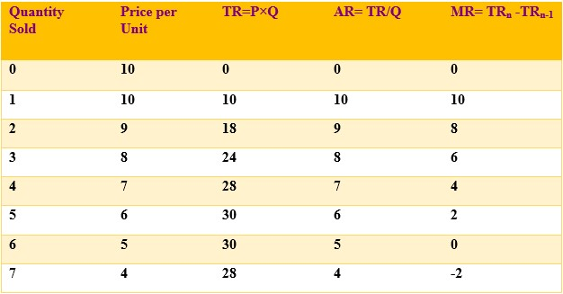

In the above table, we can see that when the quantity sold is increasing, the price is decreasing. Total revenue increases at first up to the fifth unit then becomes maximum and declines thereafter. AR and price are similar. Marginal revenue is declining, becomes zero and even negative.
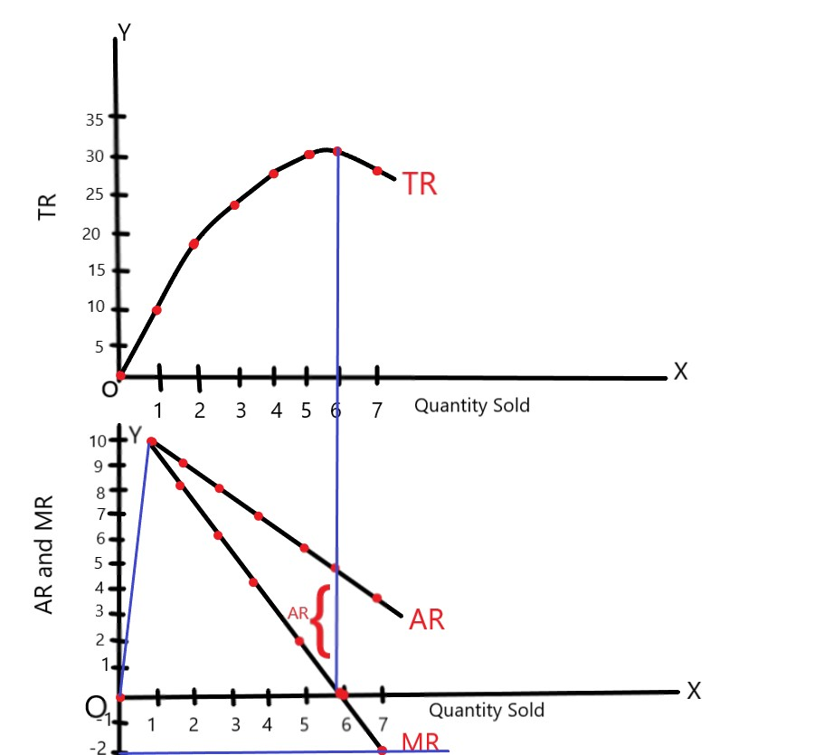

In the above diagram TR, MR and AR are shown along y-axis and quantity sold is shown along x-axis respectively. We can observe that when total revenue is rising AR and MR are falling. When TR becomes maximum, marginal revenue becomes zero. When TR starts to fall, then marginal revenue declines to negative.

UNIT-3
लागत (Cost)
कुनै पनि वस्तु वा सेवा उत्पादन गर्न एक फर्मले कच्चा पदार्थ र उत्पादनका कारकहरू (Factors of Production) प्रयोग गर्छ, जसलाई "इनपुट्स" भनिन्छ। यी इनपुट्समा भएको खर्चलाई लागत (Cost) भनिन्छ। उत्पादन लागतले फर्मको नाफा निर्धारण गर्न महत्त्वपूर्ण भूमिका खेल्छ। कुनै निश्चित मूल्यमा कम उत्पादन लागतले उच्च नाफा दिन्छ भने, उच्च उत्पादन लागतले कम नाफा वा घाटा ल्याउँछ।

cost

In order to produce goods and services, a firm uses raw materials and factors of production which are called inputs. The expenditure incurred by these inputs is called cost. Cost of production is a component of determining the profit of a firm. At a certain price of a commodity, the low cost of production results in high profit and high cost of production results in low profit or loss.

There are various kinds of cost

लागतका विभिन्न प्रकारहरू:
- स्थिर लागत (Fixed Cost)
यी त्यस्ता लागतहरू हुन् जसलाई छोटो अवधिमा परिवर्तन गर्न सकिँदैन। स्थिर उत्पादन कारकमा आएको खर्च उत्पादनको सबै तहमा स्थिर रहन्छ। यसमा व्यवसायको भाडा, पूँजीमा दिइने ब्याज, स्थायी कर्मचारीहरूको तलब, मेशिन तथा फर्निचरको मूल्यह्रास आदि समावेश छन्।
- परिवर्तनीय लागत (Variable Cost)
यी लागतहरू उत्पादनको मात्रा परिवर्तन भएसँगै परिवर्तन हुन्छन्। परिवर्तनीय लागतमा कच्चा पदार्थको लागत, मजदुरको ज्याला, बिजुली तथा इन्धनको खर्च आदि पर्दछन्। उत्पादनको मात्रा बढेमा लागत बढ्छ र घटेमा लागत घट्छ। यदि उत्पादन शून्य छ भने परिवर्तनीय लागत पनि शून्य हुन्छ।
- स्पष्ट लागत (Explicit Cost)
उत्पादनका लागि प्रयोग गरिएका इनपुटहरूको प्रयोगबापत तिर्नुपर्ने प्रत्यक्ष भुक्तानी हो।
जस्तै: मजदुरको ज्याला, भाडा, कच्चा पदार्थको लागत आदि।
- अस्पष्ट लागत (Implicit Cost)
फर्मले आफ्नै स्वामित्वमा रहेका उत्पादन कारकहरूको प्रयोग गर्दा हुने लागत हो।

Fixed cost

They are those factors which cannot be changed in the short run.

The cost incurred by the fixed factor of production remains constant at all levels of outputs. It includes rent of the business premises, interest on capital, salaries of permanent employees, depreciation of machines and furniture, etc.

Variable cost

They are the factor that can be changed in accordance with the change in production even in the short run. It includes the cost of raw materials, the wage of workers, cost of power and fuel, etc. If the quantity of production increases the cost will increase and vice versa. When the output is zero, the variable cost will be zero.

Explicit cost: payment made for use of inputs in production.

For example, wage, lease, and materials.

Implicit cost: value of factor inputs owned and used by firm in its on process.

छोटो अवधिको लागत वक्रहरूको व्युत्पत्ति (Derivation of Short-Run Cost Curves)
छोटो अवधि भनेको त्यस्तो समयावधि हो जसमा फर्मले आफ्ना उत्पादनका स्थिर कारकहरू परिवर्तन गर्न सक्दैन तर परिवर्तनीय कारकहरू परिवर्तन गरेर उत्पादनको मात्रा घटबढ गर्न सक्छ।
स्थिर कारकहरू अपरिवर्तित रहन्छन्।
- कुल स्थिर लागत (Total Fixed Cost - TFC)
  - कुल स्थिर लागत भन्नाले उत्पादनकर्ताले स्थिर उत्पादन कारकहरूमा गरेको खर्चलाई बुझाउँछ।
  - यसलाई स्थिर कारकमा गरिने कुल लागत पनि भनिन्छ।
  - छोटो अवधिमा उत्पादनको मात्रा बढ्दा वा घट्दा पनि कुल स्थिर लागतमा कुनै परिवर्तन आउँदैन।
यसलाई निम्न तालिका र ग्राफद्वारा व्याख्या गर्न सकिन्छ:

Derivation of short-run cost curves

Short run period of time in which firm can vary its output by varying the amount of variable factor.

Fixed factors remain unchanged.

1. Total fixed cost (TFC):
Fixed cost refers to the expenditure incurred by the producer on the fixed factor of production. It is also known as the total cost made on the fixed factor. In the short run, they do not change with change in output. It can be explained by the help of following schedule and diagram:

Outputs (in units) | Total fixed cost (in Rs.)
0 | 30
1 | 30
2 | 30
3 | 30
4 | 30
5 | 30
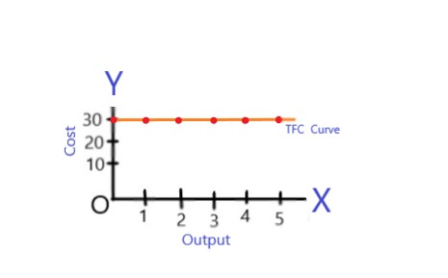

Total Variable Cost (TVC)

Variable cost refers to the cost incurred by the variable factors of production. It does not remain constant like the fixed cost at different levels of output. Whenever the output increases or decreases the variable cost will also increase or decrease. It can be explained by the help of following schedule and diagram:

कुल परिवर्तनीय लागत (Total Variable Cost - TVC)
परिवर्तनीय लागत भन्नाले उत्पादनका परिवर्तनीय कारकहरूमा हुने खर्चलाई जनाउँछ। यो स्थिर लागतजस्तो निश्चित रहँदैन, बरु उत्पादनको स्तर अनुसार परिवर्तन हुन्छ। जब उत्पादन बढ्छ, परिवर्तनीय लागत पनि बढ्छ, र जब उत्पादन घट्छ, परिवर्तनीय लागत पनि घट्छ।
यसलाई निम्न तालिका र ग्राफद्वारा व्याख्या गर्न सकिन्छ।

Output (in units) | Total variable cost
0 | 0
1 | 20
2 | 30
3 | 45
4 | 80
5 | 145
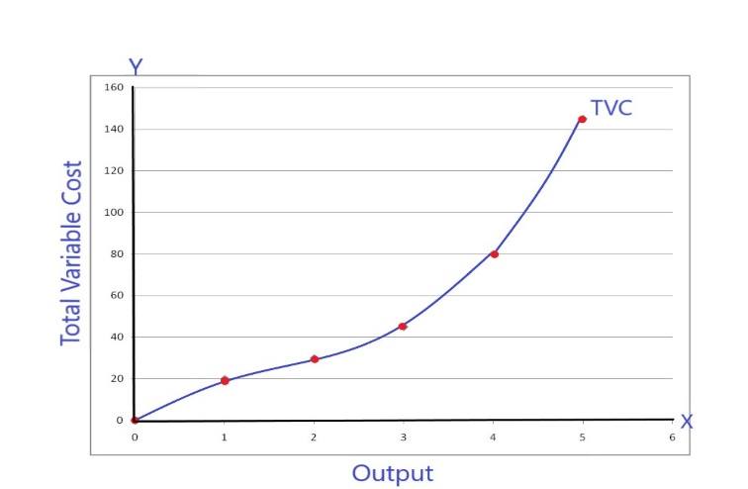

In the above figure, we can see that TVC curve increases at a decreasing rate at first and then increases at an increasing rate after some units of production because of applicability of the law of variable proportion in the short run.

Total cost (TC)
Total cost is defined as the total monetary expenditure incurred in the production process. It is the sum of the fixed cost and total variable cost.
Symbolically,
TC=TVC + TFC
It can also be explained by the help of following schedule and diagram:

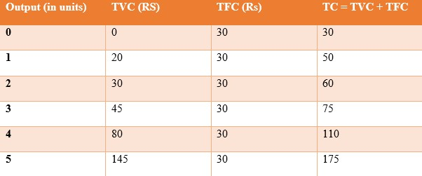
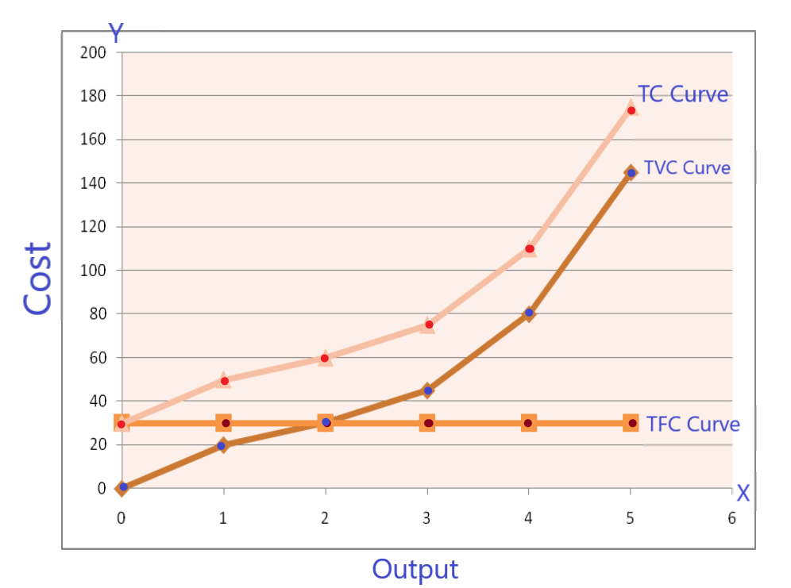

In the above figure, costs are shown along y-axis and outputs are shown along the x-axis. TFC is parallel to x-axis because it is constant at all levels of output. TVC is increasing as the output are increasing. TC is also increasing because of variable cost is also included in it. The nature of TC and TVC are similar. They are parallel to each other. The only difference is that TVC starts from origin and TC starts above the origin.

Marginal cost

Marginal cost is defined as the change in the total cost due to one additional unit of change in the output. In other words, it is the ratio of change in the total cost and change in the total output.
Symbolically;

सीमांत लागत (Marginal Cost - MC)
सीमांत लागत भन्नाले कुल लागतमा आउने परिवर्तनलाई बुझाउँछ, जुन उत्पादनको मात्रा एक इकाइले बढ्दा हुने खर्चको अन्तर हो। अन्य शब्दमा, यो कुल लागतको परिवर्तन र कुल उत्पादनको परिवर्तनको अनुपात हो।
प्रतीकात्मक रूपमा:
MC=∆TC / ∆Q
OR
MC=TC n - TC n-1
Where;
MC = Marginal Cost
∆TC = Change in Total Cost
∆Q = Change in quantity sold
TC n = Current Total Cost
TC n-1 = Initial Total Cost
The concept of Marginal cost can be explained by the help of following schedule and diagram:

Output (Q) | TC | MC
0 | 30 | -
1 | 50 | 20
2 | 60 | 10
3 | 75 | 15
4 | 110 | 35
5 | 175 | 65
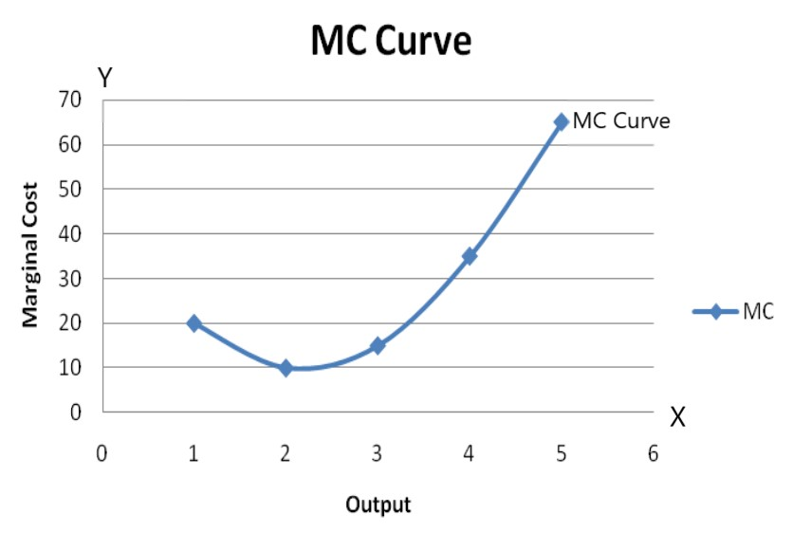
Derivation of short run average cost curves.
  - Average fixed cost: dividing the total fixed cost by level of output
AFC= TFC/Q
It can be explained by the help of following schedule and diagram:
Output (in units) | TFC (Rs) | AFC (Rs)
1 | 30 | 30
2 | 30 | 15
3 | 30 | 10
4 | 30 | 7.5
5 | 30 | 6
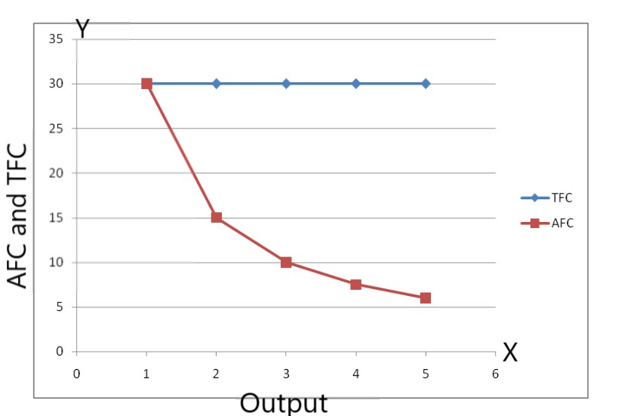
In the above figure, we can see that the AFC curve is a rectangular hyperbola. AFC curve is downward sloping because, as we produce more units of output, AFC declines. It never touches the Y axis because, at zero units of production, AFC is infinite. Similarly, it never touches x-axis because AFC never becomes zero.

  - Average variable cost: dividing total variable cost with the corresponding level of output.
AVC= TVC/Q
We can derive AVC by the help of following schedule and diagram:
Output (in units) | TVC (Rs) | AVC (Rs)
1 | 20 | 20
2 | 30 | 15
3 | 45 | 15
4 | 80 | 20
5 | 145 | 29
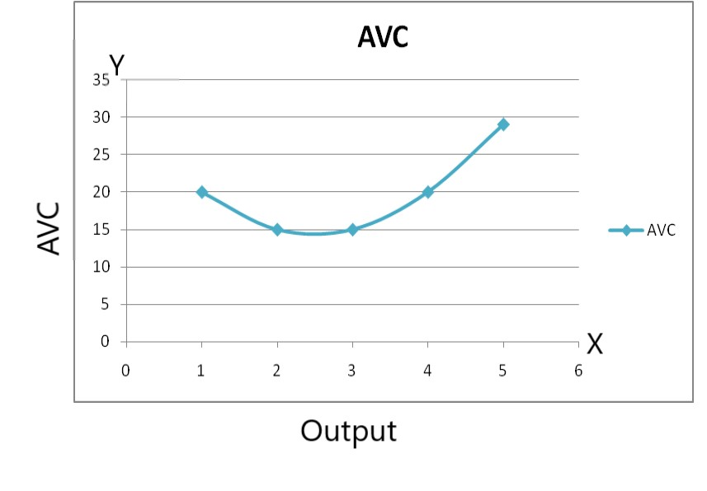
In the above figure, we can see that AVC falls at the beginning and then inclines. An AVC curve is 'U' shaped because of the operation of the law of variable proportion.

3. Average total cost: dividing total cost by corresponding level of output.
AC= TC/Q

ATC = TC / Q = (TFC + TVC ) / Q = AFC + AVC
It can be derived with the help of following schedule and diagram:
Output (in units) | AFC (Rs) | AVC (Rs) | ATC (Rs)
1 | 30 | 20 | 50
2 | 15 | 15 | 30
3 | 10 | 15 | 25
4 | 7.5 | 20 | 27.5
5 | 6 | 29 | 35

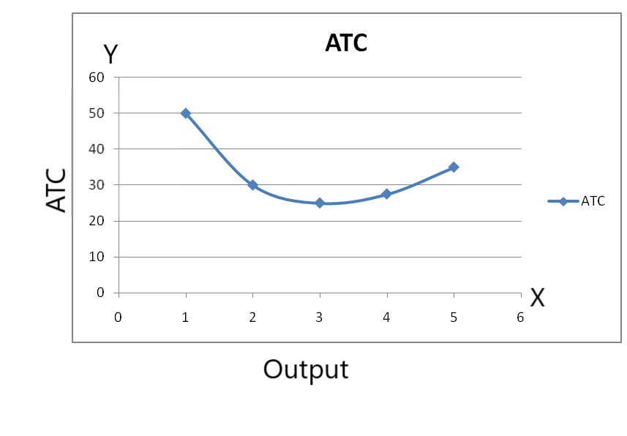
In the above diagram, we can see that ATC falls at the beginning. It becomes minimum and rises after that point. Therefore, it is 'U' shaped.

Relationship between AC and MC
There is a close relationship between AC and MC. MC is the change in TC resulted from the change in the production of one more unit of output whereas AC is the total cost divided by the output. Both AC and MC are derived from TC.
Symbolically;
MC = ∆TC / ∆Q
AC = TC / Q
the relationship between these two can be explained with the help of the following diagram:

औसत लागत र सीमांत लागतबीचको सम्बन्ध (Relationship between AC and MC)
औसत लागत (AC) र सीमांत लागत (MC) बीच घनिष्ठ सम्बन्ध हुन्छ। MC भनेको कुल लागत (TC) मा उत्पादनको एक अतिरिक्त इकाइ बढ्दा हुने परिवर्तन हो, जबकि AC भनेको कुल लागतलाई कुल उत्पादनले भाग गर्दा प्राप्त हुने लागत हो। दुबै लागतहरू कुल लागत (TC) बाट व्युत्पन्न गरिन्छन्।
प्रतीकात्मक रूपमा:
MC = ∆TC / ∆Q
AC = TC / Q
यी दुबै अवधारणाहरूलाई निम्न ग्राफ र व्याख्याबाट स्पष्ट पार्न सकिन्छ।

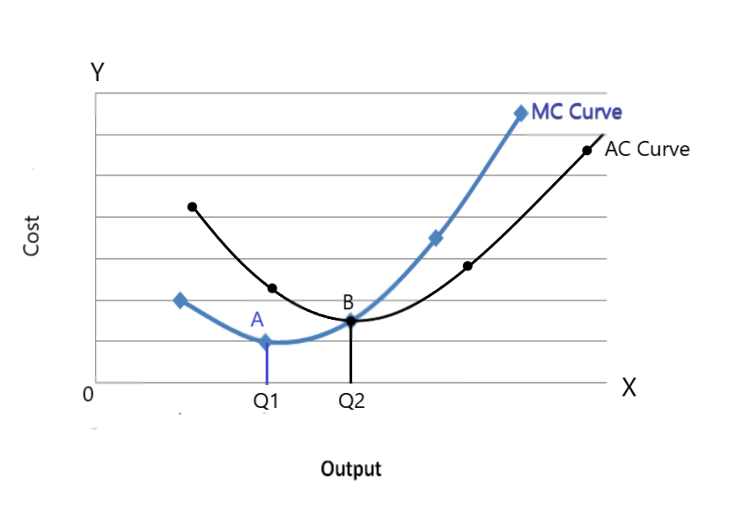
In the above figure, SMC represents the short-run marginal cost curve and SAC represents the short-run average cost curve. SMC and SAC intersect each other at the minimum point of SAC. It lies to the right of A, the minimum point of SMC I.e point B. The relationship between these two can be summarized as follows:
- Both AC and MC curve are calculated from the total cost.
- Both AC and MC are ‘U’ shaped.
- When AC is falling, the MC curve lies below AC and MC falls faster than AC.
- When AC is rising, the MC curve lies above the AC and MC rises faster than AC.
- When AC is minimum, MC=AC
- MC intersects at the minimum point of AC.
- MC cuts AC from below.
• औसत लागत (AC) र सीमांत लागत (MC) दुबै कुल लागत (Total Cost - TC) बाट गणना गरिन्छ।
• AC र MC दुबै ‘U’ आकारका हुन्छन्।
• जब AC घट्दै जान्छ, MC वक्र (Curve) AC भन्दा तल रहन्छ र MC, AC भन्दा छिटो घट्छ।
• जब AC बढ्दै जान्छ, MC वक्र AC भन्दा माथि रहन्छ र MC, AC भन्दा छिटो बढ्छ।
• जब AC न्यूनतम हुन्छ, त्यहाँ MC = AC हुन्छ।
• MC, AC को न्यूनतम विन्दुमा अन्तरिक्ष काट्छ।
• MC, AC लाई तलबाट काट्छ।

COST FUNCTION TC(Q)= 75+9Q^2
DEMAND FUNCTION (P)= 150-6Q
TOTAL REVENUE FUNCTION TR(Q)= P*Q
TR(Q) = (150-6Q)*Q
TR(Q)= 150Q-6Q^2
PROFIT = TR(Q)-TC(Q)
=150Q-6Q^2-(75+9Q^2)
PROFIT =150Q-6Q^2-75-9Q^2
PROFIT=150Q-15Q^2-75
PR=150Q-15Q^2-75, 150*5-15*5^2-75,
750-375-75
300
d (PR)/d(Q) = d (150Q-15Q^2-75)/d (Q)
150*1*1-15*2Q-0
d (PR)/d (Q) =150-30Q
STATIONARY POINT
d (PR)/d (Q) =0
150-30Q=0
150=30Q
Q=150/30
Q=5
(P)= 150-6Q
P= 150-6*5
150-30
P=120

Chapter -4
पूर्ण प्रतियोगितामा छोटो अवधिमा मूल्य र उत्पादन निर्धारण / पूर्ण प्रतियोगितामा उद्योग र फर्मको सन्तुलन अवस्था
पूर्ण प्रतियोगितामा फर्म र उद्योगको छोटो अवधिको सन्तुलन अवस्था:
छोटो अवधिले त्यो समय अवधि जनाउँछ, जसमा कुनै फर्मले स्थिर उत्पादन साधनहरू परिवर्तन गर्न सक्दैन। त्यसैले, फर्मले आफ्नो उत्पादन प्रक्रिया परिवर्तन गर्न सक्दैन। यस अवधिमा फर्मले असामान्य नाफा, सामान्य नाफा वा घाटा सामना गर्न सक्छ, जुन फर्मको राजस्व र लागतमा निर्भर हुन्छ। नाफा र घाटा मुख्य रूपमा औसत लागत (AC) र औसत राजस्व (AR) को स्वभावमा निर्भर गर्दछ, जसलाई यसरी प्रस्तुत गर्न सकिन्छः
- यदि AR = AC छ भने, फर्मले सामान्य नाफा प्राप्त गर्छ।
- यदि AR > AC छ भने, फर्मले असामान्य नाफा प्राप्त गर्छ।
- यदि AR < AC छ भने, फर्मले घाटा सहन गर्छ।
नाफा र घाटा सीमांत लागत (MC) र सीमांत राजस्व (MR) को स्वभावमा पनि निर्भर हुन्छ। पूर्ण प्रतियोगिताको बजारमा सन्तुलन कायम गर्न निम्न सर्तहरू पूरा हुनुपर्छः
- बजार आपूर्ति बजार मागसँग बराबर हुनुपर्छ।
- MC = MR हुनुपर्छ।
- MC ले MR लाई तलबाट काट्नुपर्छ।
पूर्ण प्रतियोगिताको बजारमा फर्म र उद्योगको छोटो अवधिको सन्तुलन अवस्था निम्न आरेखहरूको मद्दतले व्याख्या गर्न सकिन्छः

Price and output determination under perfect competition in the Short run/ Equilibrium of firm and industry under perfect competition in the Short run

Short-run Equilibrium of firm and industry:-
Short-run refers to that time period in which a firm cannot change the fixed factors of production. Therefore, a firm cannot change its production process and there may be abnormal profit, normal profit or even loss depending on the firm's revenue and cost. The profit and loss also depends upon the nature of AC and AR, which can be presented as follows:-
- If AR=AC, the firm receives a normal profit.
- If AR> AC, the firm receives abnormal profit.
- If AR< AC, the firm bears the loss.
The profit and loss depend also on the nature of MR and MC and the following conditions must be fulfilled in order to obtain equilibrium in the perfect competition market:
- Market supply must be equal to market demand.
- MC must be equal to MR.
- MC must cut MR from below.
The short-run equilibrium of the firm and industry under perfect competition can be explained by the help of the following diagrams.
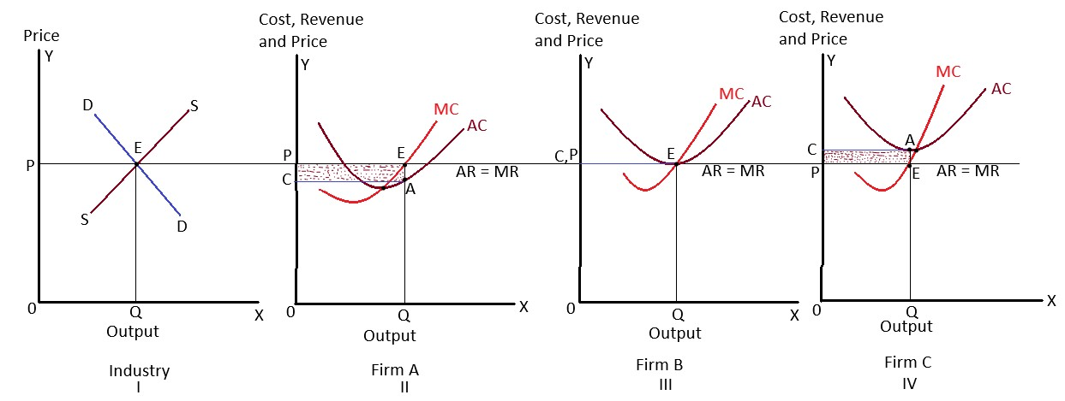
माथिका रेखहरूमा, पहिलो आरेखले उद्योगमा सन्तुलन मूल्य निर्धारण देखाउँछ। दोस्रो, तेस्रो र चौथो आरेखले पूर्ण प्रतियोगिताको अन्तर्गत छोटो अवधिमा तीन फरक फर्महरूको सन्तुलन अवस्थालाई प्रस्तुत गर्दछ। यसमा तीन सम्भावना रहेका छन्, जुन यस प्रकार छन्ः
In the above figures, we can see the equilibrium price determination in the industry in the first figure. In the second, third, and fourth figures, the conditions of equilibrium in three different firms are shown under perfect competition, in the short run. There are three possibilities which are as follows:-

1. असामान्य नाफा
दोस्रो आरेखले फर्मद्वारा कमाइएको असामान्य नाफा देखाउँछ। फर्मले असामान्य नाफा तब कमाउँछ, जब औसत राजस्व (AR) औसत लागत (AC) भन्दा ठूलो हुन्छ। यो आरेखमा, E सन्तुलन विन्दु हो, किनभने यहाँ MR र MC बराबर छन् र MC ले MR लाई तलबाट काटेको छ। त्यसैले, OQ सन्तुलन उत्पादन हो। फर्मले छायांकित आयताकार क्षेत्रफल बराबर असामान्य नाफा कमाइरहेको छ। फर्मको औसत उत्पादन लागत OC छ।. Abnormal profit (supernormal or excess profit):-
The second figure shows the abnormal profit earned by the firm. The firm earns an abnormal profit when AR is greater than AC. In this figure, E is the equilibrium point because here MR and MC are equal and MC is intersecting MR from below. So, OQ is the equilibrium quantity. The firm is earning abnormal profit equal to the shaded rectangular area. The firm's average cost of production is ‘OC’.

सामान्य नाफा:
तेस्रो आरेखमा, फर्म E विन्दुमा सन्तुलनमा छ। किनभने यस विन्दुमा MC ले MR लाई तलबाट काटेको छ। सन्तुलन उत्पादन OQ हो। फर्मले सामान्य नाफा कमाइरहेको छ, किनभने यस उत्पादन तहमा AR र AC बराबर छन्। यो त्यस्तो नाफा हो, जुन व्यवसाय चलाउनका लागि पर्याप्त हुन्छ।

Normal profit:-
In the third figure, the firm is in equilibrium at point E. Because at this point MC is intersecting MR from below. The equilibrium output is OQ. The firm is earning just a normal profit because AR and AC are equal at this level of output. It is that profit which is just sufficient to run the business.

- घाटा:
चौथो आरेखमा, फर्म E विन्दुमा सन्तुलनमा छ, किनभने यस विन्दुमा आवश्यक र पर्याप्त दुबै सर्तहरू पूरा भएका छन्। फर्मद्वारा निर्धारण गरिएको सन्तुलन उत्पादन OQ हो। यस उत्पादन तहमा, AC AR भन्दा ठूलो छ। त्यसैले, फर्मले घाटा व्यहोर्दैछ, जुन छायांकित क्षेत्रफल बराबर छ।

Loss:-
In the fourth figure, the firm is in equilibrium at point E because, at this point, both necessary and sufficient conditions are fulfilled. The equilibrium output determined by the firm is OQ. At this output, AC is greater than AR. So, the firm is bearing loss equal to the shaded area.

पूर्ण प्रतियोगितामा दीर्घकालीन अवधिमा मूल्य र उत्पादन निर्धारण / दीर्घकालीन अवधिमा उद्योग र फर्मको सन्तुलन अवस्था
दीर्घकालीन अवधिमा उद्योग र फर्मको सन्तुलन अवस्था:
दीर्घकालीन अवधिमा, फर्मले नाफा वा घाटाको अवस्थामा आधारित भएर उद्योगमा प्रवेश गर्न वा बाहिरिन सक्छ। यदि नाफा उच्च छ भने नयाँ फर्महरू उद्योगमा प्रवेश गर्छन्, र यदि फर्महरू घाटामा छन् भने, तिनीहरूले उद्योग छोड्छन्। यसका कारण, दीर्घकालीन अवधिमा असामान्य नाफा र घाटाको अवस्थाहरू समाप्त हुन्छन्, र फर्महरूले केवल सामान्य नाफा मात्र कमाउँछन्।
पूर्ण प्रतियोगिताको बजारमा दीर्घकालीन सन्तुलन अवस्था प्राप्त गर्न निम्न सर्तहरू पूरा हुनुपर्छः
- मागको मात्रा र आपूर्तिको मात्रा सन्तुलन मूल्यमा प्रतिच्छेद गर्नुपर्छ।
- LMC (दीर्घकालीन सीमांत लागत) MR (सीमांत राजस्व) संग बराबर हुनुपर्छ।
- LMC ले MR लाई तलबाट काट्नुपर्छ।
यसलाई निम्न आरेखको मद्दतले देखाउन सकिन्छः

Price and output determination under perfect competition in the long run/ Equilibrium of firm and industry under perfect competition in the long run
Long-run Equilibrium of firm and industry
In the long run, the firm can enter or exit from the industry depending on profit or loss situation. If profits are high, new firms enter into the industry and if the firms are in loss, they exit from the industry in the long run. Due to this, abnormal profit and loss situations are ruled out in the long-run and the firms will earn just the normal profit.
The following conditions must be fulfilled in order to attain equilibrium in long-run under perfect competition market:-
- The quantity demanded and the quantity supplied must intersect at an equilibrium price.
- LMC must be equal to MR.
- LMC must intersect MR from below.
It can be shown by the following diagram:-
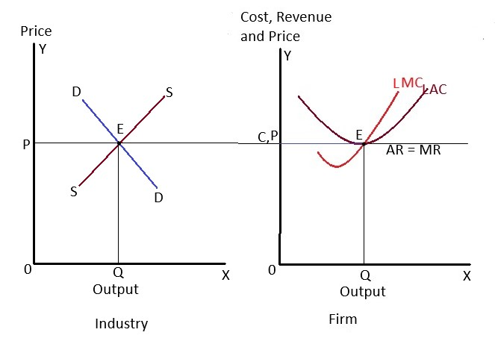
माथिको आरेखमा, उद्योग सन्तुलनमा छ, जहाँ बजार माग र आपूर्ति वक्र एक-अर्कासँग 'E' विन्दुमा प्रतिच्छेद गर्छन्। उद्योगद्वारा निर्धारण गरिएको मूल्य OP हो, र सबै फर्महरूले यस मूल्यलाई स्वीकार गर्छन्।
फर्म सन्तुलन अवस्थामा 'E' विन्दुमा छ, जहाँ LMC = MR छ र LMC ले MR लाई तलबाट काट्छ। LAC (दीर्घकालीन औसत लागत) MR वक्रलाई स्पर्श गर्छ।
यसले देखाउँछ कि दीर्घकालीन अवधिमा फर्म सामान्य नाफामा सञ्चालनमा रहन्छ।
In the above figure, the industry is in equilibrium where market demand and supply curve intersect each other at point 'E'. The price determined by industry is OP and all the firms accept this price. The firm is in equilibrium at point 'E' where LMC=MR and LMC cut MR from below. LAC is tangent to the MR curve. This shows that the firm operates under normal profit in the long run.

एकाधिकार अन्तर्गत छोटो अवधिमा मूल्य र उत्पादन निर्धारण
छोटो अवधिमा एकाधिकार अन्तर्गत मूल्य र उत्पादन निर्धारण भन्नाले त्यो समयावधिलाई जनाउँछ जसमा एकाधिकार व्यवसायीले स्थिर स्रोतहरू परिवर्तन गर्न सक्दैन। तर, प्रतिस्पर्धाको अभावका कारण व्यवसायीले मूल्य निर्धारण गर्न स्वतन्त्रता पाउँछ। एकाधिकार व्यवसायीको बजार आपूर्तिमा नियन्त्रण हुने भएकाले ऊ मूल्य निर्धारणकर्ता (मूल्य निर्माता) हो। व्यवसायीको मूल्य र उत्पादन निर्धारण नाफा र बिक्री अभिवृद्धिको उद्देश्यमा आधारित हुन्छ।
छोटो अवधिमा व्यवसायीले असामान्य नाफा, सामान्य नाफा वा घाटा बेहोर्छ भन्ने कुरा औसत लागत (AC) र औसत आम्दानी (AR) को सम्बन्धमा निर्भर गर्दछ। यसलाई निम्न रूपमा देखाउन सकिन्छः
- यदि AR = AC, व्यवसायीले सामान्य नाफा कमाउँछ।
- यदि AR > AC, व्यवसायीले असामान्य नाफा कमाउँछ।
- यदि AR < AC, व्यवसायी घाटामा जान्छ।
एकाधिकार अन्तर्गत सन्तुलन (समीकरण) कायम गर्नका लागि निम्न सर्तहरू पूरा गर्नुपर्छः
- सीमान्त आम्दानी (MR) सीमान्त लागत (MC) को बराबर हुनुपर्छ।
- सीमान्त लागत (MC) ले सीमान्त आम्दानी (MR) लाई तलबाट काट्नुपर्छ।
एकाधिकार व्यवसायीको सन्तुलन अवस्थालाई ग्राफद्वारा यसरी प्रस्तुत गर्न सकिन्छः
(ग्राफमा MR र MC काटिने बिन्दु सन्तुलनको स्थिति हो, जहाँ औसत आम्दानी (AR) ले औसत लागत (AC) लाई निर्धारण गर्नेछ।)
यदि आवश्यक भए थप व्याख्या र ग्राफ तयार पार्न म सहयोग गर्न सक्छु।

Price and output determination under monopoly in short run/ Short run equilibrium under monopoly

Price and output determination under monopoly in Short-run
Short-run refers to that period in which a monopolist cannot change the fixed factors. However, the monopolist is free in determining price due to lack of competition. A monopolist has control over the market supply. So, he/ she is the price maker. His/ her price and output determination is motivated by profit as well as sales maximization.
In short run equilibrium whether the firm makes an abnormal profit, normal profit or loss, it depends on the level of AC and AR which can be shown as follows:-
- If AR=AC, the firm receives a normal profit.
- If AR> AC, the firm receives abnormal profit.
- If AR< AC, the fir m bears the loss.
The following conditions must be fulfilled in order to attain equilibrium under monopoly:-
- MR must be equal to MC
- MC must intersect MR from below.
The equilibrium position of a monopoly firm can be graphically presented as follows:-

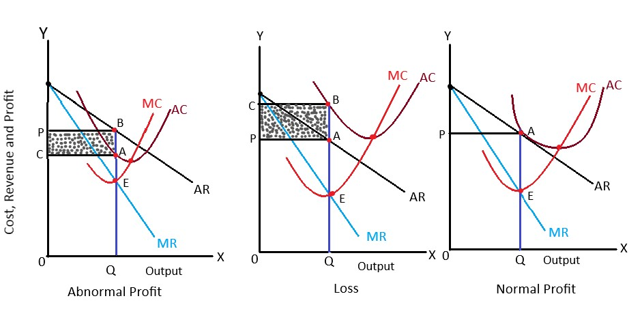
माथिका आकृतिहरूमा, एकाधिकार व्यवसायले छोटो अवधिमा भोग्न सक्ने नाफा र घाटाका तीनवटा सम्भावनाहरू देखाइएको छ। यी सम्भावनाहरूलाई निम्नानुसार व्याख्या गर्न सकिन्छः
In the above figures, the three different possibilities of profit and loss situation in the short run under monopoly firm are shown. These possibilities are explained as follows:-

१. असामान्य नाफा

पहिलो आकृतिमा, सन्तुलनको बिन्दु 'E' हो, जहाँ सीमांत लागत (MC) ले सीमांत आम्दानी (MR) लाई तलबाट काट्छ। सन्तुलन स्तरको उत्पादन OQ निर्धारण हुन्छ। कमाइ भएको राजस्व OP हो भने लागत OC हुन्छ। राजस्व लागतभन्दा बढी भएकाले व्यवसायीले छायांकित क्षेत्र (ABPC) बराबरको असामान्य नाफा कमाउँछ।

Abnormal profit:-
In the first figure, we see that the equilibrium point is 'E' when MC cuts MR from below. The equilibrium level of output is determined at OQ. The level of revenue earned is OP and the cost incurred is OC. Since Revenue is greater than cost, the firm earns abnormal profit equal to the shaded area (ABPC).

२. घाटा

दोस्रो आकृतिमा, सन्तुलनको बिन्दु 'E' हो, जहाँ सीमांत लागत (MC) ले सीमांत आम्दानी (MR) लाई तलबाट काट्छ। सन्तुलन स्तरको उत्पादन OQ निर्धारण हुन्छ। खर्च गरिएको लागत OC हो भने कमाइ भएको राजस्व OP छ। लागत राजस्वभन्दा बढी भएकाले व्यवसायीले छायांकित क्षेत्र (ABCP) बराबरको घाटा बेहोर्छ।.

Loss:-
In the second figure, point E is the equilibrium point where MC intersects MR from below. The equilibrium level of output is OQ. The cost incurred is OC and the revenue earned is OP. Since cost is higher than revenue, the firm bears loss equal to the shaded area (ABCP).

३. सामान्य नाफा
तेस्रो आकृतिमा, सन्तुलनको बिन्दु 'E' हो, जहाँ सन्तुलनका सबै सर्तहरू पूरा भएका छन्। सन्तुलन स्तरको उत्पादन OQ निर्धारण हुन्छ। राजस्व र लागत दुबै एउटै स्तरमा (OP) छन्। यस अवस्थामा, व्यवसायीले आफ्नो व्यापार चलाउन आवश्यक पर्ने सामान्य नाफा मात्र कमाउँछ।

Normal profit:-
In the third figure, we can see that the equilibrium point is at 'E' where the conditions for equilibrium are fulfilled. The equilibrium level of output is OQ. The revenue and cost are at the same level (OP). The firm earns just a normal profit to sustain its business in this case.

एकाधिकार अन्तर्गत दीर्घकालीन अवधिमा मूल्य र उत्पादनको निर्धारण/ दीर्घकालीन सन्तुलन अन्तर्गत एकाधिकार
दीर्घकालीन अवधिमा, एकाधिकार व्यवसायले आफ्नो नाफा अधिकतम बनाउनका लागि प्लान्ट र मेसिनरीको आकार परिवर्तन गर्न र उत्पादनको स्तर निर्धारण गर्न सक्छ। यसले गर्दा व्यवसायले घाटा व्यहोर्नु पर्दैन। यसैगरी, नयाँ व्यवसायहरूको प्रवेश कुनै न कुनै रूपमा रोकिएको हुन्छ, जसका कारण प्रतिस्पर्धाको अभावले एकाधिकार व्यवसायले दीर्घकालीन अवधिमा असामान्य नाफा आर्जन गर्न सक्छ।
दीर्घकालीन अवधिमा एकाधिकार अन्तर्गत सन्तुलन प्राप्त गर्न निम्न सर्तहरू पूरा हुनुपर्दछ:
i) सीमांत आम्दानी (MR) सीमांत लागत (LMC) सँग बराबर हुनुपर्छ।
ii) सीमांत लागत (LMC) सीमांत आम्दानी (MR) लाई तलबाट काट्नुपर्छ।
दीर्घकालीन अवधिमा एकाधिकारको सन्तुलनलाई ग्राफिकल रूपमा यसरी प्रस्तुत गर्न सकिन्छ:

Price and output determination under monopoly in long run/ long run equilibrium under monopoly
The firm can change the size of plant and machinery and can determine the level of output to maximize its profit. Because of this, the firm does not suffer loss. Likewise, the entry of new firms is restricted somehow and the monopolist earns abnormal profit in the long run due to lack of competition.
The following conditions must be fulfilled to attain equilibrium under monopoly in the long run.
i) MR must be equal to LMC.
ii) LMC must intersect MR from below.
The equilibrium of a monopoly, in the long run, can be graphically presented as follows:-

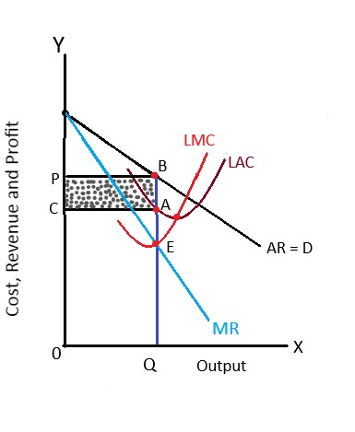
उपरोक्त चित्रमा, LAC र LMC ले क्रमशः दीर्घकालीन औसत लागत वक्र (Long-Run Average Cost Curve) र सीमांत लागत वक्र (Marginal Cost Curve) प्रतिनिधित्व गर्छन्। AR र MR ले क्रमशः औसत आम्दानी (Average Revenue) र सीमांत आम्दानी (Marginal Revenue) प्रतिनिधित्व गर्छन्। सन्तुलन बिन्दु 'E' मा निर्धारण हुन्छ, जहाँ LMC ले MR लाई तलबाट काट्छ।
सन्तुलन उत्पादन स्तर OQ मा निर्धारण गरिन्छ। यस अवस्थामा लाग्ने लागत OC हो भने आर्जन हुने आम्दानी OP हो। किनभने आम्दानी लागतभन्दा बढी छ (AR > AC), यसले गर्दा एकाधिकार व्यवसायले दीर्घकालीन अवधिमा असामान्य नाफा आर्जन गर्छ।
In the above figure, LAC and LMC represent long-run average cost curve and Marginal cost curve. AR and MR represent Average and Marginal Revenue. The equilibrium point is determined at ‘E’ where LMC intersects MR from below. The equilibrium level of output is determined at OQ. The cost incurred is OC and the revenue earned is OP. Since revenue is higher than cost (AR> AC), the monopolist earns abnormal profit in the long-run.
UNIT -5
Factor pricing
स्रोतहरूको मूल्य निर्धारण
उत्पादनका स्रोतहरूको मूल्य निर्धारण
आर्थिक वस्तु र सेवाहरू उत्पादन गर्नका लागि उत्पादनका स्रोतहरूको प्रयोग गरिन्छ।
चार प्रमुख उत्पादनका स्रोतहरू
- भूमि (Land): जमिन वा भू-क्षेत्र।
- श्रम (Labor): काम गर्ने मानवीय शक्ति।
- पुँजी (Capital): पैसा, मेसिन, उपकरण, भवन आदि।
- संगठन (Organization): उत्पादनका स्रोतहरूलाई संयोजन गर्ने क्षमता।
उत्पादनका यी स्रोतहरूको मूल्य निर्धारण गर्न बनाइएका सिद्धान्तहरूलाई "स्रोत मूल्य निर्धारणका सिद्धान्त" भनिन्छ।
लगान (Rent)
आर्थिक दृष्टिकोणले, लगान भन्नाले ती उत्पादनका स्रोतहरूको सेवा प्रयोग गर्न तिर्ने भुक्तानीलाई जनाउँछ जुन निश्चित आपूर्ति भएका (जस्तै: जमिन) र परिवर्तनशील आपूर्ति भएका (जस्तै: पुँजीगत सामान, चरहरू, मेसिन, भवन आदि) हुन्।
क्लासिकल अर्थशास्त्री डेभिड रिकार्डोका अनुसार,
“लगान भनेको भूमिबाट मात्र आर्जन गरिन्छ, र यो जमिनको मौलिक र अविनाशी योग्य शक्तिको प्रयोग गरेबापत जमिनधनीले प्राप्त गर्ने भुक्तानी हो।”

लगानका दुई मुख्य अवधारणा:
१. सम्झौताअनुसारको लगान (Contract Rent):
यो दुई पक्ष (स्रोतको मालिक र प्रयोगकर्ता) बीचको सम्झौताबाट निर्धारण गरिन्छ।
- सम्झौताअनुसारको लगान भनेको स्रोतको निश्चित समय अवधिसम्म प्रयोगका लागि स्रोत मालिकलाई तिर्ने वास्तविक भुक्तानी हो।
- उदाहरण:
  - घरको मालिकलाई तिर्ने भाडा
  - जमिनको भाडा
  - मेसिन र उपकरणको भाडा
यो उत्पादन सुरु हुनु भन्दा पहिले नै निर्धारण गरिन्छ।
२. आर्थिक लगान (Economic Rent):
क्लासिकल अर्थशास्त्री डेभिड रिकार्डोका अनुसार, आर्थिक लगान केवल भूमिबाट मात्र आर्जन गरिन्छ।
- यो भाडा भनेको जमिनको उपयोगका लागि भोगकर्ता (tenant) ले जमिन मालिकलाई तिर्ने भुक्तानीको त्यो भाग हो, जुन आवश्यक लागतभन्दा बढी हो।
- आर्थिक लगानको परिभाषाअनुसार, यो वर्तमान आम्दानी (Current Earning) र स्थानान्तरण आम्दानी (Transfer Earning) बीचको अन्तर हो।
- वर्तमान आम्दानी: स्रोतको वर्तमान प्रयोगबाट हुने आम्दानी।
- स्थानान्तरण आम्दानी: स्रोतको वैकल्पिक प्रयोगबाट हुने आम्दानी।
रिकार्डियन लगानको सिद्धान्त / शास्त्रीय लगानको सिद्धान्त v v i
रिकार्डियन लगानको सिद्धान्तलाई १८१७ मा डेभिड रिकार्डोले आफ्नो पुस्तक “प्रिन्सिपल्स अफ पोलिटिकल इकोनोमी एण्ड ट्याक्सेसन” मा विकास गरेका थिए। उनको भनाइमा,
"लगान भनेको भूमिबाट प्राप्त हुने उत्पादनको त्यो भाग हो, जुन भूमिको मौलिक र अविनाशी योग्य शक्तिको प्रयोगका लागि जमिनधनीलाई तिरिन्छ।"
यो सिद्धान्तका आधारभूत मान्यताहरू:
- लगान केवल भूमिबाट आर्जन गरिन्छ।
- भूमि निश्चित आपूर्तिमा रहेको छ।
- भूमि मौलिक र अविनाशी योग्य शक्ति राख्दछ।
- भूमि केवल खेतीपातीका लागि प्रयोग गरिन्छ।
- भूमिलाई उर्वराशक्तिको घट्दो आधारमा मात्र प्रयोग गर्न सकिन्छ।
- भूमिमा घट्दो प्रतिफलको नियम (Law of Diminishing Returns) लागू हुन्छ।
- भूमिको गुणस्तरमा फरक हुन्छ।
- भूमिको बजारमा पूर्ण प्रतिस्पर्धा हुन्छ।
- जनसंख्या बढ्दा उत्पादनशीलता पनि बढ्छ।
- यो सिद्धान्त दीर्घकालीन अवधारणा (Long-run Concept) मा आधारित छ।
व्यापक खेती (Rent under Extensive Cultivation):
- यस्तो प्रकारको खेती हो, जहाँ उत्पादनलाई थप भूमिको उपयोग गरेर बढाइन्छ।
- भूमिलाई श्रेष्ठ (Superior) बाट निम्न (Inferior) भूमिसम्म, उही परिमाणको श्रम र पुँजी प्रयोग गरेर खेती गरिन्छ।
- रिकार्डोका अनुसार, चार प्रकारका भूमिहरू (A, B, C, र D) छन्।
गहन खेती (Rent under Intensive Cultivation):
- गहन खेती त्यस्तो प्रकारको खेती हो, जसमा उत्पादन बढाउन उही भू-क्षेत्रमा पटक–पटक श्रम र पुँजीको मात्रा थप गरिन्छ।

Grades of land | Production (in kg) | Cost of production (in Kg) | Rent
A | 40 | 10 | 40-10=30
B | 30 | 10 | 30-10=20
C | 20 | 10 | 20-10=10
D | 10 | 10 | 10-10=0

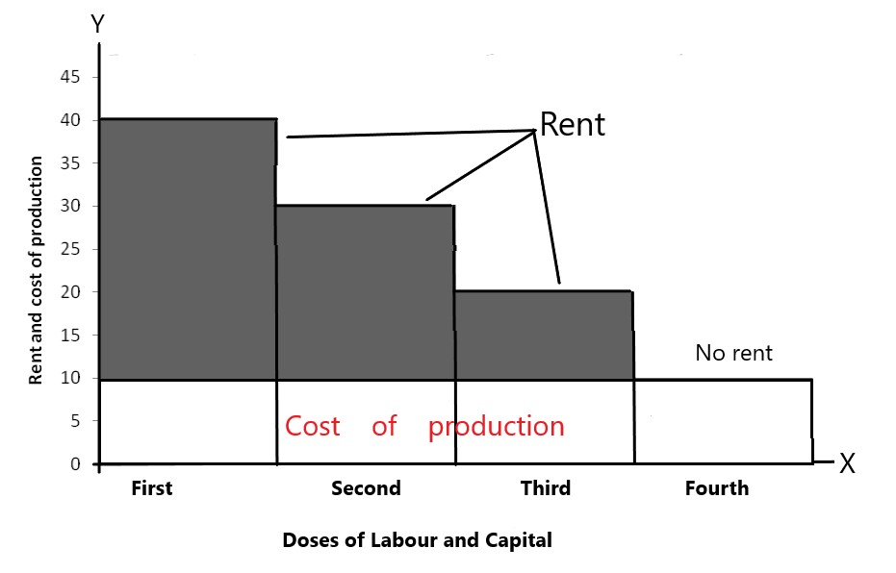

उपरोक्त चित्रको व्याख्या:
उक्त चित्रमा जमिनका स्तर (grades of land) र उत्पादनलाई क्रमशः X-अक्ष र Y-अक्षमा मापन गरिएको छ। विभिन्न जमिनका स्तरहरू (A, B, C, र D) ले आर्जन गरेको लगानको परिमाण छायांकित भागले देखाएको छ। D स्तरको जमिनले मात्र लागत पूर्ति गर्छ, त्यसैले यसलाई सीमांत (Marginal) वा लगानरहित (No Rent Land) जमिन भनिन्छ। त्यसैले, व्यापक खेतीमा लगान भनेको सीमांत जमिनको उत्पादनभन्दा माथि रहेको अन्तर्गत-सीमांत (Intra-Marginal) जमिनको अधिशेष उत्पादन हो।
रिकार्डियन लगानको सिद्धान्तमाथि आलोचनाहरू:
१. मौलिक र अविनाशी योग्य शक्तिको गलत धारणा:
रिकार्डियन सिद्धान्तले भूमि मौलिक र अविनाशी योग्य शक्ति राख्छ भनी मान्यता राख्छ। यो धारणा स्वीकार्य छैन, किनभने भूमि उत्पादनशीलता वैज्ञानिक प्रविधिहरूको प्रयोगद्वारा बढाउन सकिन्छ। अत्यधिक प्रयोग, माटोको कटान, बाढी, खडेरी आदि कारणले भूमि उर्वराशक्ति गुमाउन सक्छ।
२. भूमिको एकमात्र प्रयोगको धारणा गलत छ:
रिकार्डोले भूमिलाई एकमात्र प्रयोगका लागि उपयुक्त मान्छन्। तर, वास्तविक जीवनमा भूमि विभिन्न प्रकारका बालीनाली उब्जाउन, औद्योगिक उद्देश्य वा घरजग्गाका लागि प्रयोग गर्न सकिन्छ।
३. ‘लगानरहित जमिन’ को गलत धारणा:
रिकार्डियन सिद्धान्तले यस्तो जमिनको अस्तित्व मान्छ, जसले कुनै लगान आर्जन गर्दैन। तर, वास्तविक जीवनमा कुनै पनि जमिन लगानरहित हुँदैन। साथै, कुनै जमिन एक प्रकारको बालीनालीका लागि सीमांत हुन सक्छ भने अर्को प्रकारका लागि अन्तर्गत-सीमांत हुन सक्छ।
४. पूर्ण प्रतिस्पर्धाको गलत धारणा:
रिकार्डियन सिद्धान्तले भूमिको बजारमा पूर्ण प्रतिस्पर्धा हुने मान्यता राख्छ। तर, वास्तविक जीवनमा भूमिको बजार अपूर्ण प्रतिस्पर्धात्मक हुन्छ। जमिनधनीले एकाधिकार लगान (Monopoly Rent) पनि लिने सम्भावना रहन्छ।
५. सबै उत्पादनका स्रोतले लगान आर्जन गर्छन्:
रिकार्डोले भूमिलाई मात्र यस्तो उत्पादनको स्रोत मान्छन्, जसले लगान आर्जन गर्छ। तर, आधुनिक अर्थशास्त्रीहरूका अनुसार सबै उत्पादनका स्रोतहरूले (जस्तै श्रम, पुँजी, संगठन) लगान आर्जन गर्छन्।

ज्याला
ज्याला भनेको उत्पादनमा आफ्नो सेवा प्रदान गरेबापत श्रमिकले प्राप्त गर्ने मूल्य हो। अर्थशास्त्रमा, ज्याला भनेको श्रमिकले आफ्नो मानसिक वा शारीरिक परिश्रमका लागि प्राप्त गर्ने पारिश्रमिक हो।

नगद ज्याला वा नाममात्रको ज्याला ( nominal wages)
नगद ज्याला भनेको श्रमिकले नगदको रूपमा प्राप्त गर्ने ज्याला हो। यसलाई नाममात्रको ज्याला पनि भनिन्छ। नगद ज्यालामा श्रमिकलाई प्रदान गरिने अतिरिक्त सुविधाहरू जस्तै आवास, स्वास्थ्य सेवा, बालबालिकाको शिक्षा भत्ता, यातायात सुविधा, लुगा भत्ता, बीमा सुविधा आदि समावेश हुँदैन।

वास्तविक ज्याला(real wages)
वास्तविक ज्याला भनेको नगद ज्याला र श्रमिकले प्राप्त गर्ने अतिरिक्त सुविधाहरूबाट खरिद गर्न सकिने सामान र सेवाहरूको मात्रा हो।

निर्वाह ज्यालाको सिद्धान्त
निर्वाह ज्यालाको सिद्धान्त डेविड रिकाडो र अन्य शास्त्रीय अर्थशास्त्रीहरूले विकास गरेका हुन्।
यस सिद्धान्त अनुसार, श्रमिकलाई न्यूनतम निर्वाह स्तर बराबर ज्याला दिनुपर्छ। निर्वाह स्तर भनेको श्रमिकको न्यूनतम जीवनस्तर कायम राख्न पर्याप्त हुने स्तर हो।
यदि श्रमिकलाई निर्वाह स्तरभन्दा बढी ज्याला दिइयो भने, उनीहरूलाई धेरै विवाह गर्ने र ठूलो परिवार बनाउने प्रोत्साहन मिल्छ। यसले श्रम आपूर्ति वृद्धि गर्दछ, जसका कारण श्रमिकहरूबीच कामका लागि प्रतिस्पर्धा बढ्छ, र अन्ततः ज्यालाको दर घटेर निर्वाह स्तरमा आइपुग्छ।
यदि श्रमिकलाई न्यूनतम निर्वाह स्तरभन्दा कम ज्याला दिइयो भने, उनीहरू आफ्नो न्यूनतम आवश्यकता पनि पूरा गर्न सक्दैनन्। यसले भोकमरी, कुपोषण, मृत्यु दर वृद्धि र जन्म दर घटाउने कारण बन्छ। यसले श्रम आपूर्ति घटाउँछ, जसले गर्दा ज्यालाको दर पुनः न्यूनतम निर्वाह स्तरमा पुग्ने प्रवृत्ति देखिन्छ।
लामो अवधिमा, ज्याला न्यूनतम निर्वाह स्तर बराबर हुनुपर्छ।

निर्वाह ज्यालाको सिद्धान्तका आधारभूत मान्यताहरू:
- जनसंख्या तीव्र गतिमा वृद्धि हुन्छ।
- खाद्य उत्पादनको वृद्धि दर सुस्त हुन्छ।
- ट्रेड युनियनको अस्तित्व हुँदैन।
- श्रम उत्पादनको लागत निर्वाह ज्यालासँग समान हुन्छ।
- यो सिद्धान्त लामो अवधिको अवधारणा हो।

आलोचना:
- यो शोषणकारी सिद्धान्त हो।
- यसले श्रमको माग पक्षलाई बेवास्ता गर्दछ।
- ज्यालाको भिन्नतालाई व्याख्या गर्न असफल हुन्छ।
- यसले ट्रेड युनियनको भूमिकालाई बेवास्ता गर्दछ।
- यो निराशावादी सिद्धान्त हो।

ज्याला कोष सिद्धान्त
यो सिद्धान्त जे.एस. मिलले विकास गरेका हुन्।
यस सिद्धान्त अनुसार, कुल पुँजीको निश्चित अंश वा राष्ट्रिय आय श्रमिकलाई ज्याला तिर्नका लागि छुट्याइन्छ। यो अंशलाई ज्याला कोष भनिन्छ।
ज्यालाको दर ज्याला कोष र श्रमिकहरूको संख्याको अनुपातबाट निर्धारण हुन्छ।
ज्यालाको दर = ज्याला कोषको आकार ÷ श्रमिकहरूको संख्या
ज्याला कोष उच्च भएमा ज्यालाको दर पनि उच्च हुन्छ, र यसको विपरीत, ज्याला कोष कम भएमा ज्यालाको दर पनि कम हुन्छ। तर, श्रमिकहरूको संख्या र ज्यालाको दरबीच उल्टो सम्बन्ध हुन्छ।
ज्याला कोष बढ्दा श्रमिकहरूको मागमा नकारात्मक प्रभाव पर्छ। किनभने, जब ज्याला कोष बढ्छ, कुल पुँजीको कच्चा माल खरीद गर्न प्रयोग हुने भाग घट्छ। यसले उत्पादन पनि घटाउँछ। अन्ततः यसले श्रमिकको माग घटाउँछ र बेरोजगारी बढाउँछ।
मिलले ज्याला कोष स्थिर रहेको मान्यता गरेका छन्। त्यसैले, ज्यालाको अनुपात श्रमिकहरूको संख्या घटाएर मात्र बढ्न सक्छ।

मान्यताहरू:
- ज्याला कोष स्थिर छ।
- श्रमिकलाई रोजगारी दिनुअघि ज्याला कोष तयार गरिन्छ।
- श्रमिकलाई रोजगारी दिएपछि ज्यालाको स्तर निश्चित गरिन्छ।
- श्रमिकहरूको संख्याका आधारमा ज्यालाको स्तर परिवर्तन हुन्छ।
- ज्यालाको स्तर र ज्याला कोषबीच सीधा सम्बन्ध छ भने ज्यालाको स्तर र श्रमिकहरूको संख्याबीच उल्टो सम्बन्ध छ।

ब्याज
ब्याज पूँजीको पुरस्कार हो। ब्याज भन्नाले उत्पादन प्रक्रियामा पूँजीको प्रयोगको लागि उधारो लिने व्यक्तिले ऋण दिने व्यक्तिलाई गरेको भुक्तानीलाई जनाउँछ। 1000 10%+1%+.5+2 =13.5%
- शुद्ध ब्याज: शुद्ध ब्याज भन्नाले केवल पूँजी वा पैसाको प्रयोगको लागि तिरिएको मूल्यलाई जनाउँछ। यसलाई शुद्ध ब्याज वा पवित्र ब्याज पनि भनिन्छ, जसमा अन्य रकम समावेश हुँदैन।
- कुल ब्याज: कुल ब्याज भन्नाले ऋण लिने व्यक्तिले पूँजी फिर्ताको लागि निश्चित समयको अवधिमा ऋण दिने व्यक्तिलाई तिरिएको कुल रकमलाई जनाउँछ। यसमा शुद्ध ब्याज र अन्य शुल्कहरू समावेश हुन्छन्।
कुल ब्याज = शुद्ध ब्याज + जोखिमको प्रतिफल + व्यवस्थापनको प्रतिफल + असुविधाको प्रतिफल

ब्याजको शास्त्रीय सिद्धान्त
यो सिद्धान्त पुराना शास्त्रीय अर्थशास्त्रीहरूले प्रतिपादन गरेका हुन् र मार्शल, पिगू आदिले विकास गरेका हुन्।
यस सिद्धान्त अनुसार, ब्याजको सन्तुलन दर पूँजीको माग र पूँजीको आपूर्तिद्वारा निर्धारण हुन्छ।
यसलाई लगानी बचतको सिद्धान्त (Investment Saving Theory of Interest) पनि भनिन्छ।
- मान्यताहरू
• उत्पादनका साधनहरूको पूर्ण रोजगारी हुन्छ।
• बचत गर्ने क्षमता र इच्छामा निर्भर हुन्छ।
• आम्दानीको स्तर निश्चित हुन्छ।
• पैसा केवल विनिमयको माध्यमको रूपमा काम गर्छ।
• यो दीर्घकालीन अवधारणाको रूपमा लिइन्छ।
- पूँजीको माग
पूँजीको माग लगानीको लागि उत्पन्न हुन्छ र लगानी ब्याजदरमा निर्भर गर्दछ। पूँजीको माग र ब्याजदरबीच उल्टो सम्बन्ध हुन्छ। त्यसैले, लगानीको माग वक्र बायाँबाट दायाँतर्फ झर्दै तल झुक्दछ।
- पूँजीको आपूर्ति
पूँजीको आपूर्तिको स्रोत बचत हो। बचत भनेको उपभोग खर्च पछि बाँकी रहेको रकम हो। पूँजीको आपूर्ति बचतबाट उपलब्ध पूँजी हो। पूँजीको आपूर्ति र ब्याजदरबीच सकारात्मक सम्बन्ध हुन्छ, त्यसैले यस वक्र बायाँबाट दायाँतर्फ उकालो लाग्दछ।
Rate of interest ® | Demand for saving (Ds) | Supply of saving (Ss) | Remarks
3% | Rs. 15000 | Rs. 5000 | Ds > Ss
5% | Rs. 10000 | Rs. 10000 | Ds=Ss
7% | Rs. 5000 | Rs. 15000 | Ds < Ss
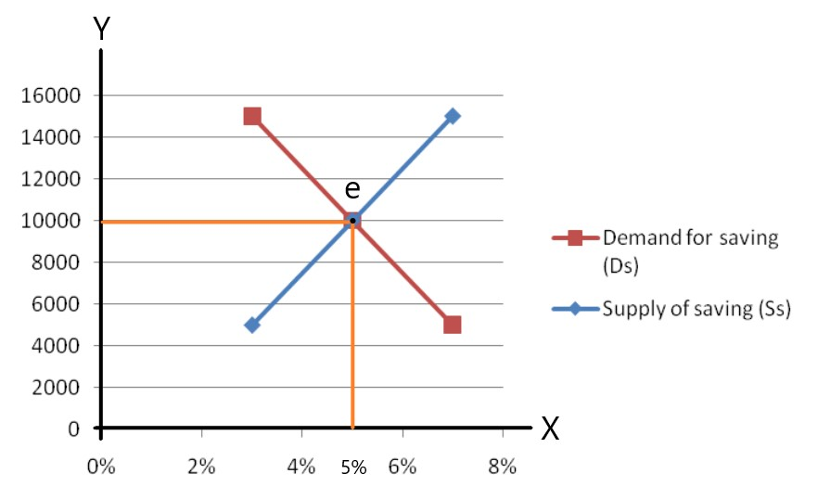
उपरोक्त तालिका रdiagramमा हामीले देख्न सक्छौँ कि जब ब्याजदर बढ्छ, मानिसहरू बढी बचत आपूर्ति गर्न इच्छुक हुन्छन्, र कम ब्याजदरमा उनीहरूले कम बचत आपूर्ति गर्छन्। तर, कम ब्याजदरमा बचतको माग बढी हुन्छ र यसको विपरीत पनि सत्य छ। ब्याजदर त्यो बिन्दुमा निर्धारण हुन्छ जहाँ बचतको माग र बचतको आपूर्ति बराबर हुन्छ।
उपरोक्त diagramमा, ‘e’ सन्तुलन बिन्दु हो, जहाँ बचतको माग र बचतको आपूर्ति एकअर्कासँग अन्तर्क्रिया गर्छ। यहाँ ब्याजदर ५% मा निर्धारण भएको छ।
नाफा
नाफा भनेको उत्पादनमा व्यवसायीले गरेको योगदानको पुरस्कार हो। अर्को शब्दमा, नाफा व्यवसायमा जोखिम र अनिश्चितता वहन गरेबापत उद्यमीले प्राप्त गर्ने पुरस्कार हो।
कुल नाफा: कुल आम्दानी र कुल स्पष्ट लागतको बीचको अन्तरलाई कुल नाफा भनिन्छ।
कुल नाफा = कुल आम्दानी - स्पष्ट लागत
शुद्ध नाफा: शुद्ध नाफा भन्नाले कुल आम्दानी र कुल लागत (जसमा स्पष्ट र अप्रत्यक्ष लागत दुवै समावेश हुन्छ) को बीचको अन्तरलाई जनाउँछ।
शुद्ध नाफा = कुल आम्दानी - स्पष्ट लागत - अप्रत्यक्ष लागत
जोखिम वहन सिद्धान्त
यो सिद्धान्त सन् १९०७ मा अमेरिकी अर्थशास्त्री प्रोफेसर हलेले विकास गर्नुभएको हो।
यस सिद्धान्त अनुसार, जोखिम लिनु उद्यमीको मुख्य कार्य हो। उद्यमीले पूँजी, श्रम, र भूमिजस्ता अन्य उत्पादनका तत्वहरूको समन्वय गर्दछ। यी तत्वहरूलाई ब्याज, ज्याला र भाडाको रूपमा भुक्तानी गरिन्छ। तर, उद्यमीको नाफा अनिश्चित हुन्छ, किनभने उत्पादन र बिक्रीको बीचमा समय अन्तराल हुन्छ। यो समय अवधिमा विभिन्न परिवर्तनहरू हुन सक्छन्।
व्यवसायिक उद्यममा विभिन्न प्रकारका जोखिमहरू समावेश हुन्छन्। यी जोखिमहरू उद्यमीले वहन गर्छन् र त्यसको बदलामा उनी नाफा प्राप्त गर्छन्।
जति धेरै जोखिम हुन्छ, नाफा हुने सम्भावना त्यति नै बढी हुन्छ र यसको विपरीत पनि सत्य छ।
जोखिम सिद्धान्तको आलोचना(
- जोखिम घटाउने पुरस्कार: यो सिद्धान्तले जोखिम घटाउने प्रक्रियालाई ध्यानमा राखेर नाफाको व्याख्या गर्दैन।
- जोखिम र नाफाबीच अनुपातिक सम्बन्ध छैन: जोखिम र नाफाबीच सिधा र निश्चित अनुपातिक सम्बन्ध हुँदैन। कहिलेकाहीँ धेरै जोखिम लिँदा पनि नाफा कम हुन सक्छ।
- सीमित सिद्धान्त: यो सिद्धान्त साँघुरो छ, किनभने यसले नाफालाई मात्र जोखिमसँग जोडेर अन्य महत्त्वपूर्ण पक्षहरूलाई बेवास्ता गर्छ।
अनिश्चितता वहन सिद्धान्त
यो सिद्धान्त प्रोफेसर नाइटद्वारा सन् १९२१ मा विकास गरिएको हो।
नाइटका अनुसार, नाफा जोखिम वहन गर्नुको कारण होइन, बरु अनिश्चितता वहन गर्नुको कारण उत्पन्न हुन्छ। नाइटले जोखिमलाई दुई भागमा विभाजन गरेका छन्।
a) बिमा गर्न मिल्ने जोखिम (ज्ञात जोखिम)
जोखिम जसको बारेमा निश्चित पूर्वानुमान र अनुमान गर्न सकिन्छ, तीलाई ज्ञात जोखिम वा बिमा गर्न मिल्ने जोखिम भनिन्छ। यस प्रकारको जोखिमलाई बिमा गरेर टार्न सकिन्छ।
उदाहरण: आगो लाग्ने, दुर्घटना, चोरी आदि।
b) बिमा गर्न नसकिने जोखिम
केहि जोखिमहरू अनुमान गर्न सकिँदैन, त्यसैले तिनीहरूलाई बिमा गर्न सकिँदैन। त्यसैले तीलाई अनबुजिएको/अज्ञात जोखिम भनिन्छ। यस प्रकारका जोखिमहरूले अनिश्चितता सिर्जना गर्छन्, जसलाई उद्यमीले वहन गर्छन् र त्यसको बदलामा नाफा प्राप्त गर्छन्। यी प्रकारका जोखिमहरू हुन्:
• प्रतिस्पर्धाको जोखिम
• सरकारी हस्तक्षेपको जोखिम
• व्यापार चक्र
• प्रविधिक जोखिम 30 mark

Unit-6
बैंकिङ प्रणाली र मौद्रिक नीति

बैंकको परिभाषा
बैंक एक यस्तो संस्था हो जसले पैसा र ऋणसँग सम्बन्धित काम गर्दछ। यसले जनताबाट निक्षेप स्वीकार गर्दछ, आवश्यकताअनुसार ऋण दिन्छ, र एक स्थानबाट अर्को स्थानमा पैसा पठाउन सहयोग गर्दछ।
विश्व बैंकका अनुसार, “बैंक भनेका यस्ता वित्तीय संस्थाहरू हुन् जसले जनताबाट निक्षेपको रूपमा रकम स्वीकार गरी यसलाई माग गरिएको समयमा वा छोटो समयमै फिर्ता दिन सक्ने किसिमले राख्दछन्।”

बैंकको विशेषताहरू
- यो पैसासँग सम्बन्धित काम गर्दछ।
- यो निक्षेप लिन्छ र ऋण प्रदान गर्दछ।
- यसले ऋणको लेनदेन गर्दछ र क्रेडिट सिर्जना गर्ने क्षमता राख्दछ।
- यसको उद्देश्य नाफा आर्जन गर्नु हो।
- यसले अर्थतन्त्रमा भुक्तानी प्रणालीको व्यवस्थापन गर्दछ।

बैंकिङ प्रणालीका भूमिकाहरू वा महत्त्व
- बचतको परिचालन
बैंकिङ प्रणालीको मुख्य भूमिकाहरू मध्ये एक बचत सङ्कलन गरी त्यसलाई व्यवसायिक क्षेत्रमा परिचालन गर्नु हो। बैंकले जनताबाट सङ्कलन गरेको पैसा उत्पादक क्षेत्रहरूलाई ऋण दिन्छ। यस प्रक्रियालाई बचतको परिचालन भनिन्छ।
- पुँजी निर्माण
पुँजी निर्माणको प्रक्रिया बचतबाट सुरु हुन्छ। जनताले बैंकमा बचत गर्छन्, उत्पादक क्षेत्रले सो रकम माग गरी पूँजीगत उपकरण किन्न, वस्तु तथा सेवा उत्पादन गर्न र आय सिर्जना गर्न प्रयोग गर्छ।
- रोजगारीको सिर्जना
बैंक तथा वित्तीय संस्थाहरूको स्थापनाले प्रत्यक्ष र अप्रत्यक्ष रूपमा रोजगारी सिर्जना गर्दछ। बैंकलाई कर्मचारीहरूको आवश्यकता पर्छ जसले प्रत्यक्ष रोजगारी प्रदान गर्छ। साथै, बैंकले व्यवसायिक क्षेत्रमा ऋण प्रदान गर्छ, जसलाई सञ्चालन गर्न नियमित जनशक्तिको आवश्यकता हुन्छ। यसरी बैंकले अप्रत्यक्ष रोजगारी पनि सिर्जना गर्दछ।
- विदेश व्यापार र भुक्तानीको व्यवस्थापन
विदेश व्यापारको विकासका कारण व्यापारीहरूले अन्तर्राष्ट्रिय बजारमा वस्तु तथा सेवा आयात–निर्यात गर्न सक्छन्। आयात–निर्यातसँग सम्बन्धित वित्तीय कारोबार बैंकमार्फत व्यवस्थापन गरिन्छ।
- पैसाको रेमिटेन्स
बैंकिङ प्रणालीको विकासले रेमिटेन्सको सुविधा पनि प्रदान गर्दछ। जनताले विश्वका विभिन्न भागबाट पैसा पठाउन र प्राप्त गर्न सक्ने बनाएको छ।
- सरकारको खर्च व्यवस्थापन
नेपालजस्ता विकासशील देशहरूमा सरकारको विकास खर्च राजस्व सङ्कलनभन्दा बढी हुन्छ। यसरी आवश्यक पर्ने थप रकम विभिन्न स्रोतबाट ऋण लिइन्छ र बैंक पनि त्यसमध्ये एक स्रोत हो।
- गरिबी निवारण
बैंकहरूले प्रत्यक्ष र अप्रत्यक्ष रूपमा विभिन्न प्रकारका रोजगारी सिर्जना गर्छन्। यसले उत्पादनमा लगानी गर्नका लागि ऋणको सुविधा पनि प्रदान गर्छ। यसले देशको गरिबी न्यूनीकरणमा सहयोग पुर्याउँछ।
केन्द्रीय बैंक र यसको कार्यहरू
नेपाल राष्ट्र बैंक
नेपाल राष्ट्र बैंक नेपालको केन्द्रीय बैंक हो। यो २०१३ साल वैशाख १४ गते स्थापना भएको हो।

केन्द्रीय बैंकका कार्यहरू
- नोट जारी गर्ने एकाधिकार
केन्द्रीय बैंकको मुख्य काम देशभित्र नोट जारी गर्नु हो। यसले कानूनी प्रावधान (जस्तै: सुन र चाँदीको निक्षेप) अनुसार नोट जारी गर्ने एकाधिकार पाएको छ। नेपालमा, नेपाल राष्ट्र बैंकले अनुपातगत राजस्व प्रणाली अन्तर्गत नोट जारी गर्दछ।
- सरकारको बैंक, एजेन्ट र सल्लाहकार
केन्द्रीय बैंकले सरकारको बैंकको रूपमा काम गर्छ। यसले सरकारका विभागहरू, बोर्डहरू, र उद्यमहरूको खाता सञ्चालन गर्छ। सरकारले कोषपत्र (जस्तै: ट्रेजरी बिल) खरिद/बिक्री गर्दा केन्द्रीय बैंकमार्फत गर्छ। साथै, केन्द्रीय बैंकले सरकारलाई मौद्रिक र राजस्व नीति निर्माणमा सल्लाह दिन्छ।
- सबै बैंकहरूको बैंक
केन्द्रीय बैंकलाई "बैंकको बैंक" भनिन्छ। यसले व्यावसायिक बैंकहरूको नगद कोष राख्छ। सबै बैंकहरूको खाता केन्द्रीय बैंकमा हुन्छ।
- अन्तिम ऋणदाता
केन्द्रीय बैंक अन्तिम ऋणदाता हो। यो व्यावसायिक बैंकहरूको लागि आपतकालीन अवस्थामा ऋणको स्रोत हो। जब व्यावसायिक बैंकहरूले आर्थिक कठिनाइ भोग्छन्, केन्द्रीय बैंकले उनीहरूलाई ऋण उपलब्ध गराउँछ।
- क्लियरिङ हाउसको सुविधा प्रदान गर्नु
केन्द्रीय बैंकले बैंकहरूको आपसी आर्थिक कारोबारको व्यवस्थापन गर्दछ। सबै व्यावसायिक बैंकहरूले आफ्नो खाता केन्द्रीय बैंकमा राख्ने भएकाले, केन्द्रीय बैंकले उनीहरूको दाबीहरूको समाधान (क्लियरिङ) गरिदिन्छ।
- क्रेडिट नियन्त्रण
क्रेडिट नियन्त्रण भनेको अर्थतन्त्रको आवश्यकताअनुसार ऋणको व्यवस्थापन गर्नु हो। केन्द्रीय बैंकले खुला बजार सञ्चालन, बैंकहरूको वैधानिक कोष अनुपात परिवर्तन, बैंक दर नीति, ब्याजदरमा नियन्त्रण जस्ता क्रेडिट नियन्त्रण उपकरणहरूको प्रयोग गरी क्रेडिट नियन्त्रण गर्दछ।
- विदेशी विनिमय नियन्त्रण
कुनै पनि देशको केन्द्रीय बैंकले विदेशी विनिमय कारोबारलाई नियमित र नियन्त्रण गर्ने अधिकार राख्छ। लचकदार विनिमय प्रणालीमा विदेशी मुद्राको माग र आपूर्तिको आधारमा विनिमय दर निर्धारण गरिन्छ। यसैगरी, स्थिर विनिमय प्रणालीमा पारस्परिक सम्झौतामा आधारित भएर विनिमय दर निर्धारण गरिन्छ।
वाणिज्य बैंक र यसको कार्यहरू
वाणिज्य बैंक भनेको निक्षेप संकलन गर्ने, व्यवसायिक ऋण दिने, साधारण लगानी उत्पादनहरू (पैसा) प्रदान गर्ने जस्ता सेवाहरू उपलब्ध गराउने संस्था हो।
नेपालको पहिलो वाणिज्य बैंक (नेपालको पहिलो बैंक), नेपाल बैंक लिमिटेड, वि.सं. १९९४ मा स्थापना भएको थियो।

वाणिज्य बैंकका कार्यहरू

A. प्राथमिक कार्यहरू
१. निक्षेप संकलन गर्ने
वाणिज्य बैंकको मुख्य र महत्त्वपूर्ण कार्य भनेको विभिन्न खातामा निक्षेप संकलन गर्नु हो। वाणिज्य बैंकहरूले संकलन गर्ने प्रमुख निक्षेपका प्रकारहरू यसप्रकार छन्:
क. चालु खाता
माग भुक्तानी खाता भनेर पनि चिनिने चालु खाता व्यवसायी र व्यापारीहरूले सञ्चालन गर्ने गर्दछन्। यसमा दैनिक रूपमा धेरै भुक्तानीहरू गर्नुपर्ने व्यक्तिहरूले यो खाता राख्ने गर्दछन्।
ख. बचत खाता
यो खाता सामान्यतया न्यून आय भएका व्यक्ति तथा जसलाई बारम्बार पैसा झिक्नु पर्दैन, उनीहरूले सञ्चालन गर्ने गर्दछन्। यस खाताबाट पैसा झिक्नका लागि समय र बारम्बारतामा केही सीमाहरू हुन्छन्।
ग. स्थायी निक्षेप
स्थायी निक्षेपलाई अवधि निक्षेप पनि भनिन्छ। यस खातामा निश्चित समयका लागि पैसा जम्मा गरिन्छ र परिपक्वतासम्म झिक्न सकिँदैन। यसमा ब्याज दर अत्यन्तै उच्च हुने गर्दछ।
२. ऋण प्रदान गर्ने
बैंकहरूले आफ्नो आम्दानी निक्षेपका रूपमा जम्मा भएको रकम ऋणका रूपमा प्रदान गरेर कमाउँछन्। बैंकले निक्षेपका आधारमा कर्जा सिर्जना गर्ने भएकाले यसलाई कर्जा उत्पादक भनिन्छ। बैंकले ऋणमा ब्याज लिन्छ, जुन निक्षेपमा दिने ब्याजभन्दा उच्च हुन्छ। वाणिज्य बैंकहरूले प्रदान गर्ने प्रमुख ऋणका प्रकारहरू यसप्रकार छन्:
क. नगद कर्जा
यो कर्जाको प्रकार हो जसमा बैंकले ग्राहकका चालु सम्पत्तिहरू जस्तै सेयर, स्टक, बन्ड आदि विरुद्ध ऋण प्रदान गर्छ। सुरक्षणको आधारमा पनि ऋण प्रदान गरिन्छ।
ख. ओभरड्राफ्ट
कहिलेकाहीं वाणिज्य बैंकहरूले आफ्ना ग्राहकहरूलाई ओभरड्राफ्टको सुविधा प्रदान गर्छन्। यस अन्तर्गत ग्राहकहरूले आफ्नो निक्षेपभन्दा बढी रकम झिक्न पाउँछन्। ओभरड्राफ्ट गरिएको रकममा ब्याज लाग्छ।
ग. ऋण तथा अग्रिम भुक्तानी
यी सामान्यतया दीर्घकालीन ऋण हुन् जसलाई बैंकले व्यक्तिहरू र संस्थाहरूलाई सुन, चाँदी, सरकारी र गैरसरकारी प्रतिभूतिहरू जस्ता पर्याप्त सुरक्षाको आधारमा प्रदान गर्छ।

B. द्वितीयक कार्यहरू / एजेन्सी कार्यहरू
वाणिज्य बैंकहरूले चेक, विनिमय बिल, प्रतिज्ञा पत्रजस्ता विभिन्न क्रेडिट उपकरणहरू सङ्कलन र भुक्तानी गर्दछन्।
१. रकम स्थानान्तरण
वाणिज्य बैंकले आफ्ना ग्राहकहरूको रकम चेक, ड्राफ्ट आदि माध्यमबाट एक स्थानबाट अर्को स्थानमा स्थानान्तरण गर्न सहयोग गर्दछ।
२. प्रतिभूतिको खरिद र बिक्री
वाणिज्य बैंकहरूले आफ्ना ग्राहकहरूको तर्फबाट विभिन्न प्रतिभूतिको खरिद र बिक्रीजस्ता कार्यहरू गर्दछन्।
३. आय प्राप्ति र भुक्तानी
वाणिज्य बैंकले ग्राहकहरूको सेयर र ऋणपत्रमा आएको लाभांश तथा ब्याज प्राप्त गर्छ। त्यस्तै, बीमा प्रिमियम, भाडा, आयकर आदि समय समयमा भुक्तानी गरिदिन्

आकस्मिक कार्यहरू (सामान्य उपयोगिता कार्यहरू)
आकस्मिक कार्यलाई सामान्य उपयोगिता कार्य पनि भनिन्छ। यी कार्यहरू यस प्रकार छन्:
१. लकर सुविधा
वाणिज्य बैंकले आफ्ना ग्राहकहरूलाई लकर सुविधा प्रदान गर्दछ। ग्राहकहरूले आफ्ना मूल्यवान वस्तुहरू जस्तै सुन, हिरा, चाँदी आदि र महत्त्वपूर्ण कागजातहरू सुरक्षाका लागि लकरमा राख्ने गर्दछन्।
२. यात्राका लागि चेक
वाणिज्य बैंकले आफ्ना ग्राहकहरूलाई यात्राका लागि चेक जारी गर्छ ताकि ग्राहकहरूले पैसाको क्षतिको डर बिना यात्रा गर्न सकून्।
३. क्रेडिट पत्र
वाणिज्य बैंकले आफ्ना ग्राहकहरूलाई उनीहरूको क्रेडिटयोग्यता प्रमाणित गर्दै क्रेडिट पत्र जारी गर्दछ। यो अन्तर्राष्ट्रिय व्यापारमा निकै उपयोगी हुन्छ।
४. विदेशी मुद्रामा कारोबार
वाणिज्य बैंकले केन्द्रीय बैंकको पूर्व स्वीकृतिमा ग्राहकहरूको विदेशी मुद्रा सटही गर्दछन्।
५. तथ्याङ्क सङ्कलन
वाणिज्य बैंकहरूले उद्योग, व्यापार र वाणिज्यसँग सम्बन्धित महत्त्वपूर्ण जानकारी दिने तथ्याङ्क सङ्कलन गर्दछन् र आर्थिक पत्रपत्रिका पनि प्रकाशित गर्दछन्।
वित्तीय बजार
वित्तीय साधनहरूको किनमेल हुने बजार।
वित्तीय साधनहरू जस्तै सेयर, ऋणपत्र, बीमा पोलिसी, सरकारी प्रतिभूति, डिबेन्चर आदि।
वित्तीय बजार दुई प्रकारका हुन्छन्:

मुद्रा बजार (Money Market)
• छोटो अवधिका वित्तीय साधनहरू किनमेल हुने बजार।
• परिपक्वता अवधि एक वर्ष वा त्यसभन्दा कम।
• खजाना बिल (Treasury Bills), वाणिज्य पत्र (Commercial Papers), निक्षेप प्रमाणपत्र (Certificates of Deposits) आदि।

मुद्रा बजारका विशेषताहरू:
• परिपक्वता अवधि एक वर्ष वा कम।
• जोखिमको स्तर न्यून।
• केन्द्रीय बैंकसँग नजिक र प्रत्यक्ष रूपमा सम्बन्धित।
• केन्द्रीय बैंकद्वारा कडाईका साथ नियमन हुने।
पुँजी बजार (Capital Market)
दीर्घकालीन वित्तीय साधनहरू जस्तै इक्विटी (सेयर) र ऋणपत्रहरू संकलन तथा किनमेल हुने बजार।

पुँजी बजारका विशेषताहरू:
• परिपक्वता अवधि एक वर्षभन्दा बढी।
• वित्तीय साधनहरू जस्तै डिबेन्चर, सेयर, सरकारी प्रतिभूति।
• मुख्य संस्था: सेयर बजार (Stock Exchange), विकास बैंक, वित्त कम्पनीहरू, भविष्य कोष (Provident Fund), लगानी कम्पनीहरू आदि।
• समयावधि लामो भएकाले जोखिम बढी।
• केन्द्रीय बैंकद्वारा कम नियमन हुने।
मौद्रिक नीति
देशको केन्द्रीय बैंकद्वारा अर्थतन्त्रमा मुद्रा आपूर्ति, ऋण, र ब्याजदरलाई नियन्त्रण र नियमन गर्न तयार गरिने नीति।

मुख्य उद्देश्यहरू:
• रोजगारीका अवसरहरू सिर्जना गर्नु।
• विनिमय दरमा स्थिरता ल्याउनु।
• व्यापार घाटा घटाउनु।
• मूल्य स्थिरता कायम गर्नु।
• आर्थिक वृद्धि हासिल गर्नु।
• वित्तीय संस्थाहरूको विकास गर्नु।
मौद्रिक नीतिका प्रकारहरू:
१. विस्तारमुखी मौद्रिक नीति (Expansionary Monetary Policy)
• केन्द्रीय बैंकद्वारा मुद्रा आपूर्ति वृद्धि गर्न लिइने कदम।
• खुला बजारमा खजाना बिल वा बन्ड खरिद गर्ने, बैंक दर घटाउने, आवश्यक रिजर्भ अनुपात (Reserve Ratio) घटाउने आदि।
• यो नीति आर्थिक मन्दी र मूल्य घट्ने (डिफ्लेसन) अवधिमा तयार गरिन्छ।
२. सङ्कुचनमुखी मौद्रिक नीति (Contractionary Monetary Policy)
• केन्द्रीय बैंकद्वारा मुद्रा आपूर्ति घटाउन लिइने कदम।
• खजाना बिल र बन्ड बिक्री गर्ने, बैंक दर बढाउने, रिजर्भ अनुपात बढाउने आदि।
• यो नीति मुद्रास्फीति (Inflation) भएको अवधिमा तयार गरिन्छ।
Unit 7
सरकारी वित्त
सरकारी वित्त
सरकारी वित्त/सार्वजनिक वित्त अर्थशास्त्रको विषय हो, जसले सरकारको आय र खर्चको व्यवस्थापनसँग सम्बन्धित हुन्छ।
सरकारी वित्तको महत्व
• स्रोतहरूको प्रभावकारी व्यवस्थापन
• आर्थिक स्थिरता कायम राख्न
• सामाजिक वस्तुहरू र पूर्वाधार निर्माण गर्न
• पूँजी निर्माण गर्न
• आय र सम्पत्तिको पुनर्वितरण गर्न
• स्रोतहरूको प्रभावकारी परिचालन गर्न (अउपयोगी क्षेत्रबाट उपयोगी क्षेत्रमा)
• आर्थिक विकास गर्न
• विदेशी भुक्तानी नियन्त्रण गर्न (उच्च कर लगाएर, विदेशमा खर्च सीमित गरेर)
सरकारी खर्च
सरकारी खर्च भन्नाले केन्द्रीय, राज्य र स्थानीय तहका सार्वजनिक प्राधिकरणहरूले जनताका लागि सेवा प्रदान गर्न र सामाजिक तथा आर्थिक समृद्धिका लागि गर्ने खर्चको प्रकृति र परिमाणलाई जनाउँछ।
सरकारी खर्चका क्षेत्रहरू
• जनतालाई सेवा प्रदान गर्न
• जनताको सामाजिक र आर्थिक समृद्धिका लागि
• देशमा शान्ति र सुरक्षा कायम गर्न
सरकारी खर्चको महत्व
• कानून र व्यवस्था कायम राख्न
• सामाजिक र आर्थिक परियोजनामा लगानी गर्न
• प्राकृतिक स्रोतहरूको उपयोग गर्न
• सब्सिडी र अनुदान प्रदान गर्न
• प्रशासनिक सेवाहरू उपलब्ध गराउन
• सन्तुलित विकास गर्न
नेपालको सन्दर्भमा सरकारी खर्चको वर्गीकरण
नेपाल सरकारको आर्थिक वर्ष २०७८/२०७९ को अनुमानित खर्च रु. १६,४७५.७६ करोड रहेको छ। यो तीन प्रकारका खर्चहरूमा विभाजन गरिएको छ, जुन निम्न प्रकार छन्:
१. आवर्ती खर्च /chalu kharch
२. पुँजीगत खर्च
३. वित्तीय खर्च

१. आवर्ती खर्च (Re-current Expenditure)
• नियमित/प्रशासनिक खर्च
• कुल खर्चको ५४.८०%
• तलब, पेन्सन, आन्तरिक र बाह्य ऋणको ब्याज भुक्तानी आदिमा हुने खर्च।
विभिन्न शीर्षकहरूमा वर्गीकरण
• संवैधानिक निकाय: सर्वोच्च अदालत, संसद, निर्वाचन आयोग
• सामान्य प्रशासन: मन्त्री परिषद्, प्रहरी, जेल, जिल्ला प्रशासन
• राजस्व प्रशासन: भूमिसम्बन्धी राजस्व, भन्सार राजस्व, उत्पाद शुल्क
• विदेश सेवा: दूतावास
• रक्षा: सुरक्षासम्बन्धी कार्यालय
• सामाजिक सेवा: स्वास्थ्य, शिक्षा, खानेपानी
• आर्थिक सेवा: कृषि, यातायात
• ऋण र लगानी: ब्याज भुक्तानी

२. पुँजीगत खर्च (Capital Expenditure)
• दीर्घकालीन खर्च कार्यक्रमहरू, आर्थिक विकासका लागि।
• आर्थिक वर्ष २०७८/२०७९ को कुल अनुमानित खर्चको ३७.४०%।
विभिन्न शीर्षकहरूमा वर्गीकरण
• संवैधानिक निकाय: (पूर्वाधार विकास)
• सामाजिक सेवा
• आर्थिक सेवा

३. वित्तीय खर्च (Financial Expenditure)
• सरकारी ऋण तिर्न, बण्ड र ट्रेजरी बिल पुनः किन्ने।
• आर्थिक वर्ष २०७८/२०७९ को कुल खर्चको ७.८०%।
सरकारी राजस्व
सरकारी राजस्व वा सार्वजनिक राजस्व भन्नाले सरकारलाई विभिन्न स्रोतबाट प्राप्त हुने आम्दानीलाई जनाउँछ।

सरकारी राजस्वका स्रोतहरू
सरकारले विभिन्न स्रोतबाट आम्दानी संकलन गर्दछ।
• कर राजस्व
• अकर राजस्व
• विदेशी अनुदान

१. कर राजस्व (Tax Revenue)
कर भन्नाले जनताले सरकारले तिर्नुपर्ने अनिवार्य भुक्तानी हो, जसलाई सार्वजनिक राजस्वको प्रमुख स्रोत मानिन्छ। विभिन्न प्रकारका करहरू जनतामाथि लगाइन्छन्, जसलाई तल वर्णन गरिएको छ:
(क) भन्सार (Customs):
निर्यात र आयातमा भन्सार कार्यालयमा लगाइने करलाई भन्सार भनिन्छ। यी कर वस्तुको परिमाण र मूल्यको आधारमा लगाइन्छ। भन्सार अप्रत्यक्ष कर हो।
(ख) वस्तु तथा सेवाको उपभोग र उत्पादनमा कर:
सरकारले वस्तु तथा सेवाको उत्पादन र उपभोगमा कर लगाउँछ। यस श्रेणीमा उत्पाद शुल्क, बिक्री कर, मनोरञ्जन कर, ठेक्का कर, सडक र पुल कर, मूल्य अभिवृद्धि कर (VAT) आदि पर्दछन्।
(ग) भूमिसम्बन्धी राजस्व र दर्ता शुल्क:
जमिनका मालिकहरूले आफ्नो जमिनको स्वामित्वका लागि तिर्नुपर्ने करलाई भूमिकर भनिन्छ। घर र जमिनको दर्ताका लागि तिर्नुपर्ने शुल्कलाई दर्ता शुल्क भनिन्छ। यी प्रत्यक्ष कर हुन्।
(घ) सम्पत्ति, नाफा र आम्दानीमा कर:
सार्वजनिक निगम, निजी कम्पनी, र व्यक्तिले आफ्नो आम्दानी र नाफाको आधारमा तिर्नुपर्ने करलाई सम्पत्ति, नाफा र आम्दानीमा कर भनिन्छ।

२. अकर राजस्व (Non-Tax Revenue)
अकर राजस्वमा निम्न समावेश छन्:
(क) उपहार र अनुदान:
प्राकृतिक प्रकोप र विपत्तिका समयमा राहत कार्यका लागि जनताले स्वेच्छाले तिर्ने भुक्तानीलाई उपहार भनिन्छ। केही संस्था वा व्यक्तिहरूले पनि सरकारलाई दान दिन्छन्।
(ख) शुल्क (Fees):
सरकारले शिक्षा, स्वास्थ्य, कम्पनी दर्ता, सवारी साधन र हतियारको इजाजतपत्र जस्ता सेवा प्रदान गरेबापत शुल्क लिन्छ।
(ग) जरिवाना र दण्ड (Fines and Penalties):
देशका नियम र कानुन उल्लङ्घन गर्ने व्यक्तिहरूलाई जरिवाना र दण्ड तिराइन्छ।
(घ) सार्वजनिक सम्पत्ति र उद्योगबाट आम्दानी:
सरकारले सार्वजनिक सम्पत्ति, जस्तै सार्वजनिक जमिनको भाडा, खनिज, नदी, जङ्गल आदि स्रोतहरूबाट आम्दानी गर्न सक्छ।

३. विदेशी अनुदान (Foreign Grants)
विकासोन्मुख देशहरूले अन्य विदेशी देशहरूबाट कोष प्राप्त गर्न सक्छन्। हालका समयमा, यस्तो देशहरूको बजेटमा विदेशी अनुदानले ठूलो हिस्सा ओगट्ने गर्दछ।
करको अवधारणा
• कर सरकारद्वारा आफ्ना नागरिक र संस्थाहरूलाई लगाइने अनिवार्य मौद्रिक शुल्क हो, जसलाई तिर्नु प्रत्येक नागरिकको कानूनी दायित्व हो।
• कर तिर्दा प्रत्यक्ष लाभको अपेक्षा गरिँदैन।
• यसबाट संकलित रकम जनताको कल्याण र देशको विकासका लागि खर्च गरिन्छ।
करका प्रकारहरू
१. प्रभाव र वहनको आधारमा
(क) प्रत्यक्ष कर:
प्रत्यक्ष करको प्रभाव र वहन त्यही व्यक्तिमा पर्छ, जसमा कानूनी रूपमा कर लगाइन्छ।
उदाहरण: आम्दानी कर (Income Tax) एक प्रत्यक्ष कर हो, जसमा करदाताले यो भार अर्को व्यक्तिमा सार्न सक्दैन।
प्रत्यक्ष करका फाइदाहरू:
• न्यायसंगत: आम्दानीको आधारमा कर निर्धारण हुने भएकाले यो न्यायपूर्ण हुन्छ।
• आर्थिक: कर संकलन खर्च कम हुन्छ।
• सुनिश्चितता: कर तिर्ने रकम स्पष्ट र निश्चित हुन्छ।
• प्रगतिशील: बढी आम्दानी हुने व्यक्तिले बढी कर तिर्नुपर्छ।
• लोचशीलता: आवश्यकता अनुसार कर दर परिवर्तन गर्न सकिन्छ।
प्रत्यक्ष करका कमजोरीहरू:
• असुविधाजनक: प्रत्यक्ष रूपमा तिर्नुपर्ने भएकाले केही व्यक्तिलाई झन्झटिलो लाग्न सक्छ।
• छल्ने सम्भावना: आय देखाउन नचाहनेहरूले कर छल्न सक्छन्।
• सीमित दायरा: सबै जनतालाई प्रत्यक्ष करको दायरामा ल्याउन कठिन हुन्छ।
• प्रेरणामा कमी: उच्च करले काम गर्न र बचत गर्न मानिसलाई हतोत्साहित गर्न सक्छ।
(ख) अप्रत्यक्ष कर:
अप्रत्यक्ष करमा करको प्रभाव एक व्यक्तिमा पर्छ तर यसको भार अर्को व्यक्तिमा सार्न सकिन्छ।
उदाहरण: मूल्य अभिवृद्धि कर (VAT) अप्रत्यक्ष कर हो, जसलाई उत्पादकले तिर्छन् र वस्तु वा सेवाको मूल्यमा जोडेर अन्तिम उपभोक्तालाई तिर्न लगाइन्छ।
अप्रत्यक्ष करका फाइदाहरू:
• सुविधाजनक: उपभोक्ताले वस्तु वा सेवा खरीद गर्दा नै कर तिर्छन्।
• व्यापक आधार: सबै उपभोक्ता अप्रत्यक्ष करको दायरामा पर्छन्।
• छल्न नसकिने: उपभोग गर्दा स्वचालित रूपमा कर तिर्नुपर्छ।
• लोचशीलता: कर दरलाई आवश्यकता अनुसार परिवर्तन गर्न सकिन्छ।
• न्यायसंगत: सबैले वस्तु वा सेवाको उपभोग अनुसार कर तिर्छन्।
अप्रत्यक्ष करका कमजोरीहरू:
• अनिश्चितता: कर संकलनबाट निश्चित राजस्व प्राप्त हुने ग्यारेन्टी हुँदैन।
• अनआर्थिक: कर संकलन प्रक्रियामा धेरै खर्च हुन सक्छ।
• शिक्षामूलक नभएको: यसले कर तिर्ने संस्कारलाई प्रोत्साहित गर्दैन।
• पछौटे स्वभावको: सबैलाई समान रूपमा लागु हुने भएकाले निम्न आय भएका व्यक्तिलाई बढी भार पर्न सक्छ।
क. समानुपातिक कर (Proportional Tax)
जब कुनै व्यक्तिको आम्दानी वा सम्पत्ति जुनसुकै तहमा भए पनि करको दर समान रहन्छ, त्यसलाई समानुपातिक कर भनिन्छ।
उदाहरण: बिक्री कर (Sales Tax)।
Income Level (In Rs.) | Rate of Tax (In %) | Total Tax Amount (In Rs.)
10,000 | 10 | 1,000
20,000 | 10 | 2,000
30,000 | 10 | 3,000
40,000 | 10 | 4,000
ख. प्रगतिशील कर (Progressive Tax)
प्रगतिशील कर भनेको यस्तो प्रणाली हो, जसमा आम्दानी र सम्पत्तिको स्तर बढ्दै जाँदा करको दर पनि बढ्दै जान्छ।

Income Level (In Rs.) | Rate of Tax (In %) | Total Tax Amount (In Rs.)
10,000 | 5 | 500
20,000 | 15 | 3,000
30,000 | 25 | 7,500
40,000 | 35 | 14,000
प्रतिगामी कर (Regressive Tax)
प्रतिगामी कर भनेको यस्तो प्रणाली हो, जसमा आम्दानीको स्तर बढ्दै जाँदा करको दर घट्दै जान्छ। उच्च आम्दानी भएका व्यक्तिहरूले कम दरमा कर तिर्नुपर्छ, जबकि न्यून आम्दानी भएका व्यक्तिहरूले उच्च दरमा कर तिर्नुपर्छ। यसको अर्थ, गरिबले धनीको तुलनामा बढी दरमा कर तिर्नुपर्ने हुन्छ।

Income Level (In Rs.) | Rate of Tax (In %) | Total Tax Amount (In Rs.)
10,000 | 10 | 1,000
20,000 | 9 | 1,800
30,000 | 8 | 2,400
40,000 | 7 | 2,800
घ. अधोगामी कर (Digressive Tax)
अधोगामी कर भनेको यस्तो प्रणाली हो, जसमा आम्दानी बढ्दै जाँदा निश्चित सीमासम्म करको दर बढ्छ। तर, उक्त सीमाभन्दा माथि आम्दानी भएमा करको दर स्थिर रहन्छ।

Income Level (In Rs.) | Rate of Tax (In %) | Total Tax Amount (In Rs.)
10,000 | 10 | 1,000
20,000 | 15 | 3,000
30,000 | 20 | 6,000
40,000 | 20 | 8,000
राम्रै कर प्रणालीका गुणहरू
• सरकारका लागि राजस्व संकलन गर्ने।
• आर्थिक स्थिरता र आर्थिक विकास कायम राख्ने।
• निश्चितता र सुविधा प्रदान गर्ने।
गुणहरू
• समानताको सिद्धान्त (Canon of Equality): कर प्रणाली समान बलिदान र तिर्ने क्षमतामा आधारित हुनुपर्छ।
• निश्चितताको सिद्धान्त (Canon of Certainty): कर तिर्ने रकम, समय, र तरिकाबारे निश्चित हुनुपर्छ।
• सुविधाको सिद्धान्त (Canon of Convenience): कर तिर्ने व्यक्तिका लागि सुविधाजनक र सरकारका लागि सजिलै संकलन गर्न मिल्ने हुनुपर्छ।
• आर्थिक सिद्धान्त (Canon of Economy): सरकारद्वारा कर संकलन गर्दा अनावश्यक खर्च नगरी आर्थिक रूपमा प्रभावकारी हुनुपर्छ।
• लोचशीलताको सिद्धान्त (Canon of Elasticity): आवश्यकताअनुसार कर दर बढाउन वा घटाउन सकिने हुनुपर्छ।
• विविधताको सिद्धान्त (Canon of Diversity): कर प्रणालीले विभिन्न समुदाय र व्यक्तिहरूलाई समेटेर व्यापक आर्थिक क्षेत्रलाई समेट्न सक्नुपर्छ।
• एकरूपताको सिद्धान्त (Canon of Uniformity): कर तिर्ने तरिका सबै व्यक्तिहरूका लागि समान र एकरूप हुनुपर्छ।
सरकारी ऋण
कुनै देशको सरकारले विभिन्न स्रोतबाट ऋणको रूपमा प्राप्त गरेको कोष वा पुँजीलाई सरकारी ऋण भनिन्छ। यसलाई सार्वजनिक ऋण पनि भनिन्छ।

सरकारी ऋणका स्रोतहरू

१. आन्तरिक ऋण
सरकारले देशभित्र रहेका व्यक्तिहरू, सार्वजनिक वा निजी संस्था, केन्द्रीय बैंक, वाणिज्य बैंक, र अन्य वित्तीय संस्थाहरूबाट लिएको ऋणलाई आन्तरिक ऋण भनिन्छ।
क. बजार ऋण
बजार ऋण भन्नाले ट्रेजरी बिल र विकास बन्डजस्ता हस्तान्तरण गर्न मिल्ने धितोपत्र बेचेर उठाइएको ऋणलाई जनाउँछ।
ख. गैर-बजार ऋण
गैर-बजार ऋण भन्नाले हस्तान्तरण गर्न नमिल्ने क्रेडिट उपकरणहरू मार्फत प्राप्त गरिएको ऋणलाई जनाउँछ। उदाहरणका लागि, निजी शेयर, राज्य र स्थानीय सरकारका धितोपत्र।

२. बाह्य ऋण
कुनै देशको सरकारले विदेशी व्यक्ति, विदेशी सरकार, र अन्तर्राष्ट्रिय संस्थाहरूबाट लिएको ऋणलाई बाह्य ऋण भनिन्छ।
क. द्विपक्षीय ऋण
यदि कुनै देशको सरकारले अर्को देशको सरकारसँग सम्झौता गरी ऋण लिन्छ भने त्यसलाई द्विपक्षीय ऋण भनिन्छ। उदाहरणका लागि, नेपाल सरकारले अमेरिका, बेलायत, जापान आदि सरकारसँग लिएको ऋण।
ख. बहुपक्षीय ऋण
यदि कुनै देशको सरकारले संयुक्त राष्ट्र विकास कार्यक्रम (UNDP), विश्व बैंक, एसियाली विकास बैंक, युरोपेली संघ (EU), अन्तर्राष्ट्रिय मुद्रा कोष (IMF) आदि जस्ता अन्तर्राष्ट्रिय संस्थाहरूबाट ऋण लिन्छ भने त्यसलाई बहुपक्षीय ऋण भनिन्छ।
सरकारी बजेटको ( government budget)
सरकारी बजेट भन्नाले कुनै सरकारको निश्चित समयावधिको लागि आर्थिक योजना हो, जसले सरकारको कुल आम्दानी र कुल खर्चको विवरण दिन्छ। यसमा सरकारको विभिन्न स्रोतबाट प्राप्त हुने राजस्व र त्यो राजस्व विभिन्न क्षेत्रहरूमा कसरी खर्च गरिन्छ भन्ने कुरा समेटिन्छ।

बजेटका प्रकारहरू
  - घाटा बजेट (Deficit Budget):
यो प्रकारको बजेटमा सरकारको कुल आम्दानी सरकारको कुल खर्चभन्दा कम हुन्छ।
उदाहरण: सरकारलाई रु. ५० अर्बको आम्दानी भए पनि खर्च रु. ६० अर्ब पुग्छ भने रु. १० अर्बको घाटा हुन्छ।
घाटा बजेट: कुल आम्दानी < कुल खर्च
  - बचत बजेट (Surplus Budget):
बचत बजेटमा सरकारको कुल आम्दानी सरकारको कुल खर्चभन्दा धेरै हुन्छ।
उदाहरण: यदि सरकारको कुल आम्दानी रु. ७० अर्ब छ भने र खर्च रु. ५० अर्ब मात्रै छ भने रु. २० अर्ब बचत हुनेछ।
बचत बजेट: कुल आम्दानी > कुल खर्च
३. सन्तुलित बजेट (Balanced Budget):
सन्तुलित बजेटमा सरकारको कुल आम्दानी र कुल खर्च बराबर हुन्छ।
उदाहरण: यदि सरकारले रु. ५० अर्ब आम्दानी गर्‍यो भने खर्च पनि रु. ५० अर्ब नै हुनेछ।
सन्तुलित बजेट: कुल आम्दानी = कुल खर्च

बजेट निर्माणको प्रक्रिया/चरणहरू V.V.I
सरकारी बजेट निर्माण गर्दा निम्न चरणहरू पालना गरिन्छ:
१. कुल आम्दानी र खर्चको पूर्वानुमान (Forecasting of Overall Income and Expenditure):
– राष्ट्रिय योजना आयोग (NPC) का उपाध्यक्षको अध्यक्षतामा स्रोत समितिले सरकारको आगामी आर्थिक वर्षको सम्भावित आम्दानी र खर्चको पूर्वानुमान गर्छ।
– यसमा वित्त मन्त्रालय (MoF), राष्ट्रिय योजना आयोग (NPC), केन्द्रीय बैंक, र वित्तीय नियन्त्रक महासेनानी कार्यालय (FCGO) का सदस्यहरूको सहभागिता हुन्छ।
२. प्राथमिकताको निर्धारण (Establishment of Priority):
– बजेट निर्माणका लागि सरकारका प्राथमिक क्षेत्रहरू निर्धारण गरिन्छ।
– जस्तै, शिक्षा, स्वास्थ्य, पूर्वाधार, कृषि, ऊर्जा, आदि।
३. परियोजना तयारी (Project Preparation):
– विभिन्न मन्त्रालय र सरकारी निकायहरूले आफ्ना प्रस्तावित परियोजनाहरू तयार गर्छन्।
– यी परियोजनाहरूले राष्ट्रिय लक्ष्यलाई समर्थन गर्नुपर्छ।
४. परियोजनाको छनोट र पेशी (Selection of Project and Submission):
– तयार गरिएका परियोजनाहरूबाट प्राथमिकता प्राप्त परियोजना छनोट गरिन्छ।
– छनोट भएका परियोजनाहरू सरकारलाई पेश गरिन्छ।
५. अन्तिम बजेट तयार गर्नु (Preparation of Final Budget):
– परियोजनाको समीक्षा र परिमार्जन गरेर सरकारको समग्र बजेट तयार गरिन्छ।
– अन्तिम बजेट तयार गर्दा आम्दानी र खर्चबीच सन्तुलन मिलाउने प्रयास गरिन्छ।
६. स्वीकृति र कार्यान्वयन (Authorization and Execution):
– तयार भएको बजेटलाई संसदमा प्रस्तुत गरिन्छ।
– संसदबाट स्वीकृति प्राप्त भएपछि बजेट कार्यान्वयनको प्रक्रिया सुरु गरिन्छ।
– बजेट अनुसार कार्यक्रम र परियोजनाहरूलाई सञ्चालन गरिन्छ।
स्वतन्त्र व्यापारका बेफाइदाहरू यस प्रकार छन्:
- प्राकृतिक स्रोतहरूको समाप्ति:
जब कुनै विकासोन्मुख देशले स्वतन्त्र व्यापारको नीति अपनाउँछ, त्यसका प्राकृतिक स्रोतहरू कच्चा पदार्थको रूपमा विकसित देशहरूमा सजिलै निर्यात हुन्छन्। यसरी विकसित देशहरूले विकासोन्मुख देशहरूको शोषण गर्दै ती प्राकृतिक स्रोतहरू चाँडै समाप्त गर्छन्।
- आन्तरिक उद्योगहरूमा प्रतिकूल असर:
विकासोन्मुख देशका उद्योगहरू पर्याप्त रूपमा विकसित भएका हुँदैनन्। ती अझै प्रारम्भिक चरणमा चलिरहेका हुन्छन्। स्वतन्त्र व्यापार नीतिमा, ती प्रारम्भिक उद्योगहरूले विकसित देशका परिपक्व उद्योगहरूसँग प्रतिस्पर्धा गर्न सक्दैनन्।
- आर्थिक निर्भरता:
स्वतन्त्र व्यापार अन्तर्गत, कुनै देशले केवल त्यस्ता वस्तुहरू उत्पादन गर्छ, जसको उत्पादनमा कम खर्च लाग्छ। बाँकी वस्तुहरूको लागि, जुन देशभित्र उत्पादन हुँदैन, देशले अन्य देशहरूमा निर्भर रहनुपर्छ। यसरी स्वतन्त्र व्यापार नीति अपनाउने देशहरूले अन्य देशहरूमा आर्थिक निर्भरता स्वीकार्नुपर्छ।
- डम्पिङ:
डम्पिङ भन्नाले उत्पादन लागतभन्दा कम मूल्यमा विदेशी बजारमा सामान बेच्ने विधिलाई जनाउँछ। यो विधि केही समयको लागि मात्र प्रयोग गरिन्छ।
- हानिकारक वस्तुहरूको आयात:
स्वतन्त्र व्यापार नीतिले कुनै पनि प्रकारका वस्तुहरूको आदान-प्रदानलाई प्रोत्साहन गर्छ। यसका कारण देशमा हानिकारक वस्तुहरूको आयात सम्भव हुन्छ। हानिकारक लागूपदार्थको आयातले देशको स्वास्थ्यलाई नष्ट गर्न सक्छ।
संरक्षणवाद (Protectionism)
संरक्षणवाद भनेको राष्ट्रिय उद्योगहरूलाई प्रोत्साहन गर्न विदेशी सामानको आयातमा प्रतिबन्ध लगाउने वा घरेलु उत्पादनहरूलाई सुविधा प्रदान गर्ने नीति हो।
संरक्षणका विधिहरू:
- शुल्क अवरोध (Tariff Barrier):
यो विदेशी सामानको आयातमा उच्च भन्सार शुल्क लगाउनलाई जनाउँछ। जब भन्सार शुल्क बढाइन्छ, विदेशी सामानको मूल्य बढ्छ। मूल्य बढेपछि विदेशी सामानको माग कम हुन्छ, जसले आयातलाई घटाउँछ।
- गैर-शुल्क अवरोध (Non-tariff Barrier):
यसमा आयातमा अनुमतिपत्र (लाइसेन्स) र कोटा प्रणालीको प्रयोग, सरकारी संस्थानहरू मार्फत विदेशी व्यापारमा प्रत्यक्ष अनुदानको प्रावधान आदि समावेश हुन्छ।
संरक्षणवादका फाइदाहरू:
- प्रारम्भिक उद्योगहरूको संरक्षण गर्न आवश्यक
- रोजगारीका अवसरहरूको सृजना
- राष्ट्रिय सुरक्षाको सुनिश्चितता
- प्राकृतिक स्रोतहरूको संरक्षण
- आत्मनिर्भरता
संरक्षणवादका बेफाइदाहरू:
- उद्योगहरूमा आलस्यता उत्पन्न हुने
- उपभोक्ताहरूलाई सीमित विकल्प उपलब्ध हुने
- एकाधिकारको सिर्जना
- असमानताको प्रवर्द्धन
अन्तर्राष्ट्रिय व्यापारको तुलनात्मक लागत सिद्धान्त (Comparative Cost Theory international trade)
- यो सिद्धान्त डेविड रिकाडोले सन् 1817 मा प्रतिपादन गरेका थिए।
- यसलाई रिकाडियन अन्तर्राष्ट्रिय व्यापार सिद्धान्त पनि भनिन्छ।
- यसले अन्तर्राष्ट्रिय व्यापारलाई तुलनात्मक लागतको आधारमा व्याख्या गर्दछ।
- जलवायु, भौगोलिक बनावट, प्राकृतिक स्रोतहरू र अन्य कारणहरूको कारणले उत्पादन लागत देशअनुसार फरक हुन्छ।
- प्रत्येक देशले त्यस्ता वस्तु उत्पादन गर्नमा विशेषज्ञता हासिल गर्दछ, जसको तुलनात्मक उत्पादन लागत सबैभन्दा कम हुन्छ।
- Propounded by David Ricardo in 1817
- Also called as Ricardian theory of international trade
- Explained the international trade on the basis of comparative cost.
- The cost of production differ from country to country due to climate, topography, natural resources and other reasons.
- Each country is specialized to produce such goods in which the comparative cost of the production is the least.

पूर्वधारणा (Assumptions):
- केवल दुई देश र दुई वस्तुहरू मात्रै छन्।
- दुवै देशले समान किसिमका वस्तुहरू उत्पादन गर्छन्।
- श्रम मात्र उत्पादनको कारक हो।
- उत्पादन प्रविधि स्थिर रहन्छ।
- उत्पादन लागत श्रमका आधारमा मापन गरिन्छ।
- दुवै देशका मानिसहरूको रुचि र प्राथमिकताहरू समान छन्।
- परिपूर्ण प्रतिस्पर्धा विद्यमान छ।
- ढुवानी लागत छैन।
- दुवै देशबीच स्वतन्त्र व्यापार छ।

Assumptions
- There exists only two countries and two commodities.
- Both the countries produce similar goods.
- Labour is only the factor of production.
- Production technology remains constant.
- Cost of production is measure in term of labour.
- The taste and preference of the people in both the countries are similar.
- There is perfect competition.
- There is no transportation cost.
- There is free trade between the two countries.

तुलनात्मक लागत सिद्धान्तको अवधारणा निम्न तालिकाको माध्यमबाट स्पष्ट गर्न सकिन्छ:
Countries | Cotton (C) |  | Jute (J)
 | Cost of production per kg in labor hours |  | Cost of production per kg in labor hours
India | 4 |  | 2
Nepal | 16 |  | 4
आलोचना (Criticism):
¬ दुई देश र दुई वस्तुको मात्र अस्तित्व छैन।
¬ उत्पादन लागतलाई केवल श्रमका आधारमा मात्र मापन गरिएको छ।
¬ समान रुचि र प्राथमिकता छैन।
¬ ढुवानी लागतलाई बेवास्ता गरिएको छ।
¬ पूर्ण विशेषीकरण सम्भव छैन।
¬ प्रविधि स्थिर रहँदैन।
Criticism
- no existence of two country and two commodities
- cost of production measured in term of labor only
- no similar taste
- transportation cost is ignored
- complete specialization is not possible
- Technology doesn’t remain constant.
नेपालको व्यापार घाटा कम गर्नका उपायहरू:
- ट्रान्जिट सुविधामा पहुँच: नेपाल एक भूपरिवेष्ठित देश हो जसको ट्रान्जिट सुविधाहरू सीमित छन्। नेपाललाई समुद्र र महासागरहरूमा प्रत्यक्ष पहुँच नभएकाले अन्य देशहरूसँग व्यापार गर्न कठिनाइ छ। नेपालले चीन र बंगलादेशसँगका ट्रान्जिट सुविधाहरू विस्तार गरी अन्तर्राष्ट्रिय बजारमा पहुँच बनाउनुपर्छ।
Access to transit facility: Nepal is a landlocked country with limited transit facilities. Nepal does not have a direct access to the seas and oceans. As a result, the ability of Nepal to trade with other countries is severely limited. Nepal must expand its transit facilities with China and Bangladesh to have access to the international market
- निर्यातको आधार विविधीकरण: नेपालले थोरै वस्तुहरू मात्र थोरै देशहरूमा निर्यात गर्छ। नेपालका निर्यातजन्य वस्तुहरू सीमित छन्, जस्तै, ऊनी गलैंचा र रेडिमेड कपडा। निर्यात गर्न सकिने वस्तुको अभावका कारण नेपाल व्यापार घाटाको सामना गरिरहेको छ। यस समस्याको समाधानका लागि वस्तु र देशका आधारमा व्यापारलाई विविधीकरण गर्नुपर्छ।
Diversify Nepal's export base: Nepal exports only a few items to a few nations. Nepal exports a limited number of products, such as woolen carpets and ready-made clothing. Nepal has been experiencing a trade deficit due to a lack of exportable goods. As a result, this problem can be handled by diversifying trade by commodity and country.
- औद्योगिक क्षेत्रको विकास: नेपालको औद्योगिक क्षेत्र अझै पनि अल्पविकसित अवस्थामा छ। निर्यातमुखी उद्योगहरू प्राकृतिक स्रोतमा निर्भर हुने भएकाले प्रायः सिजनल हुन्छन्। व्यापार घाटा कम गर्न निर्यातमुखी उद्योगसँगै सम्पूर्ण औद्योगिक क्षेत्रको विकास गर्नुपर्छ।
Industrial sector development: Nepal's industrial sector is still underdeveloped. Export-oriented industries are inherently unreliable, and the majority of them are seasonal. Export-oriented sectors should be developed alongside entire sectors to reduce the trade deficit.
- उत्पादन लागत घटाउने: अन्य देशहरूको तुलनामा नेपालमा उत्पादन लागत धेरै उच्च छ। पुरानो प्रविधि, कमजोर श्रमशक्ति र आयातित कच्चा पदार्थको प्रयोगले उत्पादन लागत बढाएको छ। यस कारण, अन्तर्राष्ट्रिय सामान र सेवाहरूलाई प्रतिस्पर्धा गर्न आधुनिक प्रविधिको प्रयोग गरी उत्पादन लागत घटाउनुपर्छ।
Reduced manufacturing costs: In comparison to other countries, Nepal's production costs are pretty high due to the employment of primitive technologies, a weak labor force, and imported raw materials. As a result, to compete with international goods and services, current technology should be used to lower manufacturing costs.
- विदेशी वस्तुहरूसँगको प्रतिस्पर्धा वृद्धि: विदेशी वस्तुहरूको अबाध प्रवेशले नेपाली उत्पादनलाई मूल्य, गुणस्तर र परिमाणमा पछि पारेको छ। यसको परिणामस्वरूप नेपाली उत्पादनले विदेशी तथा स्वदेशी बजारमा आफ्नो स्थान गुमाउँदै गएको छ। यस समस्याको समाधानका लागि उत्पादन लागत घटाउँदै गुणस्तर सुधार गर्नुपर्छ।
Increased competition with foreign goods: The unrestricted flow of foreign goods into the Nepalese market has dominated Nepalese products in terms of price, quality, and quantity. As a result, Nepalese products are losing market share in foreign and domestic markets. Therefore, on the one hand, we must improve product quality while simultaneously lowering production costs.
- प्रचारप्रसार र विज्ञापन: निर्यात व्यापार प्रवर्द्धन गर्न प्रचारप्रसार र विज्ञापनले महत्त्वपूर्ण भूमिका खेल्छ। प्रचारको अभावका कारण नेपाली वस्तुहरूको माग कम छ। यस कारण, जंगली मह, चिया, जडीबुटी, चामल र फलफूलजस्ता स्वदेशी उत्पादनहरूलाई उच्च मूल्यमा निर्यात गरी बिक्री गर्न प्रचारप्रसारमा जोड दिनुपर्छ।
Publicity and advertising: Publicity and advertising play an essential role in promoting export trade. However, demand for Nepalese goods is low due to a lack of publicity. As a result, indigenous products, such as wild honey tea, herbs, rice, and fruit, can, for example, be exported and sold at higher prices.

CHAPTER - 9
Poverty, Inequality, Unemployment and Human Resource
गरिबीको अवधारणा:
गरिबीलाई न्यूनतम जीवनस्तर प्राप्त गर्न असमर्थता भनेर परिभाषित गरिन्छ।
गरिबी यस्तो अवस्था वा स्थिति हो जसमा कुनै व्यक्ति वा समुदायसँग समाजमा स्वीकार्य मानिने न्यूनतम जीवनस्तर र भलाइको मजा लिन आवश्यक आर्थिक स्रोत र साधनहरूको अभाव हुन्छ।
Poverty is defined as the inability to attain a minimum standard of living.
Poverty is a state or condition in which a person or community lacks the financial resources and essentials to enjoy a minimum standard of life and well-being that's considered acceptable in society.
गरिबीका प्रकारहरू:
१. सापेक्ष गरिबी (Absolute Poverty): सापेक्ष गरिबी यस्तो अवस्था हो जसमा मानिसहरूले आफ्नो आधारभूत आवश्यकता पूरा गर्न नसक्ने वा न्यूनतम जीवनस्तर प्राप्त गर्न असमर्थ हुने स्थिति हो।
Absolute poverty: Absolute poverty is the situation of inability to fulfill basic needs of people or inability to attain a minimum standard of living.
२. अपेक्षात्मक गरिबी (Relative Poverty): अपेक्षात्मक गरिबी यस्तो अवस्था हो जसमा व्यक्तिले आफ्नो जीवन धान्न पर्याप्त आम्दानी गरे पनि उक्त आम्दानी र जीवनस्तर समुदायको बाँकी व्यक्तिहरूसँग तुलनात्मक रूपमा कम हुन्छ।
Relative poverty: relative poverty is the situation in which a person has enough income to sustain the life, but the income and living standard are lower compared to rest of the community.

गरिबीको विशेषताहरू:
- न्यून आम्दानी स्तर
- शिक्षा
- परिवारको खर्च गर्ने ढाँचा
- समाजमा गरिबको स्थिति

Characteristics of the poor
- Low income level
- Education
- Family expenditure pattern
- Status of poor in the society

गरिबीका कारणहरू: Causes of Poverty:
१. उच्च जनसंख्या वृद्धि:
नेपालमा जनसंख्याको घनत्व धेरै छ (प्रति वर्ग किलोमिटरमा १८० जना)। नेपालको ठूलो जनसंख्या कम उत्पादकत्व भएको खेतीमा संलग्न छ। यस्तै, नेपाली समाजमा बालबालिकालाई सम्पत्ति मानिन्छ, जसले गर्दा जन्मदर उच्च हुन्छ र यसले उनीहरूलाई गरिब बनाउँछ।
High Population Growth:
The population density of Nepal is very high (180 persons per sq. Km). A large majority of people in Nepal are engaged in less productive farming. Similarly, children are considered assets in Nepalese society and this contributes to high birth rates which consequently makes them poorer.
2.कम आर्थिक वृद्धि दर:
नेपालको औसत आर्थिक वृद्धि दर १२औँ पञ्चवर्षीय योजनाको समयमा ४% थियो। जनसंख्या वृद्धि दरको तुलनामा यो आर्थिक वृद्धि जनताको जीवनस्तर बढाउन पर्याप्त छैन।
Low growth rate:
The average economic growth rate in Nepal was 4% during the 12th-year plan. As compared to the population growth rate, this economic growth is not sufficient to raise the people's living standard.

3.धिमा औद्योगिकीकरण:
नेपालमा औद्योगिकीकरणको गति धेरै सुस्त छ। त्यसैले, कृषि बाहेकका क्षेत्रमा रोजगारीको अवसर कम छन्। नेपालमा केवल ३०% मानिस पूर्णरूपमा रोजगारित छन्। अर्कोतर्फ, अर्थतन्त्रमा मूल्य वृद्धिको दर तीव्र छ। यसले पनि गरिबी बढ्नमा योगदान पुर्‍याउँछ।
Slow industrialization:
The pace of industrialization is very slow in Nepal. So, there are fewer employment opportunities in Nepal in the non-agricultural sector of Nepal. Only 30% of people are fully employed in Nepal. On the other hand, there is a rapid price rise in the economy. So, this also contributes to poverty.
४. योजना कार्यान्वयनमा कमजोरी:
१२औँ पञ्चवर्षीय योजना सम्पन्न भए पनि जनताको जीवनस्तर उल्लेखनीय रूपमा सुधार हुन सकेको छैन। यो नेपालमा योजनाहरूको कमजोर कार्यान्वयनका कारण हो।
- Ineffective plan implementation:
Even after completion of the 12th-year plan, the living standard of people has not gone up significantly. This is due to poor implementation of plans in Nepal.

५. स्रोतहरूको न्यून उपयोग:
उपलब्ध मानव, पूँजी, र प्राकृतिक स्रोतहरूको पूर्ण उपयोग गरिएको छैन। आंशिक रूपमा उपयोग गरिए पनि वातावरणीय पक्षलाई ध्यानमा नराखिएकाले वातावरण बिग्रिएको छ, जसले धेरै समस्या ल्याउँछ र मुख्यत: गरिब मानिसहरूलाई असर गर्दछ। स्रोतहरूको कम उपयोगले उत्पादन र आम्दानीमा कमी ल्याउँछ।
Resources underutilization:
The available human, capital and natural resources have not been utilized and extracted. Even if they are utilized partially, the environmental aspect is not taken into consideration and it is being degraded which leads to many consequences and mostly the poor people suffer. Less utilization of resources leads to less production and income.

६. अशिक्षा र बेरोजगारी:
नेपालमा शिक्षा पर्याप्त छैन र व्यापक बेरोजगारी छ। २०११ को जनगणना अनुसार, नेपालमा केवल ६५.९% मानिस मात्र साक्षर छन्। जब साक्षरता कम हुन्छ, बेरोजगारी बढ्छ, जसले कम आम्दानी र उच्च गरिबीको स्तर ल्याउँछ।
- Illiteracy and unemployment:
There are inadequate education and mass unemployment in Nepal. According to the census of 2011, only 65.9% of people are literate in Nepal. When literacy is low, unemployment becomes high which leads to low income and high level of poverty in Nepal.
७. आम्दानीको असमान वितरण र असमानता:
धनी र गरिबबीचको आम्दानीमा ठूलो अन्तर छ। जनताको आम्दानी स्तरमा गम्भीर असमानता छ। आर्थिक वृद्धिका फाइदाहरू धनी व्यक्तिहरूमाझ मात्र केन्द्रित भएकाले गरिबहरू वञ्चित हुन्छन् र यो स्थिति गरिबीलाई निरन्तरता दिन्छ।
- Unequal distribution of income and inequality:
There is a high gap in income between better offs (rich) and Worse offs (poor). There is severe inequality in the income level of people. The benefits of economic growth are centered on the richer and poor people are deprived which continues the poverty level.
८. सुशासन र राजनीतिक स्थिरताको अभाव
.lack of good governance, political stability
९. ग्रामीण विकासको कमी
Low rural development

गरिबी नियन्त्रण गर्ने उपायहरू: Measures to control poverty

आर्थिक विकास:
गरिबी हटाउन आर्थिक विकास आवश्यक छ। आर्थिक विकासको संरचनाभित्र तीन महत्वपूर्ण पक्षहरूलाई विचार गरिन्छ: कृषि विकास, उर्जाको पूर्ण उपयोग, र उद्योग स्थापना गरेर स्रोतहरूको अधिकतम उपयोग।
1. Economic Development:
To remove poverty there should be economic development. Within the framework of economic development, three important factors are taken into consideration i.e. development of agriculture, fuller utilization of power and optimum utilization of resources by establishing industries.
कृषि विकास:
कृषिलाई नेपाली अर्थतन्त्रको मेरुदण्ड मानिन्छ। आर्थिक विकासका लागि पहिलो कृषि विकास हुनुपर्छ। कृषि आधुनिक बनाइनु पर्छ र यसलाई उत्पादनमुखी, नाफामुखी र रोजगारीमुखी बनाइनु पर्छ।
2. Agricultural development:
Agriculture is regarded as the backbone of the Nepalese economy. For economic development, first, there should be the development of agriculture i.e. agriculture should be modernized and should be made more product oriented, profit-oriented and employment oriented.

3.उद्योगहरूको प्रवर्द्धन:
गरिबी हटाउन रोजगारीका अवसरहरू र सुविधाहरू प्रदान गरिनु पर्छ। साना तथा ठूला उद्योगहरू स्थापना गरेर रोजगारीका अवसरहरू सिर्जना गर्नुपर्छ। ग्रामीण अर्थतन्त्रलाई बलियो बनाउन परम्परागत साना उद्योगहरूको पुनर्जागरण र विकास गरिनु पर्छ।
3. Promotion of Industries:
To remove poverty, employment opportunities and facilities should also be provided to people by the establishment of small scale and heavy industries. There should be a revival of cottage industries and small scale industries which can make the backbone of a rural economy stronger.
जनसंख्या नियन्त्रण:
गरिबी घटाउन जनसंख्या वृद्धिलाई नियन्त्रण गर्न आवश्यक छ।
4. Control population:
५. शिक्षाको विकास:
शिक्षालाई व्यावसायिक बनाउनुपर्छ। सबै शैक्षिक संस्थाहरूमा व्यावहारिक शिक्षा सुरु गर्नुपर्छ। यसले शिक्षित युवाहरूलाई आत्मनिर्भर बनाउनेछ र रोजगारीका लागि सरकार वा देशमा निर्भर हुनुपर्ने अवस्थाको अन्त्य हुनेछ।
5. Development of education:
Education should be more vocational. The practical educations should be introduced in all the educational institutions. This will enable the educated youths to earn for themselves and to add to national output instead of being dependent on the country or Government for jobs.
६. व्यक्तिगत असक्षमता हटाउने:
दीर्घ रोग, शारीरिक अशक्तता, मानसिक रोग जस्ता व्यक्तिगत असक्षमताले गरिबी निम्त्याउँछ। यसैले, सरकारले यस्ता व्यक्तिहरूलाई आत्मनिर्भर बनाउने कदम चाल्नुपर्छ। यसमा ग्रामीण गरिबहरूका लागि पर्याप्त र निःशुल्क स्वास्थ्य सेवा प्रदान गर्नु, विभिन्न रोगहरूको नियन्त्रणका लागि स्थायी जनस्वास्थ्य कार्यक्रम सञ्चालन गर्नु, शारीरिक रूपमा अशक्त व्यक्तिहरूको पुनर्वास गर्नु आदि समावेश छन्।
6. Removal of personal disabilities:
Personal disabilities like prolonged disease, physical handicap, and mental diseases, etc, cause poverty. Hence Government should take various steps as to enable these handicapped people to earn their own livelihood in this respect, Government should provide facilities like adequate and free health service to rural poor, control of various diseases by permanent public health programmes, rehabilitation of physically handicapped persons, etc.
८. शान्ति र सुरक्षाको प्रवर्द्धन गर्ने:
Enhancing peace and security
९. सुशासनको अभ्यास गर्ने:
Practicing good governance.
१०. भ्रष्टाचार नियन्त्रण र निर्मूल गर्ने:
Controlling and eradicating corruption etc.

असमानताको अवधारणा: Concept of inequality
असमानता भनेको कुनै देशका जनताबीच आय र सम्पत्ति असमान रूपमा वितरण हुने स्थिति हो। यसलाई आय असमानता पनि भनिन्छ। यो नेपालजस्ता विकासोन्मुख देशहरूको सामान्य विशेषता हो।
Inequality is defined as the situation in which income and wealth are distributed unequal among the people of a country. It is also known as income inequality. It is a common feature of developing countries like Nepal.

असमानताको कारणहरू: Causes of inequality
- उत्तराधिकारको कानुन (Law of inheritance)
- आयको निजी स्वामित्व (Private ownership of income)
- ऋण नीतिहरू(Credit policy)
- बेरोजगारी समस्या(Unemployment problem)
- त्रुटिपूर्ण कर प्रणाली(Faulty taxation system)
असमानता घटाउने उपायहरू: Measures to reduce inequalit
- रोजगारी सिर्जना गर्नु(Generate employment
- भूमि सुधार गर्नु(Land reforms
- साना उद्योगहरूको स्थापना गर्नु(Establishment of small scale industries
- सार्वजनिक क्षेत्रको विस्तार गर्नु(Extension of public sector
बेरोजगारी (Unemployment)
बेरोजगारी भन्नाले काम गर्न सक्ने र काम गर्न इच्छुक व्यक्तिहरूका लागि विद्यमान तलब दरमा रोजगारी उपलब्ध नभएको अवस्थालाई जनाउँछ। यो समस्या विकसित र विकासोन्मुख दुवै देशका लागि चुनौती हो।
Unemployment is defined as the non-availability of jobs (works) for people able and willing to work at the existing wage-rate. It is a problem to both developed and developing countries.

- बेरोजगारीका प्रकारहरू
१. खुला बेरोजगारी Open unemployment
२. अपूर्ण रोजगार (Underemployment)
३. लुकेको (प्रच्छन्न) बेरोजगारी Hidden (disguised) unemployment
४. चक्रीय बेरोजगारी Cyclical unemployment
५. मौसमी बेरोजगारी Seasonal unemployment
६. शिक्षित बेरोजगारी Educated unemployment
७. घर्षणात्मक (Frictional) बेरोजगारी Frictional unemployment

बेरोजगारीका कारणहरू: Causes of unemployment
- विस्फोटक जनसंख्या वृद्धि Explosive population growth
- गरिबी Poverty
- पुँजीमुखी प्रविधिमा बढी जोड More emphasis on capital intensive technique
- साना उद्यमहरूको पतन Decay of small enterprises
- तालिमको अभाव Lack of training
- आर्थिक वृद्धिको धीमा गति Slow speed of economic growth
रोजगारी सिर्जना गर्ने उपायहरू: Measures to create employment
- जनसंख्या नियन्त्रण Population control
- श्रमिकमुखी प्रविधिमा जोड Emphasis on labor intensive technique
- साना उद्यमहरूलाई प्रोत्साहन Encouragement to small enterprises
- शिक्षाको प्रणाली सुधार गर्नु Improve education system
- सरकारी नीतिगत उपायहरू अपनाउनु Government policy measures
- ग्रामीण विकास योजनाहरू लागू गर्नु Rural development schemes

मानव स्रोतको अवधारणा (Concept of Human resource
सामान्य भाषामा मानव स्रोत भनेको कुनै देशको जनसंख्या हो।
तर, अर्थशास्त्रमा मानव स्रोत भन्नाले देशका जनतामा अन्तर्निहित ज्ञान, सीप, दक्षता, शारीरिक तथा मानसिक क्षमता जसले काम गर्न सक्षम बनाउँछ भन्ने अर्थ लाग्छ।

In common language, human resource means population of a country.

But in economics, Human resource is the knowledge, skill, efficiency, physical and mental capacity to do work inherent in the people of the country.
मानव स्रोतको भूमिका Role of human resource
- ठूलो मात्रामा उत्पादन Large scale of production
- प्राकृतिक स्रोतहरूको उपयोग Utilization of natural resources
- प्रविधिको सुधार Improvement in technology
- भौतिक पूँजीको उपयोग: कारखाना र उद्योग सञ्चालन गर्न, मेसिन तथा उपकरण चलाउन मानव स्रोत अनिवार्य हुन्छ। Utilization of physical capital: Human resources are essential to operate machinery and equipment and to run factories and industries
- आर्थिक पछौटेपन हटाउनु: मानव स्रोतले प्रत्यक्ष रूपमा आर्थिक पछौटेपन हटाउन मद्दत गर्दछ। यसले श्रमिक दक्षता र विशेषज्ञता बढाउँछ। मानव स्रोतको विकासले प्राकृतिक स्रोत, नयाँ उत्पादन प्रविधि, बजार र आर्थिक क्रियाकलापका अवसरहरूको ज्ञान प्रदान गर्दछ। Remove economic backwardness: The human resource helps directly to remove the economic backwardness. It increases labor efficiency and specialization. The development of human resource increases the knowledge of natural resources, new production technique, market, and opportunities for economic activities.
- कृषि तथा औद्योगिक क्षेत्रको विकास: आधुनिक र उच्चस्तरीय प्रविधिहरू कृषि आधुनिकीकरण र तीव्र औद्योगिकीकरणका लागि आवश्यक हुन्छन्। यो मात्र मानव स्रोतद्वारा सम्भव छ। Development of agricultural and industrial sector: The modern and superior technologies should be used for the modernization of agriculture and rapid industrialization. This is made possible only by human resource.
- परम्परागत संस्कृति र दृष्टिकोणमा सुधार: परम्परागत संस्कृति र दृष्टिकोणले नेपालजस्ता विकासशील देशहरूको विकासमा अवरोध पुर्याएको छ। Reform in traditional cultural and attitude: The traditional culture and attitude have been harmful to the development of developing countries including Nepal.

मानव विकास Human Development
मानव विकास भन्नाले मानव क्षमताहरूको विस्तार, छनोटको दायरा फराकिलो बनाउने, स्वतन्त्रताको वृद्धि गर्ने र मानव अधिकारको परिपूर्ति गर्ने प्रक्रिया हो। अर्को शब्दमा, शिक्षा, आय, स्वास्थ्य, औसत आयु, सरसफाइ, गरिबीको अवस्था, महिलाहरूको अवस्था, सुरक्षा, र वातावरणजस्ता समग्र परिस्थितिहरूको विकासलाई मानव विकास भनिन्छ। Human development is defined as an expansion of human capabilities widening of choices, an enhancement of freedom, and a fulfillment human rights. In other words, the development of overall situations like education, income, healthy, average life of expectancy, sanitation, poverty situation, condition of women, security and environment, etc. is called human development

मानव विकासका प्रमुख सूचकहरू
- प्रति व्यक्ति आय:
प्रति व्यक्ति आय मानव विकासको आर्थिक सूचक हो। यसलाई कुनै देशको राष्ट्रिय आयलाई कूल जनसंख्याबाट भाग लगाएर गणना गरिन्छ। उच्च प्रति व्यक्ति आयले उच्च मानव विकासलाई संकेत गर्दछ भने कम प्रति व्यक्ति आयले कम मानव विकासलाई जनाउँछ। आर्थिक सर्वेक्षण आव २०७८/७९ अनुसार, नेपालीहरूको प्रति व्यक्ति आय अमेरिकी डलरमा १,३८१ डलर पुगेको छ।
Per capita income: per capita income is the economic indicator of human development. It is calculated by dividing national income by the total population of a country. Higher per capita income shows higher human development and lower per capita income shows lower human development. In US dollars, the per capita income of Nepalis has reached 1,381 dollars. According to the Economic Survey of the Fiscal Year 2078/79,
- जन्मसंगै जीवन प्रत्याशा:
जन्मसंगै जीवन प्रत्याशा भनेको कुनै व्यक्तिले औसतमा बाँच्न सक्ने वर्षहरूको संख्या हो। यो स्वास्थ्य अवस्थाको प्रमुख सूचक मानिन्छ। शिशु मृत्युदर र मृत्युको उमेरले जन्मसंगै जीवन प्रत्याशालाई प्रभाव पार्छ। सन् २०२३ मा नेपालका लागि जीवन प्रत्याशा ७१.७४ वर्ष रहेको छ।
Life expectancy at birth: life expectancy at birth is the average number of years of a man can expect to live. It is one of the most frequently used health status indicator. Infant mortality rate and age of death influence the life expectancy at birth. The life expectancy for Nepal in 2023 was 71.74 years,
शैक्षिक उपलब्धि:
कुनै व्यक्तिले पूरा गरेको उच्चतम शैक्षिक डिग्रीलाई शैक्षिक उपलब्धि भनिन्छ। उच्च शैक्षिक उपलब्धिले उच्च मानव विकासलाई जनाउँछ र यसको उल्टो पनि सत्य छ। राष्ट्रिय जनगणना २०७८ अनुसार, नेपालमा साक्षरता दर ७६.३ प्रतिशत पुगेको छ। १० वर्ष पहिले २०६८ सालमा देशको साक्षरता दर ६५.९ प्रतिशत थियो।
Education attainment: the highest degree of education that an individual has completed, is known as educational attainment. Higher educational attainment represent higher human development and vice-versa. According to the National Census 2078 BS report by the Centre Bureau of Statistics on Friday, Nepal's literacy rate reached 76.3 per cent. Before 10 years in 2068 BS country's literacy rate was 65.9 per cent.
आवश्यक आधारभूत आवश्यकताको परिपूर्ति:
खाद्यान्न, आवास, कपडा, शिक्षा र स्वास्थ्य सेवा मानिसहरूको प्रमुख आधारभूत आवश्यकताहरू हुन्। यी आवश्यकताको परिपूर्ति मानिसहरूको जीवन बाँच्नका लागि अनिवार्य छ। Fulfillment of basic needs: food, shelter, clothing, education and healthcare are the main basic needs of the people. The fulfillment of these basis needs is necessary to survive life of people.
आमाको मृत्यु दर:
बच्चा जन्माउने समयमा वा गर्भावस्थामा मर्ने आमाको दर्ता संख्या आमाको मृत्यु दर हो। उच्च आमाको मृत्यु दरले कम मानव विकासलाई जनाउँछ भने कम आमाको मृत्यु दरले उच्च मानव विकासलाई जनाउँछ। Maternal mortality rate: the number of registered mother who die in time of give birth of child or pregnancy is called maternal mortality rate. High maternal mortality rate indicates low human development and low maternal mortality rate indicates human development.

मानव विकास सूचकांक (HDI)

Human Development Index (HDI):
The HDI is an index that measures three key dimensions of human development: a long and healthy life access to education and a decent standard of living.
HDI report 2021\22 Nepal perform in the 143rd position with a 0.602 value.
मानव विकास सूचकांक (HDI) तीन प्रमुख पक्षलाई मापन गर्ने सूचक हो:
- लामो र स्वस्थ जीवन
- शिक्षाको पहुँच
- उचित जीवनस्तर
HDI प्रतिवेदन २०२१/२२ अनुसार, नेपाल ०.६०२ मानसहित १४३ औँ स्थानमा रहेको छ।

२०७८ सालको जनसंख्या
- कूल जनसंख्या: २,९१,६४,५७८
- महिला जनसंख्या: ५१.०४%
- पुरुष जनसंख्या: ४८.९६%
- जनसंख्या वृद्धि दर: ०.९३%
- 2078 population
- Total population = 2, 91, 64,578
- Female population = 51.04%
- Male population= 48.96%
- Population growth rate = 0.93%

Unit 10

नेपालको वैदेशिक व्यापार र वैदेशिक रोजगार

नेपालको वैदेशिक व्यापार
वैदेशिक व्यापारले कुनै पनि राष्ट्रको आर्थिक विकासमा महत्वपूर्ण भूमिका खेल्छ। यसले प्रतिस्पर्धात्मक क्षमता वृद्धि गर्ने, बजार विस्तार गर्ने, र औद्योगिक तथा कृषि क्षेत्रका लागि आधुनिक प्रविधि तथा मेसिनरी उपलब्ध गराउने कार्य गर्छ। त्यसैले, वैदेशिक व्यापारलाई आर्थिक विकासको साधनका रूपमा लिइन्छ।

नेपालको वैदेशिक व्यापारको संरचना

१. निर्यात हुने वस्तुहरू:
नेपालबाट निर्यात गरिने प्रमुख वस्तुहरूमा ऊनी सामान, हातले बुनेका ऊनी कार्पेट, नेपाली कागज र कागजजन्य वस्तुहरू, तयार पोशाक, हस्तकला, गरगहना, पश्मिना, दालहरू, अलैंची, जडीबुटी आदि पर्दछन्। यी वस्तुहरू भारत, अमेरिका, चीन, जर्मनी, बेलायत आदि देशहरूमा निर्यात गरिन्छन्।

२. आयात हुने वस्तुहरू:
नेपालले विभिन्न तयारी वस्तुहरू, अर्ध-तयारी वस्तुहरू, औद्योगिक कच्चा पदार्थ, मेसिनरी तथा उपकरणहरू, रासायनिक मल, पेट्रोलियम पदार्थ, सुन, विद्युतीय सामान, तयार पोशाक आदि वस्तुहरू आयात गर्छ। यी वस्तुहरू मुख्यत: भारत, चीन तथा अन्य एशियाली देशहरूबाट आयात गरिन्छ।

नेपालको वैदेशिक व्यापारको वृद्धि
सन् १९५१ (वि.सं. २००८) भन्दा अघि नेपालको व्यापारिक सम्बन्ध भारत र तिब्बतसम्म मात्र सीमित थियो। १९५१ मा राणा शासनको पतन भएपश्चात् नेपालले अन्य धेरै देशहरूसँग व्यवस्थित रूपमा व्यापार सुरु गरेको थियो।
आर्थिक वर्ष १९५६/५७ मा नेपालको कुल निर्यात मात्र रु. ९.५ करोड र आयात रु. १७ करोड थियो। कुल व्यापार रु. २६.५ करोड बराबरको थियो। अहिले आएर व्यापारको मात्रा हजारौं गुणा वृद्धि भइसकेको छ। तर, निर्यातभन्दा आयातको वृद्धिदर धेरै उच्च भएकाले नेपालको व्यापार घाटा निरन्तर बढिरहेको छ।
व्यापार घाटा कम गर्न प्रतिस्पर्धात्मक वस्तुहरूको उत्पादन बढाउनु आवश्यक छ। यसले निर्यात वृद्धि गर्न र आयात घटाउन सहयोग पुर्‍याउँछ।

नेपालको वैदेशिक व्यापारको दिशा
सन् १९५१ भन्दा अघि नेपालले आफ्नो ९५% व्यापार भारतसँग गर्थ्यो, बाँकी व्यापार तिब्बतसँग सीमित थियो। अन्य मुलुकहरूसँग व्यापार निकै न्यून थियो।
नेपाल भारतले घेरेको राष्ट्र भएकाले र खुला सिमाना, भाषा, संस्कृति, धर्म, परम्परा आदिको समानताका कारण भारतसँग व्यापार प्रमुख रूपमा चल्थ्यो। अहिले भने नेपालले भारत र चीनबाहेक अमेरिका, जर्मनी, जापान, बेलायत, फ्रान्स, इटाली, स्पेन, स्विजरल्याण्ड, बेल्जियम आदि विभिन्न देशहरूसँग व्यापार गरिरहेको छ।
नेपालले भारत र चीनबाहेक सिंगापुर, बेलायत, यूएई, मलेसिया, कुवेत आदि देशहरूबाट पनि विभिन्न सामानहरू आयात गर्दछ।

नेपालको वैदेशिक व्यापारका समस्या

१. भू-आवद्धता (Landlockedness):
नेपाल तीनतिर भारत र उत्तरतिर चीनले घेरिएको भू-आवद्ध (landlocked) राष्ट्र हो। समुद्री बन्दरगाह नभएकाले अन्य मुलुकहरूसँगको व्यापार भारतको भूमि प्रयोग गरेर वा हवाई यातायातमार्फत गर्नुपर्ने हुन्छ, जसले लागत अत्यधिक बढाउँछ।

२. कम निर्यात, उच्च आयात:
नेपालमा निर्यातयोग्य वस्तुहरूको उत्पादन सीमित छ। प्रमुख रूपमा ऊनी कार्पेट, तयार पोशाक, हस्तकला, जडीबुटी, चिया, कफी आदि निर्यात गरिन्छ, तर हाल ती वस्तुहरूको निर्यात घट्दो छ। यसको विपरीत, नेपालको आयात अत्यधिक उच्च छ।

३. न्यून गुणस्तरका सामानहरू:
नेपालमा उत्पादित वस्तुहरूको गुणस्तर न्यून छ, किनभने यहाँ अविकसित प्रविधि तथा निम्न गुणस्तरका कच्चा पदार्थहरू प्रयोग गरिन्छन्। यस्ता वस्तुहरू अन्तर्राष्ट्रिय बजारमा प्रतिस्पर्धा गर्न सक्दैनन्।

४. उच्च उत्पादन लागत:
नेपालमा उत्पादन लागत भारत र चीनको तुलनामा धेरै उच्च छ। यसका कारणहरूमा पुरानो प्रविधिको प्रयोग, अप्रशिक्षित श्रम, आयातित कच्चा पदार्थ, अक्षम उपकरणहरू आदि पर्दछन्।

५. प्रचार-प्रसारको अभाव:
वैदेशिक व्यापार प्रवर्द्धन गर्न प्रचार-प्रसार तथा विज्ञापन अति आवश्यक हुन्छ। तर, नेपालले आफ्ना उत्पादनहरूको अन्तर्राष्ट्रिय बजारमा पर्याप्त प्रचार गर्न सकेको छैन।

६. न्यून उत्पादन:
नेपालको वैदेशिक व्यापारका लागि उत्पादन निकै सीमित छ। औद्योगिक आधार तथा आवश्यक पूर्वाधारहरू अझै पर्याप्त रूपमा विकास भएका छैनन्। ऊर्जा, यातायात, सञ्चार, दक्ष जनशक्ति आदि कुराहरूको अभाव छ।

७. सुस्त औद्योगिक विकास:
नेपालमा औद्योगिक विकासको गति निकै सुस्त छ। लामो समयसम्मको राजनीतिक अस्थिरता तथा संक्रमणकालीन अवस्थाका कारण औद्योगिक क्षेत्र सुचारु रूपमा सञ्चालन हुन सकेको छैन। अधिकांश निर्यातमुखी उद्योगहरू मौसमी छन्।

८. व्यापार विविधीकरणको अभाव:
नेपालको व्यापार केही सीमित वस्तुहरूमा मात्र केन्द्रित छ। नेपालको ६०% भन्दा बढी व्यापार भारतसँग मात्र निर्भर छ। नेपाल वस्तुगत रूपमा पनि व्यापार विविधीकरणमा पछि परेको छ।
यी समस्याहरू समाधान गर्न सरकारले दीर्घकालीन व्यापार नीति ल्याउनुका साथै प्रतिस्पर्धात्मक उत्पादन वृद्धि गर्नुपर्ने आवश्यकता छ।

विश्व व्यापार संगठन (WTO)
विश्व व्यापार संगठन (WTO) एक अन्तर्राष्ट्रिय संस्था हो, जसले राष्ट्रहरूबीचको व्यापारका लागि विश्वव्यापी नियमहरू निर्धारण गर्छ। यसको मुख्य उद्देश्य निष्पक्ष र स्वतन्त्र व्यापारमार्फत आर्थिक समृद्धि हासिल गर्नु हो। WTO को स्थापना जनवरी १९९५ मा गरिएको थियो। यसको मूल जरा सन् १९४७ मा स्थापना भएको GATT (General Agreement on Trade and Tariff) हो, जसको उद्देश्य विश्वव्यापी व्यापारलाई उदार बनाउने र विस्तार गर्ने रहेको थियो।
WTO को मुख्यालय जेनेभा, स्विजरल्याण्डमा अवस्थित छ। हाल WTO का १६४ भन्दा बढी सदस्य राष्ट्रहरू छन्। नेपाल WTO को १४७औं सदस्य राष्ट्र हो, जसले अप्रिल २३, २००४ मा सदस्यता प्राप्त गरेको थियो। WTO को सदस्यता नेपालका लागि आर्थिक विकास र बहुपक्षीय व्यापार प्रणालीमा एकीकरणका हिसाबले अत्यन्त महत्वपूर्ण छ। यसले नेपाललाई देशगत तथा वस्तुगत रूपमा व्यापार विविधीकरण गर्न सहयोग पुर्‍याउँछ।

WTO का उद्देश्यहरू

१. जनताको जीवनस्तर उकास्ने:
जनताको जीवनस्तर र आम्दानी वृद्धि गर्ने, पूर्ण रोजगारी प्रवर्द्धन गर्ने, उत्पादन र व्यापार विस्तार गर्ने, तथा विश्वका स्रोतहरूको अधिकतम उपयोग गर्ने।

२. दिगो विकास (Sustainable Development):
दिगो विकास एक यस्तो अवधारणा हो, जसले विकास र वातावरणलाई सँगै लैजानुपर्ने कुरा देखाउँछ।

३. व्यापार वृद्धिमा राम्रो हिस्सा प्राप्त गराउने:
विकासशील राष्ट्रहरू, विशेष गरी न्यूनतम विकसित राष्ट्रहरू (LDCs) लाई व्यापार वृद्धिमा राम्रो हिस्सा प्राप्त गराउने सुनिश्चित गर्ने।

WTO का सिद्धान्तहरू

१. अन्तर्राष्ट्रिय व्यापारमा भेदभावरहित नीतिः
WTO का सदस्य राष्ट्रहरूबीच "Most Favored Nation" (सर्वाधिक लाभप्राप्त राष्ट्र) को अवधारणा लागू हुन्छ। कुनै पनि सदस्य राष्ट्रहरूबीच भेदभाव नगरी सामान तथा सेवा आदान-प्रदान गर्न पाउने स्वतन्त्रता हुन्छ।

२. स्वतन्त्र व्यापार (Free Trade):
सदस्य राष्ट्रहरूले व्यापारका क्रममा भन्सार शुल्क, आयात कर, कोटा प्रणाली, अनावश्यक प्रशासनिक झन्झट (Red Tape), विनिमय नियन्त्रण (Exchange Control) आदि घटाएर स्वतन्त्र व्यापार नीति अपनाउँछन्।

३. सुरक्षा ग्यारेन्टी:
WTO ले आफ्नो सदस्य राष्ट्रहरूलाई पूँजी लगानी तथा बहुराष्ट्रिय कम्पनीहरू स्थापनासम्बन्धी सुरक्षा प्रत्याभूति प्रदान गर्छ।

४. स्वतन्त्र व्यापार प्रतिस्पर्धाको विकास:
सदस्य राष्ट्रहरूबीच खुला, निष्पक्ष, स्वस्थ, र उदार प्रतिस्पर्धालाई जोड दिनुपर्छ। WTO ले संरक्षणवादी (Protectionism) नीतिलाई समर्थन गर्दैन।

५. विकासशील राष्ट्रहरूलाई समर्थन:
WTO ले विकासशील राष्ट्रहरूको प्रतिस्पर्धात्मक क्षमता विकास गर्न समान ध्यान दिन्छ, ताकि तिनीहरू पनि अन्तर्राष्ट्रिय व्यापारमा प्रभावकारी रूपमा सहभागी हुन सकून्।
दक्षिण एशियाली स्वतन्त्र व्यापार क्षेत्र (SAFTA)
दक्षिण एशियाली स्वतन्त्र व्यापार क्षेत्र (SAFTA) दक्षिण एसियाली क्षेत्रीय सहयोग संगठन (SAARC) का सदस्य राष्ट्रहरूबीच क्षेत्रीय व्यापार र सहकार्यको विकासका लागि गरिएको एउटा सम्झौता हो। यो सम्झौता जनवरी ६, २००४ मा पाकिस्तानको इस्लामाबादमा सम्पन्न १२औं SAARC शिखर सम्मेलनमा हस्ताक्षर गरिएको थियो र जनवरी १, २००६ देखि लागू भएको थियो। SAFTA को मुख्य उद्देश्य व्यापार अवरोधहरू हटाएर र सामानहरूको सीमापार आवागमनलाई सहज बनाएर आपसी व्यापार र आर्थिक सहकार्यलाई प्रवर्द्धन तथा विस्तार गर्नु हो।
दक्षिण एसियाली क्षेत्रीय सहयोग संगठन (SAARC) दक्षिण एसियाली राष्ट्रहरूको संगठन हो, जसको स्थापना १९८५ मा भएको थियो। यसको सात संस्थापक सदस्यहरू नेपाल, भूटान, बंगलादेश, भारत, माल्दिभ्स, पाकिस्तान, र श्रीलंका हुन्। अफगानिस्तान २००७ मा यस संगठनमा सामेल भयो। त्यसैले, हाल SAARC का आठ सदस्य राष्ट्रहरू छन्।
The South Asian Free Trade Area (SAFTA) is an agreement among the SAARC member countries for the development of regional trade and cooperation in South Asia. This agreement was signed on January 6, 2004, during the 12th SAARC summit held in Islamabad, Pakistan and came into force on January 1, 2006. The main objective of SAFTA is to promote and enhance mutual trade and economic cooperation by eliminating trade barriers and facilitating cross border movement of goods.
The South Asian Association for Regional Cooperation (SAARC) is the organization of South Asian Countries founded in 1985. Its seven founding members are Nepal, Bhutan, Bangladesh, India, Maldives, Pakistan, and Sri Lanka. Afghanistan joined the organization in 2007. Thus, at present, there are eight member countries of SAARC.

SAFTA का उद्देश्यहरू
- व्यापार अवरोधहरू हटाउने:
सदस्य राष्ट्रहरूको भूभागहरूबीच व्यापारको अवरोधहरू हटाउने र सामान तथा सेवाहरूको सीमापार आवागमनलाई सहज बनाउने।
Eliminating trade barriers:
Eliminating barriers to trade in and facilitating the cross-border movement of goods and services between the territories of the member countries.
- निष्पक्ष प्रतिस्पर्धा प्रवर्द्धन गर्ने:
स्वतन्त्र व्यापार क्षेत्रमा निष्पक्ष प्रतिस्पर्धाका अवस्था सिर्जना गर्ने र सबै सदस्य राष्ट्रहरूलाई तिनीहरूको आर्थिक विकासको स्तर र स्वरूपअनुसार समान लाभ सुनिश्चित गर्ने।
Promoting fair competition:
Promoting conditions of fair competition in the free trade area and ensuring equitable benefits to all the member countries, taking into account their respective levels and pattern of economic development.
- प्रभावकारी संयन्त्र निर्माण गर्ने:
सम्झौताको कार्यान्वयन र व्यवस्थापनका लागि प्रभावकारी संयन्त्र सिर्जना गर्ने तथा विवाद समाधानका लागि उचित प्रक्रिया स्थापित गर्ने।
Creating an effective mechanism:
Creating an effective mechanism for the implementation and application of this Agreement for its joint administration and for the resolution of disputes.
- आपसी लाभ अभिवृद्धि गर्ने:
यस सम्झौताबाट अधिकतम लाभ उठाउन क्षेत्रीय सहकार्यको ढाँचा निर्माण गर्ने र विस्तार गर्ने।
Enhancing mutual benefits:
Establishing a framework for further regional cooperation to expand and enhance the mutual benefits of this agreement.

SAFTA का सिद्धान्तहरू
- नियममा आधारित (Rule-based):
SAFTA सम्झौताको व्यवस्थाहरू र यससँग सम्बन्धित नियम, विनियम, समझदारीहरू तथा प्रोटोकलहरूद्वारा संचालित हुनेछ, जसमा सदस्य राष्ट्रहरू सहमत हुन्छन्।
- WTO र अन्य सम्झौतासँग मेल खाने:
सदस्य राष्ट्रहरूले विश्व व्यापार संगठन (WTO) स्थापनाका लागि गरिएको माराकेश सम्झौता तथा अन्य सम्झौताहरूअन्तर्गत रहेका अधिकार र दायित्वहरूलाई स्वीकार्नेछन्।
- पारस्परिकता र आपसी लाभ:
SAFTA पारस्परिकता र आपसी लाभको सिद्धान्तमा आधारित हुनेछ, जसले सबै सदस्य राष्ट्रहरूको आर्थिक तथा औद्योगिक विकासको स्तर, बाह्य व्यापारका समस्या तथा भन्सार नीतिहरूलाई ध्यानमा राखी समान रूपमा लाभ प्रदान गर्नेछ।
- देशहरूबीच सामानको स्वतन्त्र आवागमन:
SAFTA को माध्यमबाट भन्सार शुल्क, सहायक भन्सार शुल्क, तथा अन्य गैर-भन्सार अवरोधहरू हटाई सदस्य राष्ट्रहरूबीच सामानहरूको स्वतन्त्र आवागमन सुनिश्चित गरिनेछ।
- व्यापार सहजता (Trade Facilitation):
SAFTA अन्तर्गत व्यापार सहजताका उपायहरू अवलम्बन गरिनेछ र सदस्य राष्ट्रहरूले सम्बन्धित क्षेत्रहरूमा कानूनहरूको क्रमिक समायोजन तथा एकरूपता कायम गर्नेछन्।

विदेशी रोजगारी र रेमिट्यान्स:
यदि कुनै देशको श्रमिक शक्ति रोजगारी वा काम खोज्दै अर्को देशमा जान्छ भने त्यसलाई विदेशी रोजगारी भनिन्छ। अर्काे शब्दमा, पैसा कमाउनको लागि विदेशमा कार्य गर्नु विदेशी रोजगारी हो।
विदेशी रोजगारीबाट आफ्नै देशमा पठाइने रकमलाई रेमिट्यान्स भनिन्छ।
If labour force of a country moves to another country seeking job or employment, it is called foreign employment. In other words, foreign employment is defined as the working abroad for earning money.
The money sent by people to their home country from foreign employment is called remittance.

नेपालमा विदेशी रोजगारीको वर्तमान अवस्था
हरेक वर्ष ठूलो संख्यामा नेपाली श्रमिकहरू विदेशी बजारमा प्रवेश गरिरहेका छन्। यसरी वर्षैपिच्छे विदेश जाने नेपाली कामदारहरूको संख्या बढ्दै गएको छ। आर्थिक वर्ष २०६०/६१ (२००३/०४) मा विदेश गएका कुल श्रमिकहरूको संख्या १,०५,७०३ थियो। आर्थिक वर्ष २०७६/७७ (२०१९/२०) मा यो संख्या १,९४,०४५ पुगेको थियो। २०७७ सालको चैत महिनासम्म (मार्च २०२१) मा विदेश रोजगारीमा गएका कुल नेपाली श्रमिकहरूको संख्या ४४,६६,९७३ पुगेको थियो।
Current status of foreign employment in Nepal
we see a huge number of Nepalese labours entering foreign markets every year. Thus, the number of Nepalese workers abroad has been increasing through the years. The total number of workers who went foreign employment was 1, 05,703 in fiscal year 2003/04. It was 1, 94,045 in the fiscal year2019/20. Till mid- March 2021, total number of Nepalese workers going for foreign employment was 44, 66,973.

नेपालमा रेमिट्यान्स प्रवाहको वर्तमान अवस्था
नेपालमा रेमिट्यान्स प्रवाह वर्षैपिच्छे तीव्र रूपमा बढिरहेको छ। आर्थिक वर्ष २०६०/६१ (२००३/०४) मा विदेशी आप्रवासीहरूले पठाएको रेमिट्यान्स रू. ५४.२० अर्ब थियो। जुन आर्थिक वर्ष २०७६/७७ (२०१९/२०) मा बढेर रू. ८७५.० अर्ब पुगेको छ, जुन १२०० प्रतिशतभन्दा बढी वृद्धि हो। नेपालमा रेमिट्यान्स प्रवाह निरन्तर बढ्नुको प्रमुख कारणहरू विदेशी रोजगारीमा जाने कामदारहरूको संख्या वृद्धि, तलब वृद्धि, र विदेशबाट रेमिट्यान्स पठाउने सुविधाहरूको सिर्जना हुनु हो।
Current status of remittances flow to Nepal
In Nepal, remittances flow has been increasing rapidly year by year. Remittances sent by the overseas migrants was Rs.54.20 billion in fiscal year2003/04. Which increased to Rs.875.0 billion in fiscal year 2019/20 reflecting more than 1200 percentage rise. The continuous increase in workers remittance in Nepal is mainly due to the increase in the number of workers in the foreign employment, increase in wage rate and the creation of facilities to send remittances from abroad.

नेपालमा विदेशी रोजगारीका फाइदाहरू
क. बेरोजगारी समस्या समाधान: नेपालमा बेरोजगारीको समस्या गम्भीर छ। विदेशी रोजगारीले देशको बेरोजगारी समस्या समाधान गर्न मद्दत गर्छ।
ख. रेमिट्यान्स आय: विदेशी रोजगारीको अर्को फाइदा भनेको यसले देशको रेमिट्यान्स आम्दानी बढाउन मद्दत गर्छ। रेमिट्यान्सको रकम मुख्य रूपमा विदेश जाने कामदारहरूको संख्यामा निर्भर गर्छ।
ग. दक्ष र तालिमप्राप्त जनशक्ति: केही वर्ष विदेशमा कार्य गरी स्वदेश फर्किने कामदारहरू प्रायः दक्ष र तालिमप्राप्त हुन्छन्। उनीहरूको ज्ञान र सीपले देशभित्र नयाँ अवसर सिर्जना गर्न सक्छ।
घ. जीवनस्तर उन्नति: विदेशबाट प्राप्त हुने पैसाका कारण घरमा रहेका परिवार सदस्यहरूको जीवनस्तरमा सुधार आउँछ।
ङ. गरिबी न्यूनीकरण: विदेशी रोजगारीबाट प्राप्त हुने रेमिट्यान्सले परिवारको आम्दानी बढाउने भएकाले न्यून आय भएका परिवारहरूको खर्च गर्ने क्षमता बढ्छ। यसले जीवनस्तर सुधार गर्न र गरिबी घटाउन मद्दत गर्छ। नेपालमा गरिबी दर घट्नुको एउटा मुख्य कारण रेमिट्यान्स पनि हो।
. To solve the unemployment problem: Nepal has a severe unemployment problem. Foreign employment helps to solve the problem of unemployment in the country.
b. Remittance income: Another benefit of foreign employment is that it helps increase the country's remittance income. The amount of remittance income depends on the number of workers going abroad for foreign employment.
c. Skilled and trained human resources: The worker who returns to the home country after some years is the generally skilled and trained workforce. Their knowledge and skill can create new opportunities in the country.
d. Increase standard of living: The standard of living of the members of the family living in the home country increases. This is due to the money the worker receives from a foreign country.
e. Poverty reduction: Remittance income received from foreign employment increases household income, which helps increase the consumption of low-income families. It also increases living standards and reduces poverty. Currently, there is a decrease in poverty in Nepal because of remittance.

नेपालमा विदेशी रोजगारीका बेफाइदाहरू
क. श्रमशक्ति अभाव: विदेशी रोजगारीमा जानेको सङ्ख्या बढ्दै जाँदा कृषि तथा औद्योगिक क्षेत्रमा श्रमशक्तिको अभाव देखिएको छ। नेपाल हाल यस समस्याबाट गुज्रिरहेको छ।
ख. प्रतिभा पलायन (ब्रेन ड्रेन): विदेशी रोजगारीको गम्भीर नोक्सान भनेको प्रतिभा पलायन हो। विकसित देशहरू (अमेरिका, बेलायत, क्यानडा, अष्ट्रेलिया आदि) मा रोजगारीको अवसरका कारण नेपालका अत्यन्तै प्रतिभाशाली, दक्ष र उच्च शिक्षित जनशक्ति विदेश पलायन भइरहेका छन्। जसले गर्दा विकासशील देश नेपालको आर्थिक वृद्धिमा नकारात्मक असर पर्दछ।
ग. परिवारको असन्तुलित अवस्था: आमाबुबा विदेश गएपछि साना बालबालिकाहरू उचित संरक्षणबाट बञ्चित हुन्छन्। यसले बालबालिकाको विद्यालय अनुपस्थित हुने, पढाइ छोड्ने, कुपोषण हुने, स्वास्थ्य सेवामा कमी आउने, साथै किशोरहरूमा लागू पदार्थ दुरुपयोग जस्ता समस्या निम्त्याउन सक्छ।
घ. निर्भरता सिर्जना: रेमिट्यान्स प्राप्त गर्ने परिवारहरू विदेशी आम्दानीमा अत्यधिक निर्भर हुन सक्छन्। साथै, दक्ष श्रमिकहरूको अभावले देशको दीर्घकालीन आर्थिक वृद्धिमा बाधा पुर्याउन सक्छ।
ङ. मानविय मूल्य: विदेशी रोजगारीमा जाने श्रमिकहरूले धेरै त्याग गर्नुपर्छ। उनीहरू परिवारबाट टाढा बस्नुपर्छ र कामको खोजीमा विभिन्न जोखिम बेहोरिरहेका हुन्छन्। विशेष गरी खाडी मुलुकहरूमा काम गर्ने धेरै नेपाली श्रमिकहरू कठिनाइ भोगिरहेका छन्। केहीले त कडा परिश्रमका कारण ज्यान नै गुमाउने गरेका छन्।
Shortage of human resources in the country: The increase in foreign employment has brought the problem of a shortage of labor in the agriculture and industrial sector of the country. At present, Nepal is facing this problem.
b. Brain drain: The most severe cost of foreign employment is brain drain. Due to the opportunity for foreign employment, the country's most talented, skilled, and highly educated workforce is migrating to developed countries like the USA, UK, Canada, Australia, etc. Therefore, it harms the economic development of developing countries like Nepal.
c. Mismanaged family: Migration of parents can leave families of young children with inadequate guidance and an additional burden of household responsibilities, which can lead to higher school absences, school dropouts, poor nutrition and health care of children- especially younger children, and substance abuse - mainly older children.
d. Creates dependency: It is argued that remittance receipts from foreign employment can create dependency. This, along with a shortage of skilled workers in the country, may hurt the country's economic growth in the long term.
e. Human costs: Migrants make significant scarifies. They have to remain separated from their families and incur risks to find work in another country. They may have to work hard to save enough to send remittances. Many Nepalese workers are suffering hardship in gulf countries. Moreover, some of them die in a foreign land due to their hard work.

CHAPTER - 11
Development Planning in Nepal

नेपालमा विकास योजना

विकास योजनाको अवधारणा
विकास योजना भन्नाले राष्ट्रको आर्थिक विषयहरूमा गरिएका निर्णयहरूलाई कार्यान्वयन, अनुगमन, निरीक्षण तथा समन्वय गर्न सरकारद्वारा गरिने योजनाबद्ध प्रयासलाई बुझिन्छ।

हालको योजना (पन्ध्रौं पाँच वर्षीय योजना) का राष्ट्रिय उद्देश्यहरू
१) पहुँचयोग्य, गुणस्तरीय र आधुनिक पूर्वाधार निर्माण गरी उत्पादनशील तथा सम्मानजनक रोजगारी वृद्धि गर्दै उच्च, दिगो र समावेशी आर्थिक वृद्धि मार्फत समृद्धिको आधार सिर्जना गर्ने।
२) नागरिकहरूको गुणस्तरीय स्वास्थ्य तथा शिक्षा, स्वस्थ र सन्तुलित वातावरण, सामाजिक न्याय, र जिम्मेवार सार्वजनिक सेवा व्यवस्थापन गर्दै संघीय शासन प्रणाली अन्तर्गत जीवनस्तर सुधार गरी जनतालाई अनुभूति गराउने।
३) सामाजिक-आर्थिक रूपान्तरणमार्फत देशको सम्मान, स्वतन्त्रता तथा सार्वभौमिकतालाई संरक्षण गर्दै आत्मनिर्भर राष्ट्रिय अर्थतन्त्रको निर्माण गर्ने।

हालको योजनाका राष्ट्रिय रणनीतिहरू
- छरितो, दिगो र रोजगारमूलक आर्थिक वृद्धि
- पहुँचयुक्त तथा गुणस्तरीय स्वास्थ्य सेवा र शिक्षा सुनिश्चितता
- आन्तरिक तथा अन्तरदेशीय सहकार्यसहितको दिगो शहरी विकास
- उत्पादन र उत्पादकत्वमा वृद्धि
- पूर्ण, दिगो र उत्पादक सामाजिक न्याय तथा सुरक्षा प्रदान गर्ने
- गरिबी निवारण तथा सामाजिक-आर्थिक समानतासहित न्यायोचित समाजको सिर्जना
- प्राकृतिक स्रोत साधनहरूको संरक्षण र परिचालन तथा उद्यमशीलता विकास
- सार्वजनिक सेवा सुधार, क्षेत्रीय सन्तुलन कायम र राष्ट्रिय एकता प्रवर्द्धन

हालको योजनाका प्राथमिकताहरू
१) उत्पादन वृद्धि गर्नु
२) पूर्वाधार विकास गर्नु
३) मानव संसाधन विकासमा ध्यान केन्द्रित गर्नु
४) सुशासन प्रवर्द्धन गर्नु
५) समावेशिता र प्रविधिको विकासलाई प्राथमिकता दिनु

योजना निर्माणका चरणहरू/प्रक्रिया
- विगतका योजनाहरूको मूल्यांकन
- उद्देश्य निर्धारण
- योजनागत लक्ष्यहरू निर्धारण
- स्रोत साधनको परिचालन
- उचित विकास नीति निर्माण
- स्वीकृति तथा कार्यान्वयन
- अनुगमन र मूल्यांकन

संयुक्त राष्ट्रसंघका दिगो विकास लक्ष्यहरूको अवधारणा
संयुक्त राष्ट्रसंघको २०३० एजेन्डा अन्तर्गत १७ वटा दिगो विकास लक्ष्यहरू (SDGs) र १६९ लक्ष्यहरू समेटिएका छन्। यी लक्ष्यहरू २०१५ को सेप्टेम्बर महिनामा सम्पन्न ऐतिहासिक संयुक्त राष्ट्रसंघीय महासभामा १९३ सदस्य राष्ट्रहरूले पारित गरेका थिए, जुन २०१६ को जनवरी १ देखि लागू भएको हो।
दिगो विकासका ५ मूलभूत सिद्धान्तहरू (5Ps) यस प्रकार छन्:
- पृथ्वी (Planet)
- मानिस (People)
- समृद्धि (Prosperity)
- शान्ति (Peace)
- सहकार्य (Partnership)

१७ वटा दिगो विकास लक्ष्यहरू (SDGs)
- गरिबीको अन्त्य (No Poverty)
- भोकमरीको अन्त्य (Zero Hunger)
- असल स्वास्थ्य र कुशल जीवन (Good Health and Well-being)
- गुणस्तरीय शिक्षा (Quality Education)
- लैङ्गिक समानता (Gender Equality)
- सफा पानी र सरसफाइ (Clean Water and Sanitation)
- सुलभ तथा स्वच्छ ऊर्जा (Affordable and Clean Energy)
- उचित रोजगारी तथा आर्थिक वृद्धि (Decent Work and Economic Growth)
- उद्योग, नवीनता, तथा पूर्वाधार (Industry, Innovation, and Infrastructure)
- असमानताको न्यूनीकरण (Reduced Inequalities)
- दिगो शहर तथा समुदाय (Sustainable Cities and Communities)
- उत्तरदायी उपभोग तथा उत्पादन (Responsible Consumption and Production)
- जलवायु परिवर्तनसम्बन्धी कार्य (Climate Action)
- पानीमुनिको जीवन (Life Below Water)
- स्थलीय जीवन (Life on Land)
- शान्ति, न्याय, तथा सशक्त संस्थाहरू (Peace, Justice, and Strong Institutions)
- लक्ष्यहरू प्राप्त गर्न साझेदारी (Partnerships for the Goals)

नेपाल र दिगो विकास लक्ष्यहरू

१. गरिबी उन्मूलन र नेपाल
- २०३० सम्ममा विश्वभर चरम गरिबी (प्रतिदिन १.२५ अमेरिकी डलरभन्दा कम कमाइ गर्ने व्यक्ति) पूर्ण रूपमा अन्त्य गर्ने।
- हरेक उमेर समूहका पुरुष, महिला तथा बालबालिकाहरूको गरीबीको दरलाई कम्तीमा ५०%ले घटाउने।

२. भोकमरी उन्मूलन र नेपाल
- २०३० सम्म सबै नागरिकलाई पौष्टिक तथा सुरक्षित खाद्य आपूर्ति सुनिश्चित गर्ने, विशेष गरी गरिब तथा जोखिममा रहेका समूहहरूका लागि।
- पाँच वर्ष मुनिका बालबालिकामा कुपोषणको दर न्यूनीकरण गर्ने, साथै गर्भवती, सुत्केरी महिला, वृद्धवृद्धा र किशोरीहरूको पोषण सुधार गर्ने।
- साना किसानहरूको कृषि उत्पादकत्व र आम्दानीलाई दोब्बर बनाउने, विशेष गरी महिला, आदिवासी, परिवारिक किसान, पशुपालक र माछापालकका लागि।

४. गुणस्तरीय शिक्षा र नेपाल
- २०३० सम्म सबै बालबालिकालाई निःशुल्क, समान, गुणस्तरीय प्राथमिक तथा माध्यमिक शिक्षा प्राप्त गर्ने सुनिश्चितता गर्ने।
- सबै बालबालिकालाई गुणस्तरीय पूर्व-प्राथमिक शिक्षा उपलब्ध गराई आधारभूत शिक्षाको लागि तयारी गराउने।
- सबैलाई सुलभ तथा गुणस्तरीय प्राविधिक, व्यवसायिक तथा उच्च शिक्षामा पहुँच पुर्‍याउने।
- रोजगारी, उद्यमशीलता, तथा सम्मानजनक कार्यका लागि आवश्यक प्राविधिक तथा व्यावसायिक सीपयुक्त युवा तथा वयस्कहरूको संख्या उल्लेखनीय रूपमा वृद्धि गर्ने।

८. उचित रोजगारी, आर्थिक वृद्धि र नेपाल
- हरेक राष्ट्रको आर्थिक अवस्थाअनुसार प्रतिव्यक्ति आय वृद्धि गर्ने, विशेष गरी न्यून विकसित राष्ट्रहरूमा कम्तीमा ७% वार्षिक जीडीपी वृद्धि प्राप्त गर्ने।
- आर्थिक विविधीकरण, प्रविधिको प्रयोग र नवीनता मार्फत उत्पादकत्व वृद्धि गर्ने, विशेष गरी उच्च मूल्य-श्रृंखला भएका तथा श्रम-प्रधान क्षेत्रहरूमा।
- सूक्ष्म, साना तथा मध्यम उद्यमहरूको प्रवर्द्धन गर्ने, वित्तीय सेवा पहुँचको सुधार गर्ने तथा उत्पादक गतिविधिहरूलाई समर्थन गर्ने।
- २०३० सम्ममा सम्पूर्ण महिलाहरू, पुरुषहरू, युवा, अपांगता भएका व्यक्तिहरूका लागि उत्पादक र सम्मानजनक रोजगारी तथा समान कामको लागि समान पारिश्रमिक सुनिश्चित गर्ने।
- आर्थिक वृद्धिलाई वातावरणीय क्षति बिना अगाडि बढाउने, स्रोतको उपयोगमा दक्षता ल्याउने र दिगो उत्पादन तथा उपभोगका कार्यक्रमहरू कार्यान्वयन गर्ने।

