|  |  |  |
| --- | --- | --- |
| *Particulars* | *Amount* | *Amount* |
| 1. Opearting activities 2. Cash collection debtors   Sales  Increase/ decrease in debtors/ bill receivable   1. Cash paid to supplier   Cost of good sold  Increase/decrease in stock/ inventory  Increase/decrease current liabilities /creditors   1. Cash paid employee or other   Selling expneses /operating expense  Office and administrative expnes  O/s/ due/ payable expnes ( C.L)  Prepaid /advance expense ( C.A)   1. Cash paid interest  1. Cash paid tax | Xx  (Xx)xx  (xx)  (Xx)xx  Xx(xx)  (Xx)  (xx)  Xx(xx) xx(xx) | **Xx**  **Xx(xx)**  **Xx(xx)**  **(Xx)**  **(xx)** |
| Net cash flow from operating activities A |  | **Xx(xx)** |
| 1. Investing activities   Sales of assets ( decrease of fixed assets )  Purchase of fixed assest ( increase of fixed assets )  Purchase of investment/ sales of investment | Xx  (xx)  (xx)xx | **Xx(xx)** |
| Net cash flow from investing activities B |  | **Xx(xx)** |
| 1. Fiancing activities   Issue of share capital  Long term debt ( Increase/ decrease)  Dividend paid  Share premium ( increase/ decrease) | Xx  Xx(xx)  (xx)  Xx(xx) |  |
| Net Cash Flow from Financing activities C |  | **Xx(xx)** |
| Net Change in cash flow ( A+B+C) |  | **Xx(xx)** |
| Add: Begging cash balance ( given trail balance- last year of bank balance ) |  | **Xx** |
| Closing cash balance |  | **xx** |

**Cash Flow Statement Using Direct Method**

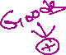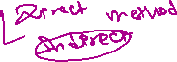

Inflow Outflow

Relationship

Assets Liabilities

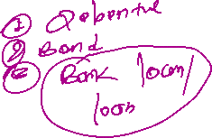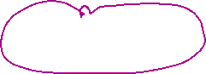

Negative Relation Positive relation  
Assets Increase - Cash decrease Liabilities Increase- Cash +   
Assets Decrease – Cash increase Liabilities decrease- Cash -

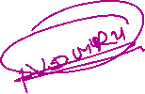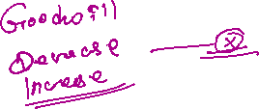

Furniture purchase Rs 400000 Loan taken Rs 2,00,000

Furniture Increase Cash +   
Cash Paid ( decrease)

Excluded Heading under direct method

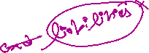

1. Depreciation/ appreciation

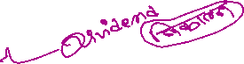

1. Reatined earning/ p/l account



1. Loss on sale of fixed assets/ profit on sale of fixed assets
2. Transfer fee related reserve.
3. Opearting activities ( related to current asset , current liabilities and revenue as well as expn ) Investing activities ( Fixed assets , investment) Financing activities ( share capital, share premium, long term debt, dividend, capital redemption) 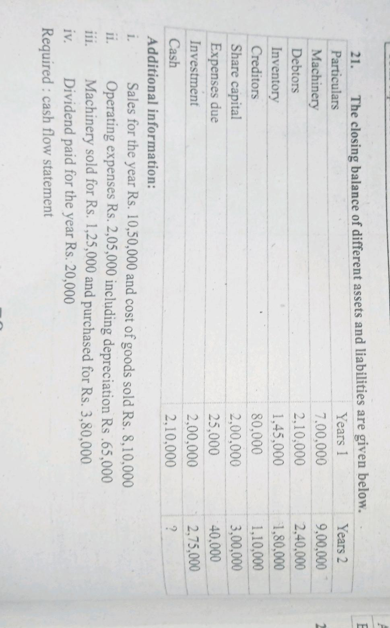

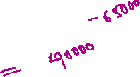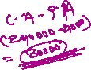

Cash flow statement under direct method

|  |  |  |
| --- | --- | --- |
| Particulars | Amount | Amount |
| 1. Operating activities 2. Cash collection from Debtors   Sales  Increase in debtors ( 240000-210000)   1. Cash paid to suppliers or creditors   Cost of Good sold  Increase in inventory/stock (180000-145000)  Increase in creditors ( 80000-110000)   1. Cash paid to employes and others   Operating expense  Increase in expesnse due (40000-25000)   1. Cash paid interest 2. Cash paid to tax | 1050000  (30000)  (810000)  (35000)  30000  (140000)  15000 | 1020000  (815000)  (125000) |
| Net Cash Flow from operating activities A |  | 80000 |
| 1. Investing activities   Machinery sold  Machinery purchase  Increase in investment | 125000  (380000)  (75000) |  |
| Net cash flow from investing activities B |  | (330000) |
| 1. Financing activities   Issue of share capital  Dividend paid  long term debt  Share premium | 1,00,000  (20000) |  |
| Net cash flow from financing activities C |  | 80000 |
| Net Change in cash Flow ( A+B+C) (80000-330000+80000) |  | (170000) |
| Add: opening cash balance ( last cash balance) |  | 210000 |
| Closing Cash balance |  | 40000 |