Cash Flow Statement Indirect Method

Only change in operating activities

Format

|  |  |
| --- | --- |
| Particulars | Amount |
| Net income …………………………..  Add: non- Operating expenses  Depreciation of fixed assets   Written of ( Intangible assets )  Loss on sale of fixed assets   Other non-operating expenses  Less: - Non-operating income/profit  Appreciation ( Gain )   Profit on sale of fixed assets   other non-operating income  Add:- Increase current liabilities and decrease in current assets  less:- Increase current assets and Decrease in current liabilities  Tax paid | Xx  Xx  Xx  Xx  Xx  (xx)  (xx) (xx)  Xx  (xx)  (xx) |
| Net cash flow from operating activities | Xx(xx) |

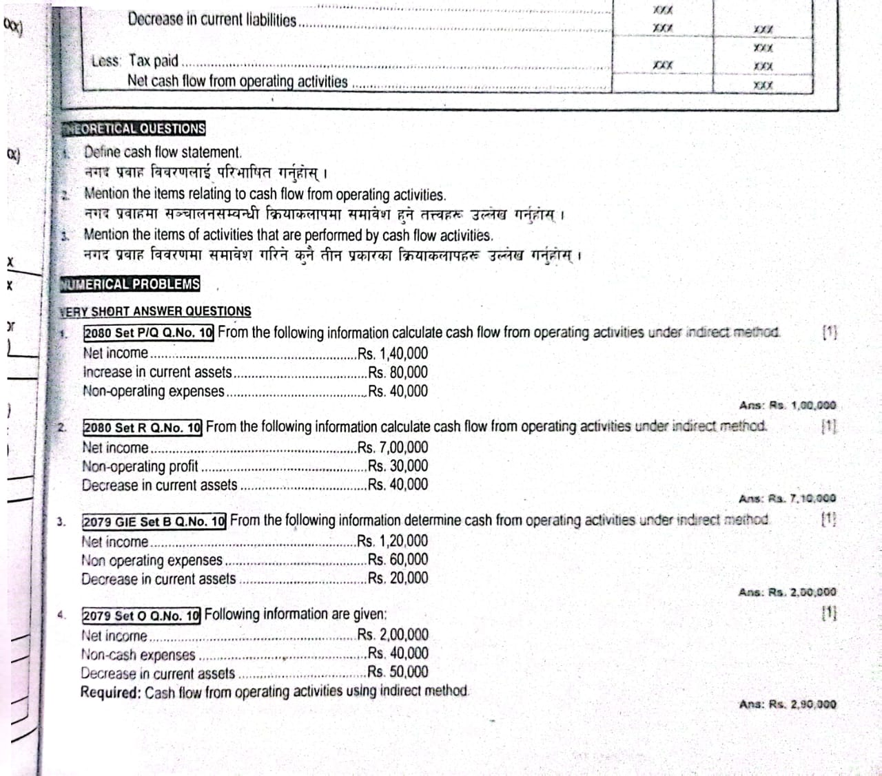

Q no 11 )

Solution Cash flow statement using indirect method

|  |  |
| --- | --- |
| Particulars | Amount |
| Net Income ……………………………….  Add: Non- Operating expenses  less:- Non-operating income Less:- Increase in current assets | 140000  40000  -  (80000) |
| Net cash flow from operating activities | 1,00,000 |

Q no2) Cash flow Statement using indirect method

|  |  |
| --- | --- |
| Particulars | Amount |
| Net income  Add:- Non- Operating expense  Less:- Non-opreating income/profit  Add:- Increase in current liabilities and decrease in current assets  less:- Increase in current assets and decrease in current liabilities | 7,00,000  -  (30000)  40000 |
| Net cash flow from operating activities | 710000 |