BBS 1st Year Account



Important Chapter With Mark Margin

|  |  |  |
| --- | --- | --- |
| Chapter | Chapter Name | Mark |
| 1 | Basic Understanding of Financial Accounting | Theory |
| 2 | Conceptual Framework of Accounting | Theory |
| 3 | Accounting Process | Numerical + Theory |
| 4 | Accrual Basis of Accounting | 2 theory |
| 5 | Accounting for Inventories & COGS | 10 marks |
| 6 | Accounting for Cash and Internal Control | 5 mark |
| 7 | Accounting for Receivables | 2+2 N |
| 8 | Accounting for Current Liabilities and Contingencies | 2 numerical |
| 9 | Accounting for Long-Lived Assets | 5 marks |
| 10 | Accounting for Long-Term Liabilities | 2 |
| 11 | Accounting for Shareholders’ Equity | 10 or 2 |
| 12 | Basic Financial Statements | 10 N |
| 13 | Cash Flow Statement | 15 N |
| 14 | Value Added Statement | 5 |
| 15 | Analysis of Financial Statements | Numerical (15/10) |

Model Set Solution 2082

Visit: nagendradhimal.com.np --------------------------------for complete notes

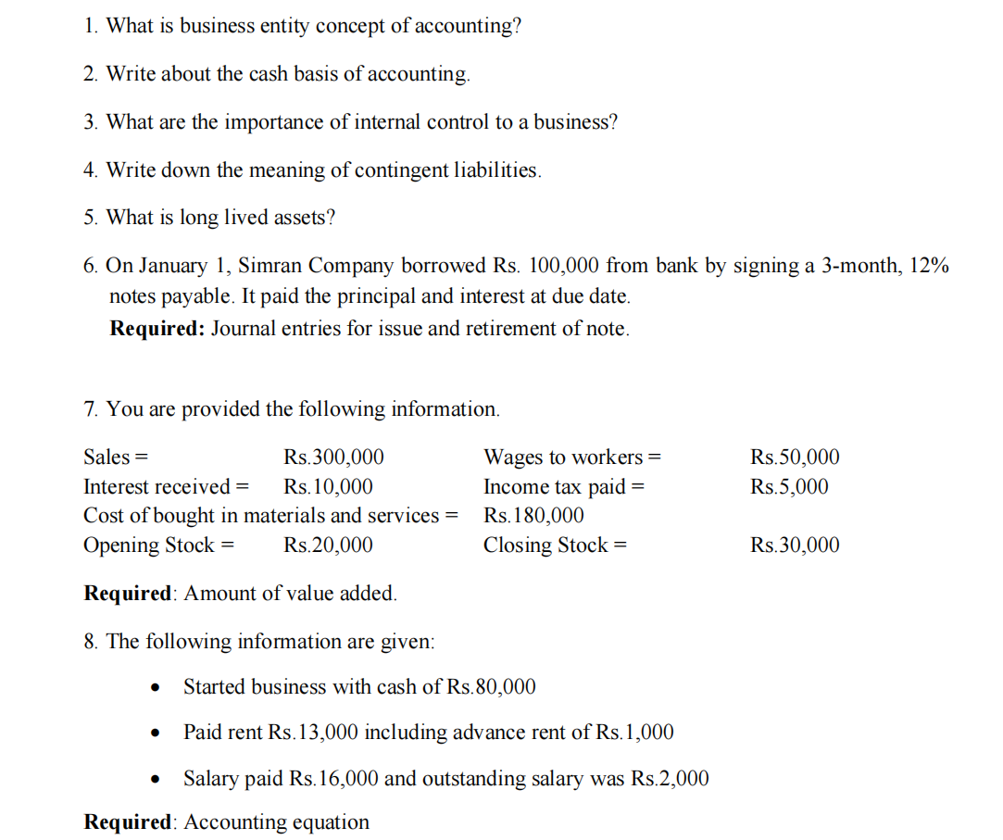

**Question 1**

* What is business entity concept of accounting?

The business entity concept assumes that the business and its owner are separate entities. This principle ensures that all financial transactions are recorded from the business’s perspective only.

**Question 2**

* Write about the cash basis of accounting.

Cash basis accounting records revenues and expenses only when cash is received or paid. It does not account for receivables or payables.

**Question 3**

* What are the importance of internal control to a business?

Internal controls help prevent fraud, ensure the accuracy of financial data, safeguard assets, ensure efficient operations, and ensure compliance with laws and regulations.

**Question 4**

* Write down the meaning of contingent liabilities.

Contingent liabilities are potential obligations that may arise depending on the outcome of a future event, such as a lawsuit.

**Question 5**

* What is long lived assets?

Long-lived assets are assets that are expected to provide economic benefits to the business for more than one year, like buildings, machinery, and equipment.

