Poem



New Nepal- Siddhicharan Shrestha

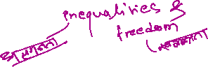

Siddhicharan Shrestha was a revolutionary writer of his time. He was sentenced in jail for 18 years as he wrote against Rana's rule. He was political prisoner.

It is a political poem that suggests to arise the voice against any types of oppression and suppression. The poem addresses Nepali people to raise their voice against the inequalities of the past and brings in a revival of freedom and self-respect. In the poem, he has expressed feelings, problems and pathos of common Nepalese people.



In the history of Nepal, political systems have been changed many times. In our society, still there is the ditch between rich and poor people. Similarly, people still believe in superstitions, and there is the problem of discrimination and corruptions. The dreams and hopes of common Nepalese people are changing but the economic condition of our nation is same. Only few people are grasping the opportunity.



He inspires us to change our Nepal by transforming from old Nepal to New Nepal. It can only be possible if we unite. If we want to make awake the nation in New Nepal, it is essential to change our social, economic, cultural, religion, and political condition.



**Write a character sketch of the type of person the speaker is on the basis of what he says in the poem.**

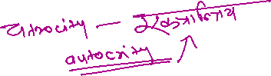

**What wrongs of "Old Nepal" does the poet want "New Nepal" to amend?**

