**Chapter 4: Skills and Values in Business Communication**



**1. Soft Skills in the Workplace**



Soft skills refer to personal attributes and interpersonal skills that determine how effectively individuals interact and collaborate with others in the workplace.



🔹 Examples: Communication, teamwork, adaptability, time management, problem-solving.  
🔹 Importance:



1. Essential for fostering a positive work environment,
2. Building relationships, and career growth.

**2. Importance of Soft Skills**

Soft skills complement hard (technical) skills and are crucial in client interactions, leadership, and teamwork.



💡 Why important?

* Boosts workplace efficiency.



* Enhances leadership and collaboration.



* Essential in customer service roles.



* Promotes adaptability and professionalism.



**3. Identifying Communication Skill Sets**



Communication skill sets include both verbal and non-verbal communication abilities essential for effective business interaction.

* **Organizational Communication Skills**:  
  🔹 Clarity and conciseness  
  🔹 Active listening  
  🔹 Email and report writing  
  🔹 Presentation skills  
  🔹 Formal and informal communication flows



**4. Interpersonal Communication Skills**

These skills involve direct interaction between individuals and are key to building professional relationships.

✨ Key aspects:

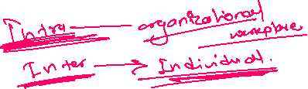

* Active listening



* Empathy



* Feedback exchange
* Conflict resolution



* Body language awareness



**5. Leadership Communication Skills**



Leaders need to inspire, guide, and motivate. Their communication must be clear, persuasive, and confident.

📌 Essential traits:



* Vision sharing
* Motivation



* Delegation through communication



* Decision-making support

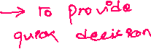

**6. Etiquette and Professionalism**



Professional etiquette is the set of behaviors expected in a professional setting.

📝 Includes:



* Respectful language



* Punctuality



* Dress code adherence



* Email and phone etiquette



**7. Elements of Professionalism**



Being professional involves more than just dressing well.

🔹 Integrity  
🔹 Responsibility  
🔹 Reliability  
🔹 Accountability  
🔹 Lifelong learning attitude



**8. Ethical Values**

Ethics in communication means sharing truthful, respectful, and fair information.

**a) Ethical Dilemma vs Ethical Lapse**

* **Ethical Dilemma**: A situation with two morally sound options, causing internal conflict. An ethical dilemma involves a difficult choice between moral principles



* **Ethical Lapse**: A clear violation of ethics (e.g., lying or plagiarism). an ethical lapse is a clear violation of ethical standards.

**b) Guidelines for Ethical Communication**



* Be honest and transparent



* Respect confidentiality



* Avoid manipulative language
* Promote fairness



**9. Intercultural Communication Skills**



As workplaces become more global, understanding cultural diversity is crucial.

**a) Diversity and Cultural Differences in the Workplace**



🌏 Includes:

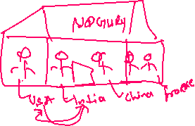

* Language barriers



* Time orientation



* Hierarchical structure



* Gestures and expressions



**b) Advantages of Diversity**



* Innovation through varied perspectives
* Better global market understanding
* Inclusive work environment



* Enhances reputation



**10. Intercultural Sensitivity**



Being sensitive means being aware of and respecting different cultures and their practices.

🛠️ Tips:



* Avoid stereotypes



* Practice active cultural listening



* Be curious and respectful



**11. Improving Intercultural Communication Skills**



✅ Strategies:

* Learn about different cultures



* Use simple and clear language



* Encourage open dialogue



* Attend cultural competency training



* Practice empathy

