**Chapter 1: The Communication Process**

**🔹 Communication – Meaning**

Communication is the process of exchanging ideas, information, feelings, and messages between individuals or groups. It involves a sender, message, medium, receiver, and feedback. The word **“communication”** comes from the **Latin word** *“communicare”*, which means **“to share”** or **“to make common.”**

* **Definition**: Communication is the act of transferring information from one place, person, or group to another.
* **Example**: A teacher explaining a lesson to students.

**🔹 Process of Communication**

The communication process includes the following elements:

1. **Sender** – The person who initiates the message.
2. **Message** – The content to be communicated.
3. **Encoding** – Converting thoughts into communicable form (words, symbols).
4. **Medium/Channel** – The method used to transmit the message (e.g., spoken, written).
5. **Receiver** – The person who receives and interprets the message.
6. **Decoding** – Interpreting the message.
7. **Feedback** – The response from the receiver to the sender.
8. **Noise** – Any disturbance that distorts the message.

**🔹 Methods of Communication**

Communication methods refer to the way information is shared.

1. **Verbal** – Spoken (face-to-face, phone).
2. **Non-verbal** – Body language, gestures, facial expressions.
3. **Written** – Emails, letters, reports.
4. **Visual** – Charts, graphs, signs.

**🔹 Modes of Communication**

Communication in an organization or society flows in different ways. These are commonly divided into formal/informal and directional modes like vertical, horizontal, and diagonal. Let’s understand each:



**1. 📋 Formal Communication**

* **Definition**: Communication that follows official, predefined channels and hierarchy within an organization.
* **Example**: A CEO issuing a notice to all department heads.
* **Features**:
  + Follows organizational structure.

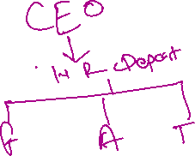

* + Usually documented.
  + Less flexible.
  + Used for official announcements, meetings, policies, etc.

**2. 🗣️ Informal Communication**

* **Definition**: Casual, unofficial interaction that doesn’t follow the formal structure.
* **Example**: A chat between two co-workers during lunch.
* **Features**:

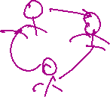

* + Spontaneous.

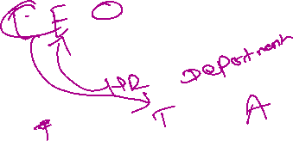

* + Builds relationships.
  + Can lead to rumors if not managed.

**3. ⬆️⬇️ Vertical Communication**

* **Definition**: Communication between different levels of the hierarchy.



* **Types**:
  + **Upward Communication**: Employee → Supervisor

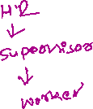

* + **Downward Communication**: Manager → Staff



* **Purpose**:



* + Reporting, feedback, instruction, delegation.



**4. ↔️ Horizontal Communication**

* **Definition**: Communication between individuals or departments at the same level in the organization.
* **Example**: Marketing team collaborating with the sales team.

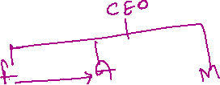

* **Purpose**:
  + Coordination, cooperation, problem-solving.



**5. 🔁 Diagonal Communication**

* **Definition**: Communication between different levels and departments that do not follow the direct hierarchy.



* **Example**: An HR assistant discussing with a finance manager.

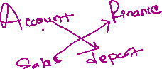

* **Purpose**:
  + Promotes quick action in cross-functional teams.
  + Enhances efficiency in complex tasks.

**🔹 Barriers to Communication**

Barriers are obstacles that hinder effective communication. Types include:

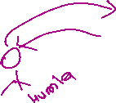

1. **Physical Barriers** – Noise, distance, environment.



1. **Semantic Barriers** – Language differences, jargon.
2. **Psychological Barriers** – Stress, emotions, biases.
3. **Organizational Barriers** – Hierarchy, rules.

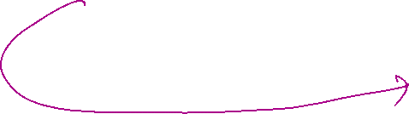

1. **Cultural Barriers** – Differences in values, beliefs.



**🔹 Oral Communication**



Oral communication involves spoken words either face-to-face or via devices.

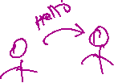

* **Examples**: Meetings, phone calls, lectures.
* **Advantages**: Quick, personal, direct.



* **Disadvantages**: No record, may be misinterpreted.

