**Chapter 2: Introduction to Business Communication**



**📌 1. Business Communication – Meaning**

Business communication is the process of sharing information between people within and outside a company. It is used to promote an organization's goals, objectives, and activities.

**Definition:**

“Business communication is the exchange of facts, ideas, orders, and information related to commerce and business.”



**📌 2. Historical Perspective**

✳️ With the arrival of radio, telephone, and television in the early nineteenth century, global business communication expanded to airwaves and electronic signals. In Nepal, modern means of communication were introduced much later, hence, their use in business is relatively new. When mass advertisements in newspaper spaces and airwaves were becoming a common phenomenon around the world, Nepal was still relying largely on oral or a limited print communication for business purposes.

✳️ With the establishment of Radio Nepal in the mid–20th century. Radio commercials became common. Radio, because of its access to a large population and instant reach, revolutionized business communication. The newspaper boom in Nepal also opened the floodgates of advertisements, helping promote many businesses. At the same time, in recent decades, television and other new media such as the internet, mobile telephony, and social media have created a complex business communication environment in the country. Business communication has been radically changed; markets today have instantaneous (rapid) means to spread their messages that can be customized to individuals, with personal and efficient services. There is no geographical or cultural boundary or barrier today for business communication. Increasing literacy rates and new media penetration are helping to expand the business environment. The challenge is to continually improve the quality of business communication for the mutual benefit of the producers and consumers.

* **Ancient Times:** Use of messengers, pigeons, and handwritten letters.
* **Industrial Revolution (18th-19th Century):** Introduction of printing presses, telegraphs.



* **20th Century:** Telephone, fax, and typewriters became popular.



* **21st Century:** Digital transformation with emails, video calls, social media, CRM systems.



**📌 3. Purpose of Business Communication**



* 📈 To inform (e.g., reports, updates)
* 🗣️ To persuade (e.g., proposals, marketing)
* 🤝 To build relationships (e.g., internal communication)



* 🛠️ To facilitate decision-making



* 🧭 To guide and instruct employees



**📌 4. Functions of Business Communication**



* **Information Sharing:** Ensures smooth flow of data and decisions.
* **Coordination:** Links departments and promotes teamwork.
* **Influencing:** Helps in negotiations, promotions, and leadership.

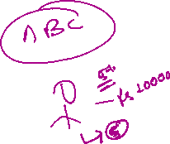

* **Problem Solving:** Identifies issues and suggests solutions.



* **Motivation:** Encourages staff through appreciation and clarity.
* **Control:** Helps in setting rules and guidelines.



**📌 5. Importance of Business Communication**



* Enhances productivity and efficiency



* Builds strong workplace relationships



* Reduces misunderstandings and conflicts
* Helps in brand image and public relations
* Supports innovation and creativity



**📌 6. Types of Business Communication**



**Based on Flow:**



* **Internal Communication:** Within the organization.



* + *Upward* (Employee to manager)



* + *Downward* (Manager to employee)



* + *Horizontal* (Peer to peer)



* + *Diagonal* (Across departments)



* **External Communication:** With clients, investors, suppliers, etc.



**Based on Mode:**



* **Verbal Communication:** Oral and written (emails, reports, calls).
* **Non-verbal Communication:** Body language, tone, eye contact.
* **Visual Communication:** Charts, graphs, infographics.

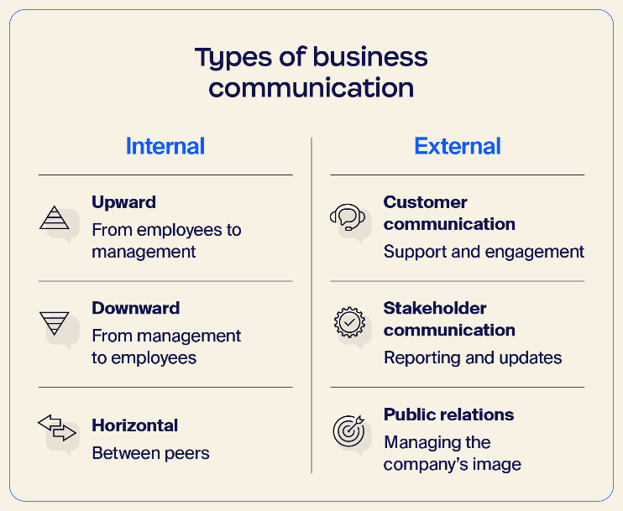



**📌 7. Challenges in Business Communication**



* 🌐 Language and cultural barriers
* ❌ Miscommunication or lack of clarity
* 🧠 Information overload
* 📱 Over-dependence on technology
* 😶 Lack of feedback
* 🕗 Time zone differences in global firms



**📌 8. Principles of Effective Business Communication**



Use the **7Cs** of communication:

1. **Clarity** – Clear message



1. **Conciseness** – Keep it brief



1. **Correctness** – No grammatical or factual errors



1. **Completeness** – Include all necessary information



1. **Concreteness** – Be specific and factual
2. **Courtesy** – Be polite and respectful
3. **Consideration** – Focus on the audience’s needs

