Power Nap Doze By NDGURU
100% Pass | Guaranteed Success
Follow us on Facebook: Nagendra Dhimal

The Reason For Your Success

Concept of Business Environment
Business environment भन्नाले business बाहिर र भित्र रहेका सबै factors हरू हुन् जसले business को decision, performance र growth लाई प्रभाव पार्छन्। Business एक्लै operate गर्दैन। यसलाई government, economy, technology, employees, society जस्ता कुराले असर गर्छ। यी सबै मिलेर business environment बन्छ।
- Business environment refers to all internal and external factors affecting business
- It influences decision making, performance and growth
- It includes economic, political, social and technological forces
- It is dynamic and continuously changing
- It creates both opportunities and threats

🔹 Characteristics of Business Environment
- Dynamic in nature (changes frequently)
- Complex (consists of many interrelated factors)
- Uncertain (future is unpredictable)
- Interrelated (one factor affects another)
- Relative (impact differs from business to business)
- Multi-dimensional (economic, political, social, technological)

🔹 Components of Business Environment
Internal Environment
- Employees
- Management
- Financial resources
- Physical resources
- Organizational culture
External Environment
Micro Environment
- Customers
- Suppliers
- Competitors
- Intermediaries
Macro Environment( PESTLEG)
- Political environment
- Economic environment
- Social environment
- Technological environment

🔹 Environmental Variables
- Variables are factors influencing business operations
- Internal variables are controllable
- External variables are uncontrollable
- Internal variables include employees, capital, management
- External variables include government policy, economy, society

🔹 Environmental Analysis Process
- Scanning: collecting relevant information
- Monitoring: observing changes continuously
- Forecasting: predicting future trends
- Assessment: evaluating impact and making decisions

🔹 Environmental Scanning
- It is the process of collecting environmental information
- Helps identify opportunities and threats
- Provides basis for strategic planning
Types:
- Concentrated scanning (focus on specific area)
- Comprehensive scanning (covers entire environment)

🔹 Importance of Business Environment
- Helps in effective decision making
- Identifies business opportunities
- Reduces risks and uncertainties
- Improves business performance
- Assists in long-term planning
- Helps in adapting to environmental changes

Unit 2: Political Environment
🔹 Concept of Political Environment
- Refers to impact of government and politics on business
- Includes laws, policies and regulations
- Influences business operations and decisions
- Determines stability and growth of business

🔹 Components of Political Environment
- Government (policy making and regulation)
- Political parties (ideology and leadership)
- Laws and regulations (rules for business operation)
- Pressure groups (trade unions, NGOs influence policies)

🔹 Business–Government Relationship
- Government provides legal framework for business
- Business depends on government policies
- Positive relationship leads to growth and support
- Negative relationship leads to restrictions and barriers
- Cooperation ensures smooth functioning

🔹 Political Risk
- Risk arising from political changes or instability
- Includes policy changes and government instability
- Affects investment and profitability
- Creates uncertainty in business environment
Impacts:
- Change in laws and policies
- Increase in taxes
- Delay in business operations
- Loss of investor confidence

🔹 Political Risk Management
- Diversification of investment
- Political risk insurance
- Forming local partnerships
- Maintaining good government relations
- Continuous monitoring of political changes

🔹 Nepalese Political Environment (Issues & Problems) ( VVVI)
- Political instability
- Frequent change in government
- Policy uncertainty
- Corruption and lack of transparency
- Weak implementation of laws
- Bureaucratic delays
- Lack of clear economic policies
Unit 3: Legal / Regulatory Environment
1. Business Law (Concept)
- Business law refers to rules and regulations governing business activities
- It controls formation, operation and closure of business
- It ensures fairness, justice and discipline in business
- It protects rights of business, employees and consumers
- It is formulated and enforced by the government

2. Features of Business Law
- Based on legal rules and regulations
- Mandatory in nature (must be followed)
- Protects all stakeholders (owners, workers, customers)
- Ensures smooth functioning of business
- Helps in dispute settlement
- Dynamic (changes with time and need)

Business Related Laws in Nepal (Very Important 🔥) ( VVI)
1. Company Act, 2063
- Governs company formation and operation
- Defines types of companies (private, public)
- Deals with registration, management and liquidation
- Ensures transparency and accountability
- Protects shareholders’ rights

2. Foreign Investment and Technology Transfer Act (FITTA), 2075
- Regulates foreign investment in Nepal
- Encourages foreign capital and technology
- Provides approval process for foreign investors
- Ensures protection of foreign investment
- Promotes economic development
3. Industrial Enterprise Act, 2076
- Regulates industrial sector in Nepal
- Promotes industrial development
- Classifies industries (small, medium, large)
- Provides facilities and incentives
- Encourages entrepreneurship

4. Labor Act, 2074
- Governs employer–employee relationship
- Defines working hours, wages and benefits
- Ensures workers’ rights and safety
- Regulates hiring and termination
- Promotes fair labor practices

5. Patent, Design and Trademark Act, 2022
- Protects intellectual property rights
- Patent → protects invention
- Design → protects product design
- Trademark → protects brand name/logo
- Prevents unauthorized use

6. Copyright Act, 2059
- Protects creative works (books, music, software)
- Gives ownership rights to creator
- Prevents copying without permission
- Encourages innovation and creativity

7. Foreign Employment Act, 2064
- Regulates foreign employment sector
- Protects rights of Nepali workers abroad
- Controls recruitment agencies
- Ensures safe migration
- Prevents exploitation
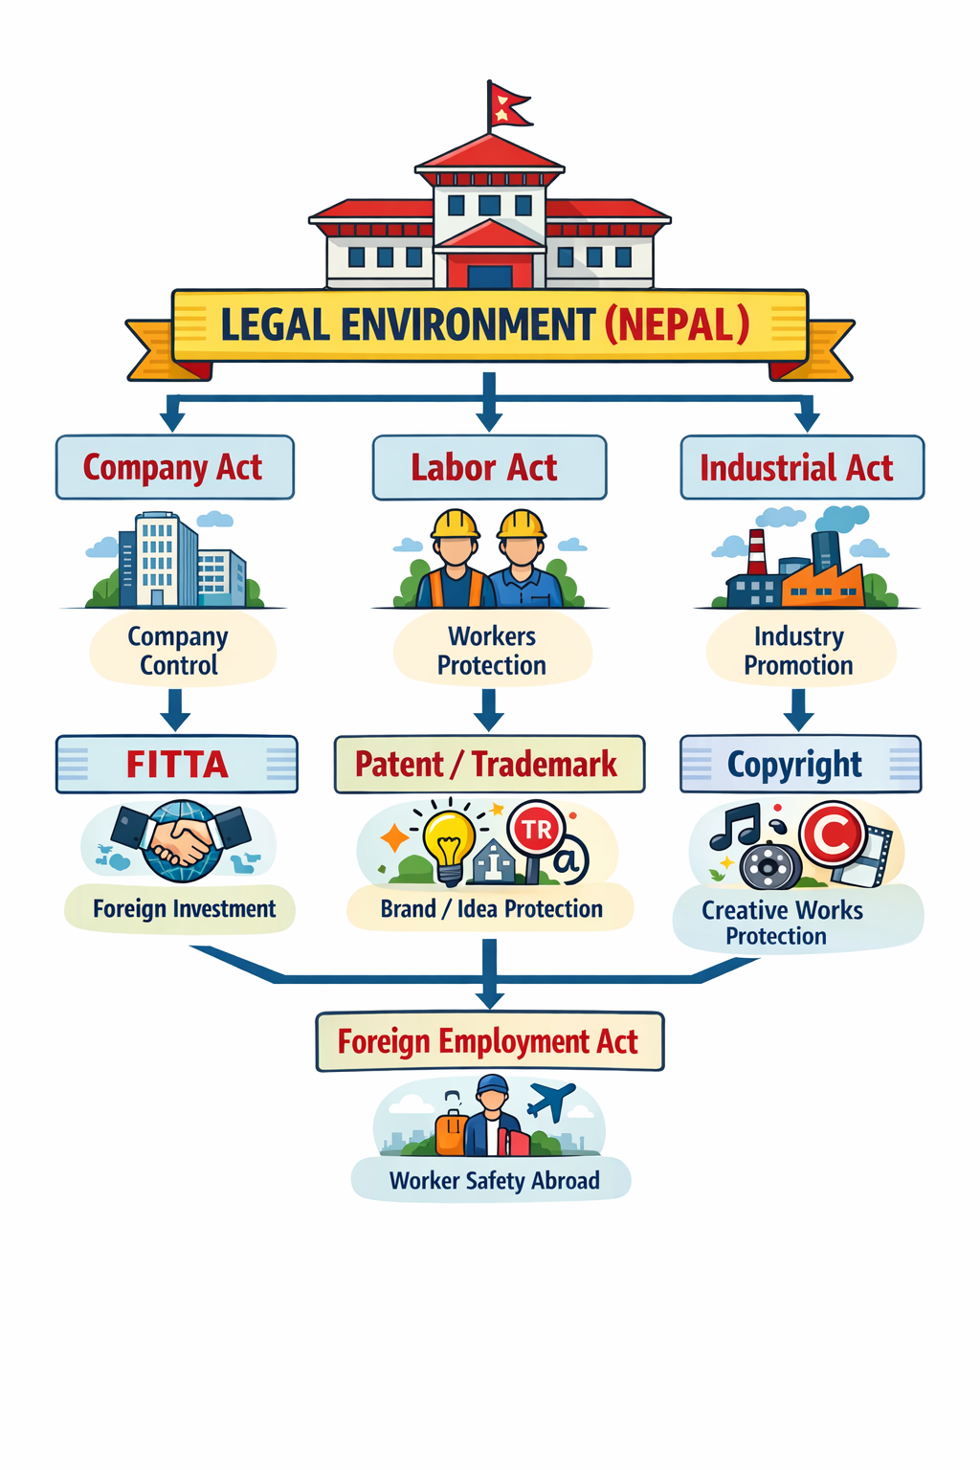

Unit 4: Economic Environment
🔹 Dimensions of an Economy
- Economic system (capitalism, socialism, mixed economy)
- Level of economic development
- Resource availability (land, labor, capital)
- Income distribution in society
- Level of industrialization
- Employment level
- Infrastructure development (transport, communication)
- Government economic policies

🔹 Structure of Nepalese Economy
- Mixed economy (public + private sector)
- Agriculture dominated economy
- Low level of industrialization
- High dependence on foreign employment/remittance
- Unequal income distribution
- High unemployment and underemployment
- Developing infrastructure
- Increasing role of service sector

🔹 Privatization (Concept)
- Transfer of ownership from public sector to private sector
- Aims to increase efficiency and productivity
- Reduces government burden
- Encourages competition and innovation

🔹 Methods of Privatization
1. Share Sales
- Selling shares of public enterprise to private investors
- Government retains partial ownership

2. Management Contract
- Private sector manages public enterprise
- Ownership remains with government

3. Lease Assets
- Private sector uses government assets for fixed period
- Pays rent/lease amount

4. Business Sale
- Full sale of public enterprise to private sector
- Ownership completely transferred

5. Other Methods
- Joint venture
- Public-private partnership (PPP)

🔹 Liberalization (Meaning)
- Reduction of government control in business
- Promotion of free market system
- Encouragement of private sector participation
- Removal of trade barriers

🔹 Requirement of Liberalization
- To promote economic growth
- To attract foreign investment
- To increase competition
- To improve efficiency
- To expand international trade

🔹 Economic Policies
1. Monetary Policy
- Controlled by central bank (NRB)
- Controls money supply and inflation
- Regulates interest rates

2. Industrial Policy
- Promotes industrial development
- Provides incentives and facilities
- Encourages entrepreneurship

3. Trade Policy
- Regulates import and export
- Promotes international trade
- Reduces trade barriers

4. Tourism Policy
- Promotes tourism sector
- Increases foreign exchange earnings
- Develops infrastructure

5. Employment Policy
- Focuses on job creation
- Reduces unemployment
- Promotes skill development

🔹 Effects of Liberalization on Nepalese Business
Positive Effects
- Increase in foreign investment
- Growth of private sector
- Improved efficiency and productivity
- Expansion of market opportunities
- Technological development

Negative Effects
- High competition (local firms suffer)
- Risk of foreign dominance
- Increase in inequality
- Small industries may close

Unit 5: Socio-Cultural Environment
Introduction to Socio-Cultural Environment
- Refers to social and cultural factors affecting business
- Includes values, beliefs, customs and traditions
- Influences consumer behavior and demand
- Affects business decisions and strategies

🔹 Socio-Cultural Components
1. Attitude and Belief
- People’s thinking and perception
- Influences buying behavior
- Affects acceptance of products

2. Religion
- Determines values and lifestyle
- Influences consumption patterns
- Affects business operations (e.g. festivals, holidays)

3. Language
- Medium of communication
- Affects marketing and promotion
- Important for customer understanding

4. Education
- Determines knowledge and skills
- Influences consumer awareness
- Affects workforce quality

5. Family Structure
- Joint or nuclear family system
- Influences buying decisions
- Affects demand pattern

6. Social Organizations
- Groups like clubs, NGOs, unions
- Influence public opinion
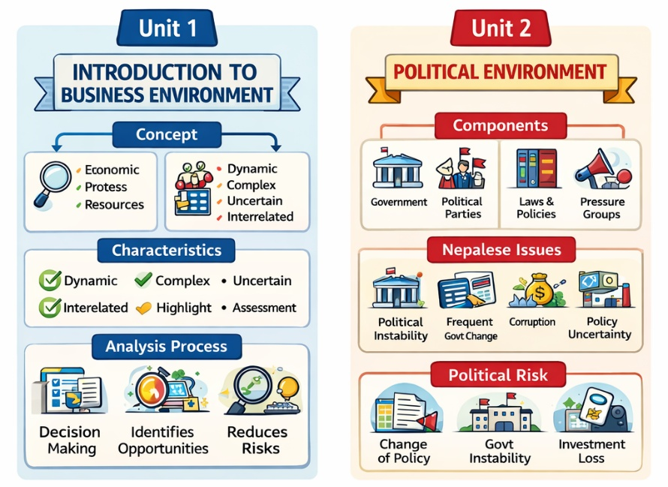
- Affect business environment
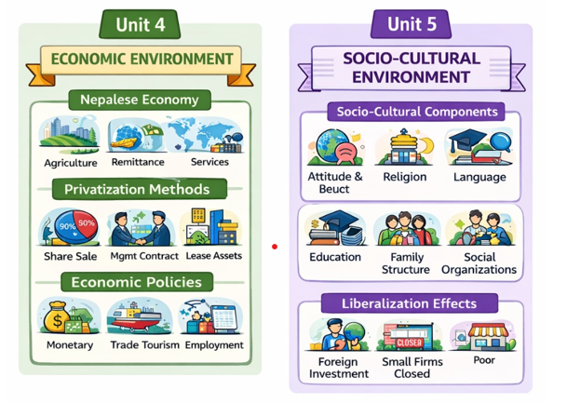
Unit 6: Technological Environment (10 LHS)

1. Meaning of Technology
Technology refers to the use of tools, machines, systems, and knowledge to produce goods and services efficiently.
- Faster production
- Better communication
- Cost reduction
- Improved quality
🧠 Shortcut: Technology = “How work is done better + faster + cheaper”

2. Components of Technological Environment
Main components:
(c) Information Systems
- Data collection and processing systems
- Example: MIS (Management Information System)
(d) R&D (Research & Development)
- Innovation and new product development
(e) Communication Technology
- Internet, mobile, email, video calls
🧠 Mnemonic: H-S-I-R-C

(a) Hardware
- Machines, computers, equipment
- Example: ATM, laptops, robots
(b) Software
- Programs and applications
- Example: accounting software, ERP

3. Effect of Technology on Business
Positive Effects:
- 🚀 Increase productivity
- 💰 Reduce cost
- ⚡ Faster decision making
- 🌍 Global market access
- 📊 Better data management
Negative Effects:
- 👨‍💼 Job displacement (automation)
- 💸 High initial cost
- 🔐 Cybersecurity risks
- 📉 Skill gap among workers

4. Factors Affecting Choice of Technology
- 💰 Cost of technology
- 👨‍🔧 Availability of skilled labor
- 📈 Size of business
- 🏭 Nature of product/service
- 🔧 Maintenance requirement
- 🌍 Market demand
- ⚖️ Government policy
🧠 Shortcut: C-S-S-N-M-M-G

5. Information Technology Policy in Nepal
Nepal’s IT policy aims to:
- Promote digital economy
- Expand internet access
- Encourage e-governance
- Develop IT industries
- Create IT employment
Focus areas:
- ICT education
- Cybersecurity
- Digital infrastructure
Problems:
- Weak infrastructure in rural areas
- Low R&D investment
- Brain drain (skilled youth leaving country)
- Digital divide

- Innovation & startups

6. Status of Technology in Nepal
Positive:
- Rapid mobile/internet growth
- Use of banking apps & e-wallets
- Expansion of e-learning platforms
- Government digital services

Unit 7: Asian and Global Environment

1. Globalization
Globalization means the process of connecting countries of the world in terms of:
- Trade (buying and selling goods)
- Culture (ideas, lifestyle, fashion)
- Technology (internet, machines, communication)
- Finance (money and investment flow)
👉 In simple words: “World becomes a small village where countries are connected.”

Forms of Globalization
1. Economic Globalization
- Free movement of goods, services, and capital between countries
- Example: Nepal importing smartphones from China
2. Cultural Globalization
- Sharing of culture, music, food, fashion across countries
- Example: K-pop, Hollywood movies in Nepal
3. Political Globalization
- Countries work together through international organizations
- Example: UN decisions affecting many countries
4. Technological Globalization
- Fast spread of technology across the world
- Example: Internet, social media, AI tools

2. WTO
World Trade Organization is an international organization that controls and manages global trade rules between countries.
👉 It helps countries trade smoothly and fairly.

Principles of WTO
1. Free Trade
- Countries should reduce taxes (tariffs) on imports and exports
2. Non-Discrimination
- Equal treatment for all member countries
- No special advantage or punishment
3. Transparency
- Trade rules must be clear and open
4. Fair Competition
- No unfair business practices like monopoly or dumping

3. Nepal and WTO
Opportunities for Nepal
- 🌍 Easy access to international markets
- 💰 Increase in foreign investment
- 🔧 Technology transfer from developed countries
- 📈 Growth in export industries (tea, handicrafts, carpet)

Threats for Nepal
- 🏭 Local industries face strong foreign competition
- 📉 Small businesses may struggle to survive
- ⚖️ Dependence on imported goods increases
- 💸 Trade deficit may increase

4. Regional Economic Integration
Meaning
It means countries of the same region working together to improve trade and economy.
👉 They reduce trade barriers like taxes and restrictions.

Examples
- SAFTA (South Asia)
- EU (Europe)
- ASEAN (Southeast Asia)

5. SAFTA
South Asian Free Trade Area is a trade agreement among South Asian countries like Nepal, India, Bhutan, Bangladesh, etc.
👉 Its goal is to increase trade in South Asia.

Opportunities of SAFTA
- 📦 Easy trade among South Asian countries
- 💰 Lower import/export taxes
- 🚚 Faster movement of goods
- 📈 Growth of regional business

Threats of SAFTA
- ⚠️ Strong countries dominate weak economies
- 📉 Trade imbalance (import more than export)
- 🏭 Local industries may not compete well

6. BIMSTEC
Bay of Bengal Initiative for Multi-Sectoral Technical and Economic Cooperation is a regional organization connecting countries around the Bay of Bengal.
👉 Members include countries from South Asia and Southeast Asia.

Opportunities of BIMSTEC
- 🤝 Strong economic cooperation between countries
- ⚡ Energy sharing projects (electricity, gas)
- 🚢 Better trade and transport links
- 📚 Technology and skill development

Threats of BIMSTEC
- ⚠️ Political instability in some member countries
- 📊 Unequal economic development
- 🚧 Weak implementation of agreements

Unit 8: Introduction to Strategic Management

1. Strategy
Concept
Strategy means a long-term plan of action made to achieve organizational goals and gain competitive advantage.
Simple: “Strategy is how a company plans to win in the market.”
सम्झिनै पर्ने
Levels of Strategy
Need of Strategy
Importance of Strategy
Process of Strategy
Role of a Strategic Auditor
Characteristics of Strategy
- Long-term plan
- Helps achieve goals
- Focus on competitive advantage
- Future-oriented
- Flexible (can change if needed)
- Based on environment analysis

2. Levels of Strategy
1. Corporate Level
- Top-level strategy
- Decides overall business direction
- Types: Diversification, Growth/Expansion, Stability and Retirement Strategy
2. Business Level
- Focus on competition in a specific market
- Types: Focus, Cost leadership and Differentiation Strategy
3. Functional Level
- Day-to-day operations strategy
- Types: Marketing, HR, finance strategies , Operational, marketing

3. Strategic Decisions
Concept
Strategic decisions are important long-term decisions that affect the whole organization.
Characteristics
- Long-term impact
- High risk
- Made by top management
- Affects organization as a whole
- Difficult to reverse

4. Strategic Management
Strategic management is the process of planning, implementing, and controlling strategies to achieve goals.

Process
- Environmental analysis
- Strategy formulation
- Strategy implementation
- Evaluation & control

Benefits
- Better decision making
- Competitive advantage
- Efficient resource use
- Long-term growth
- Improved performance

5. Phases of Strategic Management
- Planning phase
- Implementation phase
- Evaluation phase

6. Strategic Planning
Strategic planning is the process of defining goals and creating steps to achieve them.

Components
- Vision & mission
- Objectives
- Policies
- Resources
- Action plans

Process:
- Define mission & vision
- Set objectives
- Analyze environment
- Formulate strategy
- Implement strategy
- Evaluate results

7. Challenges to Strategic Management
1. Innovation
2. Globalization
3. Sustainability

8. Role of Chief Executive Officer (CEO)
- Sets vision and mission
- Makes strategic decisions
- Leads organization
- Allocates resources
- Monitors performance
- Ensures goal achievement

Unit 9: External Environment & Industry Analysis
सम्झिनै पर्ने
Components
Porter Approach
PESTLE analysis
Scenario building
Strategic Alliance and EFEM

1. Environmental Analysis (Aspects)
- Economic environment
- Political/legal environment
- Social/cultural environment
- Technological environment
- Global environment

2. Importance of External Environment
- Identifies opportunities
- Identifies threats
- Helps in decision making
- Reduces risks
- Improves competitiveness

3. Industry Analysis (Porter’s Approach)
Porter's Five Forces Model helps analyze competition in an industry.
Five Forces:
- Threat of new entrants
- Bargaining power of suppliers
- Bargaining power of buyers
- Threat of substitutes
- Industry rivalry
👉 Helps understand how strong competition is in a market.

4. PESTEL Analysis
PESTEL Analysis is used to analyze macro environment:
- Political
- Economic
- Social
- Technological
- Environmental
- Legal

5. Scenario Building
- Creating possible future situations
- Helps prepare for uncertainty
- Improves strategic decisions

6. Strategic Alliance
- Cooperation between two or more companies
- Share resources and technology
- Example: Joint ventures

7. Strategic Audit
- Systematic review of strategy
- Checks performance and effectiveness
- Identifies problems and improvements

8. EFEM Matrix
External Factor Evaluation Matrix is a tool used to:
- Identify external opportunities and threats
- Assign weights and scores
- Evaluate business environment impact

Unit 10: Organizational Appraisal

1. Concept of Organizational Appraisal
Organizational appraisal means the systematic analysis of an organization’s internal resources, capabilities, strengths, and weaknesses to understand its strategic position.
Simple meaning: “Knowing what the company is good at and what it lacks.”

2. Company Resources
Resources are the inputs used by an organization to achieve its goals.
Types of Resources
1. Available Resources
2. Threshold Resources
3. Unique Resources

3. Core Competencies
Core competencies are the special skills or abilities that help an organization perform better than competitors.
👉 Example:
- Good customer service
- Strong distribution system
- Advanced technology use
✔ These are difficult for competitors to copy.

4. Distinctive Competencies
Distinctive competencies are unique strengths that clearly differentiate a company from competitors.
👉 Simple: “What makes a company different and better.”
Example:
- Apple’s design innovation
- Nike’s brand image

5. Strategic Advantage
Strategic advantage means a benefit that helps a company perform better than rivals in the long run.
👉 It comes from:
- Better resources
- Strong competencies
- Unique capabilities

6. Strategic Advantage Profile (SAP)
Strategic Advantage Profile is a tool used to evaluate the strengths and weaknesses of an organization compared to competitors.
It helps to:
- Identify strengths
- Identify weaknesses
- Compare with competitors
- Improve strategy
👉 Simple: “A performance report card of the company.”
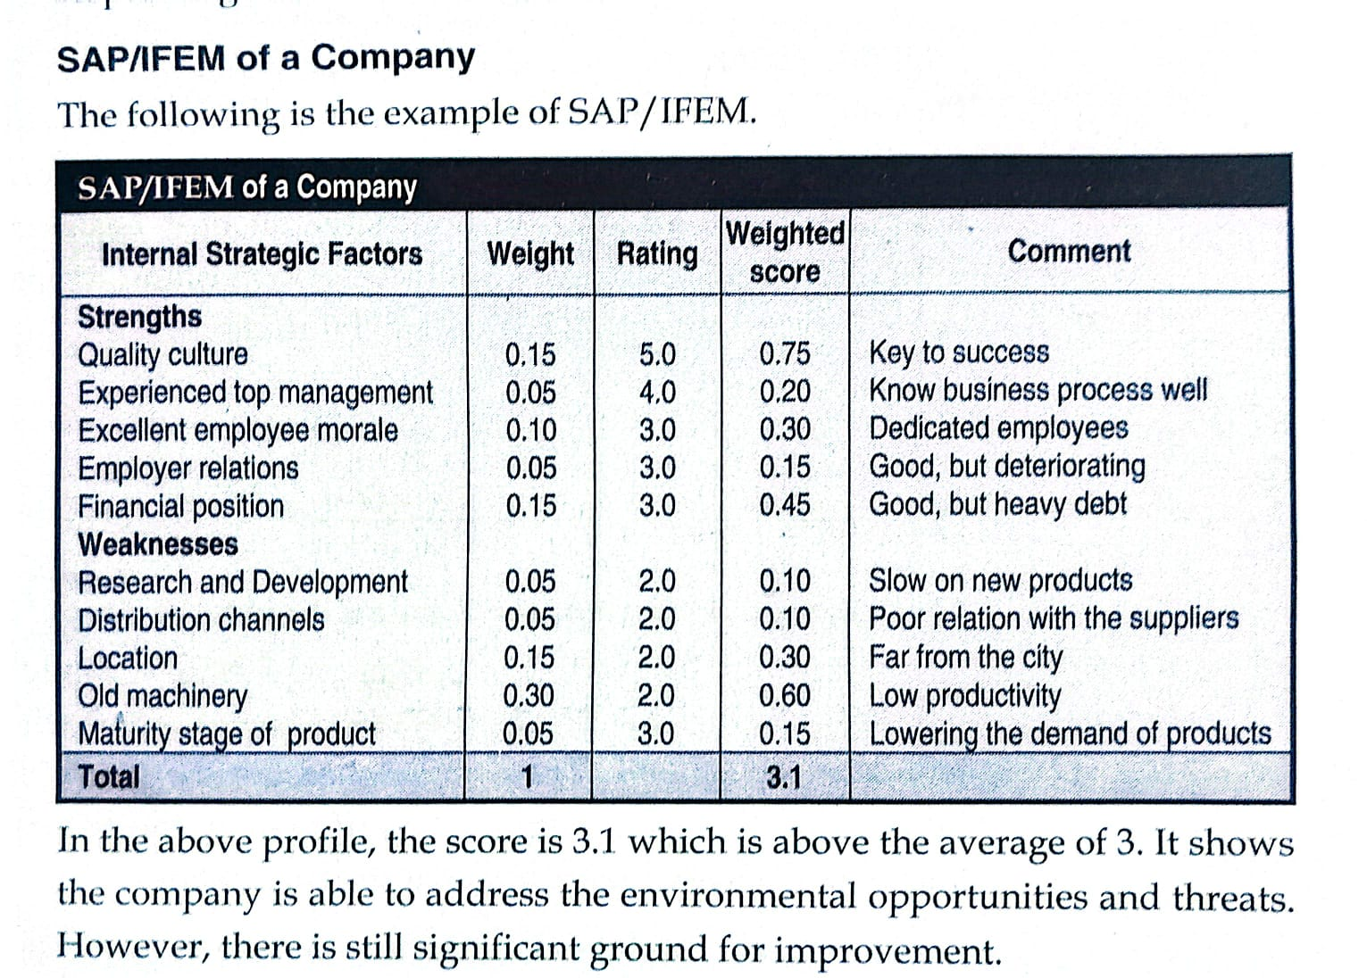

7. Value Chain Analysis
Value Chain Analysis is a method used to analyze all activities of a business to find where value is created.

Concept
It breaks business activities into primary and support activities to understand cost and value creation.

Importance of Value Chain Analysis
- Helps reduce cost
- Improves efficiency
- Identifies weak areas
- Improves competitive advantage
- Enhances customer value

Unit 11: Strategy Formulation (15 marks Fix)

1. Strategy Formulation
Concept
Strategy formulation means developing plans and choosing the best strategies to achieve organizational goals.
👉 Simple: “Deciding what a company should do to succeed.”
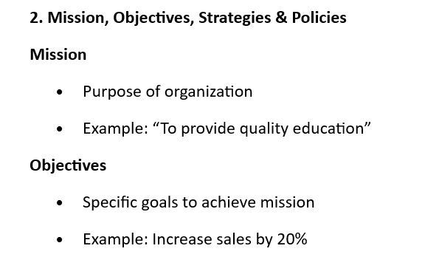
Importance
- Helps achieve long-term goals
- Improves decision making
- Provides clear direction
- Helps face competition
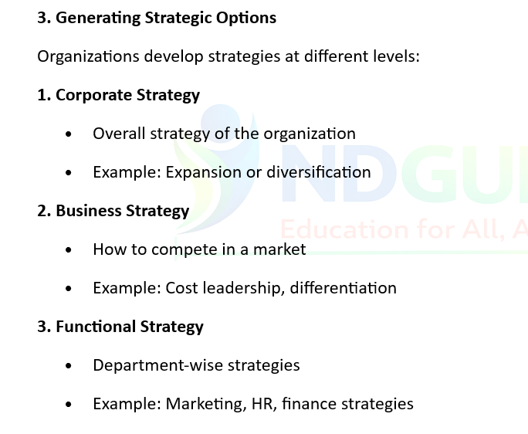
Strategies
- Long-term action plan
- Example: Expand market internationally
Policies
- Guidelines for decision making
- Example: “No credit sales policy”

3
4. SWOT Analysis
SWOT Analysis is used to identify internal and external factors.
Components
- S = Strengths (internal advantages)
- W = Weaknesses (internal limitations)
- O = Opportunities (external chances)
- T = Threats (external risks)
Helps in better strategy making.

5. Corporate Level Strategies
1. Stability Strategy
- No major change
- Maintain current business
2. Growth Strategy
- Expand business
- Increase sales, markets
3. Retrenchment Strategy
- Reduce size or cut costs
- Used in crisis
4. Combination Strategy
- Mix of growth, stability, and retrenchment

6. Business Level Strategies
Porter’s Competitive Strategy
Porter's Generic Strategies
- Cost leadership (low cost)
- Differentiation (unique products)
- Focus strategy (niche market)
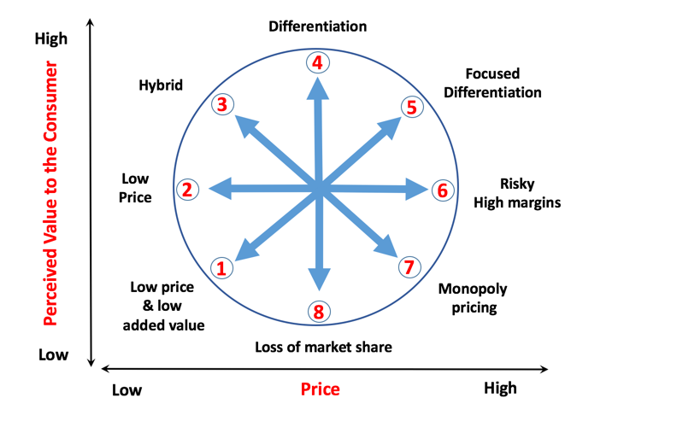
Strategic Clock Model
- Low price strategy
- Differentiation strategy
- Hybrid strategy (balance of price & quality)

7. Functional Level Strategies
1. Marketing Strategy
- Promotion, pricing, distribution
2. Financial Strategy
- Investment, budgeting, cost control
3. Operation Strategy
- Production efficiency, quality control
4. HRM Strategy
- Recruitment, training, motivation
5. R&D Strategy
- Innovation and product development

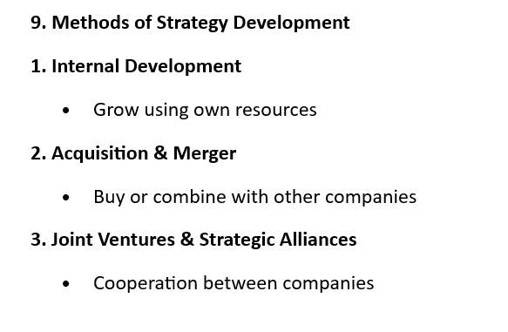
8. Direction for Strategy Development
1. Market Penetration
- Sell more in existing market
2. Market Development
- Enter new markets
3. Product Development
- New products in existing market
4. Diversification
- New products + new markets
5. Consolidation
- Focus on core business, reduce expansion

10. Portfolio Analysis for Strategic Choice
1. BCG Matrix, Hofers Matrix and General Eletric Mckinsey Matrix
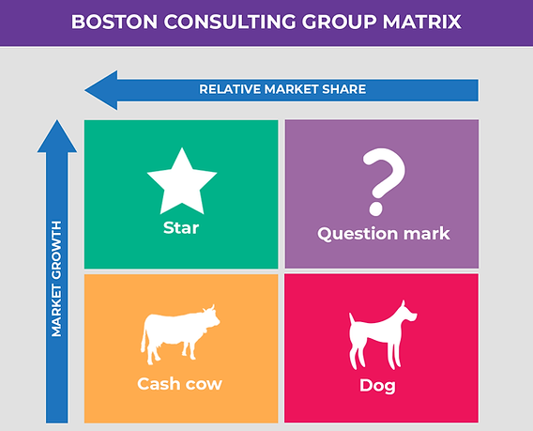
BCG Matrix
- Stars (high growth, high share)
- Cash cows (low growth, high share)
- Question marks (high growth, low share)
- Dogs (low growth, low share)

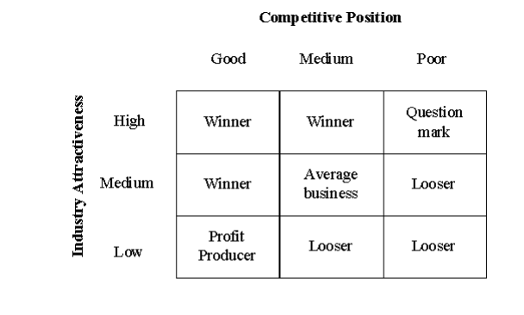
2. GE Business Screen
GE McKinsey Matrix
- Industry attractiveness vs business strength
- Helps investment decisions

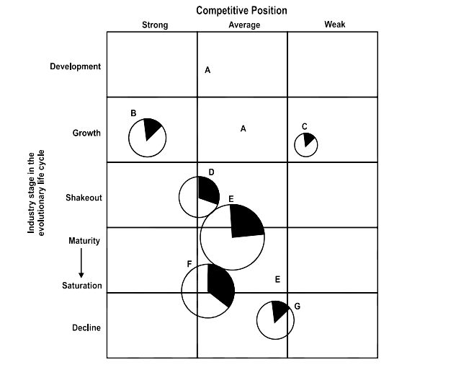
3. Hofer’s Matrix
Hofer Matrix
- Focuses on product life cycle
- Helps in strategic planning of business units

Unit 12: Strategy Implementation

1. Concept of Strategy Implementation
Strategy implementation means putting formulated strategies into action to achieve organizational goals.
Simple: “Doing what is planned in strategy.”

2. Process of Strategy Implementation
- Set clear objectives
- Allocate resources
- Design organizational structure
- Assign responsibilities
- Develop policies & systems
- Execute strategy
- Monitor performance

3. Requirements for Strategy Implementation
1. Structure
- Proper organizational structure is needed
- Clear roles and responsibilities
- Helps coordination
Example: Separate marketing, finance, HR departments

2. Resources
- Financial resources (money)
- Human resources (employees)
- Physical resources (machines, technology)
- Information resources

3. Management System
- Planning system
- Control system
- Communication system
- Reward system
Helps in smooth execution of strategy

4. Strategic Change
Concept
Strategic change means modifying strategies, structure, or systems to adapt to the environment.
Simple: “Changing organization to survive and grow.”

Levels of Strategic Change
1. Operational Change
- Small changes in daily activities
- Example: improving customer service
2. Strategic Change
- Major changes in strategy
- Example: entering new market
3. Transformational Change
- Complete organizational change
- Example: digital transformation

Management of Strategic Change
- Identify need for change
- Communicate change clearly
- Reduce employee resistance
- Provide training
- Monitor progress

Unit 13: Strategic Evaluation and Control

1. Concept of Control in Strategic Management
Control means monitoring and correcting activities to ensure goals are achieved.
Simple: “Checking whether plan is working or not.”

2. Strategic Information System
Management Information System is a system that collects, processes, and provides information for decision-making and control.

3. Types of Control
1. Pre-Control (Feedforward)
- Before implementation
- Prevents problems
2. Concurrent Control
- During implementation
- Real-time monitoring
3. Post-Control (Feedback)
- After completion
- Evaluates results

4. Strategy Evaluation
Strategy evaluation means checking whether strategies are achieving desired results or not.

Characteristics
- Continuous process
- Objective-based
- Performance-focused
- Feedback-oriented
- Future improvement tool

5. Measures of Corporate Performance
- Profitability (profit, ROI)
- Market share
- Sales growth
- Customer satisfaction
- Employee performance
- Productivity

6. Problems in Measuring Performance
- Lack of accurate data
- Changing business environment
- Intangible factors (brand value)
- Time lag in results
- Human bias

7. Characteristics of Effective Evaluation & Control
- Clear objectives
- Timely feedback
- Accurate information
- Flexible system
- Cost-effective
- Easy to understand

8. Guidelines for Proper Evaluation & Control
- Set clear performance standards
- Use reliable data
- Compare actual vs planned results
- Take corrective action
- Involve employees
- Regular monitoring

