9. Journal Entries

|  |  |  |  |  |
| --- | --- | --- | --- | --- |
| Date | Particulars | Lf | Debit | Crede |
| 1 | Commission a/c Dr  To unearned commission a/c  ( Being adjusted commission received but not earned) |  | 15000 | 15000 |

Calculation purchase

|  |  |
| --- | --- |
| Particulars | Amount |
| Cost of good sold  Opening stock  Less:- Closing stock | 350000  50000  (40000) |
| Purchase | 360000 |

11

Given

Ordering cost per order ( O) =300  
carrying cost ( C) = Rs 2   
annual requirements ( A) + 30000  
EOQ= ?

Solutioin

We have   
EOQ = Root under 2AO/C   
 Root Under 2*30000*300/2

Economic order quantity (EOQ) = 3000 Units   
1. Application

2. Allotment   
3. First and Final call

Failed to pay = calls in arrear ( Bank Dr )   
Full vale paid/ paid on allotment = calls in advance ( Cr side tyo allotment money received )

Allotment calls in arrear = No of share applied/ issued share   
allotment rate- rate   
No of Share * Rate

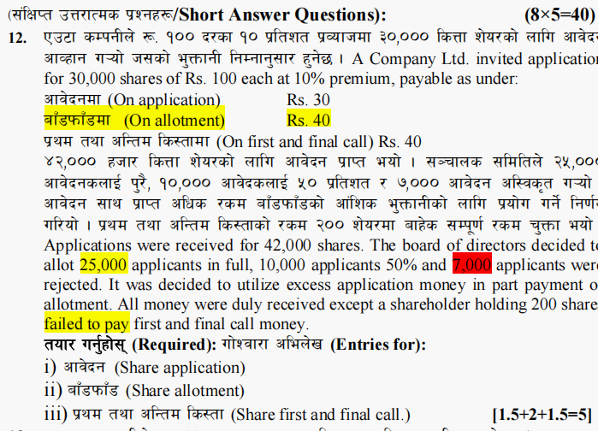

Journal Entries

|  |  |  |  |  |
| --- | --- | --- | --- | --- |
| Date | Particulars | LF | Debit | Credit |
| 1. | Application money received  Bank a/c Dr ( 42000*30)  To share application a/c  ( Being share application money received) |  | 1260000 | 1260000 |
| 2 | Transfer into share capital  Share application a/c Dr ( 42000*30)  To share capital a/c (30000*30)  To bank a/c (7000*30)  To share allotment a/c ( 5000*30)  (being share application money transfer to share capital) |  | 1260000 | 900000  210000  150000 |
| 3 | Allotment money due  Share Allotment a/c Dr ( 30000*40)  To share capital (30000*30)  To share premium a/c (30000*10)  ( Being share allotment money due) |  | 1200000 | 900000  300000 |
| 4 | Allotment money received  Bank a/c Dr (1200000-150000)  To share allotment a/c  ( Being share allotment money received) |  | 1050000 | 1050000 |
| 5 | Final call money due  Share final a/c Dr (30000*40)  To share capital a/c  ( Being share final call money due)_ |  | 1200000 | 1200000 |
| 6 | Share final call money received  Bank a/c Dr (1200000-8000)  Calls in arrear a/c Dr (200*40)  To share final call a/c  ( Being share final call money received) |  | 1192000  8000 | 1200000 |

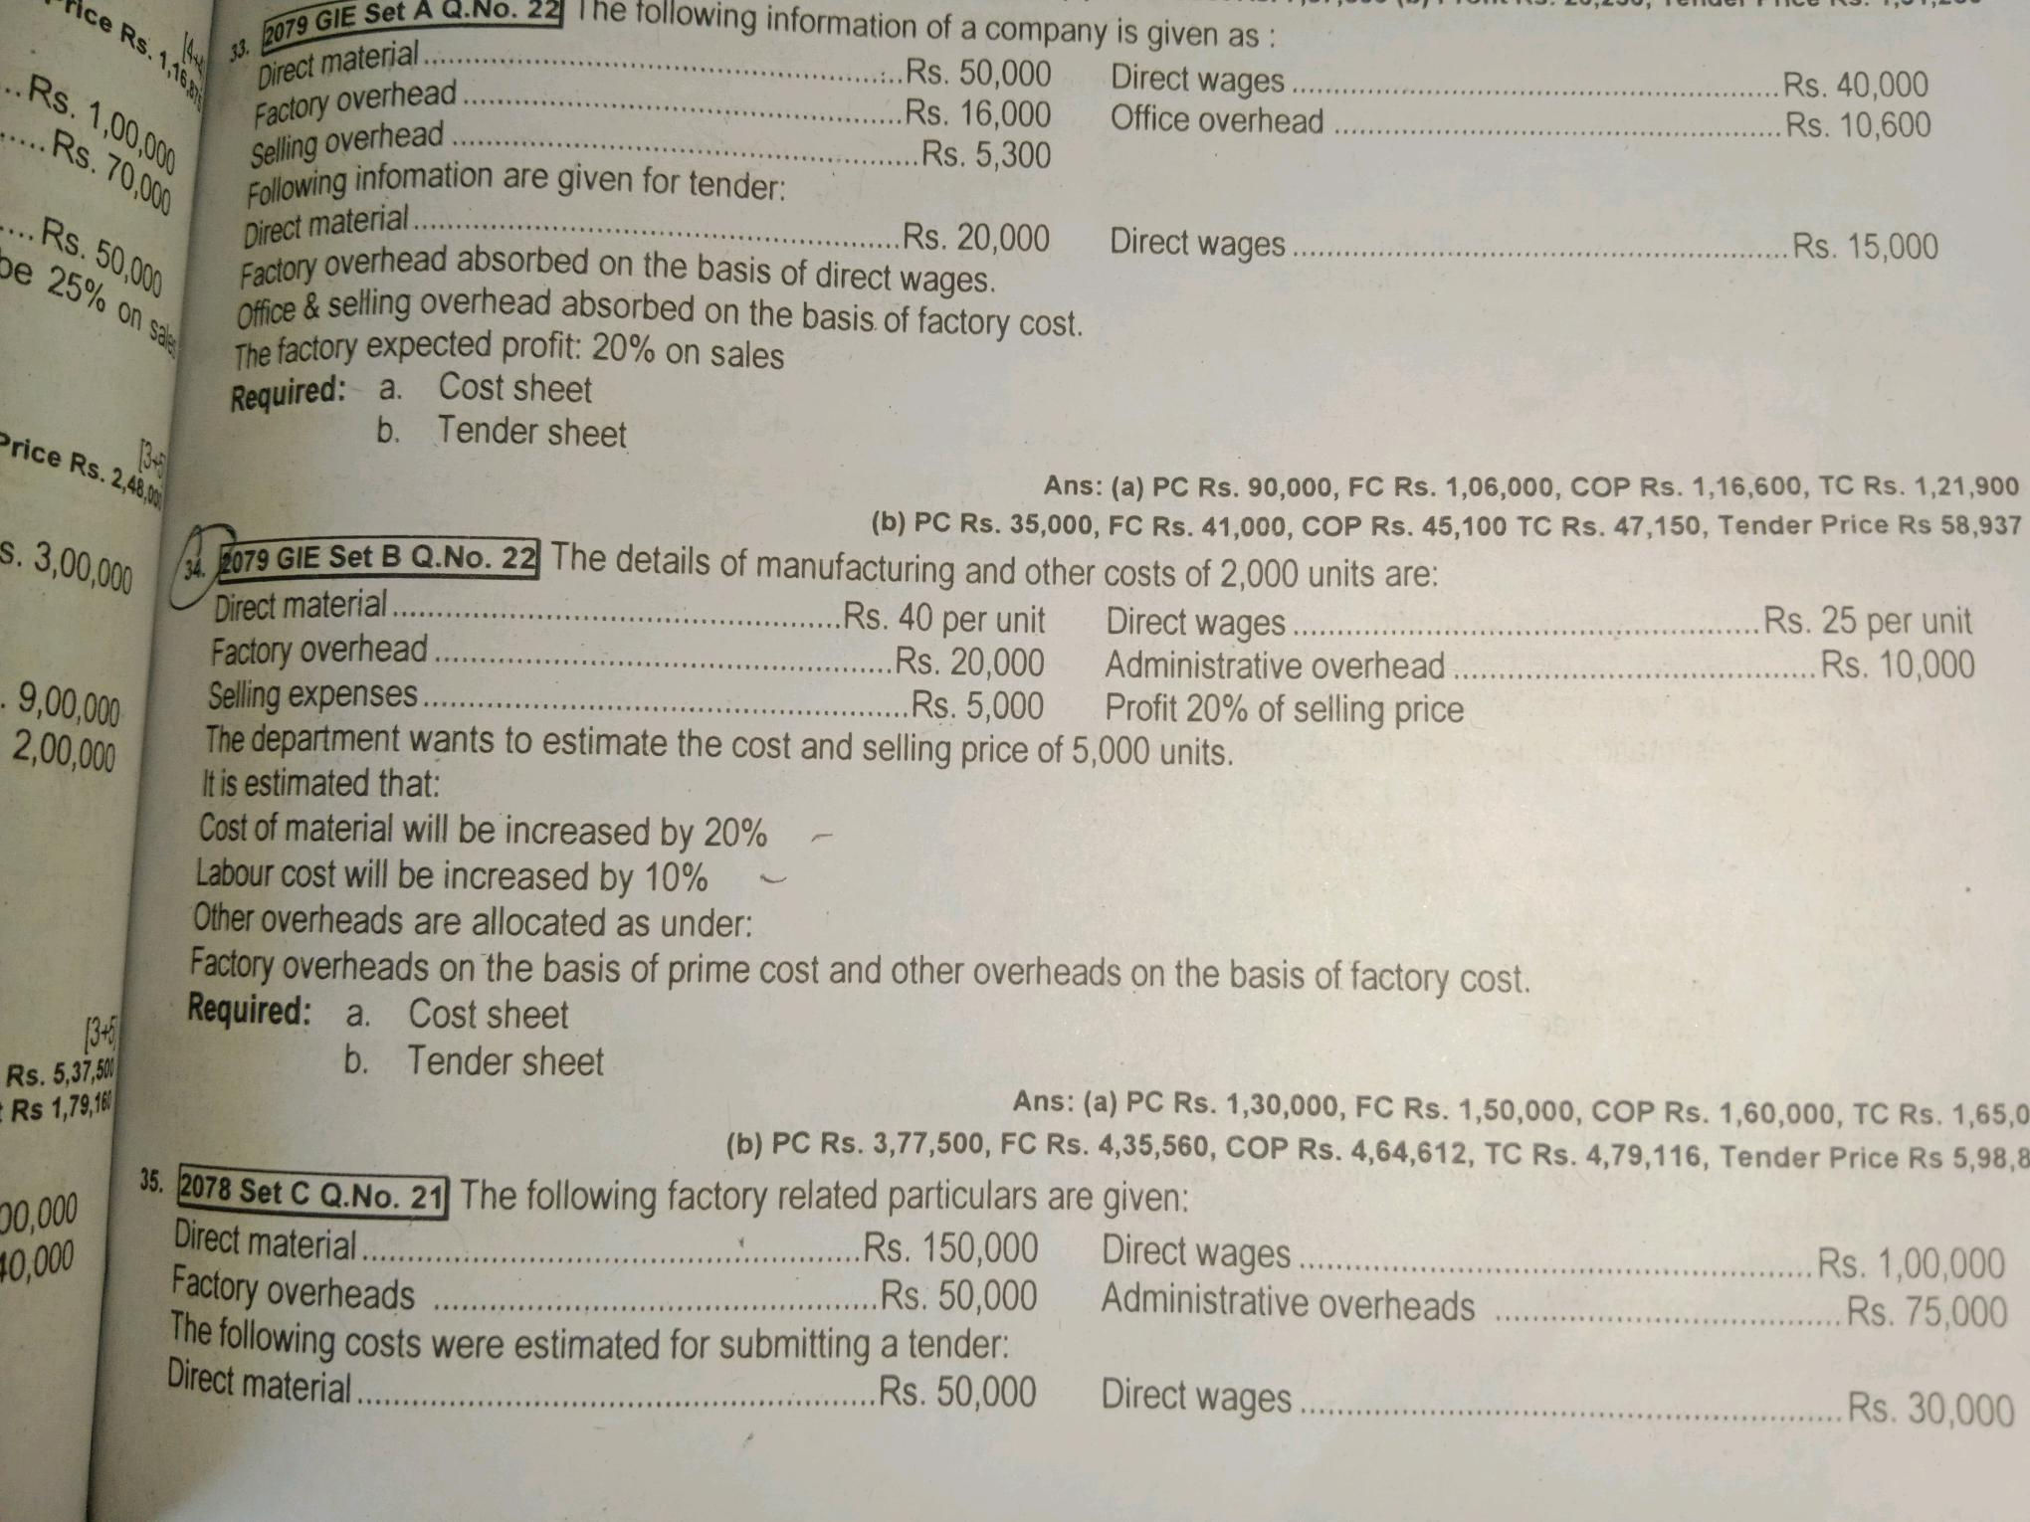

1. % of factory OH = Factory OH / Prime cost * 100 =20000/130000*100= Rs 15.38%
2. % of Office Oh = Office OH /Factory Cost *100= 10000/150000*100= Rs 6.67%
3. % of selling OH = selling Oh / Factory Cost *100= 5000/150000*100= 3.33%
4. Cost sheet of ABC Company for 2000 units

|  |  |  |
| --- | --- | --- |
| Particulars | Rate | Amount |
| Direct materials(2000*40)  Direct wages (2000*25) | 40  25 | 80000  50000 |
| Prime cost  Add:- Factory OIverheads |  | 130000  20000 |
| Factory cost  Add:- Office and Administrative OH |  | 150000  10000 |
| Cost of production |  | 160000 |
| Add:- Selling Overheads |  | 5000 |
| Total Cost  Add:- Profit @ 20% ( 165000*20/100-20) |  | 165000  41250 |
| Sales price |  | 206250 |

1. Tender sheet for 5000 units

|  |  |  |
| --- | --- | --- |
| Particulars | Rate | Amount |
| Direct Materials 40 +40*20% = 8  Add:- increase by 20 %  Direct wages Rs 25+25*10% = Rs 2.5  Add:- Increased by 10% | 48  27.5 | 240000  137500 |
| Prime Cost  Add:- Factory Overheads  Factory OH 15.38% of Prime cost  Rs 377500*15.38/100 |  | 377500  58059.5 |
| Factory Cost  Add:- Office and administrative OH  6.67% of Factory cost  435559.5*6.67/100 |  | 435559.5  29051.81 |
| Cost of production  Add: Selling OH  3.33% of Factory Cost  435559.5*3.33/100 |  | 464611.31  14504.13 |
| Total Cost  Add:- Profit 20 % on sales  TC*P%/100-P% ( 479115.44*20/100-20) |  | 479115.44  119778.86 |
| Tender Price |  | 598894.30 |

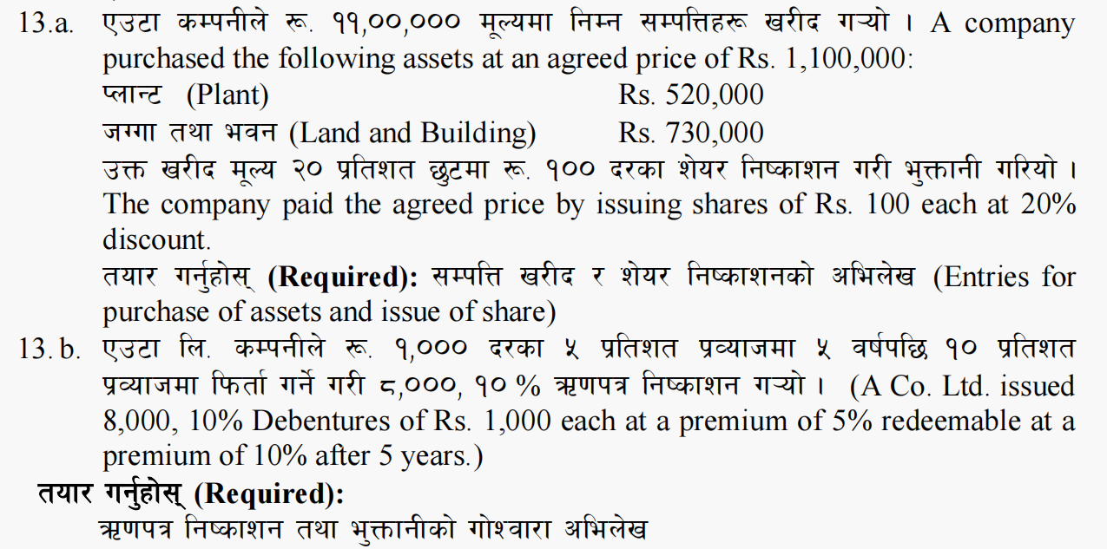

13 a. Journal Entriers

|  |  |  |  |  |
| --- | --- | --- | --- | --- |
| Date | Particualrs | LF | Debit | Credit |
|  | Plant a/c Dr………………………….  Land and Building a/c Dr………………….  Goodwill a/c ………….Dr  To Vendor a/c / Agreed price  To capital Reserve a/c  ( Being took over A company ltd by purchased assets and liabilities) |  | 520000  730000 | 1100000  150000 |
|  | Total |  | 1250000 | 1250000 |
|  | Vendor a/c Dr  Discount on share a/c (13750*20)  To Share capital (13750*100)  To share premium a/c  ( Being share capital transfer to vendor) |  | 1100000  275000 | 1375000 |

b. Journal Entries

|  |  |  |  |  |
| --- | --- | --- | --- | --- |
| Date | Particulars | LF | Debit | Credit |
|  | Issue of Debentures  Bank a/c Dr ( 8000*(1000+50)  Loss on redemption of debenture a/c Dr  To 8% Debenture a/c (8000*1000)  To Premium on debenture a/c (8000*50)  To premium on redemption of debenture a/c  ( Being issue of 8% Debenture at 5% premium) |  | 8400000  800000 | 8000000  400000  800000 |
|  | Redemption of debenture  8% Debentrure a/c Dr (8000*1000)  Premium on redemption a/c Dr(8000*100)  To Bank a/c (8000*1000+100)  ( Being redemption of 8% debenture after 5 years ) |  | 8000000  800000 | 8800000 |

Agreed price = No of Share* Issued amount   
No of share = Agreed price / Issued Amount = 1100000/80 = 13750

Issued amount = Par Value + Premium – Discount

100-20 = Rs 80

Share forfeiture

Share capital a/c Dr

Share premium a/c Dr

To call in arrear a/c

To Discount   
 To share forfeiture a/c – Profit

Re-issue

Bank a/c Dr

Share forfeiture a/c Dr

To share capital a/c   
 To Premium a/c

Transfer   
Share forfeiture a/c ( no of re-issued share* actual profit per share)   
 To capital Reserve a/c

Combine

( allotment, final call and share forfeiture)

Issue of share for cash ( application, allotment and Final call )

Website : [www.nagendradhimal.com.np](http://www.nagendradhimal.com.np)

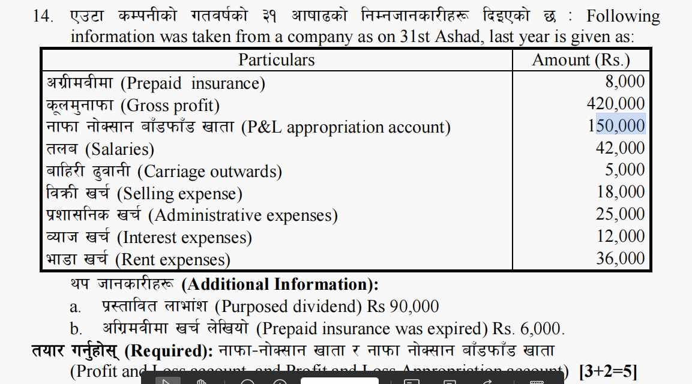

1. Profit or loss account of ABC Company

Dr Cr

|  |  |  |  |
| --- | --- | --- | --- |
| Particualrs | Amount | Particulars | Amount |
| To Gross loss b/d |  | By gross profit b/d | 420000 |
| To salaries | 42000 |  |  |
| To carriage outwards | 5000 |  |  |
| To selling expense | 18000 |  |  |
| To administarive expense | 25000 |  |  |
| To interest expense | 12000 |  |  |
| Rent Expnese | 36000 |  |  |
| To prepaid insurance Expired | 6000 |  |  |
| To Net profit c/d | 276000 | By Net loss c/d |  |
| Total | 420000 | Total | 420000 |

1. Profit or loss appropriation account

Dr Cr

|  |  |  |  |
| --- | --- | --- | --- |
| Particulars | Amount | Particulars | Amount |
| To Dividend  Proposed Dividend  Cash dividend  Interim Dividend  ( either given in trail or additional information) | 90000 | By Balance b/d | 150000 |
| To General rserve ( additiona info) |  | By Net Profit b/d | 276000 |
| To tax paid ( last year ( trail balance) |  | By provision for tax ( tarial balance diyo vane ) |  |
| To Balance/surplus | 336000 |  |  |
| Total | 426000 | Total | 426000 |

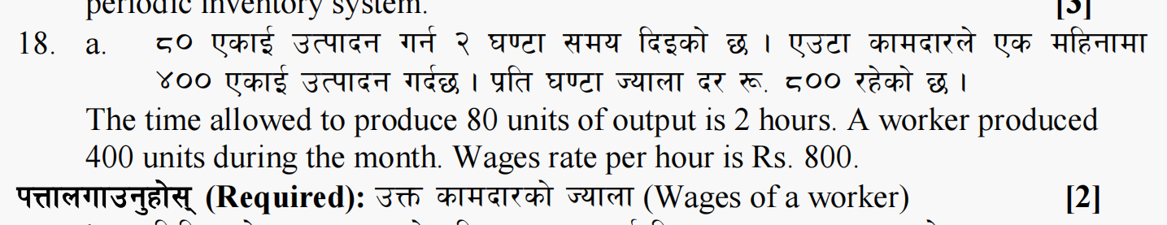

Solution

Total wages = Total Time Taken* Wage rate Per Hour

10 hours Rs 800

Total wages = Rs 8000 Ans

Working note

Total time taken = Total output/ one hour output

= 400/ 40 = 10hours