Unit-1 Basic concept of economic & distribution of
Resources (chapter-1)
Unit -2 Micro economic
- Market and revenue curve(chapter-2)
- Cost curve(chapter-3)
- Theory of price and Output Determination(Chapter-4)
- Theory of factor pricing(chapter-5)
Unit-3 Macro Economics
- Banking System and Monetary policy(chapter-6)
- Government finance(chapter-7)
- International Trade(chapter 8)
Unit -4 Development Economics (chapter-9)
Unit-5 Nepalese Economy
- Foreign trade and foreign employment(chapter-10)
- Development Planning in Nepal(chapter-11)
- Goals of sustainable Development(chapter-12)
Unit-6 Quantity techniques in economic (chapter-13)

Mark A B C Mark
Group A (11*1) = 11 Unit-1 1+5+0 = 6
Group B (8*5 )= 40 Unit -2 1+(3*5)+8=24
Group C (3*8)= 24 Unit-3 2*1 +5+8=15
Total= 75 Unit -4 1 +5+0 =6
Unit-5 3*1+5+8=16
Unit-6 3*1+5+0=8

Unit-1 Basic concept of economic & distribution of
resources (chapter-1)
- Scarcity and choice
- Opportunity
- PPC
- Distribution of Resources
- Divison of Resources
- Division of Labor and Specialization
- Economic system (Capitalist, Socialist and Mixed)
Unit -2 Micro economic
- Market and revenue curve(chapter-2)
- Market and Types of Market stricture
- Perfect competition
- Oligopoly
- Monopoly
- Monopolistic competition
- Derivation of AR and MR From TR under perfect competion and Monopoly market
- Cost curve(chapter-3)
- Concept of cost (Explicit,Implicit,Fixed,variable,Total,Average and Marginal cost)
- TC,AC, and MC
- Derivation of short-run and Long- run cost Curve(TC,AC,AR)
- Theory of price and Output Determination(Chapter-4)
- Perfect competition market (characteristics)
- Price and Output Determination Under Perfect competition and Equilibrium
- Monopoly (characteristics)
- Price and output determination under monopoly and equilibrium

- Theory of factor pricing(chapter-5)
- Concept of rent (Economic Rent, contract rent)
- Ricardian Theory of Rent
- Concept of wage(Nominal wage, Real wage)
- Subsistence Theory of wages
- Wage fund Theory of wages
Unit-3 Macro Economics
- Banking System and Monetary policy(chapter-6)
- Role of Banking system in Economy
- Classification of Banks
- Function of central Bank
- Function of commercial Bank
- Money market and capital market
- Monetary policy
Government finance(chapter-7)
- Concept and importance of government finance
- Classification of government expenditure
- Direct and indirect taxes
- Progressive, proportion and regression tax
- Merits of good tax system
- Government revenue
- Government Borrowing
- Budget and stages of budget formulation in nepal
International Trade(chapter 8)
- Concept and importance of international trade
- Balance of trade and balance of payment
- Measure to reduce trade deficit
- Exchange rate
- Free trade (merits and demerits)
Unit -4 Development Economics (chapter-9)
- Poverty
- Inequality
- Unemployment (types, causes and measures to create employment)
- Human resource
- Indicators of human development and HDI
- Present position of population of nepal
Unit-5 Nepalese Economy
Foreign trade and foreign employment(chapter-10)
- Foreign trade of Nepal
- Problem of foreign trade in Nepal
- WTO
- SAFTA
- Foreign employment and remittance

Development Planning in Nepal(chapter-11)
- Objectives of current plan
- Process of plan formulation
- Review of current past five years development plans of nepal
Goals of sustainable Development(chapter-12)
- UN’s 17 goals of sustainable development
- Zero poverty and Nepal
- Zero hunger and Nepal
- Decent work and economic growth
- Quality education and nepal
Unit-6 Quantity techniques in economic (chapter-13)
- Statistics (definition, areas, scope and limitation)
- Data collection
- Types of data (primary and secondary data)
- Methods of collection of primary and secondary data
- Standard deviation
- Variance
- Coefficient of variation
- Index number

Unit-1
Scarcity
Scarcity here means failure to meet wants through available resources or there is a shortage of resources. Human wants are unlimited but productive resources are limited. The major scarce resources are labor resources, natural resources, and capital resources. Because of the scarcity of resources, wants will not be fulfilled, leading to economic problems.
Human wants are unlimited, but the means to satisfy them are limited.
Choice
The choice is the act of selecting a few goods or quantities among the bundles of goods. In other words, it is the process of selecting few wants from the bundles of wants. So, choice means the allocation of income to the purchase of different goods and services in a manner such that he maximizes his satisfaction.
Opportunity cost
Opportunity cost refers to a benefit that a person could have received, but gave up, to take another course of action. Stated differently, an opportunity cost represents an alternative given up when a decision is made.
In microeconomic theory, the opportunity cost, also known as alternative cost, is the value (not a benefit) of the choice of a best alternative cost while making a decision.
Division of labour
Division of Labour means that the main process of production is split up into many simple parts and each part is taken by different workers who are specialized in the production of that specific part.
According to Hanson "Division of Labour means specialization of process."

Advantages of Division of Labour
- Increase in Production: With the adoption of the Division of Labour, the total production increases.
2 . Maximum Utilization of Machinery: The Division of Labour is the result of large-scale production which implies more use of machines.
3.Increases Producer's profit: Due to the fuller use of plants and machinery under the Division of Labour, production starts increasing rapidly thereby reducing the cost of production. Less cost of production increases the profit of the producer.
4. Availability of Commodities at a Cheaper Price: Division of Labour leads to mass production. Thus, production becomes less expensive and more economical. Hence, cheaper goods are produced by manufacturers. Availability of cheaper goods for consumers improves their living standards.
5. Increase in Efficiency of Labour: With the Division of Labour, a worker has to do the same work frequently, and he gets specialization in it. So, the Division of Labour leads to an increment in the efficiency of the workers.
6. Increase in Skill: Division of Labour contributes to the development of labor skills to a great extent. With the repetition of the same type of work, labor becomes well versed and specialized in it. This specialization enables him to do the work in the best possible way.
7. Full Utilization of Natural Resources: Division of Labour in the country also helps in the full utilization of natural resources. There will be production on a large scale to increase the utilization of resources.

Dis-Advantages of Division of Labour
- Danger of Over-production: Over-production means that the supply of production is comparatively more than its demand in the market. Because of the Division of Labour when production is done on a large scale, the demand for production lags much behind its increased supply.
2 .Increased Dependence: When the production is divided into several processes and each department/ segment is handled by different workers, it may lead to over-dependence.
3. Division of Labour Kills Creative Instinct: Since many workers contribute to the making of a commodity, no one can claim credit for making it. Labor's creative instinct is not satisfied.
4. Monotony of Work: Under the Division of Labour, a worker has to do the same job repeatedly for years long. Therefore, the worker feels bored.
5. Reduction in Mobility of Labour: It has been observed that the mobility of labor is reduced due to the Division of Labour. The worker performs in case they want to change the job. In this situation the mobility of labor gets retarded.
7. Lack of Responsibility: Since multiple processes are involved in a production process, no department of labor will be accountable for the poor production. They want to shift the burden to another division for the defective output.
Specialization
Specialization means doing the same thing over and over until one becomes an expert in doing that particular task. It is the outcome of the division of labor. In the process of specialization, an individual or firm concentrates on what they are good at. When an individual specializes, they limit their focus to one specific activity. When a company specializes, it focuses on a narrow range of goods or services. This helps to use scarce resources efficiently.

Advantages

1.Increases efficiency: In specialization, jobs and duties are divided among the employees according to their skills and abilities.
2.Reduces the risk of errors and mistakes: The person who is a specialist is less likely to commit a mistake in doing a particular task than a non-specialist person doing the same task. Hence, specialization helps to reduce errors and mistakes.
3.Time-saving: In specialization, workers have to do the same job again and again. This leads to finding the shortcut way to do the thing which in turn results in a lot of saving of time. Also, the workers have to perform specific types of jobs, there is no need to change tools and machines. This helps to save time.
4. Reduces costs: Increased efficiency, fewer errors, and mistakes increase the production and productivity of the firm. Specialization also reduces waste and unnecessary costs, which helps to minimize the cost of production and increases the revenue of the firm.
5. Less supervision and control: Specialization is based on the principle of "right man in the right place". Thus, a firm hires highly competent and self-motivated employees. So it requires less supervision, guidance, and control to carry out activities.

Disadvantages of Specialization
- Monotony: Specialization means focusing on a specific job. Repetitive work or doing the same job, again and again, can create monotony. The work becomes boring, which leads to dissatisfaction and loss of interest.
- . Increase in cost: Skilled employees may demand a high salary and other financial benefits as compared to unskilled workers. So, it may increase administrative expenses in the organization.
3. Increases dependency: Specialization increases dependency. One worker depends on the other, one company depends on the other and one country depends on the other. This is because specialization leads to concentration in one product or one sector only.

Economic system
An economy is a system of interrelated production, consumption, and exchange of goods and services. In other words, it is an integrated activity or organization for production, distribution, and consumption. In carrying out these activities, people are involved in making transactions, i.e. buying and selling of goods and services. It provides people with the means to work and earn a living.

Types of economic System
There are three types of economic system or economy, which are as follows:
- Capitalistic/Market Economic System
- Socialist Economic System
- Mixed Economic system

Market economy/ Capitalistic economy
It is based on private ownership of means of production and their operation for profit.
Self-regulated produced and distributed in response to demand from consumers.

Features of Market Economic System
The main features of market economic system are as follows:
a. Private property and ownership: A market economic system always has the institution of private property. An individual can accumulate property and use it according to her/his will.
b. Profit motive: In this economy, the desire to earn a profit is the most important inducement for any economic activity. All entrepreneurs try to start those industries or occupations in which they hope to earn the highest profit.
c. Competition: A market economic system is characterized by free competition because entrepreneurs compete for getting the highest profit.
d. Consumers' sovereignty: In a market economic system a consumer is compared to a sovereign king. The whole production framework is according to their directions. Consumers' taste governs the whole production line because entrepreneurs have to sell their products.
e. Limited role of the government: there is obviously little role for the government to play.

2. Socialist economy
A Socialist economic system is defined as the economic system in which production and distribution activities are owned and controlled by the government. It ensures welfare, equality of opportunity, and social justice to people. It is also known as the command or planned economy.

Features of Socialist Economic System
- State-owned resources: In such an economic system, all the means of production are owned and operated by the state in the interest of society as a whole. This is to ensure equality of opportunity for all citizens. This is also aimed at full and efficient utilization of the country's resources.
b. A planned economy: A socialist economy is a fully planned economy. The main task of the central planning authority is to formulate short-term and long-term plans for the economy.
c. Government control: In a fully socialist economic system, the government controls the main aspects of all economic activities. There are controls on the production and price determination of goods and services. In a fully socialist economic system, market forces are given very little importance.
d. Social welfare: One of the most important features of a socialist economic system is social welfare.
e. Absence of private enterprises: In the socialist economic system, private enterprises are not allowed to establish. Production is initiated and conducted by the state. The state makes investment itself and makes all arrangements for the production itself. There is no profit motive in the production.
f. Economic equality: There is economic equality in the socialist economic system. Since there is no private property, private enterprises, or businesses, there is no possibility of an individual to collect the wealth alone. There is also equality of opportunity. The government also makes sincere efforts to maintain economic equality.

3. Mixed economy
The mixed economic system is defined as the economic system where there is the coexistence of both the private sector and the public or government sector. In other words, in the mixed economic system, both public and private sectors decide about production and distribution activities.

Features of Mixed Economic System
- Co-existence of the public and the private sectors: In mixed economic systems, the role of the public sector and the private sector is clearly defined. These two sectors cannot operate in the absence of another. The co-operation between these two sectors is considered important.
b. Price mechanism and controlled price: In a mixed economic system, both price mechanism and price control are in operation. Generally, the price of consumer goods that are produced by private industries is left to be determined by the market itself.
c. Profit motive and social welfare: Economic activities in mixed economic systems are conducted for both the purpose of profit and social welfare as in capitalist and socialist economic systems respectively.
d. Control on monopoly power: In a mixed economic system, the government controls the monopoly practice of the private businesses by enforcing different rules and regulations.
e. Economic planning: Most of the mixed economic systems of the world have taken economic planning as an instrument for rapid economic development and growth. For example, in Nepal, the National Planning Commission has been set up by the government. Its main function is to formulate plans in order to allocate and effectively mobilize the resources of the nation.

Production possibility Curve

PPC is the different combination of two goods that an economy can be produce using full resources and technology during a specific period.
PPC is the graphical representation of alternative production possibility of two goods. Which are produce by limited resources. Each point of PPC curve shows maximum production of goods.
Assumptions
- Only two commodity are produced
- There is full utilization of resources
- Factors of production is constant
- Factors of production can be substitute in different uses.
- Production Technology is given and constant.

PPC is a graph that shows various combinations of the amount of two commodities that an economy can produce per unit of time such as the number of shoes versus kilograms of butter. The table and diagram are given below clarify about PPC.
Possibilities | Butter (Kilograms) | Shoes ( Pairs)
A | 0 | 10
B | 1 | 9
C | 2 | 7
D | 3 | 4
E | 4 | 0

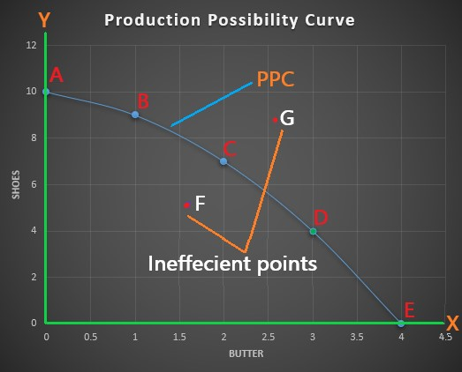

In the above table and diagram, there are different possibilities with factor combinations A, B, C, D and E. When all the resources are employed to produce shoes, then no butter can be produced in possibility A. when 1 kg of butter is produced, then only 9 pairs of shoes can be produced and so on.
Allocation of resources
Use of scarce resources in order to produce goods and services that maximize satisfaction of human wants.
Points to consider while allocation of resources
What to produce?
How to produce?
Labour intensive – use of production labour than capital and technology
Capital intensive- capital and technology used more than labour
Deciding factor – maximum output and cost minimization
For whom to produce
How to achieve efficient use of resources?
What provision should be made for economic growth
- Allocation of resources on consumer goods
- - Allocation of resources on capital goods

END
UNIT-2

Concept of market

Market is a place or process where buyers and sellers involve for buying and selling of goods and services. Market can be physical or virtual. For market there should be buyers, sellers, place, goods, price, communication etc.

According to P.A Samuelson,” a market is a mechanism by which buyer and seller interact to determine the price and quantity of a good or service. “

Features/characteristics of the market:
- Availability of commodity
There should be a commodity in the market which is being demanded and supplied.
- Availability of buyers and sellers
There must be buyers and sellers of the commodity in the market. Without buyers and sellers, there is no trading and no market.
- Communication
There must be communication between buyer and seller in the market. Without interaction between buyer and seller, there is no transaction.
- Place
There must be a place or an area where buyers and sellers interact with each other. It may be local, national or global.
- Medium of exchange
There must be a medium of exchange in order to trade in a market. Such a medium may be money, cheques, swipe cards, and other near money items.
Types of market
1. Perfect competition
2. Imperfect competition
(a) Monopoly market
(b) Monopolistic market
(c) Oligopoly market

1. Perfect competition market

- Perfect competition is the market structure in which, there are large number of buyers and sellers engaged in transaction of homogeneous product.
- There are many small firms, they can easily entry and exit in market and no single firm has control over the price of product.
- Each firm is price taker meaning that it has to accept the market price of product and has no power to influence the price.

Feature of perfect competition market
- Large number of buyers and sellers
- Homogeneous product
- Free entry and exit of firm
- Perfect knowledge of market
- Uniform (constant) price
- No government regulation

2 . Imperfect competition
It is a market structure where market do not fulfill all the necessary condition of perfect competition. it is market situation with missing of homogenous product, large number of sellers , price taker etc. it include,
(a) Monopoly market
(b) Monopolistic market
(c ) Oligopoly market

Monopoly market
It has a market structure where exist single seller of product having no close substitute of it. Single sellers or firms dominates the market and has the power to control the price of product and services. the monopolist has the power to set price , they can charge higher price than competitive market.
According to Anna Koutsoyiannis, “Monopoly is a market situation in which there is a single seller. There are no close substitutes of the commodity it produces, there are barriers to entry.”

Features of monopoly:
- Single seller and a large number of buyers
A monopoly firm is the only firm and industry of a monopolist. But there are a large number of buyers.
- No close substitutes
There are no substitutes which are close to the product and services sold by a monopolist.
- Entry barriers
There is a difficulty for new firms to enter into the monopoly industry. There are either natural or artificial restrictions on the entry of firms into the industry.
4.Price maker
A monopolist has absolute control over the supply of the commodity. As monopolist is a single supplier of a product, the buyer has to pay the price fixed by the monopolist. So, he/she is the price maker.
5.profit motive objective

Monopolistic market
It is a market structure where many producer involve to produce differential (heterogeneous) product which are close substitute of each other.
It is mixed firm of perfect competition and monopoly, as the product are differentiated, they include the power of monopoly but present of close substitute create of competition.

Feature of monopolistic market
  - Large number of buyers and sellers
  - Heterogeneous product
  - Price difference
  - Close substitute

Oligopoly market
Oligopoly is a market situation in which there are few firms selling a homogeneous or differentiated product.
The entry and exit of a firm are difficult in an Oligopoly market.

Market and revenue curve
The total amount of money received by a firm from the sale of the product is called revenue. The profit of a firm depends upon the cost and revenue. The profit earned by the firm is the difference between the revenue and the cost of production.

Total revenue(TR)
Total revenue is the total amount of money received by a firm from the sales of a given quantity of product. Technically, total revenue is the sum of marginal revenues. Mathematically, total revenue is the product of price and quantity sold.
Symbolically;
TR=P×Q
Where,
TR= Total Revenue
P=price per unit
Q= Quantity sold

Average revenue (AR)
Average revenue is the price per unit. Average revenue is obtained by dividing the total revenue by the total number of quantity sold.
Symbolically;
AR=TR/Q
Where,
AR= Average Revenue
TR= Total revenue
Q= Quantity sold

Marginal Revenue (MR)
Marginal revenue is the addition to the total revenue from the sales of an additional unit of a commodity. Marginal revenue is obtained by dividing change in total revenue by the change in quantity sold.
Symbolically,
MR= ∆TR / ∆Q
Where,
∆TR =Change in TR
∆Q= Change in quantity sold

Derivation of TR, AR, and MR under perfect competition:
Perfect competition is a market structure having a large number of buyer and sellers selling homogeneous products at a uniform price. The TR, AR, and MR under Perfect competition can be derived as follows:

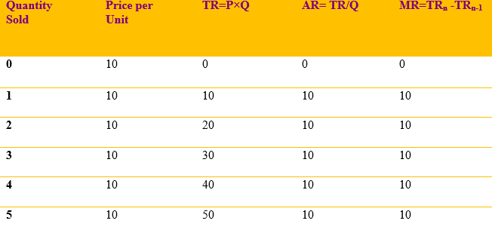

In the above schedule, we can see that the value of TR is increasing at the same rate because every additional of the commodity is sold at Rs.10. Average revenue remains constant at all levels of output. AR, MR, and price are equal to each other. It can be graphically explained as follows:
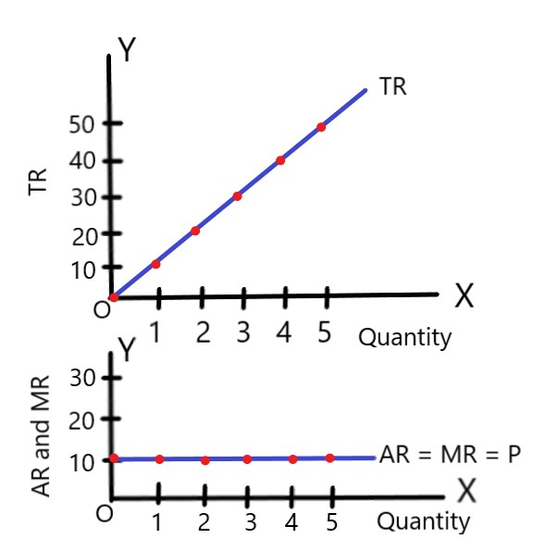
In the above diagram, we can see that the TR curve is increasing at a constant rate. AR and MR curve are the same and they coincide with each other. They are the same at all levels of output. TR curve is positively sloped whereas AR and MR are a horizontal straight line parallel to the x-axis.

Derivation of TR, AR, and MR under Monopoly or imperfect competition
Monopoly is the market structure having a single seller selling the type of product which has no close substitute. They are the price makers. Under Monopoly, a monopolist can increase its revenue by selling few products at a high price and more products at a low price. The TR, AR, and MR can be derived with the help of the following schedule:

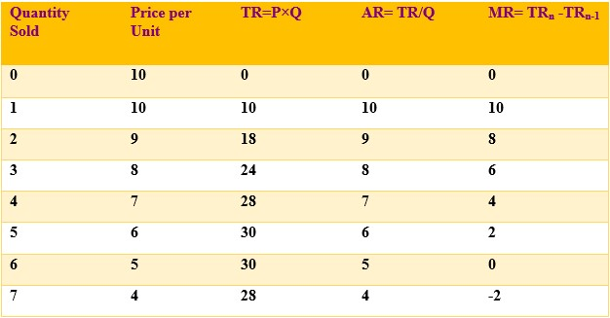
In the above table, we can see that when the quantity sold is increasing, the price is decreasing. Total revenue increases at first up to the fifth unit then becomes maximum and declines thereafter. AR and price are similar. Marginal revenue is declining, becomes zero and even negative.

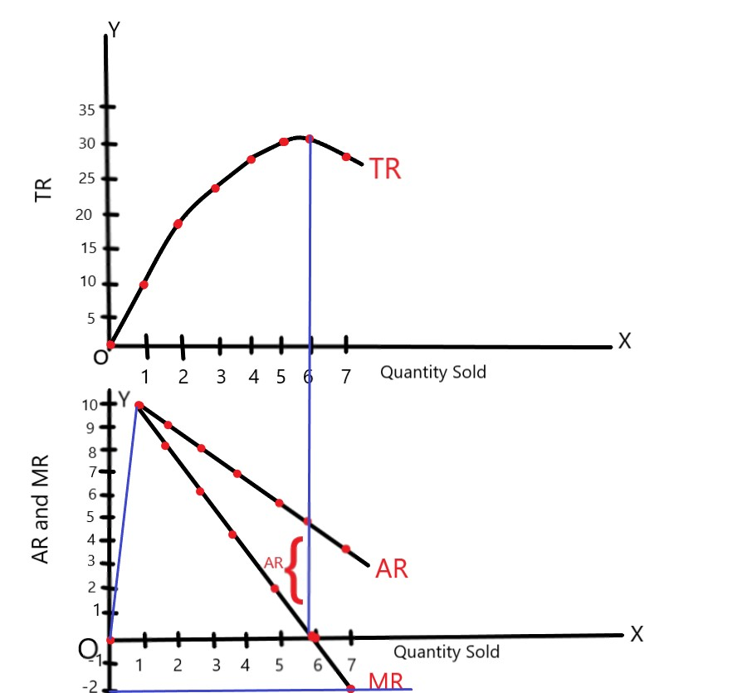
In the above diagram TR, MR and AR are shown along y-axis and quantity sold is shown along x-axis respectively. We can observe that when total revenue is rising AR and MR are falling. When TR becomes maximum, marginal revenue becomes zero. When TR starts to fall, then marginal revenue declines to negative.

Unit-3

cost

In order to produce goods and services, a firm uses raw materials and factors of production which are called inputs. The expenditure incurred by these inputs is called cost. Cost of production is a component of determining the profit of a firm. At a certain price of a commodity, the low cost of production results in high profit and high cost of production results in low profit or loss.

There are various kinds of cost

Fixed cost

They are those factors which cannot be changed in the short run.

The cost incurred by the fixed factor of production remains constant at all levels of outputs. It includes rent of the business premises, interest on capital, salaries of permanent employees, depreciation of machines and furniture, etc.

Variable cost

They are the factor that can be changed in accordance with the change in production even in the short run. It includes the cost of raw materials, the wage of workers, cost of power and fuel, etc. If the quantity of production increases the cost will increase and vice versa. When the output is zero, the variable cost will be zero.

Explicit cost: payment made for use of inputs in production.

For example, wage, lease, and materials.

Implicit cost: value of factor inputs owned and used by firm in its on process.

Derivation of short-run cost curves

Short run period of time in which firm can vary its output by varying the amount of variable factor.

Fixed factors remain unchanged.

1. Total fixed cost (TFC):
Fixed cost refers to the expenditure incurred by the producer on the fixed factor of production. It is also known as the total cost made on the fixed factor. In the short run, they do not change with change in output. It can be explained by the help of following schedule and diagram:

Outputs (in units) | Total fixed cost (in Rs.)
0 | 30
1 | 30
2 | 30
3 | 30
4 | 30
5 | 30

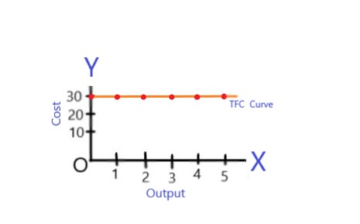

Total Variable Cost (TVC)

Variable cost refers to the cost incurred by the variable factors of production. It does not remain constant like the fixed cost at different levels of output. Whenever the output increases or decreases the variable cost will also increase or decrease. It can be explained by the help of following schedule and diagram:
Output (in units) | Total variable cost
0 | 0
1 | 20
2 | 30
3 | 45
4 | 80
5 | 145

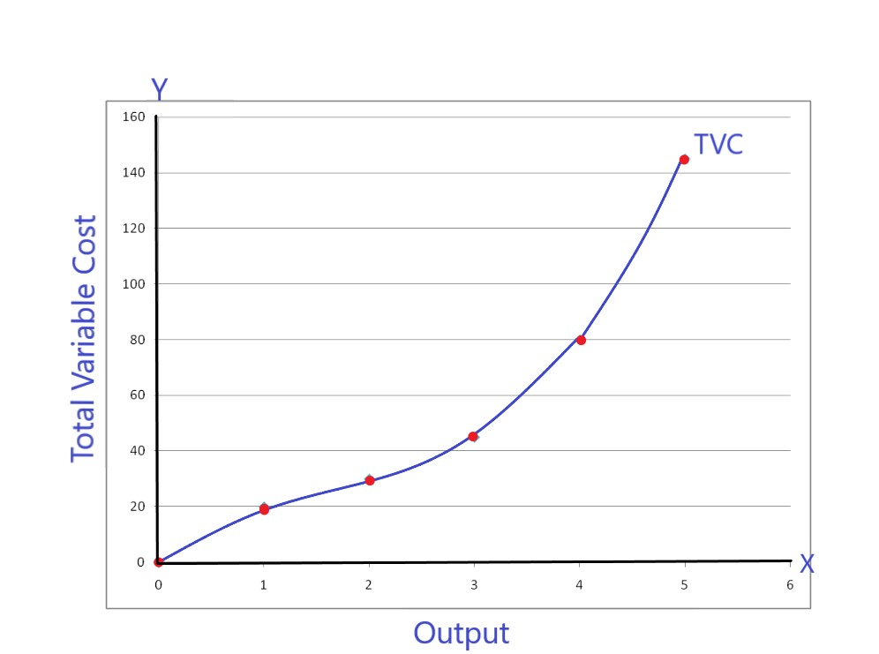

In the above figure, we can see that TVC curve increases at a decreasing rate at first and then increases at an increasing rate after some units of production because of applicability of the law of variable proportion in the short run.

Total cost (TC)
Total cost is defined as the total monetary expenditure incurred in the production process. It is the sum of the fixed cost and total variable cost.
Symbolically,
TC=TVC + TFC
It can also be explained by the help of following schedule and diagram:

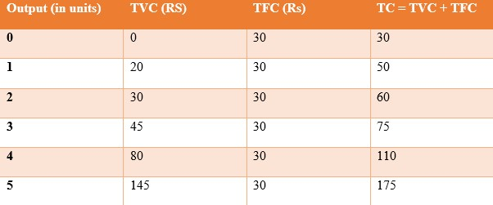

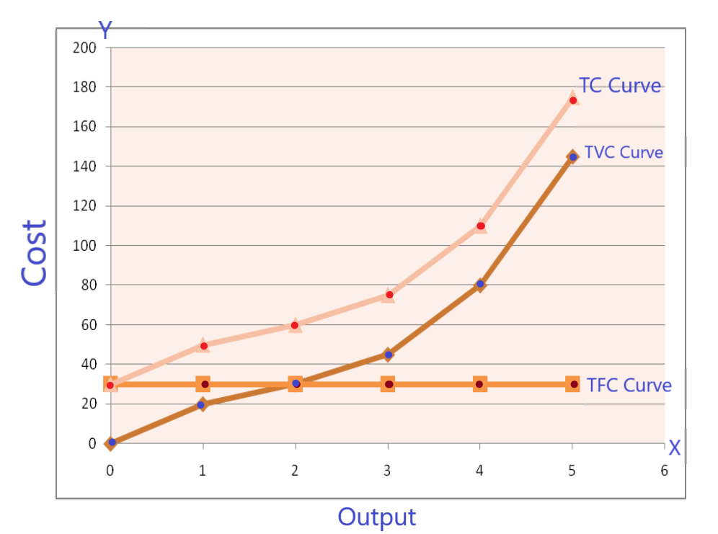

In the above figure, costs are shown along y-axis and outputs are shown along the x-axis. TFC is parallel to x-axis because it is constant at all levels of output. TVC is increasing as the output are increasing. TC is also increasing because of variable cost is also included in it. The nature of TC and TVC are similar. They are parallel to each other. The only difference is that TVC starts from origin and TC starts above the origin.

Marginal cost

Marginal cost is defined as the change in the total cost due to one additional unit of change in the output. In other words, it is the ratio of change in the total cost and change in the total output.
Symbolically;
MC=∆TC / ∆Q
OR
MC=TC n - TC n-1
Where;
MC = Marginal Cost
∆TC = Change in Total Cost
∆Q = Change in quantity sold
TC n = Current Total Cost
TC n-1 = Initial Total Cost
The concept of Marginal cost can be explained by the help of following schedule and diagram:

Output (Q) | TC | MC
0 | 30 | -
1 | 50 | 20
2 | 60 | 10
3 | 75 | 15
4 | 110 | 35
5 | 175 | 65

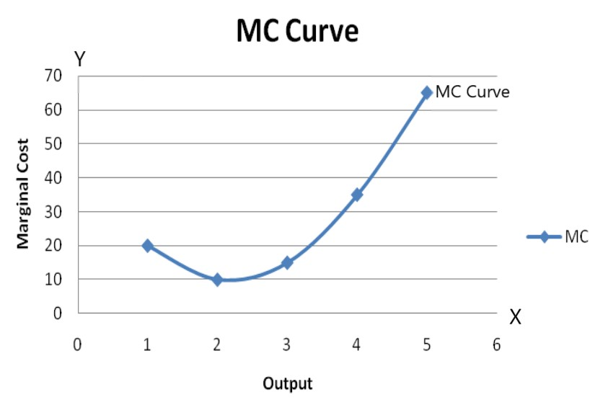
In the above figure, SMC or MC represents the short-run marginal cost curve. Up to the second unit of output it has declined to become minimum and rises thereafter. It is also ‘U’ shaped because of the operation of the law of variable proportion in the short run.

Derivation of short run average cost curves.
  - Average fixed cost: dividing the total fixed cost by level of output
AFC= TFC/Q
It can be explained by the help of following schedule and diagram:
Output (in units) | TFC (Rs) | AFC (Rs)
1 | 30 | 30
2 | 30 | 15
3 | 30 | 10
4 | 30 | 7.5
5 | 30 | 6
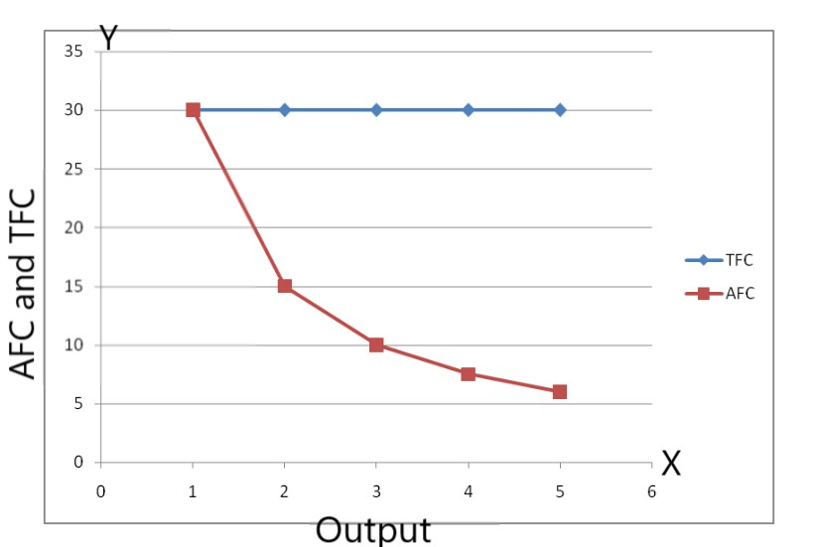

In the above figure, we can see that the AFC curve is a rectangular hyperbola. AFC curve is downward sloping because, as we produce more units of output, AFC declines. It never touches the Y axis because, at zero units of production, AFC is infinite. Similarly, it never touches x-axis because AFC never becomes zero.

  - Average variable cost: dividing total variable cost with the corresponding level of output.
AVC= TVC/Q
We can derive AVC by the help of following schedule and diagram:
Output (in units) | TVC (Rs) | AVC (Rs)
1 | 20 | 20
2 | 30 | 15
3 | 45 | 15
4 | 80 | 20
5 | 145 | 29
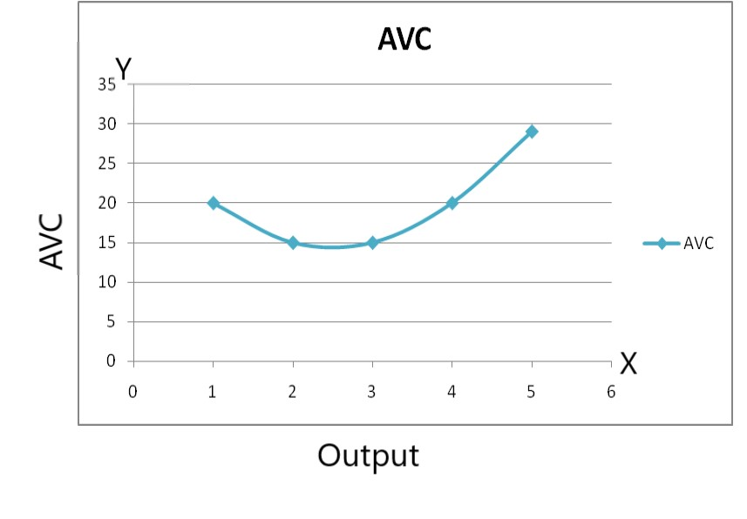
In the above figure, we can see that AVC falls at the beginning and then inclines. An AVC curve is 'U' shaped because of the operation of the law of variable proportion.
3. Average total cost : dividing total cost by corresponding level of output.
AC= TC/Q

ATC = TC / Q = ( TFC + TVC ) / Q = AFC + AVC
It can be derived with the help of following schedule and diagram:
Output (in units) | AFC (Rs) | AVC (Rs) | ATC (Rs)
1 | 30 | 20 | 50
2 | 15 | 15 | 30
3 | 10 | 15 | 25
4 | 7.5 | 20 | 27.5
5 | 6 | 29 | 35
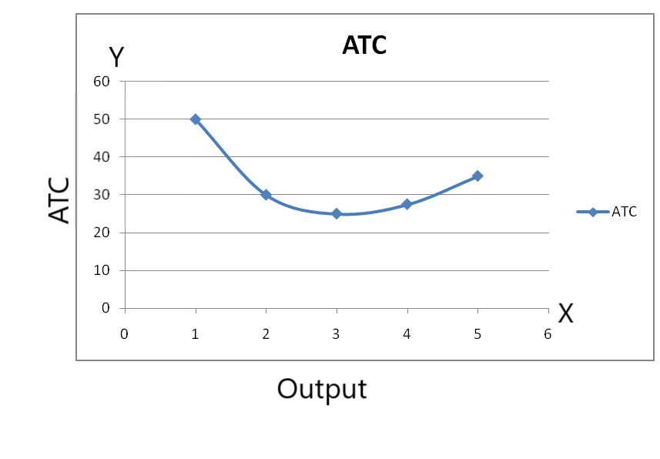
In the above diagram, we can see that ATC falls at the beginning. It becomes minimum and rises after that point. Therefore, it is 'U' shaped.

Relationship between AC and MC
There is a close relationship between AC and MC. MC is the change in TC resulted from the change in the production of one more unit of output whereas AC is the total cost divided by the output. Both AC and MC are derived from TC.
Symbolically;
MC = ∆TC / ∆Q
AC = TC / Q
The relationship between these two can be explained with the help of the following diagram:
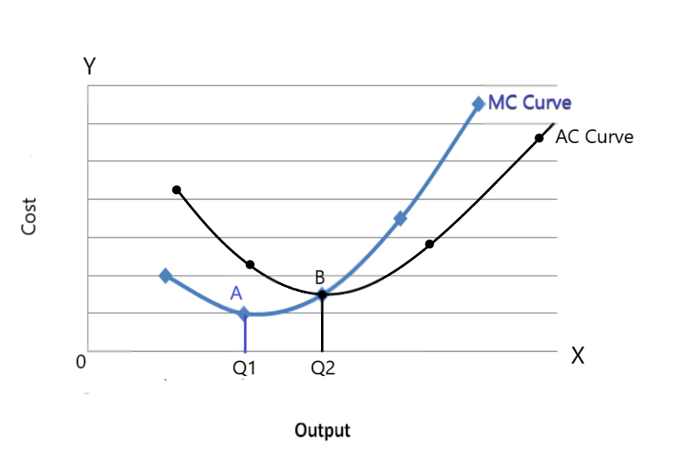
In the above figure, SMC represents the short-run marginal cost curve and SAC represents the short-run average cost curve. SMC and SAC intersect each other at the minimum point of SAC. It lies to the right of A, the minimum point of SMC I.e point B. The relationship between these two can be summarized as follows:
- Both AC and MC curve are calculated from the total cost.
- Both AC and MC are ‘U’ shaped.
- When AC is falling, the MC curve lies below AC and MC falls faster than AC.
- When AC is rising, the MC curve lies above the AC and MC rises faster than AC.
- When AC is minimum, MC=AC
- MC intersects at the minimum point of AC.
- MC cuts AC from below.

Unit-4

Theory of price and output determination

Concept of firm and industry
- Firm is a single unit of industry producing goods and services with the objective of maximizing the profit.
- Industry is group of firms producing homogenous products.
Equilibrium of firm
- A firm is said to be in equilibrium when it has no condition to expand or contract its output.
- State of earning maximum profit or minimizing the loss.
Two approaches for determination of equilibrium of a firm
- Total revenue and total cost approach (TR-TC approach) under perfect competition and monopoly
- Marginal revenue and marginal cost (MR-MC approach ) under perfect competition and monopoly

Total revenue and total cost approach (TR-TC approach) under perfect competition
Perfect competition is the market structure in which there are a large number of buyers and sellers selling homogeneous products.
According to TR-TC approach, a firm gains equilibrium position at that output at which the difference between total revenue and the total cost is maximum.
π = TR-TC
where; π = profit,
TR = Total Revenue and
TC = Total Cost
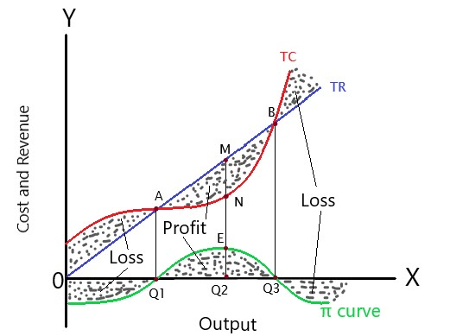
In the above figure, TR and TC represent Total Revenue and Total Cost curves. The difference between TR and TC is measured by the vertical distance between TR and TC. Up to OQ1 level of output, the firm bears loss because Total Cost is higher than Total Revenue. Between OQ1 and OQ3 level of output, the firm is in profit because TR is higher than TC. The firm earns maximum profit at OQ2 level of output which is shown by the vertical gap MN. The firm is in equilibrium at OQ2 level of output at point E which is shown in the π curve (profit curve).
Total revenue and total cost approach (TR-TC approach) under monopoly
Monopoly is the market structure having a single seller selling the type of product which has no close substitute. They are the price makers.
The monopoly firm increases its price to increase the revenue or may decrease the price to increase its sales. Therefore, TR curve is inverse ‘S’ shaped. The firm chooses that level of output at which the profit is maximum.
It can be explained by the help of the following diagram:-
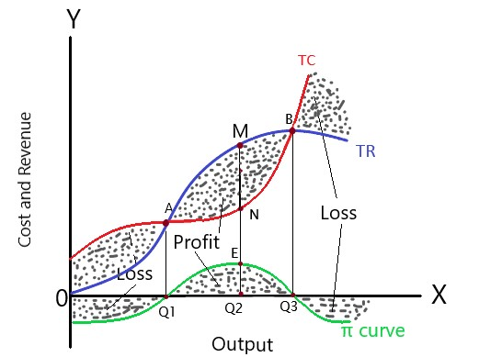
In the above figure, TR and TC represent Total Revenue and Total Cost Curve. π curve represents the profit curve. Before OQ1 and after OQ3 level of output, the firm bears loss because the total cost is higher than total revenue. From OQ1 to OQ3 level of output, the firm enjoys profit because TR is higher than TC. The maximum profit is the vertical gap MN which is also represented in the π curve as Q2E. The firm is equilibrium at this level of output and does not want to deviate from this point.

Marginal Revenue and Marginal Cost approach (MR-MC approach)
MR-MC approach is a very important and useful method for determining the equilibrium of the firm. Under this approach, the following conditions must be fulfilled to attain equilibrium by the firm.
A. Equilibrium of a firm under perfect competition:-
Perfect competition is characterized by a large number of buyers and sellers. Firms produce homogeneous goods and they are taken as the price takers. In this market, the firm has no control over the price. It must sell the products at that price which is determined by the industry.
Under this approach, the following conditions must be fulfilled to attain equilibrium by the firm.
i. Necessary condition:-
Marginal revenue should be equal to Marginal Cost i.e. MR=MC.
ii. Sufficient condition:-
Marginal Cost curve must intersect the Marginal Revenue curve from below.
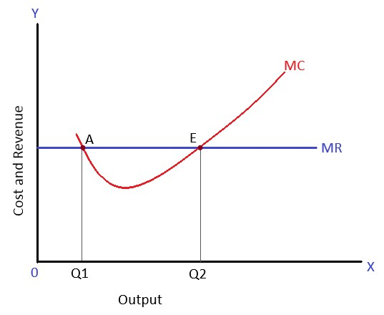
In the above figure, MR and MC represent Marginal Revenue and Marginal Cost curve. MC equals MR at point A and points E which fulfills the necessary condition. Point E fulfills both necessary and sufficient condition. So, Point 'E' is the equilibrium point and OQ2 is the equilibrium level of output.

Equilibrium of a firm under monopoly or imperfect competition:-
In the monopoly market, the firm is the price maker. It can sell less output at a high price and more output at a low price. So, AR and MR curves slope downward. The MC curve is U-shaped.
Under this approach, the following conditions must be fulfilled to attain equilibrium by the firm.
i. Necessary condition:-
Marginal revenue should be equal to Marginal Cost i.e. MR=MC.
ii. Sufficient condition:-
Marginal Cost curve must intersect the Marginal Revenue curve from below.

The equilibrium of the firm under monopoly using MR-MC approach can be explained by the help of the following diagram:-
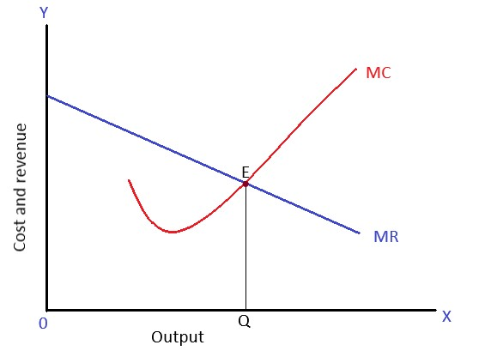
In the above figure, MR represents the Marginal Revenue curve which is downward sloping and MC represent Marginal Cost curve which is U- Shaped. The point 'E' is the equilibrium point because, at this point, MC equals MR and MC cuts MR from below. So, the firm is in equilibrium at OQ level of output and can maximize its profit.

Price and output determination under perfect competition in the Short run/ Equilibrium of firm and industry under perfect competition in the Short run

Short-run Equilibrium of firm and industry:-
Short-run refers to that time period in which a firm cannot change the fixed factors of production. Therefore, a firm cannot change its production process and there may be abnormal profit, normal profit or even loss depending on the firm's revenue and cost. The profit and loss also depends upon the nature of AC and AR, which can be presented as follows:-
- If AR=AC, the firm receives a normal profit.
- If AR> AC, the firm receives abnormal profit.
- If AR< AC, the firm bears the loss.
The profit and loss depend also on the nature of MR and MC and the following conditions must be fulfilled in order to obtain equilibrium in the perfect competition market:
- Market supply must be equal to market demand.
- MC must be equal to MR.
- MC must cut MR from below.
The short-run equilibrium of the firm and industry under perfect competition can be explained by the help of the following diagrams:-

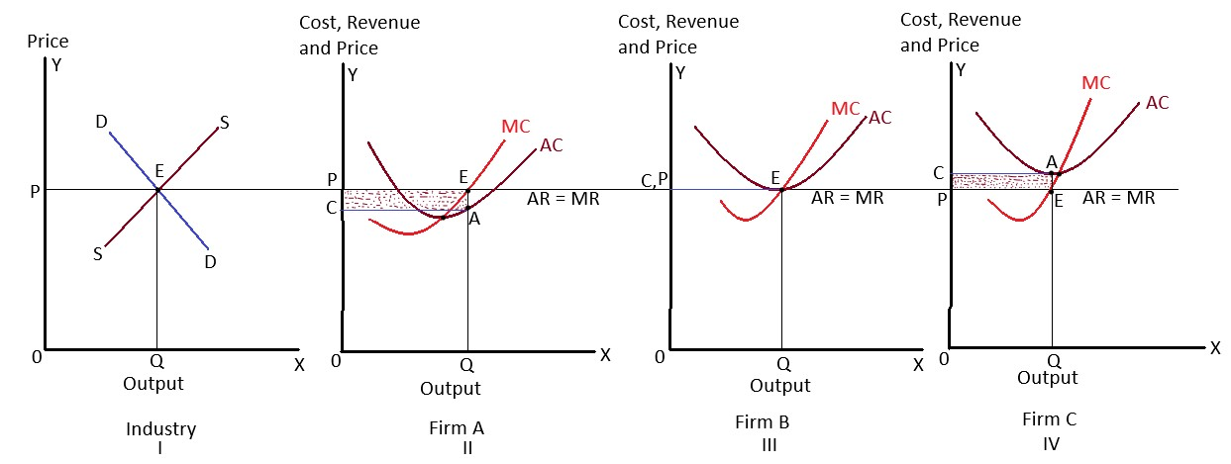
In the above figures, we can see the equilibrium price determination in the industry in the first figure. In the second, third, and fourth figures, the conditions of equilibrium in three different firms are shown under perfect competition, in the short run. There are three possibilities which are as follows:-

1. Abnormal profit (supernormal or excess profit):-
The second figure shows the abnormal profit earned by the firm. The firm earns an abnormal profit when AR is greater than AC. In this figure, E is the equilibrium point because here MR and MC are equal and MC is intersecting MR from below. So, OQ is the equilibrium quantity. The firm is earning abnormal profit equal to the shaded rectangular area. The firm's average cost of production is ‘OC’.

2. Normal profit:-
In the third figure, the firm is in equilibrium at point E. Because at this point MC is intersecting MR from below. The equilibrium output is OQ. The firm is earning just a normal profit because AR and AC are equal at this level of output. It is that profit which is just sufficient to run the business.

3. Loss:-
In the fourth figure, the firm is in equilibrium at point E because, at this point, both necessary and sufficient conditions are fulfilled. The equilibrium output determined by the firm is OQ. At this output, AC is greater than AR. So, the firm is bearing loss equal to the shaded area.

Price and output determination under perfect competition in the long run/ Equilibrium of firm and industry under perfect competition in the long run

Long-run Equilibrium of firm and industry
In the long run, the firm can enter or exit from the industry depending on profit or loss situation. If profits are high, new firms enter into the industry and if the firms are in loss, they exit from the industry in the long run. Due to this, abnormal profit and loss situations are ruled out in the long-run and the firms will earn just the normal profit.
The following conditions must be fulfilled in order to attain equilibrium in long-run under perfect competition market:-
- The quantity demanded and the quantity supplied must intersect at an equilibrium price.
- LMC must be equal to MR.
- LMC must intersect MR from below.
It can be shown by the following diagram:-
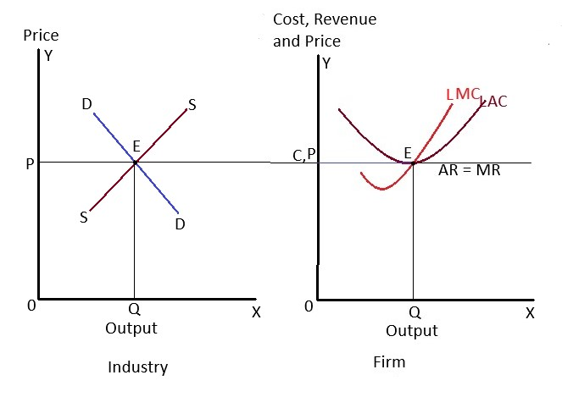
In the above figure, the industry is in equilibrium where market demand and supply curve intersect each other at point 'E'. The price determined by industry is OP and all the firms accept this price. The firm is in equilibrium at point 'E' where LMC=MR and LMC cut MR from below. LAC is tangent to the MR curve. This shows that the firm operates under normal profit in the long run.

Price and output determination under monopoly in short run/ Short run equilibrium under monopoly

Price and output determination under monopoly in Short-run
Short-run refers to that period in which a monopolist cannot change the fixed factors. However, the monopolist is free in determining price due to lack of competition. A monopolist has control over the market supply. So, he/ she is the price maker. His/ her price and output determination is motivated by profit as well as sales maximization.
In short run equilibrium whether the firm makes an abnormal profit, normal profit or loss, it depends on the level of AC and AR which can be shown as follows:-
- If AR=AC, the firm receives a normal profit.
- If AR> AC, the firm receives abnormal profit.
- If AR< AC, the firm bears the loss.
The following conditions must be fulfilled in order to attain equilibrium under monopoly:-
- MR must be equal to MC
- MC must intersect MR from below.
The equilibrium position of a monopoly firm can be graphically presented as follows:-
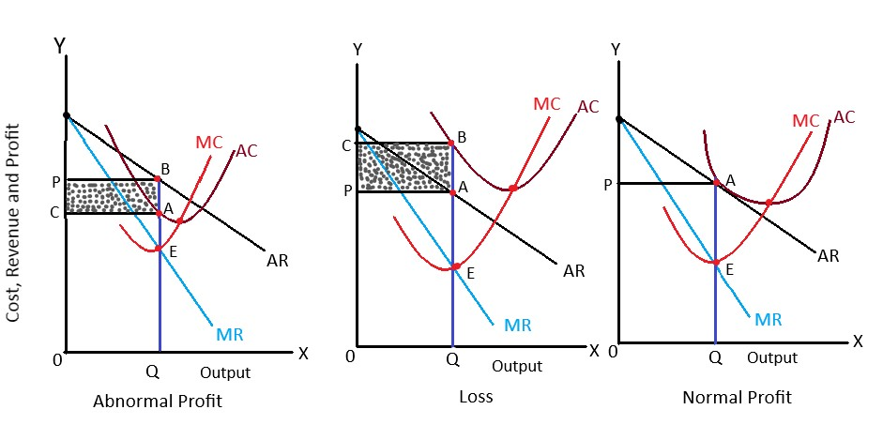
In the above figures, the three different possibilities of profit and loss situation in the short run under monopoly firm are shown. These possibilities are explained as follows:-

1. Abnormal profit:-
In the first figure, we see that the equilibrium point is 'E' when MC cuts MR from below. The equilibrium level of output is determined at OQ. The level of revenue earned is OP and the cost incurred is OC. Since Revenue is greater than cost, the firm earns abnormal profit equal to the shaded area (ABPC).

2. Loss:-
In the second figure, point E is the equilibrium point where MC intersects MR from below. The equilibrium level of output is OQ. The cost incurred is OC and the revenue earned is OP. Since cost is higher than revenue, the firm bears loss equal to the shaded area (ABCP).

3. Normal profit:-
In the third figure, we can see that the equilibrium point is at 'E' where the conditions for equilibrium are fulfilled. The equilibrium level of output is OQ. The revenue and cost are at the same level (OP). The firm earns just a normal profit to sustain its business in this case.

Price and output determination under monopoly in long run/ long run equilibrium under monopoly
The firm can change the size of plant and machinery and can determine the level of output to maximize its profit. Because of this, the firm does not suffer loss. Likewise, the entry of new firms is restricted somehow and the monopolist earns abnormal profit in the long run due to lack of competition.
The following conditions must be fulfilled to attain equilibrium under monopoly in the long run.
i) MR must be equal to LMC.
ii) LMC must intersect MR from below.
The equilibrium of a monopoly, in the long run, can be graphically presented as follows:-
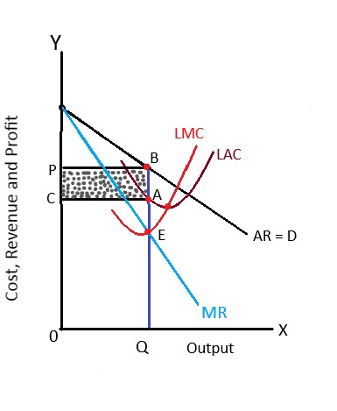
In the above figure, LAC and LMC represent long-run average cost curve and Marginal cost curve. AR and MR represent Average and Marginal Revenue. The equilibrium point is determined at ‘E’ where LMC intersects MR from below. The equilibrium level of output is determined at OQ. The cost incurred is OC and the revenue earned is OP. Since revenue is higher than cost (AR> AC), the monopolist earns abnormal profit in the long-run.

Factor pricing
Price Determination of factors of production
Economics goods and services are produced by employing the factors of production.
Four factors of production
1 . land
2 . labor
3 . capital
4 . organization
Theories for determination of price of each factors of production are called theories of factor pricing.
Rent
In economics, rent refers to the payment for the use of services of those factors of production which are fixed in supply such as land and also to the payment which are variable in supply such as capital goods, variables, machines, building, etc.
According to classical economist David Ricardo, “Rent is earned only from the land and rent is the payment received by the landlord for the use of original and indestructible power of soil”.
There are mainly two concepts of rent
- Contract rent
- Economic rent

Contract rent
It is determined by the agreement made between two parties i. e. owner and renter of the factor.
Contract rent is the actual payment made on the factor owner for the use of factor for a period of time. For example- payment made to the owner of the house, owner of the land, owner of machinery and equipment, etc. by its users. Determined before the production starts.
Economic rent
Classical economist David Ricardo argued that economic rent is earned only from the land. It refers to that part of the payment made by a tenant to landlord only for the use of land.
They define economic rent as the surplus of current earning over transfer earning.
Current earning is the earning of a factor of production from its current use and transfer earning is the earning of the factors of production from its alternative use.

Ricardian theory of rent / Classical theory of rent:-

The Ricardian theory of rent was developed by David Ricardo in his book, “Principles of Political Economy and Taxation” published in 1817 A. D. According to him, “Rent is that portion of the produce of the earth which is paid to the landlord for the use of original and indestructible power of soil”.
This theory has the following assumptions:-
- Rent is earned only on land.
- The land is fixed in supply.
- The land possesses indestructible and original power.
- Land can be used only for farming.
- Land can be used only in diminishing order of their fertility.
- Law of diminishing returns operates in the land.
- Land differs in quality.
- Perfect competition prevails in the market.
- More population increases more productivity.
It is based on the long-run concept.
Rent under extensive cultivation
- It is such type of cultivation where the production is increased by using more and more plots of land.
- Land are cultivated from superior to inferior land by using same amount of labour and capital.
- Ricardo assumes four grade of land ie. A,B,C and D
Rent under intensive cultivation
Intensive cultivation is a type of farming under which the quantities of labor and capital are used successively on the same plots of land to increase production.

Grades of land | Production (in kg) | Cost of production (in Kg) | Rent
A | 40 | 10 | 40-10=30
B | 30 | 10 | 30-10=20
C | 20 | 10 | 20-10=10
D | 10 | 10 | 10-10=0
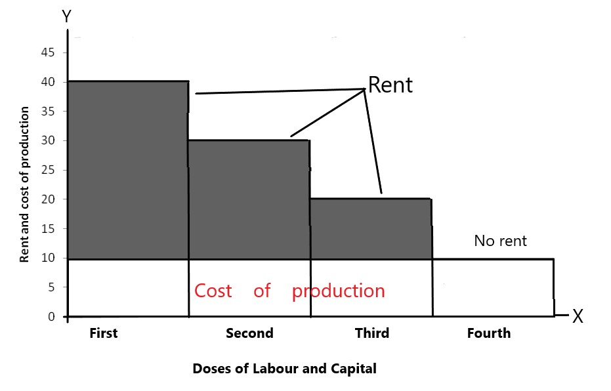
In the above figure, the grades of land and production are measured along X-axis and Y-axis respectively. The amount of rent earned by different grades of land A, B, C, and D are shown by the shaded area. The production from the land D covers just the cost only. So, land D is called marginal or no rent land. So, rent under extensive cultivation is the surplus product of intra-marginal land over the production of marginal land.

Criticisms of Ricardian Theory of Rent:-
No original and indestructible power of soil:- The ricardian theory assumes that the land possesses original and indestructible power. This view is not acceptable because the productivity of land can be increased through scientific techniques. Fertility can be destroyed by intensive use of land, soil erosion, flood, drought, and so on.
No single use of land:-
Ricardo assumes only one use of land. The land has no next best alternative. However, in real life, land can be used to grow various types of crops, for industrial purposes or real estate purposes.
The wrong assumption of ‘no rent land':-
Ricardian theory of rent assumes the existence of land which is available free of rent but in real life, nobody can obtain any land which is free of rent. Likewise, a plot of land regarded as marginal land for 1 crop maybe intra-marginal land for other crops.
The wrong assumption of perfect competition:-
Ricardian theory of rent assumes the existence of competition in the land market. But in real life, the market that we find in land is imperfect competition. Similarly, the landlord may charge the monopoly rent.
All the factors of production earn rent:-
Ricardo assumes that the land is the only one factor of production that earns rent. According to modern economists, all the factors of production earns rent.
Wages
Wage is the price paid to the labor for the use of his/her service in the production. In economics, the wage is the reward paid to the worker for his/her mental or physical work.

Money wage or nominal wage:-
Money wage is the wage received by labor in the form of money. It is also known as nominal wage. Money wage does not include extra facilities provided to the labor like accommodation, health care, children education allowance, transportation facilities, clothes allowance, insurance facilities, etc.

Real wage
Amount of goods and services which can be purchased by the money wages and extra benefits that the labour received.

Subsistence theory of wages
The subsistence theory of wages is developed by David Ricardo and other classical economists.
According to this theory workers should be paid wages equal to the minimum subsistence level. The subsistence level is just sufficient to maintain their minimum standard of living.
If they are paid higher wages than subsistence level, they are encourage to marry more wife and to have a large family size. Thus supply of labour increase which also increase the competition among the labourers to get work as a result the wages rate diminishes as a subsistence level.
If worker are paid below the minimum subsistence level, they will be unable to join their hands to mouth, if increase starvation, malnutrition, decrease and death rate. This will reduce the labour supply . hence wages rate tends to increase to the minimum subsistence level.
In the long run the wages should be equal to the minimum subsistence level.
The following are the assumptions of the subsistence theory of wage:-
- Population increases at a faster rate.
- Food production increases at a slow rate.
- There is no existence of a trade union.
- The cost of production of labor is equal to subsistence wages.
- This theory is based on the long-run concept.
Criticism
- It is exploitative theory
- It ignores the demand side of labour
- Fails to explain the difference in wages
- It ignores the role of trade union
- Pessimistic theory
Wages fund theory of wages
Developed by J.S.mill
According to this theory, fixed proportion of total capital stock or national income is allocated for the payment of wages to the labours. This proportion is called wages fund.
Wages rate determined by the ratio of wages fund and number of workers.
Wages rate= size of wages fund / no of worker
At higher wages fund the wages rate is also higher and vice-versa but there are inverse relation between no of labour and wages rate.
Increase wages fund negative affects the demand for labour because, when wages fund increase the part of total capital used in purchasing raw material decrease as a result production also decrease. This ultimately leads to decrease demand for labour and increase unemployment.
Mill assumed that wages fund is fixed. hence wages ratio can be increase by decreasing the number of worker.
Assumptions
- Wages fund is fixed
- Wage fund is raised before the employment workers
- The level of wage is fixed after the employment of labour
- The wages level change according to the number of worker.
- There is direct relationship between level of wages and wages fund and inverse relationship between level wages and no of worker.
Interest
Interest is the reward of capital. Interest refers to the payment made by a borrowers to the lender for the use of capital in production process.
Net interest: net interest is the price paid only for the use of capital or money. It is also called pure interest, which does not include other amounts.
Gross interest: Gross interest is the total amount paid by a borrower to the lender for return of the capital for a period of time. Which include net interest and other charge.
Gross interest= net interest+ return for risk+ return for management+ return for inconvenience
Classical theory of interest
It is propounded by old classical economist and developed by marshall, piegue, etc.
According to this theory equilibrium role of interest is determined by demand for capital and supply of capital.
It is also known as investment saving theory of interest
Assumptions
- There is full employment of factors of production
- Saving depends on capacity and willing to pay
- Level income is given
- Money works only as a medium of exchange
- Long run concept
Demand of capital
Demand of capital is arises for investment and investment depend on interest rate. There is inverse relationship between demand of capital and interest rate. Hence, Investment demand curves slope downward from left to right.
Supply of capital
The source of supply of capital is saving. Saving is the amount which is remain after consumption expenditure. Supply of capital is available capital from saving. The supply of capital is positively related to the rate of interest, so it is slope upward from left to right.

Rate of interest ® | Demand for saving (Ds) | Supply of saving (Ss) | Remarks
3% | Rs. 15000 | Rs. 5000 | Ds > Ss
5% | Rs. 10000 | Rs. 10000 | Ds=Ss
7% | Rs. 5000 | Rs. 15000 | Ds < Ss

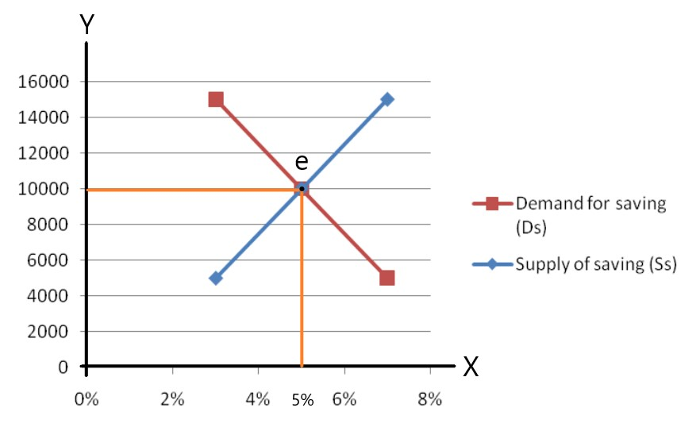
In the above schedule and diagram, we can see that when the rate of interest increases, people are willing to supply more saving to invest and at a low rate of interest they will supply less. But at the low rate of interest, demand for saving is high and vice-versa. The interest rate is determined at that point where the demand for saving and supply of saving are equal. In the diagram above, ‘e’ is the equilibrium point where demand for and supply of saving interact with each other. The interest rate here is determined at 5%.
Profit
Profit is the reward received by businessman for his contribution in production. In other words, profit is the reward of entrepreneur for bearing risk and uncertainty in the business.
Gross profit: the difference between total revenue total revenue and total explicit cost is called gross profit.
Gross profit= total revenue-explicit cost
Net profit: net profit can be defined as the difference between total revenue and total cost include explicit and implicit cost.
Net profit= total revenue- explicit cost-implicit cost

Risk bearing theory of profit
It is developed by American economist, prof. Hawley in 1907 A.D.
According to this theory risk taking is the main function of entrepreneur. An entrepreneur coordinate other factors of production such as capital, labour and land. There factors are paid in the form of interest, wages and rent but profit of entrepreneur is uncertain because there is time lag between production and sell. During this time various charge can take place. There are various risk involved in business enterprise this risk will undertake by entrepreneur and he gets reward which is called profit.
Higher risk is higher possibilities of profit and vice-versa.

Criticisms of Risk theory of profit
The reward for reducing risk
No proportional relation between risk and profit
Narrow theory

Uncertainty Bearing Theory Of Profit
Developed by prof. knight in 1921 A.D.
According to knight, profit arises due to uncertainty bearing rather than risk bearing. Knight divides the risk in to two part.
  - Insurable risk (known risk)
Risk about which certain predication and estimates are possible to insured they are called known risk or insurable risk. This type of risk can be avoid by doing insurance.
Example, predication of fire, accident, theft etc.
  - Uninsurable risk
Some risk cannot be predicted so they cannot be insured. This is why they are called uninsurable/ unknown risk. This risk create uncertainties, which is taken by entrepreneur and get reward as a profit. This types of risk are
- Competition risk
- Risk of government intervention
- Business cycle
- Technical risk

Unit-6
Banking system and monetary policy
Definition of bank
A bank is an institution which deals with money and credit, accepts deposits from the public, makes funds available to those who need them, public and helps in remittance of money from one place to another.
According to world bank,” Banks are financial institutions that accept funds in the form of deposits repayable on demand or in short notice”.
Features
- It deals with money
- It accepts deposits and advances loans.
- It also deals with credit and it has ability to create credit.
- It aims at earning profit.
- It managers the payment system in the economy.

Roles or importance of the banking system
1. Mobility of saving
One of the major roles of the banking system is to collect saving from the general public and mobilize them in business sectors. The collected money is lent to productive sectors. It is called the mobilization of saving.
3.Capital formation
The process of capital formation begins with saving. People save in the bank, productive sectors demand it and use to purchase capital equipment, to produce goods and services are thereby to create income.
4. Creation of employment opportunity
Establishment of banks and financial institutions creates direct and indirect employment opportunities. The bank needs employees who create direct employment. Banks provide loan to the business sector which needs regular manpower to run it. So, banks create indirect employment.
5. To manage foreign trade and payments
Due to the introduction of foreign trade, businessmen can import and export goods and services in the global market. Financial transactions related to import and export are managed through banks.
6. Remittance of money
The development of the banking system also facilitates for the remittance of money. People send and receive money from different parts of the world only because of a good banking system.
7. To meet government expenditures
In developing countries like Nepal, the development expenditure of the government is more than the revenue collected. So, the excess amount borrowed from various sources and the bank is one of them.
8.Poverty alleviation
Banks create different types of direct and indirect employment. They also facilitate credit to invest in production. This helps in poverty reduction in the country.

Central bank and its Functions
Nepal Rastra Bank is the central bank of Nepal which was established on 14th Baisakh 2013 B.S.

Functions of the central bank
1. The monopoly of note issue
The primary function of a central bank is to issue notes in the country. It has the monopoly right of issuing bank notes subject to certain safeguard (deposits of gold and silver) imposed by the law. In Nepal, Nepal Rastra bank issues the notes under proportional revenue system.
2. Government’s banker, agent and advisor
Central bank fulfills the function of bankers, agent, and advisor of the government. The central bank maintains the banking account of government departments, boards enterprises, etc. The government purchases securities like treasury bills and sells it through the central bank. It advises the government to formulate monetary and fiscal policies in the country.
3. Bank of all banks
The central bank is also called the bank of banks of the country. It keeps the cash reserve of commercial banks. All the commercial banks and other banks have their account in the central bank. So, it performs as a bankers bank.
4. Lender of the last resort
The central bank is the lender of last resort. It is the ultimate source of funding of commercial banks. During the hard times of commercial banks, central bank advances loans to a commercial bank.
5. Provides clearing house facilities
The central bank also acts as the shelter of financial claims of a bank against others. Each commercial bank maintains its bank in the central bank. The central bank clears each other's claims of their respective accounts.
6. Control of credit
Credit control refers to the arrangement of credit according to the requirement of the economy. The central bank controls credit by using credit control instruments such as open market operation, changes in the statutory reserve requirement of banks, bank rate policy, control over interest, etc.
7. Foreign exchange control
The central bank of any country holds the absolute right to regulate and control foreign exchange operations. The foreign exchange rate is determined with the help of demand for and supply of the foreign currencies under flexible exchange system. Likewise, the exchange rate is determined with a mutual agreement under the fixed as exchange regime of system.

Commercial bank and its Functions
A commercial bank is an institution that provides services such as accepting deposits, providing business loans, offering basic investment products (money), etc.
The first commercial bank in Nepal (First bank in Nepal), Nepal bank limited was established in the year 1994 B.S.

The function of a commercial bank

A. Primary functions
1. Accepting deposits
The first important function of a commercial bank is to accept deposits in different accounts. The main forms of deposits accepted by the commercial banks are as follows
a. current deposit
A demand deposit is also known as the current account deposit. It is generally maintenance by traders and businessman who have to make a number of payments every day.
b. Saving deposit
This account is generally maintained by the low-income people and those who do not need to withdraw money frequently. There are certain restrictions of time and frequency while withdrawing from this deposit.
c. Fixed deposit
Fixed deposits are also known as time deposits. In this account, money is deposited for a fixed period of time and cannot be withdrawn until the maturity period. The interest rate is very high in this deposit.
2. Providing loans
The banks earn profit by giving the amount deposited in it in the form of loans. Since the bank creates credit with its deposits, it is called the manufacturer of credit. The bank charges interest on loans which is usually higher than that offered on deposits. The main forms of loans provided by commercial banks are as follows:
a. Cash credit
It is a type of loan which is given to borrower against his/her current assets such as shares, stocks, bonds, etc loans are also provided on the basis of security deposit.
- Overdraft
Sometimes the commercial banks provide overdraft facilities to its customers through which they are allowed to withdraw more than their deposits. Interest is charged to the customers on the overdrawn amount.
c. Loans and advances
These are generally long term loans which are provided by the bank to individuals and institutions against adequate securities like gold, silver, government and non-government securities that are easily traded, etc.

B. Secondary function/ Agency functions
Commercial banks collect and pay various credit instruments like cheques, bills of exchange, promissory note, etc.
1. Remittance of money
Commercial bank helps its customers in transferring money from one place to another through cheques, draft, etc.
2. Purchase and sale of securities
Commercial banks undertake functions like purchase and sale of various securities on behalf of their customers.
3. Income receiving and payment
Commercial banks receive dividends, interest on shares and debentures of their customers. Similarly, they make the payment of insurance premium, rent, income tax periodically.

C. Contingent Function
The contingent function is also called a general utility function. The contingent functions are as follows:
1. Locker facility
The commercial bank provides the locker facility to its customers. The customers keep their valuable things like gold, diamond, silver, etc and important documents in the locker for safety.
2. Traveler’s cheque
Commercial banks issue traveler’s cheque to their customers to help travel without fear of loss of money.
3. Letter of credit
Letter of credit is issued by the banks to their customers certifying their credit worthiness. It is very useful in foreign trade.
4. Dealing in foreign exchange
Commercial banks exchange foreign currency of customers with prior approval of the central bank.
5. Collection of statistics
Commercial banks collect statistics giving important information relating to industry, trade, and commerce and also publish financial journals.

Financial market
Market where financial instruments are traded
Financial instruments like stock, bonds, insurance policies, government securities, debentures, etc.
There are two types
Money market
- Market where short-term financial instruments are traded
- The maturity period is one year or less.
- Treasury bills, commercial papers, certificates of deposits, etc
Feature of money market
- Maturity period one year or less.
- Degree of risk is small
- Closely + directly linked with central bank.
- Closely regulated by central bank
Capital market
Market in which long- term financial instruments such as equities and bonds are raised and traded.
Features of capital market
- Maturity period more than one year.
- Credit instrument like debenture, equities, government, securities.
- Important institutions are stock exchange, development banks, finance companies, provident fund, investment companies etc.
- More risk as time period is higher.
- Less regulated by central bank.

Monetary policy
Policy formulated by central bank of the country to control and regulated the money supply, credit, and interest rate in the economy.
Main objectives
- Generate employment opportunities.
- Exchange rate stability.
- Reduce trade deficit
- Price stability
- Achieve economic growth
- Development of banking of financial intuitions

Types of monetary policy
Expansionary monetary policy
- Action taken by central bank to increase the money supply.
- Can purchase treasury bills of bonds in open market, decrease bank rate, reduce required reserves ratio etc.
- Formulated during economic depression and deflationary period
Contractionary monetary policy
- Action taken by central bank to decrease the money supply
- Sell treasury bills and bonds, increase bank rate, increase reserve ration etc.
- Formulated during an inflationary period.

CHAPTER - 7
Government Finance

Government finance
Government finance/public finance is subject matter of economics which deals with the income and expenditure of government.
Importance of government finance
- Efficient allocation of resources
- To maintain economic stability
- Social goods and infrastructure
- Capital formation
- Redistribution of income and wealth
- Efficient mobilization of resource( from non-productive to productive)
- Economic development
- Control foreign payments (by imposing higher taxes, limit on expenditures in foreign countries)
Government expenditure
Government expenditure means the nature and quantum of expenses incurred by the public authorities of central, state and local level for
- Delivering services to the public.
- Social and economic wealth of people
- Maintain peace and security in the country.
Importance of government expenditure
- Maintain law and order
- Investment in social and economic projects
- Utilization of nature resources
- Subsidies and grant
- Provide administration services
- Balance growth

Classification of government expenditure with reference to Nepal
The estimated expenditure of the government of Nepal for the fiscal year 2021/2022 is Rs. 16475.76 crores. It consists of three types of expenditures which are as follows:
1. Recurrent expenditure
2. Capital expenditure
3. Financing

Re-current expenditure
- Regular / administrative expenditure
- 54.80% of total expenditure
- Payment of salaries, pensions, interest on internal and external loans etc.
Classification into various headings
- Constitutional organs: supreme court, parliament, election commission
- General administrative: council of ministers, police, jail, district administration
- Revenue administration: land revenue, custom revenue, excise
- Foreign services: embassy
- Defense: defense related office
- Social services: health, education, drinking water
- Economic services: agriculture , transports
- Loans and investment: interest payments.
Capital expenditures
- Long- term expenditure programs for economic development
- 37.40% of total estimated expenditure of fiscal yearn2021/2022
Classification of different headings
- Constitutional organs: (infrastructure development)
- Social services
- Economic services

Financial expenditure
- Repayment of government debts, repurchase of bonds and treasury bills.
- 7.80 of total expenditure fiscal year 2021/2022.

Government Revenue
Government revenue or public revenue refers to the income of the government received from various sources.

Sources of Government Revenue
A government raises income from different sources.
- Tax Revenue
- Non-Tax Revenue
- Foreign Grants

Tax Revenue
Taxes are the compulsory payments made by the people to the government and the major sources of public revenue. Various kinds of taxes are imposed on the people, which are described as follows:
Customs: The taxes which are imposed on exports and imports at the customs office are called customs. These taxes are imposed on goods according to the quantity and the value of such goods. Customs are the indirect taxes.
Tax on consumption and production of goods and services: Government imposes taxes on the production and the consumption of goods and services. In this category, excise duty, sales tax, entertainment tax, contract tax, road and bridge tax, value-added tax, etc.
Land revenue and registration: Land tax is imposed on landlords for the ownership of the land. Registration charges are the payments made for the registration of land and houses. These taxes are direct taxes.
Tax on property, profit, and income: Public corporations, private companies, and individuals should pay profit and income taxes according to their income and profit.

Non-Tax Revenue
Non-tax revenue includes the following:
Gifts and grants: Voluntary payments made by the people for the relief works at the time of natural calamities and disasters are called gifts. Some institutions or persons also make donations to the government.
Fees: Government collects fees from different sources such as fees are charged on the services of education, health, and firm registration, license of vehicles and guns,etc.
Fines and penalties: Fines and penalties are charged to those persons who violate the rules and regulations of the country.
Income from public properties and enterprises: Government can earn income from public properties like rent on public land, minerals, rivers, forests, etc.

Foreign Grants

The government of a developing country can receive funds from foreign countries. In recent times, foreign grants consist of a large share in the budget of such countries.

Concept of tax
- Compulsory monetary charge imposed by government to its citizens and institution and nobody can deny it.
- Direct benefits in return are not expected at the time of tax payment.
- Spend for welfare of the people.
Types of taxes
On the basis of impact and incidence
1 . direct tax: impact and incidence of tax falls on the same person on whom it is imposed legally. For example, income tax is the direct tax because the taxpayer cannot shift the amount of tax to another person.
Merits
- Equity
- Economic
- Certainty
- Progressive
- Elasticity
Demerits
- Inconvenient
- Possibility of evasion
- Limited scope
- Disincentive on work effort and saving
2 . indirect tax: impact of tax falls on one person and incidence of tax is shifted to another. For example, value-added tax (VAT) is an indirect tax because it is paid by a producer or seller of a commodity and can be shifted to the final purchaser by adding the amount of tax with the price of that commodity.
Merits
- Convenient
- Broad based
- Non-evadable
- Elastic
- Equitable
Demerits
- Uncertain
- Uneconomical
- Un-educative in nature
- Regressive in nature

A. Proportional Tax
If the rate of tax remains the same at every level of income and wealth, it is called proportional tax. Example, sales tax
Income Level (In Rs.) | Rate of Tax (In %) | Total Tax Amount (In Rs.)
10,000 | 10 | 1,000
20,000 | 10 | 2,000
30,000 | 10 | 3,000
40,000 | 10 | 4,000

B. Progressive Tax
A progressive tax is a system in which the rate of tax increases with the rise in the level of income and wealth.

Income Level (In Rs.) | Rate of Tax (In %) | Total Tax Amount (In Rs.)
10,000 | 5 | 500
20,000 | 15 | 3,000
30,000 | 25 | 7,500
40,000 | 35 | 14,000

C. Regressive Tax
A regressive tax is a system in which the rate of tax decreases with the rise in the level of income. The lower rate of tax is charged on the higher level of income. It means the poor should pay a higher rate of tax in comparison to the rich.

Income Level (In Rs.) | Rate of Tax (In %) | Total Tax Amount (In Rs.)
10,000 | 10 | 1,000
20,000 | 9 | 1,800
30,000 | 8 | 2,400
40,000 | 7 | 2,800

D. Digressive Tax
Digressive tax is a system in which the tax rate increases with the rise in income up to a certain limit but beyond that limit the tax rate becomes constant.

Income Level (In Rs.) | Rate of Tax (In %) | Total Tax Amount (In Rs.)
10,000 | 10 | 1,000
20,000 | 15 | 3,000
30,000 | 20 | 6,000
40,000 | 20 | 8,000

Qualities of good tax system
- Raises revenue from government
- Maintains stability and economic growth
- Certainty and convenience
Qualities
- Canon of equality: equality of sacrifice and ability to pay
- Canon of certainty: certain regarding amount, time and method of tax payment
- Canon of convenience: convenient to pay taxpayer convenient to collect by government
- Canon economy: collection by government economically
- Canon of elasticity: can increase/ decrease rate for better collection
- Canon of diversity: cover wide range of economy various communities and persons
- Canon of uniformity: method of tax should be uniform to all people.

Government Borrowing
The fund or capital received in the form of a loan by the government of a country from various sources is called government borrowing. It is also called public borrowing or public debt.

Sources of government Borrowing

Internal Borrowing
The loan borrowed by the government from internal sources like individuals, public or private organizations, central banks, commercial banks, and other financial institutions within the country is called internal borrowing.

a. Market borrowing:
Market borrowing refers to that loan that is raised by selling transferable securities like treasury bills and development bonds.

b. Non-market borrowing:
The loan received by means of nontransferable credit instruments is called non-market borrowing. example, private share, state and local government securities.

2. External Borrowing
The loan received by the government of a country from foreign individuals, foreign government, and foreign or international institutions is called external borrowing.
a. Bilateral borrowing: If the government of a country borrows a loan by making an agreement with the government of another country, it is called bilateral borrowing. For example, the loan taken by the Government of Nepal from the Government of USA, UK, Japan, etc. is bilateral borrowing.
b. Multilateral borrowing: If the government of a country borrows a loan from international organizations like UNDP, World Bank, Asian Development Bank, European Union (EU), International Monetary Fund (IMF), etc then it is called multilateral borrowing.

Meaning of government budget
- Refers to statement of financial plan for a given period relating to income and expenditure of the government.
Types of budget
- Deficit budget: total revenue<total expenditure
- Surplus budget: total revenue>total expenditure
- Balance budget: total revenue=total expenditure
Steps/ process of budget formulation
- Forecasting of overall income and expenditure
-by a resource committee chaired by vice chairperson of NPC and other members include from ministry of finance (MoF), NPC, central bank, financial comptroller general’s officer(FCGO)
- Establishment of priority
- Project preparation
- Selection of project and submission
- Preparation of final budget
- Authorization and execution

UNIT-8

Concept of International Trade

International trade or foreign is the sale and purchase of goods and services between the people of different countries. It involves exports and import.
Importance of international trade
1. Qualitative and cheaper goods: International trade helps in the better and efficient utilization of resources. Because of international trade, it is possible for every country to concentrate on the production of those goods which can be produced at lower cost and import other goods from other countries. Thus, international trade makes qualitative and cheaper goods available.

2. Agricultural development: Development of agriculture sector is not possible without its modernization. There is a need for machinery and tools, fertilizer, pesticides, etc. for the modernization of the agriculture sector which can be imported from abroad and can be adapted to develop and modernize the agriculture sector.

3. Industrial development: Underdeveloped countries require machinery and capital goods to establish and operate industries. They have to import such machinery and capital goods from abroad. If there was no international trade, industrial development of these countries would be very difficult.
4. Development of competitive capacity: In order to stand in international trade, every country has to improve its competitive capacity. Necessity is the mother of invention. When the need arises, the efforts are made. Every country seeks to be able to survive in the international competition for the market. This leads to the development of competitive capacity.

5. Modern and high standard life: All the people of the world have modern and high standard life due to international trade. The people of many backward countries like Nepal are using high standard goods like cars, computers, air conditioners, television washing machines, etc. imported from other countries.

6. Increase in employment opportunities: International trade increases the number of export-oriented industries in the country. It encourages large scale production which helps to increase employment.

7. Expansion of the market: International trade helps to expand the market of small countries like Nepal. It integrates the country with other countries of the world. Goods produced efficiently can be sold worldwide in the extensive international market.

8. Benefit of technological progress: developing countries like Nepal are technologically backward. They are still using primitive technology. But in developed countries, there is rapid technological progress. International trade helps to import technology, receive technical knowledge and managerial skill.

Concept of Balance of trade

Balance of trade is defined as the difference between the value of exports and the value of imports of a country. It includes only import and export of visible material goods, which have a physical structure, size, shape, and form. These goods can be seen, weighed, counted, and touched. It does not include invisible or non-material goods or services such as transportation, banking, insurance, etc.

Types of Balance of Trade:
Balance of trade can be divided into the following three types:
1.Trade surplus: Trade surplus = Export (X) > import (M)
2.Trade deficit: Trade Deficit = Import (M) > Export (X)
3.Balanced trade balance: Balanced Trade Balance = Export (X) = Import (M)

Balance of payment
Balance of payment is defined as the systematic record of receipt and payment of a country with the rest of the world.

Types of Balance of payments
There are two types of balance of payment account which are as follows:
1. Favorable balance of payment:
If the total receipts of a country exceed its total payments, it is called a favorable balance of payment. It is also known as the surplus of the balance of payment.
Favorable Balance of Payment = Total Receipts > Total Payments
2. Unfavorable balance of payment:
If the total payments of a country exceed its total receipts, it is called unfavorable balance of payment It is also known as the deficit of the balance of payment.
Unfavorable Balance of Payment = Total Receipts < Total Payments

Concept of exchange rate
The exchange rate can be defined as the rate at which one country's currency is exchanged with the currency of another country.
Types of exchange rate
1.Flexible exchange rate
2. Fixed exchange rate
3. Forward exchange rate: The rate of exchange at which a futures contract for foreign currency is made is called the forward exchange rate.
4. Multiple exchange rate: The system in which a country adopts more than one exchange rate for its currency is called multiple exchange rate. According to this system, different exchange rates are fixed for importers, exporters, and different countries.
5. Two-tier exchange rate system: It is a multiple exchange rate system. In this system, a country maintains two rates, a higher rate for commercial transactions and a lower rate for capital transactions.

Free trade
If the government does not impose any kind of restriction on export and import of goods and services, it is defined as free trade. The movement of goods and services can be made without any restriction from country to country.
Advantages of free trade is as follows.
1. The benefit of specialization:
Free trade encourages the division of labor due to which a country is specialized to produce certain kinds of goods in the country. This helps to increase the efficiency of the resources of the country and produce high-quality goods at a lower cost.
2. Benefits to international consumers:
Free trade policy benefits the consumers of international market through the exchange of the best quality goods and services at the minimum prices. Under this policy, every country specializes in production and exchanges those goods which can be produced at a comparative cost advantage. As a result, international consumers would be able to consume any types of products they like.

3. Promotes healthy competition:
When the free trade policy is adopted, healthy competition with the foreign producers will be promoted. It also helps to reduce per unit cost of production, exchange policy, consumption pattern, and develop the skills of resources of the country.

4. Expansion of the market:
When the movement of goods are not restricted from one country to another, the market of a product is expanded in a wide range. The domestic goods can be supplied in the international market and the activity of trade of a country is expanded with the rest of the world.

5. The gain of technology:
New and improved technology is required for industrial development. Hence, developing countries which are backward in technology can import suitable technology from foreign countries.
6. Increase in production:
Due to free trade, the production of a country can be easily exported to another country. As a result, domestic producers produce goods not only for the local market but also for the international market. This leads to an increase in the production of goods and services.

8. Cheaper price:
A country produces such a commodity whose production cost is the lowest one. With free trade, people can consume goods at the lowest price. It ends the monopoly and helps in proper utilization of the raw materials in the country.
Disadvantages of free trade are as follows:
1. Exhaustion of natural resources:
When a developing the country adopts the policy of free trade, its natural resources are easily exported to the developed countries in the form of raw materials. In this way, the developed countries exploit the developing countries and exhaust natural resources very soon.
2. Adverse effect on domestic industries:
The industries of developing countries are not well flourished. They are running in an infant stage. Under a free trade policy, the infant industries cannot compete with the well-developed industries of the developed countries.

3. Economic dependency:
Under free trade, a country produces only those goods which comparatively cost the least. For all the other goods which are not produced within the country, the country has to depend on other countries. So, the countries which adopt free trade policy will have to accept the economic dependencies on other countries.
4. Dumping
Dumping is a method of selling the products at a lower price than the cost in the foreign market. This method is applied for a temporary period.
5. Import of harmful goods:
Free trade policy encourages exchanging all kinds of goods without any restriction. It is possible to import harmful commodities in the country. The import of harmful drugs can ruin the health of the nation.

Protectionism
Protectionism is a policy which encourages the national industries by imposing restrictions on the import of foreign goods or by providing facilities to domestic products.

Methods of protection:
1. Tariff barrier:
It refers to the high customs duty imposed on the import of foreign goods. When the custom duty is increased, the price of foreign goods increases. The increase in the price reduces the demand for foreign goods and thus import decreases.
2. Non-tariff barrier:
It includes the methods of licensing and quota system on imports, provision of direct subsidy on foreign trade through government enterprises, etc.
Advantages of protectionism are as follows:
- Need for protecting infant industries
- Generation of employment opportunities
- Correction of the balance of payment
- National defense
- To preserve natural resources
- Self-dependent
Disadvantages of protectionism are as follows:
- Idleness in industries
- Limited choices for consumers
- Creation of monopoly
- Promotion of inequality

Comparative cost theory of international trade
- Propounded by David Ricardo in 1817
- Also called as Ricardian theory of international trade
- Explained the international trade on the basis of comparative cost.
- The cost of production differ from country to country due to climate, topography, natural resources and other reasons.
- Each country is specialized to produce such goods in which the comparative cost of the production is the least.
Assumptions
- There exists only two countries and two commodities.
- Both the countries produce similar goods.
- Labour is only the factor of production.
- Production technology remains constant.
- Cost of production is measure in term of labour.
- The taste and preference of the people in both the countries are similar.
- There is perfect competition.
- There is no transportation cost.
- There is free trade between the two countries.
The concept of comparative cost theory can be explained by the help of the following schedule:
Countries | Cotton (C) |  | Jute (J)
 | Cost of production per kg in labor hours |  | Cost of production per kg in labor hours
India | 4 |  | 2
Nepal | 16 |  | 4

Criticism
- no existence of two country and two commodities
- cost of production measured in term of labor only
- no similar taste
- transportation cost is ignored
- complete specialization is not possible
- Technology doesn’t remain constant.

Measures to reduce trade deficit in Nepal
1.Access to transit facility: Nepal is a landlocked country with limited transit facilities. Nepal does not have a direct access to the seas and oceans. As a result, the ability of Nepal to trade with other countries is severely limited. Nepal must expand its transit facilities with China and Bangladesh to have access to the international market.
2. Diversify Nepal's export base: Nepal exports only a few items to a few nations. Nepal exports a limited number of products, such as woolen carpets and ready-made clothing. Nepal has been experiencing a trade deficit due to a lack of exportable goods. As a result, this problem can be handled by diversifying trade by commodity and country.
3.Industrial sector development: Nepal's industrial sector is still underdeveloped. Export-oriented industries are inherently unreliable, and the majority of them are seasonal. Export-oriented sectors should be developed alongside entire sectors to reduce the trade deficit.
4. Reduced manufacturing costs: In comparison to other countries, Nepal's production costs are pretty high due to the employment of primitive technologies, a weak labor force, and imported raw materials. As a result, to compete with international goods and services, current technology should be used to lower manufacturing costs.

5. Increased competition with foreign goods: The unrestricted flow of foreign goods into the Nepalese market has dominated Nepalese products in terms of price, quality, and quantity. As a result, Nepalese products are losing market share in foreign and domestic markets. Therefore, on the one hand, we must improve product quality while simultaneously lowering production costs.

6. Publicity and advertising: Publicity and advertising play an essential role in promoting export trade. However, demand for Nepalese goods is low due to a lack of publicity. As a result, indigenous products, such as wild honey tea, herbs, rice, and fruit, can, for example, be exported and sold at higher prices.

CHAPTER - 9
Poverty, Inequality, Unemployment and Human Resource

Poverty

Concept of poverty:
Poverty is defined as the inability to attain a minimum standard of living.

Poverty is a state or condition in which a person or community lacks the financial resources and essentials to enjoy a minimum standard of life and well-being that's considered acceptable in society.
Types of poverty
      - . Absolute poverty: Absolute poverty is the situation of inability to fulfill basic needs of people or inability to attain a minimum standard of living.
      - .Relative poverty: relative poverty is the situation in which a person has enough income to sustain the life, but the income and living standard are lower compared to rest of the community.

Characteristics of the poor
- Low income level
- Education
- Family expenditure pattern
- Status of poor in the society

Causes of Poverty:
- High Population Growth:
The population density of Nepal is very high (180 persons per sq. Km). A large majority of people in Nepal are engaged in less productive farming. Similarly, children are considered assets in Nepalese society and this contributes to high birth rates which consequently makes them poorer.
- Low growth rate:
The average economic growth rate in Nepal was 4% during the 12th-year plan. As compared to the population growth rate, this economic growth is not sufficient to raise the people's living standard.
- Slow industrialization:
The pace of industrialization is very slow in Nepal. So, there are fewer employment opportunities in Nepal in the non-agricultural sector of Nepal. Only 30% of people are fully employed in Nepal. On the other hand, there is a rapid price rise in the economy. So, this also contributes to poverty.
- Ineffective plan implementation:
Even after completion of the 12th-year plan, the living standard of people has not gone up significantly. This is due to poor implementation of plans in Nepal.
- Resources underutilization:
The available human, capital and natural resources have not been utilized and extracted. Even if they are utilized partially, the environmental aspect is not taken into consideration and it is being degraded which leads to many consequences and mostly the poor people suffer. Less utilization of resources leads to less production and income.
- Illiteracy and unemployment:
There are inadequate education and mass unemployment in Nepal. According to the census of 2011, only 65.9% of people are literate in Nepal. When literacy is low, unemployment becomes high which leads to low income and high level of poverty in Nepal.
- Unequal distribution of income and inequality:
There is a high gap in income between better offs (rich) and Worse offs (poor). There is severe inequality in the income level of people. The benefits of economic growth are centered on the richer and poor people are deprived which continues the poverty level.
8.lack of good governance, political stability
9. Low rural development

Measures to control poverty
1. Economic Development:
To remove poverty there should be economic development. Within the framework of economic development, three important factors are taken into consideration i.e. development of agriculture, fuller utilization of power and optimum utilization of resources by establishing industries.
2. Agricultural development:
Agriculture is regarded as the backbone of the Nepalese economy. For economic development, first, there should be the development of agriculture i.e. agriculture should be modernized and should be made more product oriented, profit-oriented and employment oriented.
3.Promotion of Industries:
To remove poverty, employment opportunities and facilities should also be provided to people by the establishment of small scale and heavy industries. There should be a revival of cottage industries and small scale industries which can make the backbone of a rural economy stronger.
4. Control population:
5. Development of education:
Education should be more vocational. The practical educations should be introduced in all the educational institutions. This will enable the educated youths to earn for themselves and to add to national output instead of being dependent on the country or Government for jobs.
6. Removal of personal disabilities:
Personal disabilities like prolonged disease, physical handicap, and mental diseases, etc, cause poverty. Hence Government should take various steps as to enable these handicapped people to earn their own livelihood in this respect, Government should provide facilities like adequate and free health service to rural poor, control of various diseases by permanent public health programmes, rehabilitation of physically handicapped persons, etc.
8. Facilitating empowerment.
9. Enhancing peace and security.
10. Practicing good governance.
11. Controlling and eradicating corruption etc.

Concept of inequality
Inequality is defined as the situation in which income and wealth are distributed unequal among the people of a country. It is also known as income inequality. It is a common feature of developing countries like Nepal.

Causes of inequality
- Law of inheritance
- Private ownership of income
- Credit policy
- Unemployment problem
- Faulty taxation system
Measures to reduce inequality
- Generate employment
- Land reforms
- Establishment of small scale industries
- Extension of public sector

Unemployment
Unemployment is defined as the non-availability of jobs (works) for people able and willing to work at the existing wage-rate. It is a problem to both developed and developing countries.
Types of unemployment
- Open unemployment
- Underemployment
- Hidden(disguised) unemployment
- Cyclical unemployment
- Seasonal unemployment
- Educated unemployment
- Frictional unemployment
Causes of unemployment
- Explosive population growth
- Poverty
- More emphasis on capital intensive technique
- Decay of small enterprises
- Lack of training
- Slow speed of economic growth
Measures to create employment
- Population control
- Emphasis on labor intensive technique
- Encouragement to small enterprises
- Improve education system
- Government policy measures
- Rural development schemes

Concept of Human resource

In common language, human resource means population of a country.

But in economics, Human resource is the knowledge, skill, efficiency, physical and mental capacity to do work inherent in the people of the country.
Role of human resource
- Large scale of production
- Utilization of natural resources
- Improvement in technology
- Utilization of physical capital: Human resources are essential to operate machinery and equipment and to run factories and industries.
- Remove economic backwardness: The human resource helps directly to remove the economic backwardness. It increases labor efficiency and specialization. The development of human resource increases the knowledge of natural resources, new production technique, market, and opportunities for economic activities.
- Development of agricultural and industrial sector: The modern and superior technologies should be used for the modernization of agriculture and rapid industrialization. This is made possible only by human resource.
- Reform in traditional cultural and attitude: The traditional culture and attitude have been harmful to the development of developing countries including Nepal.

Human Development
Human development is defined as an expansion of human capabilities widening of choices, an enhancement of freedom, and a fulfillment human rights. In other words, the development of overall situations like education, income, healthy, average life of expectancy, sanitation, poverty situation, condition of women, security and environment, etc. is called human development.

The major indicators of human development are as follows
- Per capita income: per capita income is the economic indicator of human development. It is calculated by dividing national income by the total population of a country. Higher per capita income shows higher human development and lower per capita income shows lower human development. In US dollars, the per capita income of Nepalis has reached 1,381 dollars. According to the Economic Survey of the Fiscal Year 2078/79,
- Life expectancy at birth: life expectancy at birth is the average number of years of a man can expect to live. It is one of the most frequently used health status indicator. Infant mortality rate and age of death influence the life expectancy at birth. The life expectancy for Nepal in 2023 was 71.74 years,
- Education attainment: the highest degree of education that an individual has completed, is known as educational attainment. Higher educational attainment represent higher human development and vice-versa. According to the National Census 2078 BS report by the Centre Bureau of Statistics on Friday, Nepal's literacy rate reached 76.3 per cent. Before 10 years in 2068 BS country's literacy rate was 65.9 per cent.
- Fulfillment of basic needs: food, shelter, clothing, education and healthcare are the main basic needs of the people. The fulfillment of these basis needs is necessary to survive life of people.
- Maternal mortality rate: the number of registered mother who die in time of give birth of child or pregnancy is called maternal mortality rate. High maternal mortality rate indicates low human development and low maternal mortality rate indicates human development.

Human Development Index (HDI):
The HDI is an index that measures three key dimensions of human development: a long and healthy life access to education and a decent standard of living.
HDI report 2021\22 Nepal perform in the 143rd position with a 0.602 value.

2078 population
Total population = 2, 91, 64,578
Female population = 51.04%
Male population= 48.96%
Population growth rate = 0.93%

CHAPTER - 10
Nepalese Foreign Trade and Foreign Employment

Nepalese foreign trade/ Foreign trade of Nepal
Foreign trade plays a very important role in the economic development of a country. It promotes economic development by improving competitive capacity, expanding market, and providing modern technology and machinery for the industrial and agricultural sector. Therefore, it is also considered as the vehicle of economic development.

Composition of Nepalese foreign trade:
1. Composition of export:
The major exportable goods of Nepal are woolen goods, carpets (hand-knotted woolen), Nepalese paper and paper products, readymade garments, handicrafts, ornaments, Pasmina, pulses, cardamom, medical herbs, etc. These goods are exported to India and other countries like USA, China, Germany, UK, etc.

2. Composition of import:
The major goods imported in Nepal are various finished goods, semi-finished goods, raw materials of industry, machinery, equipment, chemical fertilizers, petroleum products, gold, electrical goods, readymade garments, etc. These goods are imported mainly from India, China, and other Asian countries.

Growth of Nepalese foreign trade:
Before 1951 AD, Nepal‘s trade relation was only with India and Tibet. The decline of the Rana regime in 1951 AD was the turning point of Nepalese foreign trade. After this, the foreign trade of Nepal has run systematically with many countries of the world and the volume of trade has also increased. During the fiscal year 1956/57, the total export of Nepal was equivalent to Rs. 9.5 crore and the total import was equivalent to Rs. 17 crores. The total volume of trade was equivalent to Rs. 26.5 crore. But now, it has increased thousands of times. Nepal's export, import, the volume of trade, and trade deficit are increasing rapidly. But the rate of increase in import is higher, than the rate of increase in export. Consequently, Nepal's trade deficit is very high and increasing rapidly every year. The persistent deficit in foreign trade is due to the low production of export-oriented goods and higher import of consumer goods. In order to reduce this deficit, the Production of competitive goods should be increased, which will help to increase export and reduce import.

The direction of foreign trade of Nepal
Before 1951 AD, Nepal's foreign trade was limited only with India and Tibet The trade with India formed 95 percentages and the remaining trade was with Tibet. The trade with overseas countries was almost nil. The major reasons behind the concentration of Nepalese trade with India were: Nepal bordering by India, open border with India, and similarities in language, culture, religion, tradition, etc. But now, Nepal‘s trade relation is with many overseas countries besides India and China. But India is still a major trading partner of Nepal. Other countries include USA, Germany, Japan, UK, France, Italy, Spain, Switzerland, Belgium, etc. Besides India and China, Nepalese products are exported to USA, Germany, Japan, Bangladesh, the UK, France, Italy, Spain, Switzerland, Belgium, etc. Similarly, besides India and China, Nepal imports from Singapore, UK, UAE, Malaysia, Kuwait, etc.

Problems of Nepalese foreign trade
1. Landlockedness:
Nepal is a landlocked country. It is bordered by India from three sides: east, west, and south and by China from the north. Therefore, Nepal has no direct access to the sea and it has no seaport. Goods are to be exported to different countries either using the land of India or through air transportation. Both of these are very expensive.
2. Low export and high import:
The production of exportable commodities is very limited in Nepal. There are very few goods which Nepal has been exporting such as woolen carpets, ready-made garments, handicrafts, herbs and shrubs, tea, coffee, etc. But the export of these goods is declining in recent years. On the other hand, Nepal's import is very high in comparison to export.
3. Low-quality goods:
The goods produced in Nepal are of low quality because of the use of inferior inputs and backward technology. Such goods cannot compete with foreign products. Therefore, it is very difficult to sell these goods in the international market.

4. The high cost of production:
The cost of production in Nepal is very high in comparison to our neighboring countries: India and China. The causes behind the high cost of production in Nepal are the use of primitive technology, inefficient labor, imported raw materials, inefficient, equipment, etc.

5. Lack of publicity and advertisement:
Publicity and advertisement plays a very important role in the promotion of export trade. But, Nepal is not able to publicize and advertise its products in the international market. As the domestic goods are not published in the international market in an attractive way, the speedy and satisfactory development of Nepal's export trade could not take place.

6. Low production:
Low production is one of the major problems of Nepalese foreign trade. There are very limited economic activities in Nepal. The industrial base and necessary infrastructure are not well developed. There is still a lack of energy, transportation, communication, skilled and trained manpower, etc.

7. Slow industrial development:
The pace of industrial development in Nepal is very slow. The industrial sector of Nepal is still in undeveloped and infant stage. Because of long political instability and transitional period, there is not smooth functioning of the industrial sector and there is also a decline in industrial production. The export-oriented industries are not fully reliable and most of them are seasonal in nature.
8. Lack of trade diversification:
There is a lack of diversification of Nepalese foreign trade. It is concentrated on limited goods and countries. Nepal's more than 60 percent of trade is only with India. Nepal is also backward in commodity-wise trade diversification.

World Trade Organization (WTO)
World Trade Organization (WTO) is an international organization which deals with global rules of trade between nations. Its main objective is to achieve economic prosperity through fair and free trade. It was established in January 1995. The main root of WTO is GATT (General Agreement on Trade and Tariff) which was established in 1947 with a View to liberalize and expand the world trade.
The headquarters of WTO is located at Geneva, Switzerland. At present, there are more than 164 member countries of WTO. Nepal is a 147th member and got WTO membership on April 23, 2004. Nepal's membership of WTO is very important for its economic development and integration into the multilateral trading system. It will help Nepal for country-wise and commodity-wise trade diversification.

Objectives of WTO:
1. Raising the living standard of the people:
Raising the standard of living and income, promoting full employment, expanding production and trade, and optimum utilization of the world's resources.
2. Sustainable development:
Sustainable development is a concept which envisages that development and environment can go together.
3. A better share of growth in trade:
Taking positive steps to ensure that developing countries, especially the least developed countries (LDCs), secure a better share of growth in trade.
Principles of WTO
1. International trade without discrimination:
The member countries of WTO can have total freedom to carry out international trade among them as the most favored nations. There will be no discrimination among them for the exchange of goods and services.
2. Free trade:
The member countries adopt free trade policy by reducing customs duties, import taxes, the quota system, red tape, exchange control, etc. in their business transactions.
3. Security guarantee:
WTO provides a security guarantee to its member countries regarding capital investment and the establishment of multinational companies.
4. Development of free trade competition:
Emphasis should be given for open, fair, healthy, and liberal competition among the member countries. It does not allow the principle of protection.
5. Support for developing nations:
It also gives equal emphasis to build up the competitive capacity of the developing nations.

South Asian Free Trade Area (SAFTA)
The South Asian Free Trade Area (SAFTA) is an agreement among the SAARC member countries for the development of regional trade and cooperation in South Asia. This agreement was signed on January 6, 2004, during the 12th SAARC summit held in Islamabad, Pakistan and came into force on January 1, 2006. The main objective of SAFTA is to promote and enhance mutual trade and economic cooperation by eliminating trade barriers and facilitating cross border movement of goods.
The South Asian Association for Regional Cooperation (SAARC) is the organization of South Asian Countries founded in 1985. Its seven founding members are Nepal, Bhutan, Bangladesh, India, Maldives, Pakistan, and Sri Lanka. Afghanistan joined the organization in 2007. Thus, at present, there are eight member countries of SAARC.

Objectives of SAFTA:
1. Eliminating trade barriers:
Eliminating barriers to trade in and facilitating the cross-border movement of goods and services between the territories of the member countries.
2. Promoting fair competition:
Promoting conditions of fair competition in the free trade area and ensuring equitable benefits to all the member countries, taking into account their respective levels and pattern of economic development.
3. Creating an effective mechanism:
Creating an effective mechanism for the implementation and application of this Agreement for its joint administration and for the resolution of disputes.
4. Enhancing mutual benefits:
Establishing a framework for further regional cooperation to expand and enhance the mutual benefits of this agreement.

Principles of SAFTA:
1. Rule-based:
SAFTA will be governed by the provisions of the Agreement and also by the rules, regulations, understandings, and protocols to be agreed upon within its framework by The Contracting States.
2. Compatibility with WTO and other agreements:
The contracting states affirm their existing rights and obligations with respect to each other under the Marrakesh Agreement establishing the World Trade Organization and other Treaties / Agreement to which the Contracting States are signatories.
3. Reciprocity and mutuality of advantage:
SAFTA shall be based and applied on the principles of overall reciprocity and mutuality of advantages in such a way as to benefit equitably all Contracting States, taking into account their respective levels of economic and industrial development, the problem of their external trade and tariff policies and systems.
4. Free movement of goods between countries:
SAFTA shall involve the free movement of goods between countries through; inter alia, the elimination of tariffs, para-tariffs, and non-tariff restrictions on the movement of goods and other equivalent measures.
5. Trade facilitation:
SAFTA shall entail the adoption of trade facilitation and other measures and the progressive harmonization of legislation by the contracting States in the relevant areas.

Foreign employment and remittance:
If labour force of a country moves to another country seeking job or employment, it is called foreign employment. In other words, foreign employment is defined as the working abroad for earning money.
The money sent by people to their home country from foreign employment is called remittance.
Current status of foreign employment in Nepal
we see a huge number of Nepalese labours entering foreign markets every year. Thus, the number of Nepalese workers abroad has been increasing through the years. The total number of workers who went foreign employment was 1, 05,703 in fiscal year 2003/04. It was 1, 94,045 in the fiscal year2019/20. Till mid- March 2021, total number of Nepalese workers going for foreign employment was 44, 66,973.

Current status of remittances flow to Nepal
In Nepal, remittances flow has been increasing rapidly year by year. Remittances sent by the overseas migrants was Rs.54.20 billion in fiscal year2003/04. Which increased to Rs.875.0 billion in fiscal year 2019/20 reflecting more than 1200 percentage rise. The continuous increase in workers remittance in Nepal is mainly due to the increase in the number of workers in the foreign employment, increase in wage rate and the creation of facilities to send remittances from abroad.

Advantages of Foreign Employment in Nepal
a. To solve the unemployment problem: Nepal has a severe unemployment problem. Foreign employment helps to solve the problem of unemployment in the country.
b. Remittance income: Another benefit of foreign employment is that it helps increase the country's remittance income. The amount of remittance income depends on the number of workers going abroad for foreign employment.
c. Skilled and trained human resources: The worker who returns to the home country after some years is the generally skilled and trained workforce. Their knowledge and skill can create new opportunities in the country.
d. Increase standard of living: The standard of living of the members of the family living in the home country increases. This is due to the money the worker receives from a foreign country.
e. Poverty reduction: Remittance income received from foreign employment increases household income, which helps increase the consumption of low-income families. It also increases living standards and reduces poverty. Currently, there is a decrease in poverty in Nepal because of remittance.

Disadvantages of Foreign Employment in Nepal
a. Shortage of human resources in the country: The increase in foreign employment has brought the problem of a shortage of labor in the agriculture and industrial sector of the country. At present, Nepal is facing this problem.
b. Brain drain: The most severe cost of foreign employment is brain drain. Due to the opportunity for foreign employment, the country's most talented, skilled, and highly educated workforce is migrating to developed countries like the USA, UK, Canada, Australia, etc. Therefore, it harms the economic development of developing countries like Nepal.
c. Mismanaged family: Migration of parents can leave families of young children with inadequate guidance and an additional burden of household responsibilities, which can lead to higher school absences, school dropouts, poor nutrition and health care of children- especially younger children, and substance abuse - mainly older children.
d. Creates dependency: It is argued that remittance receipts from foreign employment can create dependency. This, along with a shortage of skilled workers in the country, may hurt the country's economic growth in the long term.
e. Human costs: Migrants make significant scarifies. They have to remain separated from their families and incur risks to find work in another country. They may have to work hard to save enough to send remittances. Many Nepalese workers are suffering hardship in gulf countries. Moreover, some of them die in a foreign land due to their hard work.

CHAPTER - 11
Development Planning in Nepal
Concept of development planning
Development planning is defined as the deliberate government attempt to implement, monitor, supervise as well as coordinate economic decisions made on economic issues of the nation.
Current plan national objectives
The national objectives of the fifteenth five year plan/ current plan are as follows:
  - To create the bases of prosperity by constructing accessible, quality and modern infrastructures, increasing the productive and respectable employment with high sustainable and inclusive economic growth.
  - To maintain the qualitative health and education, healthy and balanced environment, social justice and responsible public service for the citizens and make them realize the standard lifestyle improving the rule under the federal system.
  - To protect the dignity, freedom and sovereignty of the nation through the socio-economic transformation and forming self- esteemed national economy.
National strategies of current plan
- Rapid, sustainable and employment oriented economic growth
- Ensure accessible and qualitative health service and education
- Internal and inter-country’s involvement and sustainable urban development.
- Increase production and productivity
- Provide full, sustainable and productive social justice and protection
- Creation of justifiable society with poverty alleviation and socio-economic equality.
- Protection and mobilization of natural resources and entrepreneurship development.
- Improve the public service, regional balance and promote national unity.
Priorities of current plan
  - To increase production
  - To develop infrastructure
  - To focus on human development
  - To promote good governance
  - To give emphasis on development of inclusiveness and technology.
Steps/process of plan formulation
- Evaluation of past plan
- Objectives
- Plan targets
- Mobilization of resources
- Proper development policy
- Authorization and implementation
- Monitoring and evaluation

Concept of Sustainable Development Goals of United Nations
The 17 SDGs and 169 targets are part of the 2030 Agenda for Sustainable Development, which was adopted by 193 member countries at the historic UN General Assembly Summit in September 2015 and took effect on January 1, 2016.
The 5 principles (5Ps) of sustainable development are planet, people, prosperity, peace, and partnership.

The following are the 17 SDGs:
SDG Goal 1. No poverty

SDG Goal 2. Zero hunger
SDG Goal 3. Good health and well-being: Some of the proposed targets for this goal are: by 2030, reduce the global maternal mortality ratio to less than 70 per 100,000 live births; end preventable deaths of newborns and children under the age of five; end epidemics of AIDS, tuberculosis, and malaria, and neglected tropical diseases; combat hepatitis, water-borne diseases, and other contagious diseases; and improve mental health and well-being.
SDG Goal 4. Quality education: SDG-4 includes seven targets. This goal includes the following targets: ensure that all girls and boys complete free, equitable, and high-quality primary and secondary education by 2030.
SDG Goal 5. Gender equality: The Gender Equality SDG-5 sought to achieve gender equality and empower all women and girls.

SDG Goal 6. Clean water and sanitation:

SDG Goal 7. Affordable and clean energy: The SDG-7, Affordable and Clean Energy, aims to ensure everyone can access affordable, reliable, sustainable, and modern energy.

SDG Goal 8. Decent work and economic growth: The SDG-8, Decent Work and Economic Growth, aimed to promote inclusive, long-term economic growth, full and productive employment, and decent work for all.

SDG Goal 9. Industry, innovation, and infrastructure: Industry, Innovation, and Infrastructure (SDG-9) aimed to build resilient infrastructure, promote inclusive and sustainable industrialization, and foster innovation.

SDG Goal 10. Reduced inequalities: The SDG-10, Reduced Inequalities, aimed to reduce inequality within and between countries. This goal includes the following targets: by 2030.

SDG Goal 11. Sustainable cities and communities: Sustainable Cities and Communities, SDG-11, aimed to make cities and human settlements more inclusive, safe, resilient, and sustainable.

SDG Goal 12. Responsible consumption and production: The SDG-12, Responsible Consumption, and Production sought to ensure long-term consumption and production patterns. Some proposed targets for this goal include: achieving sustainable management and efficient use of natural resources by 2030.

SDG Goal 13. Climate action

SDG Goal 14. Life below water: The SDG-14, Life below Water, aims to conserve and sustainably use oceans, seas, and marine resources for long-term development. This goal and its objectives are irrelevant to inland countries.

SDG Goal 15. Life on land

SDG Goal 16. Peace, justice, and strong institutions

SDG Goal 17. Partnerships for the goals

No poverty, and Nepal
- Eliminate extreme poverty for all people worldwide by 2030, which is currently defined as a person making less than $1.25 per day.
- Reduce the percentage of men, women, and children of all ages living in poverty in all manifestations by at least 50% by 2030, as determined by national definitions.

Zero hunger and Nepal
- End hunger by 2030 and ensure that everyone has access to year-round, healthy food, with a focus on the poor and those in vulnerable situations, such as infants.
- End all forms of malnutrition by 2030, including reaching the goals for preventing stunting and wasting in children under five years old by 2025. Take care of the nutritional needs of older people, pregnant and lactating women, and adolescent girls.
- Double the agricultural productivity and incomes of small-scale food producers by the year 2030, with a focus on women, indigenous peoples, family farmers, pastoralists, and fishers. This will be accomplished by ensuring that all producers have equal access to land, other productive resources, knowledge, financial services, markets, and value-adding and non-farm employment opportunities.

Quality Education and Nepal
- Make sure that by 2030, both girls and boys have received a free, equitable, and high-quality primary and secondary education that produces useful and efficient learning outcomes.
- By 2030, ensure that every boy and girl has access to high-quality pre-primary education so they are prepared for primary education.
- By 2030 all men and women will have equal access to affordable and high-quality technical, vocational, and tertiary education, including higher education.
- Increase youth and adult populations who possess the necessary skills—including technical and vocational ones—for employment, respectable jobs, and entrepreneurship—by a significant margin by 2030.

Decent work, Economic growth, and Nepal
- Maintain per capita economic growth under national circumstances, with the least developed countries achieving at least 7% annual GDP growth.
- Increase economic productivity through diversification, technological advancement, and innovation, focusing on high-value-added and labor-intensive sectors.
- Encourage the formalization and growth of micro, small, and medium-sized enterprises, including access to financial services, through development-oriented policies that support productive activities, decent job creation, entrepreneurship, creativity, and innovation.
- Improve global resource efficiency in consumption and production gradually through 2030, and strive to decouple economic growth from environmental degradation, under the 10-year framework of sustainable consumption and production programs, with developed countries leading the way.
- Achieve full and productive employment and decent work for all women and men, including young people and people with disabilities, by 2030, as well as equal pay for equal work.

CHAPTER - 13
Introduction to statistics
The practice of collecting and analyzing numerical data in large quantities especially for analysis, interpretation and presentation.
Singular definition
According to A. L. Bowley ‘’ statistics is the science of average ‘’. Again ,he defined statistics as the science of counting number’’.
According to croxton and cowden ‘’ statistics may be defined as the collection, presentation, analysis and interpretation of numerical data.
Plural definition
According to yule and kendall, ‘’ by statistics we mean quantitative data affected to a marked extent by a multiplicity of causes.
The plural definition of statistics covers following aspects
- Statistics are aggregate of facts
- The values of statistics are numerically expressed
- It is collected in a systematic manner
- Prepared for pre-determined purpose
- Makes easy for comparison
Limitation of statistics
- It doesn’t study individual
- Statistical laws are not exact
- It is not suitable to the study of qualitative phenomenon.
- Statistics is only a mean
- Statistics is liable to be misused
Importance/ scope of statistics
- Statistics in economics
- Statistics in business and management
- Statistics in planning
- Statistics to the state
- Statistics is social science
- Statistics in natural science
- Statistics in mathematics

Difference between primary data and secondary data
Primary data
- First hand / original data gathered by the researcher himself.
- Real time data
- Requires huge efforts, time and money
- Sources: personal interview, observation, questionnaire, experiments, etc
- Available in crude form
- More reliable
Secondary data
- Second hand data collected someone else earlier.
- Past data
- Requires less efforts, time and money
- Sources: government publications, website, books, internal records, etc
- Available in refine form
- Less reliable
Methods of collecting
Primary data
- Direct personal interview
- Indirect oral interview
- Information collected through correspondents
- Mailed questionnaire method
- Questionnaire sent through enumerators

Secondary data
- Published
- Government publications
- Semi- governmental publications
- Private publications
- International publications
- Unpublished sources
Standard deviation
Individual series
S.D. = root under {(Σx²/n) - (Σx/n)²}
Discrete series
S.D. = root under {(Σfx²/N) - (Σfx/N)²}
Continuous series
S.D. = root under {(Σfm²/N) - (Σfm/N)²}
Variance= σ²
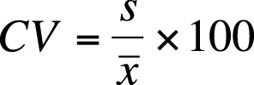

Example 1.(for individual)
Marks(x)=1, 5, 8, 9, 11, 15
Solution,

Example 2 (for discrete series)

Mark(x) 5 10 15 20 25
(f) 2 6 4 6 9
Con,
Mark (X) 5-10 10-15 15-20 20-25
F 2 8 6 3

