**Exam tips**

**Do all theory**

**Take a calculator and pencil**

**Use a pencil to draw the format**

**100% pass if you solve this**

*Prepaid by Nagendra sir*

Follow us on Facebook: The Learning Hub

Subscribe our channel: Nagendra Dhimal

**Class 12 Account Model Question**  **2081**

FM = 75

PM= 27

*Candidate are required to give their own words answer. Given in the figure indicates mark margin*

**Attempt all Question**

**Language = Both (Nepali + English)**

Group ( 11*1=11)

1. What is the meaning of company and write two fractures of the company

Ans:- A company is a legal entity formed by a group of individuals to engage in and operate a business—commercial or industrial—enterprise. Companies are structured in various ways, such as partnerships, corporations, and sole proprietorships, depending on their ownership arrangements.

Features of Company (कम्पनिका बिषेशता)

1. **Legal Entity**: A company is recognized as a separate legal entity, meaning it can own property, incur debts, sue, and be sued independently of its shareholders.
2. **Limited Liability**: In most cases, the liability of shareholders is limited to the amount they have invested in the company, protecting their personal assets from business debts.
3. Mention the meaning of the time payment system.

Ans:- The time payment system refers to a method of compensating employees based on the amount of time they have worked, typically calculated on an hourly, daily, or weekly basis. This system is straightforward and ensures workers are paid a fixed rate for the hours they work, regardless of the output.

1. Differentiate between equity shares and preferred shares.

Ans:- The main difference between equity share and preferred share are listed below

|  |  |
| --- | --- |
| Equity share | Preferred share |
| Represent ownership in the company and entitle shareholders to vote in corporate decisions. | Have a fixed dividend rate, which is paid out before any dividends are distributed to equity shareholders. |
| Shareholders receive dividends based on the company’s profits, but dividends are not guaranteed and can fluctuate. | Typically do not carry voting rights, except in certain situations. |

1. What is the meaning of accounting master?

Ans:- An accounting master refers to the comprehensive records or lists that serve as the foundation for the accounting system of a company. It includes master data such as the chart of accounts, customer lists, vendor lists, and inventory items, which are essential for generating accurate financial reports

1. Why the inventory management is important for an payment.

Ans:- Inventory management is crucial for ensuring that a company maintains the right balance of stock—neither too much nor too little. Proper inventory management helps in minimizing costs, maximizing sales, and ensuring that customers’ needs are met without overstocking or stockouts. It also plays a critical role in cash flow management and overall profitability

1. Write the meaning of called up capital.

* Ans:- Called-up capital refers to the portion of a company's subscribed capital that the company has requested shareholders to pay. It is the amount of money that shareholders are obligated to contribute to the company as part of their equity investment, based on the shares they hold.

1. Define the public and private company in short.

Ans:- **Public Company**: A public company is one that has issued shares to the public and is listed on a stock exchange. It is required to follow strict regulatory requirements and must disclose financial information to the public.

**Private Company**: A private company is owned by a small group of investors and does not offer its shares to the public. It is not listed on a stock exchange and has fewer regulatory obligations compared to a public company.

1. Mention any two disadvantages of the time rate system of wage

Ans:- There are some disadvantages of time rate payment system are listed below:

1. **Lack of Incentive for Increased Productivity**: Since workers are paid based on time rather than output, there is little motivation for them to work more efficiently or increase their productivity.

2. **Higher Labor Costs**: Employers may incur higher labor costs, especially if workers are paid for time spent idle or if they take longer than necessary to complete tasks.

10. Prepare the adjustment entry of depreciation of furniture Rs 20000, tax paid, commission earned but not received, dividednd paid, bad debts.

and closing stock

Ans:- The adjusted entry of given statement are listed below

|  |  |  |  |  |
| --- | --- | --- | --- | --- |
| Date | Particulars | LF | Debit | Credit |
|  | Depreciation a/c ……..Dr  To Furniture a/c  ( Being Depreciation has been charged on furniture) |  | 20000 | 20000 |

10. Calculate the cash flow from operating activities using the indirect method:

Net income for the year Rs 400000

Non operating income Rs 30000

Increase in debtors Rs 30000

Ans

|  |  |
| --- | --- |
| Particulars | Amount |
| Net Income  Add: Non- Operating Expense  Less: Non- Operating Income  Less: Increase in debtors | 4,00,000  -  (30000)  (30000) |
| Net cash flow from operating activities | 340000 |

1. If annual requirement/demand (A) is 40000 units and No of order (N) is 10 times what is the value of economic order quantity (EOQ) carrying cost 10 % inventory value ( purchase cost/materials cost) Rs 200 carrying cost( c) = 200 of 10% = Rs 20

Given

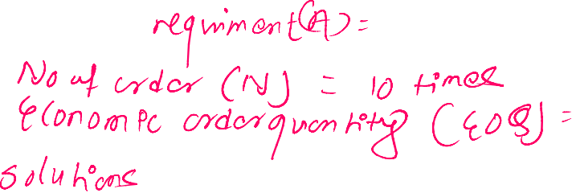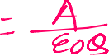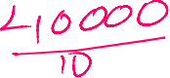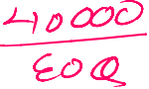

Group-B(8*5=40)

12. A Company Ltd. invited applications for 30,000 shares of Rs. 100

each at a 10% premium, payable as under: Rs 10

(On application) Rs. 30

(On allotment) Rs. 40 ( 30+10= 40)

(On first and final call) Rs. 40

Applications were received for 42,000 shares. The board of directors

decided to allot 25,000 applicants in full, 10,000 applicants 50% and

7,000 applicants were rejected. It was decided to utilize excess application money in part payment of allotment. All money were duly received except a shareholder holding 200 shares failed to pay first and final call money. Those share re-issued at Rs 90 full paid.

Calls in advance = full value paid, paid on allotment

(Required): (Entries for):

i) (Share application)

ii) (Share allotment)

iii) (Share first and final call.)

iv) share forfeitures

share allotted table

|  |  |  |  |  |
| --- | --- | --- | --- | --- |
| Received | Issued | Excess | Rejected | Prorate |
| 42000 | 30000 | 12000 | 7000 | 5000 |

Call arrera ( no of share * rate ( average rate) = No of aapiled share / issued share

Allotment amount – rate

= ?

Journal entries of ABc Company

|  |  |  |  |  |
| --- | --- | --- | --- | --- |
| Date | Particulars | LF | Debit | Credit |
| 1 | Bank a/c Dr ( 42000*30)  To share application a/c  ( Being share application money received) |  | 1260000 | 1260000 |
| 2 | Share application a/c Dr  To share capital a/c ( 30000*30)  To bank a/c ( 7000 * 30)  To share allotment a/c ( 5000*30)  To share final call a/c  ( Being share application money transfer into share capital ) |  | 1260000 | 9,00,000  210000  150000 |
| 3 | Share allotment a/c Dr ( 30000*40)  Discount on share  To share capital a/c ( 30000*30)  To share premium a/c ( 30000*10)  ( being share allotment money due) |  | 12,00,000 | 9,00,000  3,00,000 |
| 4 | Bank a/c Dr ( 12,00,000- 150000)  To share allotment a/c  To calls in advance a/c  ( Being share allotment received ) |  | 1050000 | 1050000 |
| 5 | Final call a/c dr ( 30000*40)  To share capital a/c  ( Being share final call money due) |  | 12,00,000 | 12,00,000 |
| 5 | Bank a/c Dr ( 12,00,000-8000)  Call in arrear a/c Dr (200*40)  To share final call a/c  ( Being share final call money received) |  | 1192000  8000 | 1200000 |
|  | Share forfeitures  Share capital a/c Dr (200*100)  To calls in arrear a/c (200*40)  To share forfeiture a/c (200*60)  ( being forfeited of 200 share for non payment of final call money) |  | 20,000 | 8000 12000 |
|  | Re-issued  Bank a/c Dr ( 200*90)  Share forfeiture a/c Dr (200*10)  To share capital a/c ( 200*100)  ( being re-issued of 200 shares) |  | 18000  2000 | 20000 |
| 3. | Share forfeiture a/c Dr ( 200*50)  To capital reserve a/c  ( Being transfer of gain into capital reserve) |  | 10000 | 10000 |

13. a) (X Company purchased the following assets of Y Company at an agreed price of Rs. 550,000.)

(Machinery) Rs.300,000 (Debtors) Rs.100,000

(Inventories) Rs.150,000

(X Company paid the purchase price by issuing shares of Rs.100 each

at a premium of 10%.)

or issued 10000 share at Rs 100 of 10 % premium

(Required):

(Entry for purchase of above assets by issuing shares) [3]

Ans:- Journal entries ‘

|  |  |  |  |  |
| --- | --- | --- | --- | --- |
| Date | Particulars | LF | Debit | Credit |
|  | Machinetry a/c Dr  debtors a/c Dr  Inventory a/c Dr  Goodwill a/c  To agreed price / vendor a/c  To capital reserve a/c  ( being took over of Y company X company agreed with assest and liabilities) |  | 3,00,000  1,00,000  150000 | 550000 |
|  | Vendor a/c Dr  To share capital a/c (5000*100)  To share premium a/c ( 5000*10)  (Being transfer of vendor a/c to share capital ) |  | 550000 | 5,00,000  50000 |

Agreed price = ( no of share * issued amount) ( issued amutn + premium – discount)

No of share = agreed price / issued amount

= 550000/ 110 = 5000 shares

b) P Company Ltd issued 5,000, 9% Debenture of Rs 100 each at a 10%

discount and redeemable at a 10% premium after 5 years.)

(Required):

(Journal entries for issue and redemption of debentures) (3)

Journal entries for issue and redemption of debentures

|  |  |  |  |  |
| --- | --- | --- | --- | --- |
| Date | Particulars | Lf | Debit | Credit |
|  | Issue  Bank a/c Dr (5000*90)  Discount on debenture a/c Dr ( 5000*10)  Loss on redemption of debenture a/c Dr  To 9% debenture a/c (5000*100)  To premium on redemption of debenture a/c  ( Being issued of 9% Debenture at 10% discount ) |  | 450000  50000  50000 | 5,00,000  50000 |
|  | Redemption  9% debenture a/c Dr ( 5000*100)  Premium on redemption of debenture a/c Dr ( 5000*10)  To bank a/c  ( Being redemption of 9% debenture after 5 years at 10 % premium) |  | 5,00,000  50000 | 550000 |

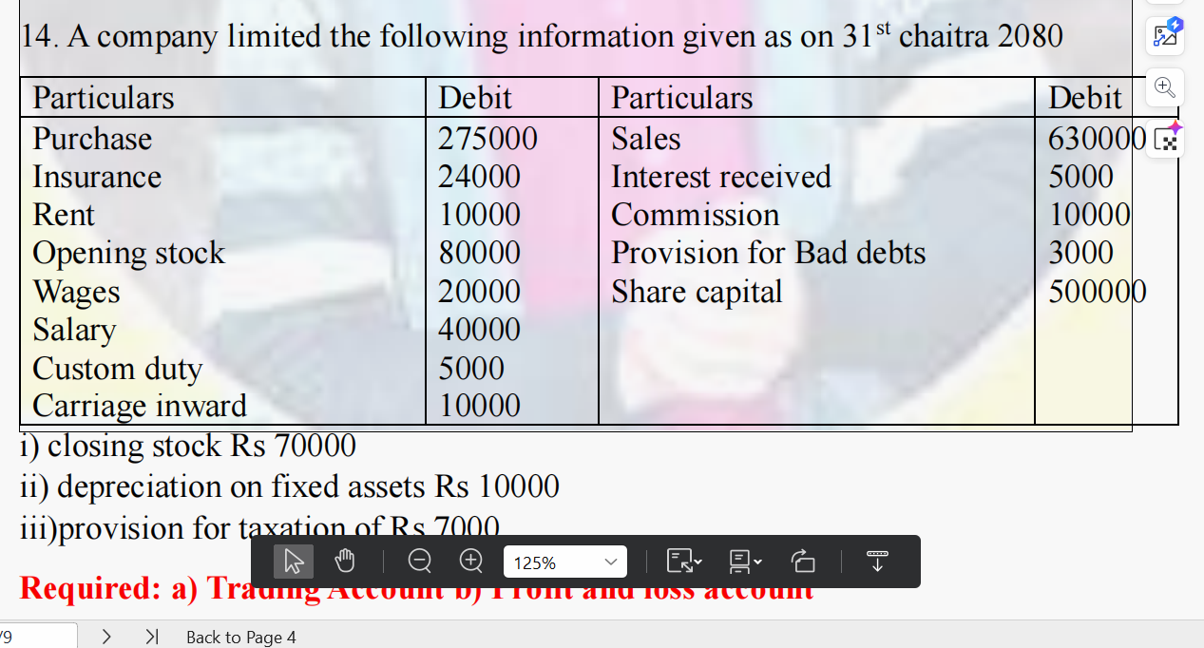

**Required**

i) closing stock Rs market price 70000 at cost price is Rs 80000

ii) depreciation on fixed assets Rs 10000

iii)provision for taxation of Rs @ 50%

**: a) Trading Account b) Profit and loss account )**

* 1. Trading account of ABC Company end of Chaitra 31st

Dr Cr

|  |  |  |  |
| --- | --- | --- | --- |
| Particulars | Amount | Particulars | Amount |
| To, opening stock  To, purchase  less:- Purchase return  To, wages  To, custom duty  To carriage inward/ carriage/ fright on purchase  To Gross profit c/d | 80000  275000  20000  5000  10000  310000 | By, sales  less:- sale return  By closing stock ( if additional )  By, Gross loss c/d | 630000  70000  - |
| Total | 7,00,000 | Total | 7,00,000 |

* 1. Profit and loss account of ABC Company for the ended year 2082 Chaitra 31st

Dr Cr

|  |  |  |  |
| --- | --- | --- | --- |
| Particulars | Amount | Particulars | Amount |
| To gross loss b/d  To, Insurance  To, Rent  To, salary  To Depreciation  To provision for tax  To Net profit …………………. | 24000  10000  40000  10000  7000  237000 | By, Gross profit b/d  By, interst received  By commission received  By provision for bad debts | 310000  5000  10000  3000 |
| Total | 328000 | Total | 328000 |

Hidden adjustment

10% investments = Rs 1,00,000

Interest amount(Cr ) = Rs 10000

Interest received = 5000   
add: Receivable = 5000 = Rs 10000

Salary 2 months due

Salary = 40000 ( 10 months)

Monthly salary = 40000/10 = 4000

Due salary = 4000*2= 8000

15. The trial balance of Co. Company Limited on 31st March 2023 - 5

|  |  |  |  |
| --- | --- | --- | --- |
| Particular | Debit | Particular | Credit |
| Opening stock  Purchases  Furniture  Rent  Machinery  Salaries  Wages  Debtors  Investment  Cash | 10,000  1,00,000  50,000  10,000  120,0000  20,000  10,000  50,000  50,000  20,000 | Sales  Interest received  Creditors  Share capital | 3.00,000  10,000  30,000  1,00,000 |
| Total | 440000 | Total | 440000 |

Additional information:

i) salaries payable Rs 4000

ii) Depreciation on machinery @10%

**Required: Worksheet draw yourself. Depreciation a/c Dr to machinery**

**Final account**

1. **Trading account Dr = expnese, assets, loss**
2. **Profit or loss account Cr= Gain, income, liabilities, share capital**
3. **Retained eaarning**
4. **Balance sheet**

**For columnm = 12 - dividend, p/l appropration**

**10 = both are not given**

**Worksheet of ABC Company For The year of 2081 chitara 31st**

|  |  |  |  |  |  |  |  |  |  |  |  |
| --- | --- | --- | --- | --- | --- | --- | --- | --- | --- | --- | --- |
| **S.N** | **Praticulars** | **Unadjusted T/B** | | **Adjuestment** | | **Adjusted T/B** | | **Income statement** | | **Balance sheet** | |
| **Dr** | **Cr** | **Dr** | **Cr** | **Dr** | **Cr** | **Dr** | **Cr** | **Dr** | **Cr** |
|  | Opening stock | **10000** |  |  |  | **10000** |  | **10000** |  |  |  |
|  | Purchase | **100000** |  |  |  | **100000** |  | **100000** |  |  |  |
|  | Furniture | **50000** |  |  |  | **50000** |  |  |  | **50000** |  |
|  | Rent | **10000** |  |  |  | **10000** |  | **10000** |  |  |  |
|  | Machinery | **120000** |  |  | **12000** | **108000** |  |  |  | **108000** |  |
|  | Salary | **20000** |  | **4000** |  | **24000** |  | **24000** |  |  |  |
|  | Wages | **10000** |  |  |  | **10000** |  | **10000** |  |  |  |
|  | Debtors | **50000** |  |  |  | **50000** |  |  |  | **50000** |  |
|  | Investment | **50000** |  |  |  | **50000** |  |  |  | **50000** |  |
|  | Cash | **20000** |  |  |  | **20000** |  |  |  | **20000** |  |
|  | Sales |  | **3,00,000** |  |  |  | **300000** |  | **3,00,000** |  |  |
|  | Interest received |  | **10000** |  |  |  | **10000** |  | **10000** |  |  |
|  | Creditors |  | **30000** |  |  |  | **30000** |  |  |  | **30000** |
|  | Share capital |  | **1,00,000** |  |  |  | **100000** |  |  |  | **100000** |
|  | Additional information |  |  |  |  |  |  |  |  |  |  |
|  | Salary payable |  |  |  | **4000** |  | **4000** |  |  |  | **4000** |
|  | Depreciation on machine |  |  | **12000** |  | **12000** |  | **12000** |  |  |  |
|  | Net profit |  |  |  |  |  |  | **144000** |  |  | **144000** |
|  | Total | **440000** | **440000** | **16000** | **16000** | **444000** | **444000** | **310000** | **310000** | **278000** | **278000** |

**Dr unadjuest and adjustment Dr = +, Dr unadjuested and adjustment Cr = -**

Additional information

Unrelated heading

1. Diividend paid/ closing stock

17) a) write the meaning of materials classifications with suitable examples

Ans:-

Materials classification refers to the process of categorizing materials based on their nature, usage, and importance in production or operations. This classification helps in effective inventory management, cost control, and procurement planning. Common classifications include:

1. **Raw Materials**: These are the basic materials used in the production process. For example, cotton for a textile company or crude oil for a petroleum company.
2. **Work-in-Progress (WIP)**: These are partially finished goods that are still in the production process. For example, a car chassis in an automobile manufacturing plant.
3. **Finished Goods**: These are completed products ready for sale to customers. For example, a fully assembled computer.
4. **MRO (Maintenance, Repair, and Operations) Supplies**: These are items used in the maintenance and repair of equipment but not directly in the production process. Examples include lubricants, cleaning supplies, and small tools.
5. **Consumables**: These materials are used up in the production process but are not part of the final product. Examples include welding rods, adhesives, and solvents.

Language = Both ( Nepali + English)

16) Differentiation between cost accounting and financial accounting. ( VVI)

Ans:- The main difference between of cost accounting and financial accounting are listed below:

|  |  |
| --- | --- |
| Cost Accounting | Financial accounting |
| To determine the cost of production and operations for cost control, budgeting, and decision-making. | To record, summarize, and report the financial performance and position of a business to external stakeholders. |
| Reports are generated as needed (e.g., daily, weekly, monthly). | Reports are typically generated at regular intervals (e.g., quarterly, annually). |
| Not legally required but essential for internal management. | Legally required and governed by accounting standards like GAAP or IFRS. |
| Focuses on both past and future costs for budgeting and forecasting. | Primarily focuses on historical financial data. |

Or write usages of computers in accounting system

Ans:- **Usages of Computers in Accounting System**

1. **Automation**: Computers automate repetitive accounting tasks like data entry, calculations, and report generation, increasing efficiency and reducing errors.
2. **Data Storage and Retrieval**: Computers allow vast amounts of financial data to be stored securely and retrieved quickly.
3. **Accuracy**: Computerized accounting systems reduce the likelihood of human errors in calculations and data recording.
4. **Speed**: Computers process financial data faster than manual methods, enabling timely financial reporting.
5. **Real-Time Financial Analysis**: Computerized systems provide real-time data analysis, helping businesses make quicker and more informed decisions.

Or what is cost accounting mention its any limitations

Ans:- Cost accounting is the process of recording, classifying, and analyzing costs associated with the production or provision of goods and services. It helps businesses control costs, set prices, and make strategic decisions.

**Limitations**:

1. **Time-Consuming**: The process of cost accounting can be complex and time-consuming.
2. **Estimates and Assumptions**: Often relies on estimates and assumptions, which may not always be accurate.
3. **Not Always Relevant**: Some cost accounting data may not be relevant for external reporting purposes.
4. **Complexity**: For small businesses, the detailed analysis required can be overwhelming and costly to implement.

Or Explain the limitations of computerized accounting system

Ans:- The Limitations of Computerized Accounting System

1. **High Initial Cost**: Setting up a computerized accounting system can be expensive due to the cost of software, hardware, and training.
2. **Technical Issues**: Systems can face technical issues like software bugs, hardware failures, or cyberattacks, which can disrupt operations.
3. **Dependency on Technology**: Over-reliance on computerized systems can lead to problems if the system fails or there is a lack of technical support.
4. **Data Security Risks**: Storing financial data electronically makes it susceptible to hacking and unauthorized access.
5. **Need for Regular Updates**: Software needs to be regularly updated to keep up with changes in tax laws, accounting standards, and business needs.

Or write a meaning of fixed cost and variable cost with suitable example

Ans:- **Fixed Cost**: These are costs that do not change with the level of production or sales. They remain constant regardless of business activity.  
**Example**: Rent for a factory building remains the same whether the factory produces 1,000 units or 10,000 units.

**Variable Cost**: These are costs that vary directly with the level of production or sales.  
**Example**: The cost of raw materials, such as wood for a furniture manufacturer, increases as more furniture is produced.

**Or** State the proper meaning of computer software and what is its advantages in

account .

Ans:- Computer software refers to the programs and applications used to perform specific tasks on a computer. In accounting, software is used to manage financial transactions, generate reports, and ensure compliance with accounting standards.

**Advantages in Accounting**:

1. **Efficiency**: Automates many accounting tasks, saving time and reducing errors.
2. **Accuracy**: Improves the accuracy of financial data and calculations.
3. **Real-Time Processing**: Provides real-time data analysis, aiding in quick decision-making.
4. **Compliance**: Helps ensure compliance with accounting standards and regulations by automating tax calculations and financial reporting.
5. **Scalability**: Can easily be scaled to handle growing volumes of transactions as the business expands.

17 b) The following information are given below:

June: opening inventory 2000@ rs 100  
July: purchase 1000units @ Rs120  
August: purchase 1500 units @ Rs 125

Sales for the years 4000 units

Required: cost of goods sold and ending inventory using perod system and avegae weighted method. ( LIFO and FIFO)

Formula   
cost of good sold = Sold units * weighted average cost per unit   
Ending inventory = Cost of goods sold available for sales- cost of good sold

Working notes

Cost of sales avaiables for sold = opening * rate+ purchase * rate   
= 2000*100+1000*120+1500*125  
Rs = 507500

Weighted average cost per unit = cost of sales available for sales / total available inventory

= 507500/ ( 2000+1000+1500)  
= 112.77 per unit

Solution

We have

1. Cost of good sold = Sold units * WA C   
   = 4000 units * 112.77   
   Cost of good sold = Rs 451080Ans
2. Ending inventory = Cost of good sold avaiable for sale - cost of good sold   
    = 507500- 451080

Total ending inventory = Rs 56420

To

LiFo = Last in First Out Method   
Fifo= Fisrt in first out method

Total 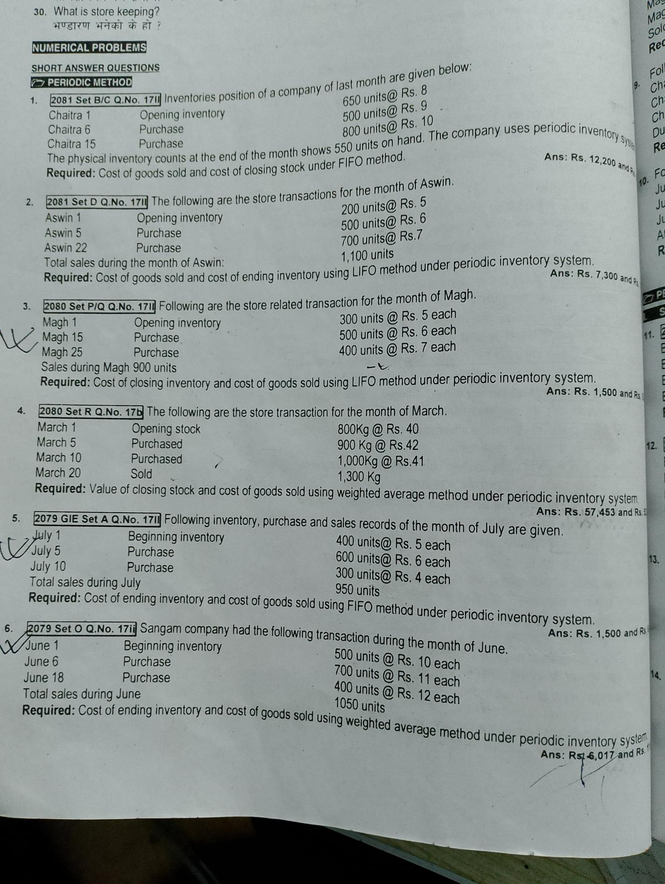

1. Cost of Good sold uning periodic system ( LIFO) for 1100

|  |  |  |
| --- | --- | --- |
| Date | Rate | Total |
| Asjo purchase 700 units | Rs 7 | 4900 |
| Asoj 5 Sold 400 units | Rs 6 | 2400 |
| Total cost of good sold |  | Rs 73000 |

1. Ending inventory

|  |  |  |
| --- | --- | --- |
| Particulars | Rate | Toatl |
| 100 units | 6 | 600 |
| 200 units | 5 | 1000 |
| Total ending inventory |  | Rs 1600 |

Or

Ending inventory = Total inventory cost - cogs   
= (200*5+500*6+700*7)- 7300

Total Ending Inventory = Rs 1600 Ans

1. 700 = 400

18 a) The time allowed to produce 80 units of output is 2 hours. A worker produce 400 units during the months. Wages rate per hour is Rs 800

**Required: wages payable of worker**

**Solution**

**Given,**

Time allowed = 80 units for 2 hours 1 hour produce = 80/2 = 40 units   
Total Production = 400 units   
Wage rate per hour = Rs 800

Total wages = ?

**Total wages = total time taken * wage rate per hour**

**10 hours * Rs 800**

**Total wages = Rs 8000 ans**

**Or**

**Total wages = total production * wage rate per unit**

**= 400 units * 20 Per unit**

**Total wages = Rs 8000 ans**

**Working**

**Total time taken = total production unit/ hourly output**

**Wage rate per unit = wages rate per hour / hourly output**

**= Rs 800/ 40   
= Rs 20 Per unit**

400 units / 40   
total time taken = 10 hours



b) On reconciling the cost account and financial account following facts are



disclosed - 3



i) Profit shown by financial account Rs 420000

ii) Works overhead under-recorded in cost account Rs 25000

iii) office overhead under-recorded in financial account Rs 15000

iv) A profit on sales fixed assets shown in financial account Rs 5000

Required: Cost Reconciliation Statement

|  |  |  |
| --- | --- | --- |
| Particulars | Amount | Amount |
| Net profit as per fiancial account  Add:-  Works overhead under in cost account  Less:-  Office oevrhead under recored in fiancial account  Profit shown in fiancial account | 25000  15000  5000 | 420000  25000  445000  (20000) |
| Net profit as per cost account |  | 425000 |

Exapnese= overhead, opening stock, Debit, depreciation, loss on sale   
Income =Credited, clsoing stock, profit on sale   
Under, recored = थोरै  
Over = धेरै

Heading only receored in fiancial

Dividend, bad debts, tax paid, tarnsfer fee, ineterest ect ….

Reaatined earning = net profit + p/l appropartion - dividend

**18.** Explain the features of software accounting or Write the usages and advantages

of excel in accounting

**Group- C ( 3*8=24)**

19) The trail balance of the company ltd as on 31st Chitra 2080

|  |  |  |  |
| --- | --- | --- | --- |
| Particulars | Debit | Particular | Credit |
| Opening stock  Purchase  Wages  Salary  Office expneses  Prepaid insurance  Advertisement  Interest  Machinery  Debtors  Water expnes  Investment  Cash | 20000  150000  25000  50000  15000  25000  12000  5000  250000  11000  30000  40000  100000 | Sales  Share capital  Debentures  Creditors  Other income | 4,00,000  250000  50000  18000  15000 |
| Total | 733000 | Total | 733000 |

Additional Information

i) Prepaid insurance Expired Rs 15000

ii) Closing Inventory market price Rs 30000, cost price Rs 40000

iii) Depreciation on machinery @ 15%

iv) Provision for income @ 10%

Requried: Income statement as per NFRS and balance sheet

Or NFRS= Nepal Fiancial reporting Standard

Multistep income statement and vertical balance sheet

Sales- Cogs= Gross profit - opearting expense ( selling + office) = inccome from opearting + other income - fiancial expnese = net profit before tax - tax = Net Income

1. Income statement of ABC Company

|  |  |  |
| --- | --- | --- |
| Particulars | Amount | Amoutn |
| Sales  Less:- sales return |  | 4,00,000 |
| Less:- **cost of good sold**  Opening stock  Purchase  Wages  Water expesnse  Less:- closing stock | 20000  150000  25000  30000  (30000) | (195000) |
| Gross profit |  | 205000 |
| Less:- Opeaarting expnese ( a+b)  - Office and administrative expense (a)  Salary  Office expense  Prepaid insurance expired  Dpreciation on machiery  Total office (a) | 50000  15000  15000  37500  117500 |  |
| - selling and distribution expanse  Advetrisments | 12000 |  |
| Total opearting expnse ( a+b) |  | (129500) |
| Income from opearting ( GP- OE) |  | 75500 |
| Add:- other income  Commission received  Interest received  Discount received  Dividend received |  | 15000 |
| Less:- Non- operating expanse ( financial expense)  Ineterest |  | (5000) |
| Net profit before tax |  | 85500 |
| Less:- tax ( 85500 of 10% ) |  | 8550 |
| Net income |  | 76950 |
| Less:- Non -cotroling ineterst |  | -? |
| Net income after noni |  | ? |
| Reatined earning |  | - |

Non- contorlling ineterst = @ 40%

Dividend ( cash dividend/ proposed divined/ interiem dividend) either given trail balance or additional information) = reatined eaning

1. Balance Sheet under Multi Step Of ABC Company

|  |  |  |
| --- | --- | --- |
| Assets | Amount | Amount |
| **- current assets**  Prepaid insurance 25000 less:- Expired insurance ( 15000)  Debtors  Cash  Closin stock | 10000  11000  100000  30000 |  |
| Total current Assets |  | 151000 |
| - **long term investment**  Investment |  | 40000 |
| - **property planta nd equipments**  **Machinery 250000**  **Less:- Dpreciation (37500)** |  | 212500 |
| **- intangiable assets**  Goodwill  Copyright  Tademark |  | - |
| Total assets ( a+b+c+d) |  | 403500 |

Slaray paid = 40000

Add:- due slaeray -= 8000 = 48000   
due moths = 2 moths   
10 months slaray = 40000  
1 months = 40000/10   
= 4000   
2 months = 2*4000= Rs 8000

B.

|  |  |  |
| --- | --- | --- |
| Liabilities and equity capital | Amount | Amount |
| **- current laibilities and provision**  Creditors/ a/c payable bills payable  Bank overdarft/ payable expnse  Provision for tax | 18000  8550 |  |
| Total current liabilities |  | 26550 |
| - **non- current liablities**  Debentures |  | 50000 |
| - **equity share capital**  Share capital  Add:- Net Income  Less:- net loss | 250000  76950  - | 326950 |
| Toat equity and liabilities (a+b+c) |  | 403500 |

Account/biils receiavbles = debtors/ book debts

Cogs = tarding account ( manufacturing expense factory expesne)

Relationship

Assets ( Negative relationship) Liabilities - Positive relationship

1. Operating activities ( C.A, C.L expense income)
2. Investing activities ( Fixed assets, investment)
3. Financing activities ( long term debt, dividend, share premium, share capital)

20. Following information are taken from 2021 and balance sheet

|  |  |  |  |  |  |
| --- | --- | --- | --- | --- | --- |
| Liabilities | 2075 | 2076 | Assets | 2075 | 2076 |
| Creditors  Expnes due  Retained  Earnings  Loan  share capital | 29000  2000  89000  50000  80000 | 32000  3000  62000  68000  90000 | Debtors  Stock  Cash at bank  Fixed assets | 15000  30000  25000  180000 | 10000  20000  ?  195000 |
| total | 250000 | 255000 | total | 250000 | 255000 |

Additional information

sales during the year Rs 100000

Cost of goods sold Rs 80000

Operating Expense ( including interest expense Rs 4000) Rs 26000

Fixed Assets purchase Rs 29000

Cash dividend Rs 7000

Required: Cash Flow Statement Using Direct Method

Cash Flow Statement Using Direct Method

|  |  |  |
| --- | --- | --- |
| Particulars | Amount | Amount |
| 1. Opearting Activities 2. Cash collection from debtors   Sales  decrease in debtors (10000-15000) | 1,00,000  5000 | 105000 |
| 1. Cash paid to suppliers   Cost of goods sold  Decrease in stock  Increase in creditors | (80000)  10000  3000 | (67000) |
| 1. Cash paid to employees and others   Opearting expnese  Increase in expense due | (22000)  1000 | (21000) |
| 1. Cash paid tax |  | - |
| 1. Cash paid interest |  | (4000) |
| Add:- other income |  | - |
| Net cash flow from opearting activities (A) |  | 13000 |
| 1. Investing activities   Fixed assets purchase  Sale of fixed assets | (29000)  - | (29000) |
| Net cash flow from investing activities (B) |  | (29000) |
| 1. Financing activities   Issue of share capital  Increase in loan  Cash divined | 10000  18000  (7000) | 21000 |
| Net cash flow fro, fianancing activities ( C) |  | 21000 |
| Net change in cash Flow ( A+B+C) |  | 5000 |
| Add:- Begnning cash balance ( last year ko bank balance) |  | 25000 |
| Closing cash balance |  | 30000 |

Exclude heading while calculating

1. Depreciation
2. Goodwill written
3. Reatined earning
4. Premilimary expense written
5. Loss on sale of fixed assets
6. Profit on sale of fixed assets

Cash flow from opearting activities using indirect method

|  |  |  |
| --- | --- | --- |
| Particulars | Amount | Amount |
| Net Income  Add:- non- Operating expense  Goodwill written off  depreciation  Loss on sale of fixed assets  Premium on redemption  Transfer fees  Less:- Non operating income  Dividend received  Other income receieved  Profit on sale of fixed assets  Aprreciation  Income from opearting/ net profit  Add:- increase current liabilities / decarease in current current assets  Less:- Decrease in current liabilities/ increase in curent assets  Less;- Tax paid |  | xx |
| Net cash flow from operating activities ( A) |  |  |

Facebook: Nagendra Dhimal

21. Cost information for manufacturing a product is given below):

(Direct Material) : 20,000 kgs @ Rs. 10 per kg

(Direct Labour cost) : 80% of cost material

(Factory overhead) : Rs.64,000

(Administrative overhead) : Rs.42,400

(The following estimations were made for submitting a tender):

- (The estimated cost of materials is) Rs.30,000

- (Direct labour) Rs.24,000

(Factory overhead are absorbed on the basis of direct labor)(Administrative overheads are absorbed on the basis of factory cost)

(A profit of 20% on the selling price is estimated)

(Required): [3+5]

(A Statement of Cost and Tender sheet

99.9 % direct method   
indirect chance = 0.

9745862965